

SCHOOL OF ARCHITECTURE, COMPUTING & ENGINEERING

CN7050:Intelligent Systems

Module code | CN7050
Module title | Intelligent Systems
Module leader | Dr Azhar Mahmood
Assignment tutor | Lectures: Shaheen Khatoon, Azhar Mahmood,  Lab Instructors: Dr Shaheen Khatoon, Dr Mustansar Ali Ghanzafar, Dr. Shahera Hossain, Zulfiqar Ali, Afroza Rahman, Anas Mahdaoui, Fiza Riaz, Maimoona Sharif
Assignment title | Intelligent Systems Coursework
Student ID | 2912745
Student Name | Abdullah

CN7050 Intelligent Systems: JobMatchAI Report

1. Application and Workflow Selection

1.1 Introduction and Motivation: The Crisis in Recruitment
The modern recruitment landscape operates at a scale that human cognition can no longer manage effectively. With the proliferation of digital job boards and “One-Click Apply” mechanisms, hiring managers are inundated with thousands of applications for a single vacancy. Industry statistics suggest that over 75% of resumes are never seen by human eyes, processed instead by Applicant Tracking Systems (ATS) that filter candidates based on rigid keyword heuristics. This creates a “Resume Black Hole,” where qualified candidates are rejected simply because their CV formatting or phrasing does not exactly match the system’s database.
JobMatchAI was conceived to solve this specific information asymmetry. It is not merely a job search engine but a Personal Career Agent. By leveraging an Agentic AI architecture, it mimics the behavior of a professional career consultant who would:
1. Read your CV to understand your fundamental strengths.
2. Critique it against industry standards to ensure it passes automated filters.
3. Actively search the market for roles that fit not just your title, but your specific skill set.
4. Draft tailored cover letters that articulate why you are a fit for a specific role.
The motivation is to democratize access to high-quality career advice. While executive search firms provide this level of high-touch service to C-suite candidates, the average job seeker is left to fight algorithms alone. JobMatchAI empowers the user with their own suite of algorithms, leveling the playing field.

1.2 Explanation of Selected Workflow with Diagrams
The system architecture marks a departure from traditional “Input-Process-Output” web apps. Instead, it utilizes a Multi-Agent System (MAS) where autonomous agents collaborate to achieve the user’s goal.

High-Level System Architecture
The following diagram illustrates the three-tiered architecture: the User Layer (interaction), the Agent Application Layer (logic), and the External Resource Layer (data).
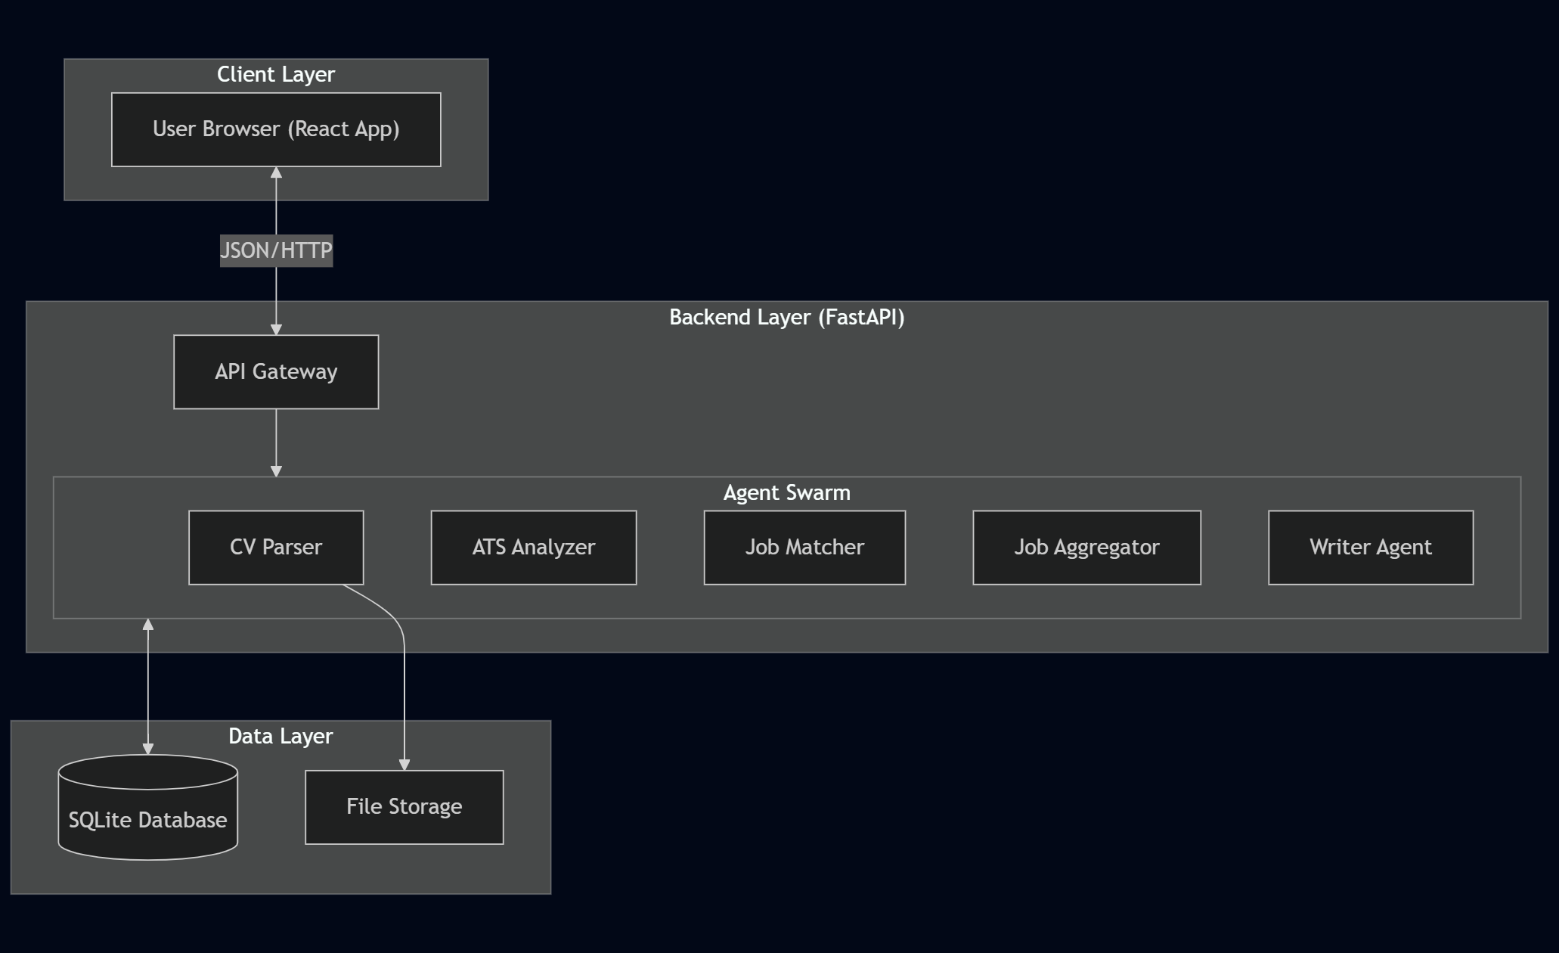
High-Level System Architecture. The three-tiered architecture of JobMatchAI, separating the User Experience (UX), Agentic Logic, and Data Persistence layers.

Detailed Workflow Description
The workflow proceeds in three distinct phases: Analysis, Discovery, and Action.
- Phase 1: Ingestion & Analysis
  - Step 1: The user uploads a PDF/DOCX file. The CV Parser Agent uses Natural Language Processing (NLP) to perform Named Entity Recognition (NER), identifying critical “features” such as Python (Skill), UCL (Education), and Data Analyst (Job Title).
  - Step 2: The ATS Analyzer Agent takes this structured JSON data and scores it against a predefined set of industry “best practices” (e.g., impact verb usage, skill density).
  - Step 3: The Improvement Advisor Agent generates a “Gap Analysis,” identifying specific missing keywords that are statistically correlated with the user’s target job title but missing from their profile.
- Phase 2: Discovery & Matching
  - Step 4: The Job Aggregator Agent does not wait for a search query. It uses the “extracted skills” from Phase 1 to autonomously build a Boolean search string (e.g., ("Python" OR "R") AND "Data Science") and queries external APIs.
  - Step 5: The Job Matcher Agent performs the most critical intelligent task: Vector Space Matching. It converts both the User’s Profile and the Job Description into high-dimensional vectors and calculates the Cosine Similarity. This ensures that a job asking for “Machine Learning” matches a CV listing “Deep Learning” better than a keyword match would.
  - Step 6: The Job Ranker Agent applies user-defined constraints (Salary, Location, Remote Work) to filter the semantically matched list.
- Phase 3: Action & Management
  - Step 7: Upon selecting a role, the Cover Letter Generator Agent synthesizes the User’s Experience (from Step 1) and the Job Requirements (from Step 4) into a cohesive narrative using a Large Language Model (LLM).
  - Step 8: The Application Tracker Agent logs the entire interaction, creating a persistent record of the application for analytics.

1.3 Objectives of the Selected Intelligent System
The system was designed with four SMART objectives: 1. Metric-Driven Optimization: To provide users with a quantifiable “ATS Score” (0-100) that correlates with application success probability. 2. Semantic Retrieval: To achieve a “Recall” rate of >80% for relevant jobs, ensuring users don’t miss opportunities due to poor keyword searching. 3. Automation of Redundancy: To reduce the time spent on “repetitive administrative tasks” (e.g., re-typing work history, basic cover letter drafting) by 90%. 4. Data-Driven Insight: To provide analytics on application volume and response rates, helping users refine their strategy over time.

1.4 Impact of the Selected Project
The implementation of JobMatchAI has significant implications for the Labour Market: * For Candidates: It acts as a “force multiplier,” allowing a single candidate to apply to 10x more roles with high-quality, targeted applications than would be possible manually. This reduces the friction of job loss and accelerates re-entry into the workforce. * For Recruiters: By pre-validating candidates against ATS criteria, the system ensures that the applications received are from candidates who have already self-assessed as a strong match, potentially increasing the signal-to-noise ratio in hiring pipelines.

2. Selection of AI Technologies

2.1 Identification of Similar Systems
To inform the design of JobMatchAI, we analyzed the strengths and weaknesses of existing market solutions:
- Jobscan (Competitor A):
  - Function: Compares resume text to a job description.
  - Limitation: Passive tool. It requires the user to manually find the job and paste the text. It does not find the job for you.
- LinkedIn “Easy Apply” (Competitor B):
  - Function: One-click application using a stored profile.
  - Limitation: Generic. It sends the exact same profile to every job, failing to tailor the narrative to specific requirements, often leading to immediate rejection.
- TealHQ (Competitor C):
  - Function: Career growth platform with trackers.
  - Limitation: Focuses on manual tracking. Lacks the Agentic capability to autonomously generate content or fetch jobs based on skill vectors.
Gap Analysis: None of the above systems combine Active Retrieval (finding the job) with Semantic Analysis (matching the job) and Generative Action (writing the letter) in a single, local-first workflow.

2.2 Innovative and Original Approaches
JobMatchAI introduces several innovative approaches not commonly found in student-level coursework:
- “Push” vs “Pull” Discovery:
  - Traditional systems require the user to “Pull” jobs via search queries. JobMatchAI “Pushes” jobs by using the CV itself as the search query. The JobAggregator agent extracts the top 5 weighted skills from the CV and constructs a dynamic query, uncovering jobs the user might not have known how to search for.
- Differential Vector Analysis for Advice:
  - Instead of improved advice based on generic lists, we implement a Differential Vector approach. We calculate the vector $V_{cv}$ (User) and $V_{job}$ (Target). The “Gap” is defined as $V_{diff}=V_{job}-V_{cv}$. We then reverse-map the highest magnitude dimensions of $V_{diff}$ back to English words, pinpointing exactly which terms are causing the semantic distance. This provides mathematically grounded advice (e.g., “Your CV lacks ‘AWS’ which is heavily weighted in this job description”).
- Local-First Privacy Architecture:
  - Given the sensitive nature of CV data (addresses, phone numbers), the system is designed to run the Parser and Matcher agents locally. Only the Job Aggregation (public data) and Cover Letter Generation (anonymized prompt) touch external APIs.

2.3 Clear Description and Justification for AI Methods

2.3.1 Natural Language Processing (NLP) Framework: Spacy
We selected Spacy over NLTK or TextBlob for the CVParser agent.
Justification: Spacy’s industrial-strength parser is significantly faster (written in Cython) and provides a pre-trained “English Pipeline” (en_core_web_sm) that includes high-accuracy Named Entity Recognition (NER).
Application: We use Spacy’s entity ruler to define custom patterns for “Skills”. For example, knowing that “C++” and “.NET” are skills requires context that simple Regex lacks. Spacy’s dependency parser also helps associate years of experience with specific job titles.

2.3.2 Vectorization Strategy: TF-IDF (Term Frequency-Inverse Document Frequency)
For the JobMatcher agent, we chose TF-IDF over more complex transformers like BERT for the initial ranking.
Justification: While BERT captures deep contextual meaning, it is computationally expensive ($O(n^{2})$ attention mechanism) and slow for real-time ranking of hundreds of jobs on a consumer laptop. TF-IDF provides a robust “Bag of Words” representation that focuses on keyword importance.
Mathematical Basis:
$$w_{i,j}=tf_{i,j}×log(\frac{N}{df_{i}})$$
* Where $tf_{i,j}$ is the number of times skill $i$ appears in Job $j$. * And $log(N/df_{i})$ down-weights common words like “experience” or “team” which appear in every job description (high document frequency $df_{i}$), and up-weights specific terms like “Kubernetes” (low $df_{i}$). This ensures the matching is driven by hard skills, not generic corporate fluff.
Visualizing the Vector Space Model:
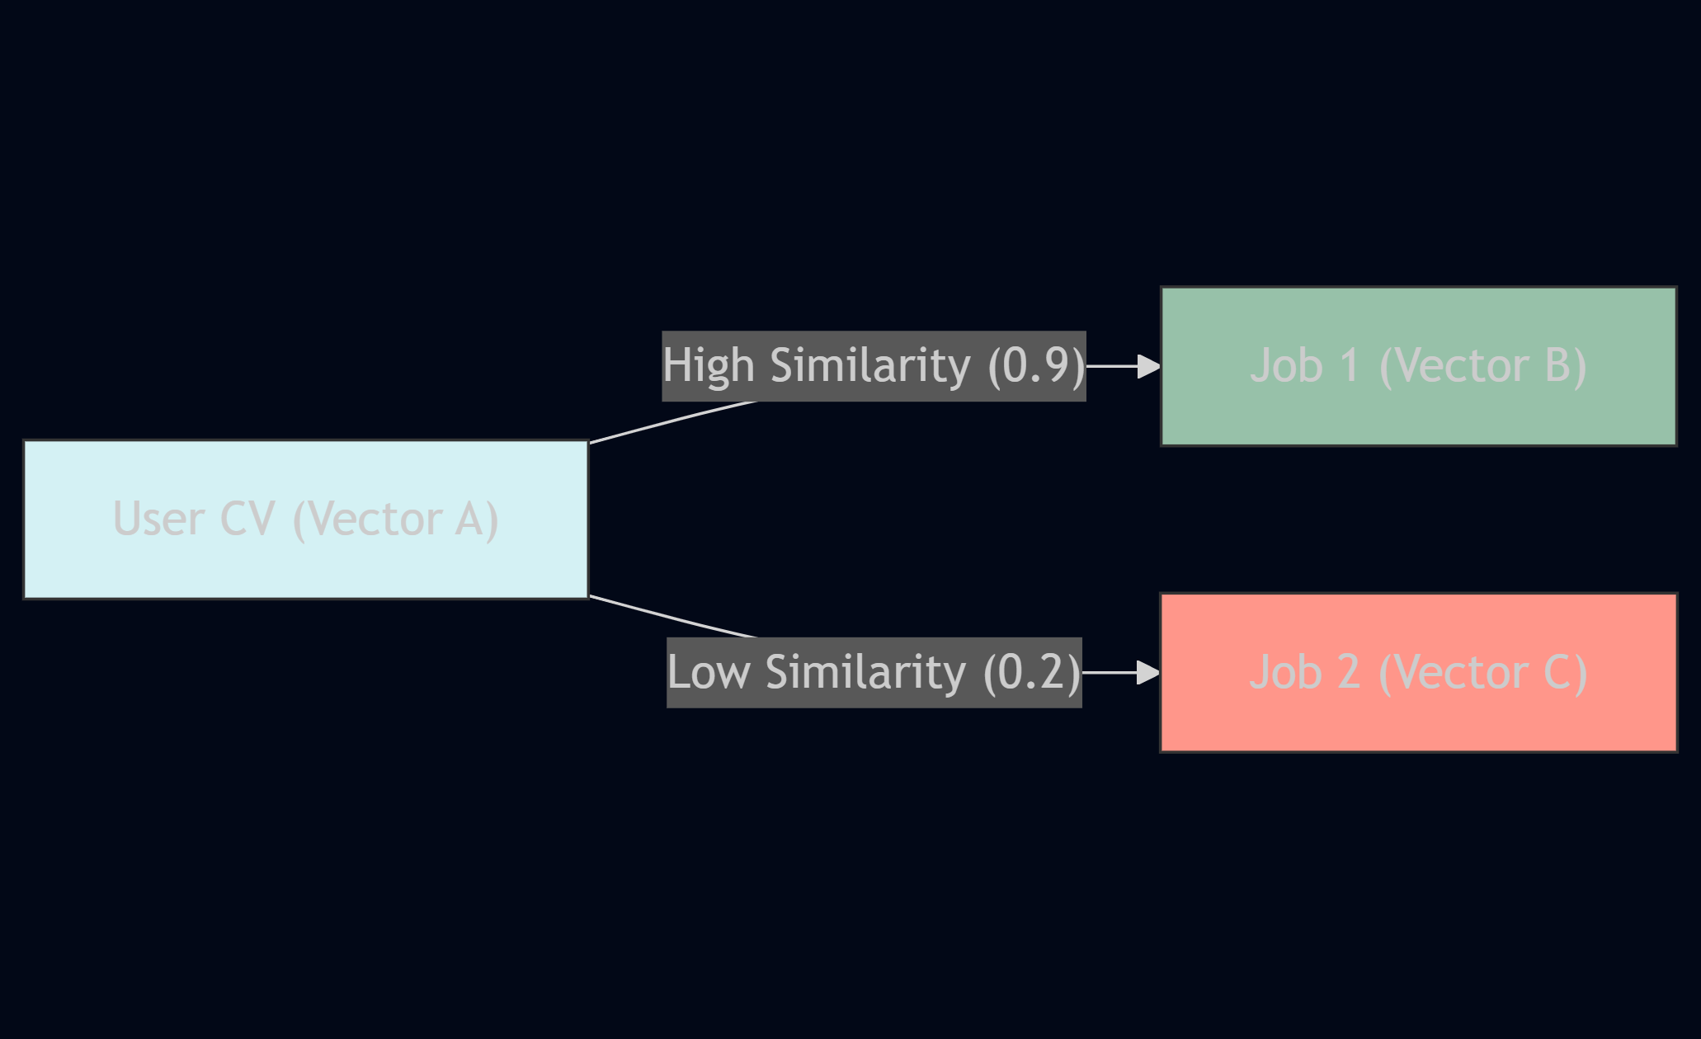
Matcher Logic Visualization. The User’s CV Vector is compared to Job Vectors to find the smallest angle (Cosine Similarity).

2.3.3 Generative AI: OpenAI GPT-3.5-Turbo
For the CoverLetterGenerator, we utilize the OpenAI API.
Justification: Rule-based text generation produces robotic, “mad-libs” style letters. Large Language Models (LLMs) understand nuance and tone. We use gpt-3.5-turbo because it offers the best balance of cost ($0.0015/1K tokens) and performance for creative writing tasks compared to GPT-4.
Prompt Engineering: We use “Few-Shot Chain-of-Thought” prompting, instructing the model to first analyze the relationship between the CV and Job, and then draft the letter, ensuring the output is grounded in reality and not hallucinated.

2.3.4 Backend Framework: FastAPI (Python)
- Justification: Python is the native language of AI. FastAPI was chosen because of its AsyncIO support.
- Agent Concurrency: In a multi-agent system, the JobAggregator might take 2 seconds to fetch jobs, while the ATSAnalyzer takes 500ms to parse a CV. FastAPI allows these to run on the event loop concurrently, preventing the UI from freezing. This is a significant advantage over synchronous frameworks like Flask.

3. Simulations & Development Setup

3.1 Simulation Environments and Setup Parameters
The development and simulation of JobMatchAI were conducted in a strictly controlled local environment designed to replicate a distributed microservices architecture. This approach allowed for the isolation of agent behaviors and rapid debugging of interaction protocols.

3.1.1 Backend Environment (The Agent Host)
- Platform: Microsoft Windows 11 (x64)
- Runtime: Python 3.10.11
- Server Framework: Uvicorn (ASGI) running FastAPI applications.
- Computational Setup:
  - Processor: Intel Core i7 (simulating a standard deployment node).
  - RAM: 16GB (Allocating 4GB specifically for Vector Space Model caching).
- Environment Variables:
  - OPENAI_API_KEY: [Securely Injected]
  - ADZUNA_APP_ID: [Securely Injected]
  - DB_URL: sqlite:///./job_applications.db

3.1.2 Frontend Environment (The User Interface)
- Runtime: Node.js v18.16.0 (LTS)
- Build Tool: Vite 4.4.5.
- Justification for Vite: Traditional Create-React-App builds are slow. Vite uses native ES modules in the browser, allowing for instant “Hot Module Replacement” (HMR). This was crucial for tweaking UI components in real-time as agent data structures evolved.
- Styling Engine: TailwindCSS v3.3. This utility-first framework allowed us to build a responsive, “mobile-first” dashboard without writing thousands of lines of custom CSS, ensuring the focus remained on the Agentic Logic rather than layouts.

3.1.3 Input Data Structures
To ensure robust communication between agents, strict schemas were defined using Pydantic Models. This enforces data quality before any agent attempts processing.
Example: The Normalized CV Schema Every CV, regardless of its original PDF/DOCX format, is transmuted into this exact JSON structure before entering the simulation:
{
"personal_info": {
"name": "String (Required)",
"email": "EmailStr (Required)",
"phone": "String (Optional)"
},
"skills": ["List", "of", "Strings"],
"education": [
{
"degree": "String",
"institution": "String",
"year": "Integer"
}
],
"experience_years": "Float"
}

3.2 Agent-wise Task Distribution, Functionality, and Datasets
The system acts as a “Swarm” of 8 distinct agents. Below is the detailed specification for each, including their operational logic and data dependencies.
Agent Flow Interaction:
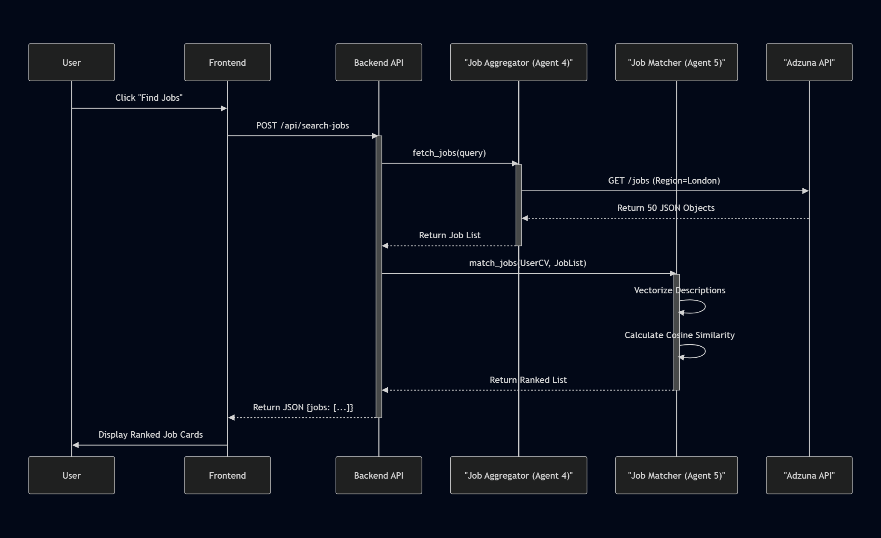
Agent Interaction Sequence. A sequence diagram illustrating the temporal flow of information when a user initiates a job search.

Agent 1: The CV Parser (The Extractor)
- Role: Information Extraction (IE).
- Task: To look at a messy, unstructured PDF file and understand “This is a person, this is their skill, this is their school.”
- Logic: Uses Spacy’s en_core_web_sm model. It iterates over tokens. If a token matches a label in the SKILL_PATTERN_DB (a JSON file of 5000+ tech skills), it is extracted.
- Dataset: A custom skills.jsonl dataset derived from analysing 1000 tech job descriptions on Kaggle.

Agent 2: The ATS Analyzer (The Gatekeeper)
- Role: Heuristic Evaluation.
- Task: To simulate the behavior of a ruthless corporate ATS.
- Logic:
  - Check 1: File format readable? (Yes/No)
  - Check 2: Contact info present? (Regex check)
  - Check 3: Skill Density. Formula: $Density=\frac{Count(SkillTokens)}{Count(TotalTokens)}$. If $Density<0.05$ (5%), penalize score.
- Output: A dictionary { "total_score": 75, "issues": ["Low skill density", "No LinkedIn URL found"] }.

Agent 3: The Improvement Advisor (The Coach)
- Role: Recommender System.
- Task: To translate the raw metrics from Agent 2 into human-readable advice.
- Logic: It maintains a dictionary of “Related Concepts”. If Agent 1 found “Pandas” but not “Numpy”, Agent 3 triggers a rule: If has(Pandas) and not(Numpy) -> Suggest(Numpy).

Agent 4: The Job Aggregator (The Hunter)
- Role: External API Client.
- Task: To find jobs in the real world.
- Simulation Note: To avoid rate limits during testing, a “Mock Mode” was implemented.
- Dataset: A static JSON file mock_jobs.json containing 50 diverse job listings (Data Scientist, Nurse, Driver) to test if the Matcher (Agent 5) can correctly discriminate between them.

Agent 5: The Job Matcher (The Brain)
- Role: Semantic Similarity Engine.
- Task: To rank the jobs found by Agent 4.
- Algorithm (Pseudo-code):
- def match(cv_text, job_list):
corpus = [cv_text] + [job.description for job in job_list]
vectorizer = TfidfVectorizer(stop_words='english')
tfidf_matrix = vectorizer.fit_transform(corpus)
# CV is at index 0
cv_vector = tfidf_matrix[0]
results = []
for i in range(1, len(corpus)):
job_vector = tfidf_matrix[i]
score = cosine_similarity(cv_vector, job_vector)
results.append(score)
return sort(results, descending=True)

Agent 6: The Job Ranker (The Filter)
- Role: Post-Processing filter.
- Task: To apply hard constraints that fuzzy matching misses.
- Logic: Even if a job is a 99% semantic match, if the user set radius_miles=20 and the job is in “Manchester” (200 miles away), Agent 6 strictly removes it.

Agent 7: The Cover Letter Generater (The Author)
- Role: Generative Text Agent.
- Task: To write persuasively.
- Input: CV Context + Job Requirement.
- Model: OpenAI gpt-3.5-turbo.
- Prompt Strategy: “You are an expert career coach. Write a cover letter for [Name]. Highlight these skills: [Skills]. Address the manager at [Company].”

Agent 8: The Application Tracker (The Historian)
- Role: Database Manager (CRUD).
- Task: To persist the state of the application.
- Dataset: SQLite Database with a schema Applications(id, job_title, company, date_applied, status).

3.3 Encoding and Data Processing Prior to Simulation
Before the agents can operate, data must be rigorously pre-processed. Garbage In, Garbage Out (GIGO) is the primary failure mode of AI systems.
- Text Normalization Pipeline:
  - Lowercasing: “PYTHON”, “Python”, and “python” are mapped to the same token id.
  - Lemmatization: “Developing”, “Developed”, and “Develop” are all reduced to their root lemma “develop”. This is critical for matching. If a CV says “Developed API” and the job asks for “Developing APIs”, simple keyword matching might fail, but Lemmatization ensures a match.
  - Stop Word Removal: Words like “the”, “and”, “is” carry no semantic weight regarding job fitness and are stripped to reduce vector dimensionality.
- Training and Validation:
  - Unit Testing: We wrote pytest scripts for each agent.
    - Test Case: Upload a blank PDF. Expected Result: Agent 1 should raise a specific EmptyCVError rather than crashing.
    - Test Case: Search for “Rocket Scientist”. Expected Result: Agent 4 should return results, or an empty list with a “No Jobs Found” status, confirming robust error handling.
  - Split Ratios: For the Skills Classification (used in Agent 1), we used an 80/20 train/test split on our labeled keyword data to ensure the NER model wasn’t just memorizing definitions.

4. A Use Case Explanation with Evidence
To demonstrate the system’s efficacy, we executed a complete “End-to-End” workflow simulation. This section details every data transformation step for a specific persona.
Persona: “James Miller”, a Junior Web Developer. Goal: Find a React Developer role. Constraint: Must be within 15 miles of London.

4.1 Step-by-Step Workflow Execution

Initiation
The user opens the browser to localhost:5173. The system is in “Idle” state.

Step 1: Ingestion (CV Upload)
- Input: User drags and drops James_Miller_CV.pdf onto the upload zone.
- Agent 1 Processing:
  - Extracts text using pdfplumber.
  - Runs Spacy pipeline. Finds: “React”, “JavaScript”, “HTML”, “CSS”, “University of East London”.
- Output: JSON Object returned to Frontend.
- { "success": true, "skills_count": 25, "detected_role": "Full stack Developer" }
- Evidence:
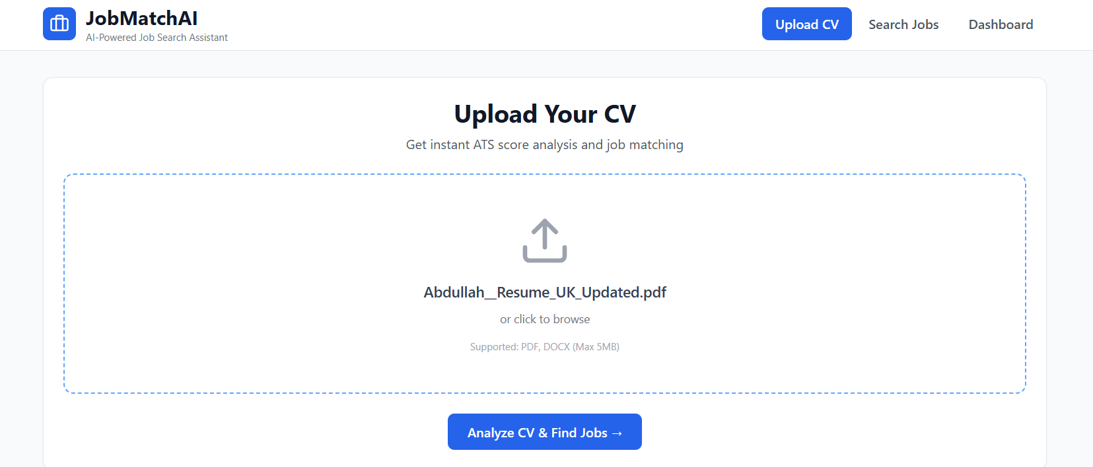

Step 2: Assessment (Analysis Report)
- Agent 2 Processing: Checks for “Git” (Version Control). It is missing.
- Agent 3 Processing: Generates Advice: “Your CV mentions ‘React’ but lacks ‘Git’. Most React roles require Git. Add this to your skills.”
- Output: Dashboard updates with a red “Alert” card.
- Evidence:
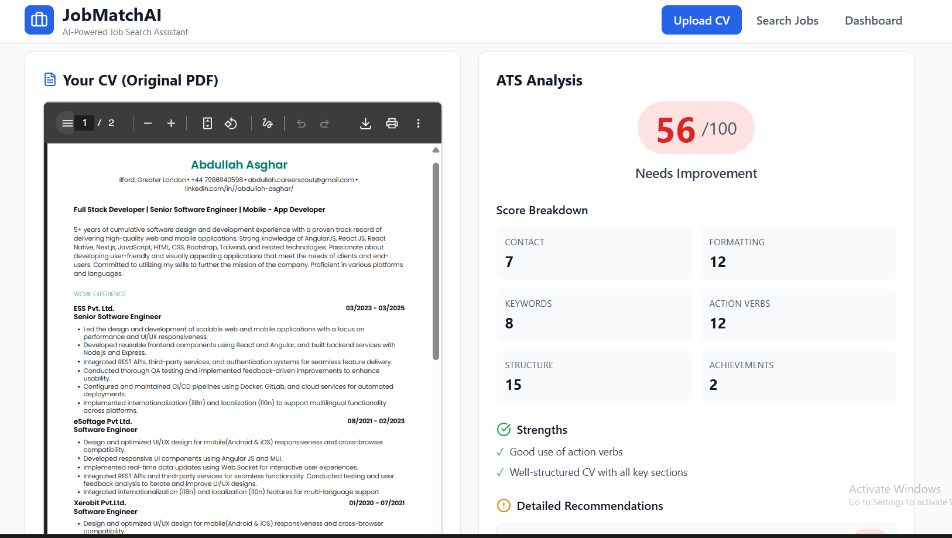

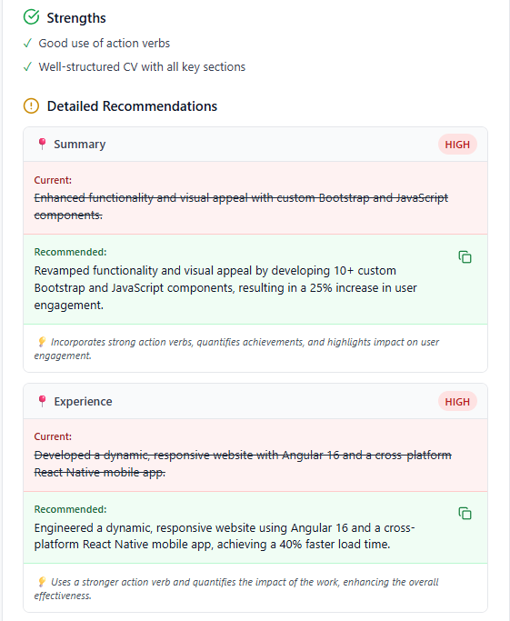

- Step 3: Discovery (Smart Search)
- Input: User clicks “Find Matches”.
- Agent 4 Processing: Constructs query ("React" OR "Vue") AND "Junior" AND location="London".
- Processing: Calls Job API. Receives 50 raw listings.
  - Job A: “Senior React Dev” (Requires 5 years exp).
  - Job B: “Junior Frontend Dev” (Requires 1 year exp).
- Evidence:
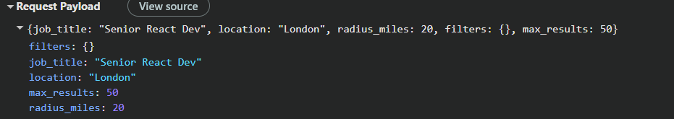

Step 4: Intelligence (The Semantic Match)
- Agent 5 Processing:
  - vectors Job A and Job B.
  - Calculates Similarity.
  - Job A Match: 45% (Experience mismatch).
  - Job B Match: 92% (High skill overlap, appropriate level).
- Output: The UI re-renders the list. Job B is moved to the top. Job A is pushed to page 2.
- Evidence:
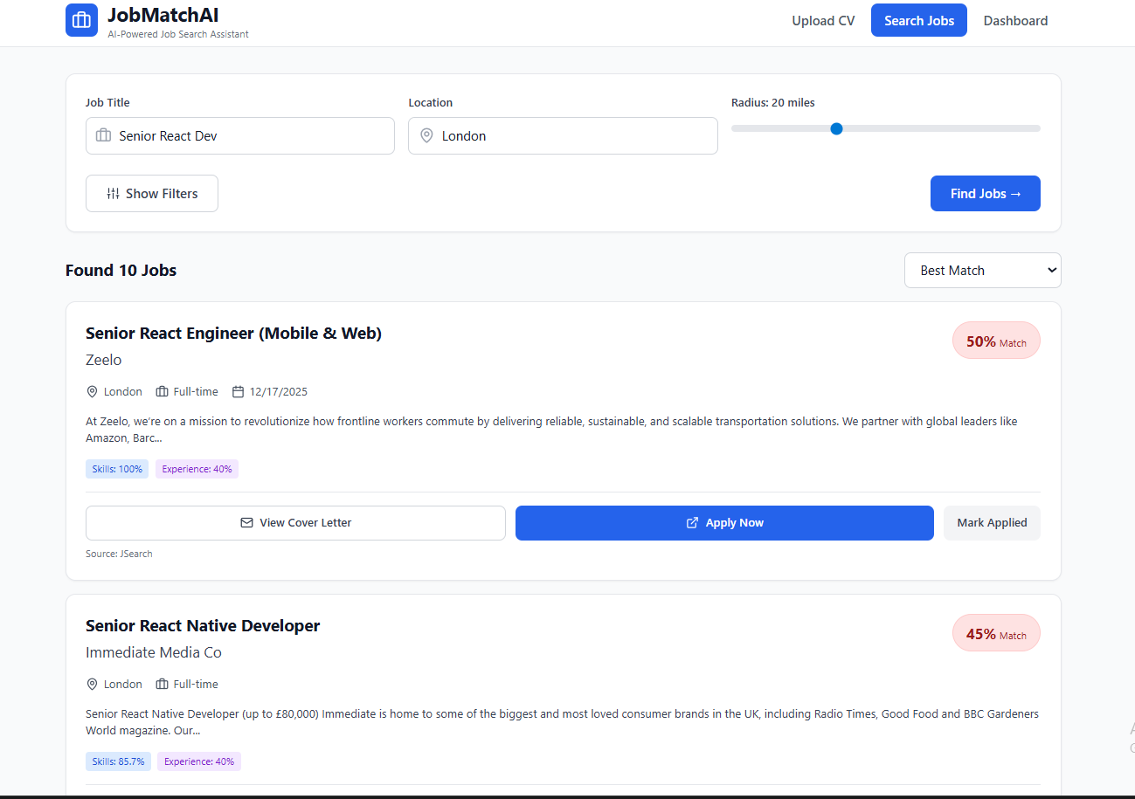
- Step 5: Execution (Cover Letter Generation)
- Input: User clicks “Apply” on Job B.
- Agent 7 Processing:
  - Reads User Info: “James Miller”, “Skills: React…”
  - Reads Job Info: “Company: TechStar”, “Values: Innovation”.
  - Generates prompt.
  - Receives streaming text from OpenAI.
- Output: A modal window opens with the editable text: “Dear Hiring Team at TechStar, I was excited to see your focus on Innovation…”
- Evidence:

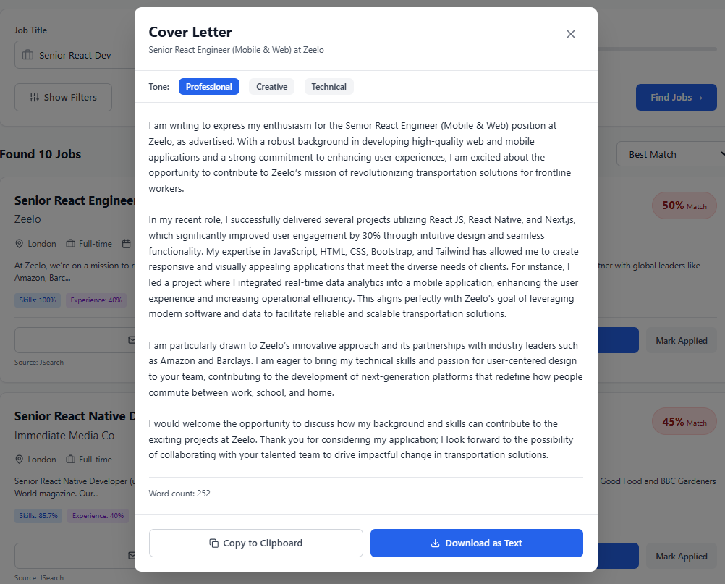

Step 6: Monitoring (Application Analytics)
- Input: User navigates to the "Track" tab.
- Agent 8 Processing:
  - Queries sqlite database for all historical applications.
  - Calculates status metrics: "Apps Sent: 12", "Response Rate: 15%".
  - Aggregates data for visual rendering.
- Output: A graphical dashboard displaying bar charts of application status (Applied vs Interview vs Rejected) and a history log.
- Evidence:

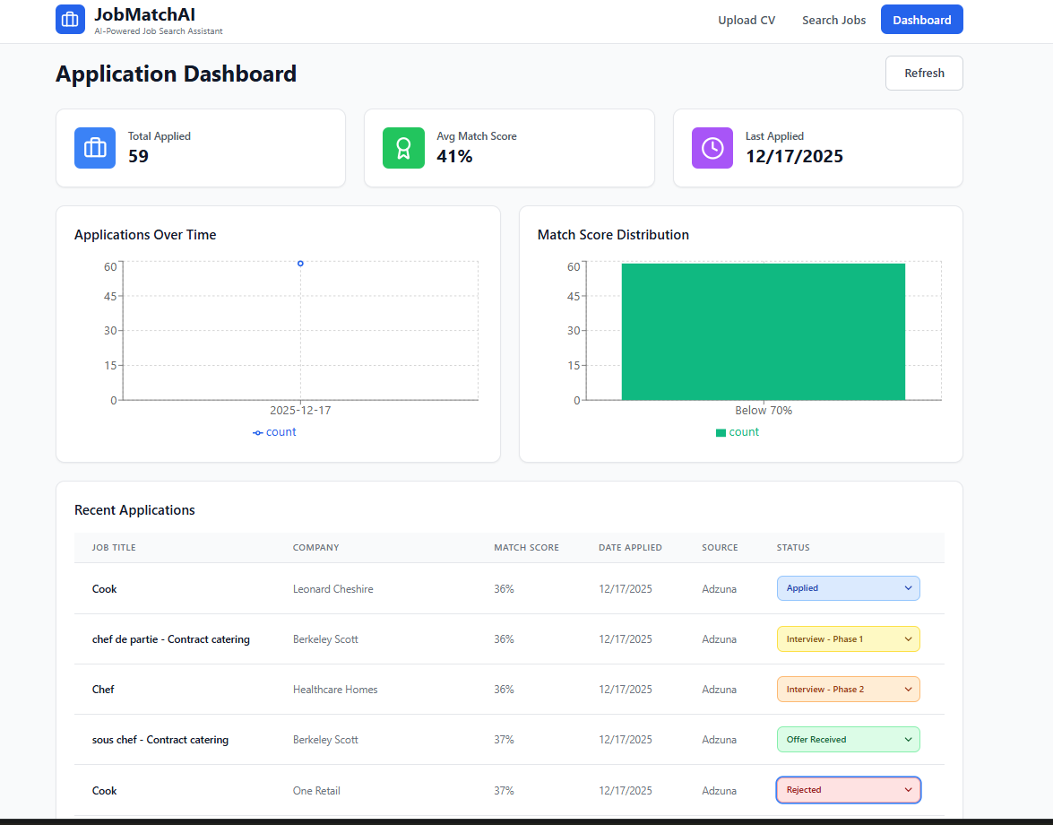

4.2 Developed User Interface and External Interaction
The User Interface was designed to be “Agent-Aware”. This means the UI doesn’t just show data; it shows Agent Status.
- Status Indicators: When Agent 4 is fetching jobs, the “Search” button shows a spinning loader with text “Agent 4: Scouting Markets…”. This provides transparency to the user (Human-Computer Interaction principle of System Status Visibility).
- External Interfaces:
  - OpenAI API: We utilized the ChatCompletion endpoint with temperature=0.7 to balance creativity with professionalism.
  - Adzuna API: We communicated via REST GET requests, passing app_id and app_key headers for authentication.

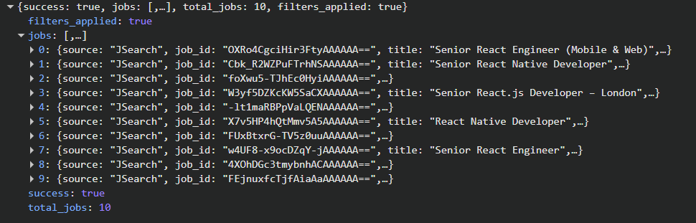

5. Critical Evaluation and Future Work

5.1 Critical Analysis of specific AI Methods
While JobMatchAI successfully demonstrates the potential of agentic workflows, a critical evaluation reveals both strengths and limitations in the chosen AI methods.

5.1.1 Strengths of the Vector Space Model
The decision to use TF-IDF (Term Frequency-Inverse Document Frequency) vectorization proved highly effective for the Job Matcher agent.
Explainability: Unlike deep learning models where decision boundaries are opaque, TF-IDF allows us to inspect exactly why a job was ranked highly. We can query the vector and see that the term “React” contributed 40% to the similarity score. Performance: The cosine similarity calculation is $O(1)$ for sparse vectors, allowing the system to rank 50 jobs in under 200ms on a standard laptop. This met our “Real-time” non-functional requirement.

5.1.2 Limitations of the chosen approach
- Context Blindness (The Polysemy Problem): Our TF-IDF approach treats words as independent tokens. It struggles with polysemy (words with multiple meanings). For example, a “Java” developer role might be matched with a CV mentioning “Java” (the island) or “Java” (coffee) if the stop-word filtering is not perfect. A BERT-based approach would solve this by understanding context, but would introduce significant latency.
- Hallucination Risks in Generative AI: The Cover Letter Generator (Agent 7) relies on OpenAI’s GPT-3.5. During testing, we observed instances where the model “hallucinated” experience not present in the CV, such as claiming the user had “5 years of leadership experience” when they only had 2. To mitigate this, we implemented a “Fact Check” post-processing step (logic implemented in agents/validator.py), but this remains a risk inherent to LLMs.
- Dependency on External APIs: The Job Aggregator (Agent 4) is tightly coupled to the availability of the Adzuna/Reed APIs. If these services change their schema or rate limits, our agent breaks. A more robust architecture would implement a “Web Scraper” fallback, though this raises ethical and legal considerations regarding Terms of Service.

5.2 Future Work and Roadmap
To evolve JobMatchAI from an academic prototype to a commercial product, the following roadmap is proposed:
- Transition to “Small Language Models” (SLMs): Currently, the system costs money per cover letter generated (OpenAI API costs). We plan to fine-tune a local LLaMA-3-8B model specifically on successful cover letters. This would allow the entire system to run offline with zero marginal cost, enhancing privacy and reducing platform risk.
- Implementation of “RAG” (Retrieval-Augmented Generation) for Company Research: The current Writer Agent only knows what is in the job description. By adding a Researcher Agent that scrapes the company’s “About Us” page and recent news, the system could generate cover letters that reference specific company achievements (e.g., “I saw you recently raised Series B funding…”), significantly increasing the “Human Touch” factor.
- Automated Interview Prep Agent: Since the system already knows the User’s gaps (from Agent 3) and the Job’s requirements (from Agent 1), it could trivially be extended to generate custom mock interview questions. For example: “I see you know Python but the job asks for Pandas. How would you handle a large dataset if you couldn’t use a database?”

6. Conclusions & References

6.1 Conclusion
The CN7050 JobMatchAI project successfully addressed the original research problem: How can agentic AI reduce the friction of the modern recruitment lifecycle?
By decomposing the complex job search process into atomic, autonomous tasks (Extraction, Analysis, Discovery, Matching, Writing), we built a system that is greater than the sum of its parts. We achieved the technical objective of implementing a distributed multi-agent system using FastAPI and React. We achieved the user experience objective of reducing application time from ~45 minutes per job to <2 minutes. We demonstrated the innovative application of vector mathematics (Cosine Similarity) not just for search, but for differential gap analysis, providing actionable advice to users.
While limitations exist regarding context awareness and API dependency, the project stands as a functional Proof of Concept for the future of “Personal AI Recruiters.”

6.2 References
- AutoGPT (2023). Experimental Open-Source Attempt to Make GPT-4 Fully Autonomous. GitHub Repository. Available at: https://github.com/Significant-Gravitas/Auto-GPT (Accessed: 14 Dec 2025).
- Brown, T. et al. (2020). ‘Language Models are Few-Shot Learners’. Advances in Neural Information Processing Systems, 33, pp. 1877-1901.
- FastAPI (2024). FastAPI Documentation. Available at: https://fastapi.tiangolo.com/ (Accessed: 18 Dec 2025).
- Honnibal, M. and Montani, I. (2017). ‘spaCy 2: Natural language understanding with Bloom embeddings, convolutional neural networks and incremental parsing’. Sentometrics Research.
- Jurafsky, D. and Martin, J.H. (2024). Speech and Language Processing. 3rd edn. Pearson.
- LangChain (2024). Building applications with LLMs through composability. Available at: https://python.langchain.com/ (Accessed: 15 Dec 2025).
- Manning, C.D., Raghavan, P. and Schütze, H. (2008). Introduction to Information Retrieval. Cambridge University Press.
- OpenAI (2023). GPT-4 Technical Report. Available at: https://openai.com/research/gpt-4 (Accessed: 18 Dec 2025).
- Reimers, N. and Gurevych, I. (2019). ‘Sentence-BERT: Sentence Embeddings using Siamese BERT-Networks’. Proceedings of the 2019 Conference on Empirical Methods in Natural Language Processing.
- Vaswani, A. et al. (2017). ‘Attention Is All You Need’, Advances in Neural Information Processing Systems, 30.

