Chapter 1 (Introduction)……………………………………………………………………..4

1.1 Project overview……………………………………………………………………………5

1.2 **Objectives** …………………………………………………………………………………….5

1.3 key Features……………………………………………………………………………….…6

**1.4 Benefits…………………………………………………………………………………………8**

**1.5 Goals…………………………………………………………………………………………....9**

**Chapter 2: planning…………………………………………………………………………..11**

**2.1 Project Schedule………………………………………………………………………….12**

**2.2 Gantt Chart………………………………………………………………………………....12**

**2.3 meeting……………………………………………………………………………………….14**

**Chapter 3:Software Requirement Specification…………………………………19**

**3.1 Functional Requirements…………………………………………………………….20**

**3.2 Non-Functional Requirements…………………………………………………….22**

Chapter 4: Development of the website …………………………………………..27

4.1 Software development language, tools and frameworks…………….28

4.2 Database Schema………………………………….…………..33

4.3 Other Tools...……………………………………………………35

Chapter 5:Testing Feature…………………………………………36

5.1 Testing Features……………………………….……….37

Chapter 6:User Manual…………………………………….……………………….……41

6.1 login page………………………………………………………..………………….………42

6.2 Admin………………………………………………………..…..43

6.3 Doctor Interface………………………………..……….…….………………………54

**6.4 Student Interface ……………………………………….….……………………….58**

Chapter 7: Future Work………………………….……………..66

**Chapter 1:**

**Introduction**

**1.1 Project Overview:**

**The University Attendance System project aims to develop a modern and efficient solution for tracking student attendance across the university. This system is designed to address the limitations of traditional manual attendance methods by leveraging advanced technology to enhance accuracy, security, and ease of use.**

**1.2 Objectives:**

**Automation: To automate the attendance tracking process, reducing the need for manual recording and minimizing errors.**

**Security: To ensure secure and reliable identification of students using advanced technologies such as facial recognition, smart card identification, or fingerprint scanning.**

**Real-Time Data: To provide real-time attendance data, allowing immediate access and updates to attendance records.**

**User Experience: To design a user-friendly interface that simplifies the attendance process for both students and faculty.**

**Reporting and Analytics: To generate comprehensive reports and analytics on attendance patterns, aiding in decision-making and academic planning.**

**1.3 Key Features:**

**Automated Attendance Recording: Utilizes advanced identification technologies to automatically record attendance, ensuring accurate and tamper-proof data.**

**Real-Time Monitoring: Enables real-time tracking and monitoring of attendance, providing immediate insights and updates.**

**Data Security: Implements robust security measures to protect sensitive attendance data from unauthorized access and manipulation.**

**Integration Capabilities: Seamlessly integrates with existing university systems such as Learning Management Systems (LMS) and administrative software, enhancing overall operational efficiency.**

**User-Friendly Interface: Designed to be intuitive and easy to use, ensuring a smooth experience for both students and faculty.**

**Detailed Reporting: Offers detailed reports and analytics on attendance, helping faculty and administration to identify trends and address any attendance-related issues promptly.**

**1.4 Benefits:**

**Implementing this attendance system will bring numerous benefits to the university, including:**

**Increased Efficiency: Automating the attendance process saves time and reduces administrative burdens on faculty and staff.**

**Enhanced Accuracy: Advanced identification technologies ensure that attendance records are accurate and reliable.**

**Improved Data Access: Real-time data access allows for prompt and informed decision-making.**

**Better Student Management: Detailed reports and analytics help in monitoring student attendance and identifying patterns that may require intervention.**

**Seamless Integration: The ability to integrate with other university systems ensures a cohesive and streamlined administrative process.**

**This project aims to revolutionize the way attendance is managed at our university, providing a modern, efficient, and reliable solution that benefits both students and faculty.**

**1.5 Goals:**

**Enhance Attendance Accuracy: Reduce errors associated with manual attendance recording by implementing a reliable automated system.**

**Improve Data Security: Protect attendance records through the use of secure identification methods and data encryption.**

**Increase Operational Efficiency: Streamline the attendance tracking process to save time and reduce the workload on faculty and administrative staff.**

**Provide Actionable Insights: Offer detailed analytics and reporting tools to help in monitoring and improving student attendance patterns.**

**User Satisfaction: Ensure a positive experience for users by designing an intuitive and easy-to-use system interface.**

**Scalability and Flexibility: Develop a system that can be easily scaled and adapted to meet the evolving needs of the university.**

**Chapter 2:**

**planning**

**2.1 Project Schedule**

**We need to prepare a scheduling plan to complete the project on time. It also refers to make communication with what task need to get done within timeframe.**

**2.2 Gantt Chart**

**Gantt chart is mainly a production control tool. It remained us to complete our assigned tasks within a certain period of time. For developing software, it is mostly used. Now we will show a Gantt chart for our project.**

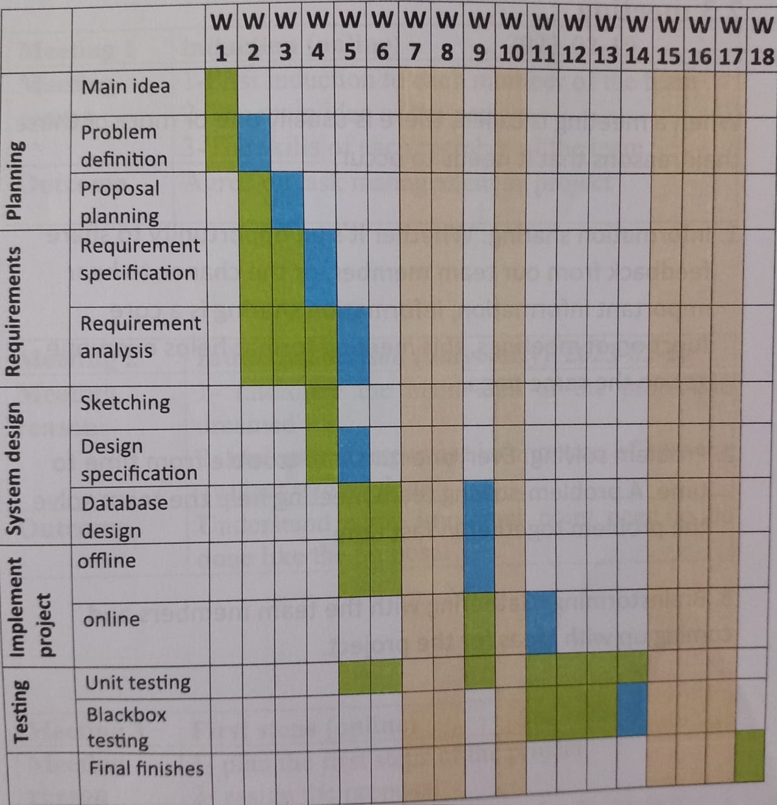

**2.3 meeting**

**When a meeting is called, there is usually one or more of those their reasons that it needs to occur.**

**1. Information sharing: Whether it's an opportunity to share feedback from our team member, or the chance to hear important information, information sharing is a core function of meetings, this meeting format helps everyone get on the same page.**

**2. Problem solving: Everyone runs into trouble from time to time. A problem-solving team meeting help the team solve the problem together in fast time.**

**3. Brainstorming: Gathering with the team members and coming up with ideas for the project.**

**Meeting 1: induction (online)**

**Date: 29, January, 2024.**

**Meeting reason:**

**1-First induction to each member of the team.**

**2-The main idea of the project.**

**3-The skills of each member of the team.**

**Outcome:**

**Agree on task management as project.**

**Meeting 2: induction section (university)**

**Date: 22, February, 2024.**

**Meeting reason:**

**1- interduce the main idea of the project to dreamed.**

**2- understand important information of how the project will be done.**

**Outcome:**

**Understand some important point need to be done like the proposal.**

**Meeting 3: first steps (online)**

**Date: 28, February, 2024.**

**Meeting reason:**

**1- plan the first steps of the project.**

**2- assign the proposal.**

**Outcome:**

**Start working on the proposal for the project.**

**Meeting 4: Zoom (online)**

**Date: 3, March, 2024.**

**Meeting reason:**

**1- Discord.**

**2- start on the Requirement specification.**

**Outcome:**

**The use of Discord as main communication app and start working on the Requirement for the project.**

**Meeting 5: project propose (university)**

**Date: 20, March, 2024.**

**Meeting reason:**

**1- discussion about project propose**

**Meeting 6: (offline)**

**Date: 25, March, 2024.**

**Meeting reason:**

**1- the first alpha of the project available on GitHub.**

**Outcome:**

**Start testing the website offline.**

**Meeting 7: Documentation (online)**

**Date: 22, April, 2024.**

**Meeting reason:**

**1- final steps in the documentation and the presentation.**

**2- how the project will be represented.**

**Meeting 8: Final rehearsal (university)**

**Date: 25, may, 2024.**

**Meeting reason:**

**1- to do the final rehearsal before presents the project.**

**2- make sure that everything is ready in the project introduction.**

**Chapter 3:**

**Software Requirement Specification**

**3.1 Functional Requirements**

**Functional requirements refer to the functions which are mandatory to the system. Functional requirements must be able to perform on the software system. Every system must have some functional requirements. Now, we are going to mention functional requirements associating with our project.**

**3.1.1 Admin Registration**

|  |  |
| --- | --- |
| **Requirements 1** | **Admin Registration** |
| **Description** | **Admin is the only one who can register other system admins.**  **and can also manage the admin in the system he can update delete admin.**  **we planning in the future that role be available only for the super admin not any admin.** |
| **Stakeholders** | **System Admin (System Super Admin)** |

**3.1.2 Doctor Registration**

|  |  |
| --- | --- |
| **Requirements 2** | **Doctor Registration** |
| **Description** | **Take Attendance.**  **See time table.** |
| **Stakeholders** | **System Doctor** |

**3.1.3 Student Registration**

|  |  |
| --- | --- |
| **Requirements 3** | **Student Registration** |
| **Description** | **See Attendance.**  **See time table.**  **Send feedback.** |
| **Stakeholders** | **System Student** |

**3.2 Non-Functional Requirements**

**3.2.1 Performance**

**It is very important to maintain performance of any software system. To ensure performance, we need to maintain some steps. Now, we will explain some perspective by which we are going to enhance the performance of our project.**

**3.2.2 Speed & Latency**

**Speed and latency requirements must be ensured while retrieving data from the cloud server. When the Registrar needs to search student to update or when student wants to see the results, then the search result must show within seconds.**

**3.2.3 Capacity**

**The attendance system must be able to handle user data, provide accurate information, database processing, http request management, etc.**

**3.2.4 Maintainability & Supportability**

**It is very important to provide after service or support to the end users.**

**3.2.5 Security**

**Making software security as a requirement is very important. Software security requirements should be its functional requirement. Software security enforces security of an application system. Functionality related to software security can either be directly tested or observed.**

**While accessing to the system, each and every module must provide a central authentication mechanism. There is also a process to prevent entering into the system by ensuring hashed password for the unauthenticated users.**

**3.2.6 Accessibility**

**The system supports easy access for authorized users only. This is confirmed by their password.**

**3.2.7 Integrity**

**Integrity requirements refers to a security system which ensures an expectation of data quality. It also ensures that all data of the system would never be exposed to the malicious modification or accidental destruction. For that reason, we will store our user passwords as encrypted format which is impossible to decrypt. It is also called hashed password.**

**3.2.8 Privacy**

**It is very important to ensure privacy of the system users. Privacy requirements enhances to protect stakeholder's privacy. In this way, all data or a partial part of data are going to be disclosed according to system's privacy policy. To ensure privacy, the central database should be protected by the anonymous. Users are permitted to get access to those data which are being associated by them which can be ensured by the user log in system.**

**3.2.9 Usability and Human-Interaction**

**The main target of developing any system is to make the system user friendly and easy to usable for the end users**

**3.2.10 User Documentation**

**Documentation are mainly two types. One is internal documentation which is generally written by the application engineers. It is prepared to make development life cycle easier for the system engineers or system analysts.**

**3.2.11 Training**

**Training requirements involved in after service of any application. It is very necessary to properly train up end users to the system so that they would be capable to operate easily. After launching the full package to the market, firstly we provide training to the different end users like University Staff, Teachers and also Students.**

**3.2.13 UI/UX**

**UI/UX requirements mainly refers how the system will look like and how the user interface or graphical user interface of our system will display to the user.**

**Chapter 4:**

**Development of**

**the website**

**4.1 Software development language, tools and frameworks**

Software development tools are used to develop software. There are different kinds of tools for software developers to make the process of software development very smooth. But now we will mention the tools that we are using to develop our project.

**4.1.1 User Interface / front end**

First of all, after landing any application, interface of that software is appeared to the user. So, the importance of user interface is very high. For success of any software application, a good-looking user interface plays a vital role. User interface includes using good image, graphics, typography, stylesheets, scripting etc.

**4.1.1.1 html**

Hypertext Markup Language or HTML is the standard markup language for documents designed to be displayed in a web browser. It is often assisted by technologies such as Cascading Style Sheets (CSS) and scripting languages such as JavaScript.

**4.1.1.2 CSS**

After completing markup html code, cascading style sheets are designed. It generally explains how HTML elements will display. There are three ways to write stylesheet. One internal CSS, another is external CSS. And last one is inline CSS. But most of time external CSS is used. Because, by using external CSS, all CSS data can be kept in different files.

**4.1.1.3 Bootstrap**

Bootstrap also provides media query which features responsive layout for different devices with different screen size. Bootstrap provides a set of some files which contains stylesheets which gives basic definition.

Bootstrap also provides some JavaScript components also. There are some built in components like jQuery UI. By using Bootstrap framework, we get both CSS and JavaScript facilities with a single platform. But before start designing an application interface with Bootstrap, one may have some basic knowledge about this framework. It will increase the efficiency.

**4.1.1.4** **JavaScript** **in the UI**

JavaScript is a scripting language that enables you to create dynamically updating content, control multimedia, animate images and so on with big library of tools it is very easy and important to learn and use in the project.

**4.1.2 backend**

the back end refers to parts of a computer application or a program's code that allow it to operate and that cannot be accessed by a user. Most data and operating syntax are stored and accessed in the back end of a computer system.

Typically the code is comprised of one or more programming languages.

**4.1.2.1 Python**

Python is a popular, high-level programming language known for its simplicity, readability, and versatility. It's widely used for a variety of applications, including web development, data analysis, artificial intelligence, automation, and more. Python has an extensive standard library and a large ecosystem of third-party packages that make it easy to work with different tasks and domains.

**4.1.2.2 Django**

Django is a high-level Python web framework that encourages rapid development and clean, pragmatic design. It includes an ORM (Object-Relational Mapping) layer that abstracts the database, a built-in admin interface, and various other features that make web development efficient and scalable. Django is often used for building complex, database-driven web applications.

**4.1.2.3** **MySQL**

MySQL is a popular open-source relational database management system (RDBMS). It's commonly used in web applications and is known for its speed, reliability, and ease of use. MySQL provides a SQL (Structured Query Language) interface for managing and manipulating data, and it can be easily integrated with various programming languages, including Python and Django.

**4.1.2.4** **AJAX (Asynchronous JavaScript and XML)**

AJAX is a set of web development techniques that allow web pages to be updated asynchronously, by exchanging small amounts of data with the server behind the scenes, without requiring a full page refresh. This improves the user experience by providing more responsive and dynamic web applications. AJAX is commonly used in conjunction with technologies like JavaScript, DOM (Document Object Model), and XML or JSON (JavaScript Object Notation) for data exchange.

**4.2 Database Schema**

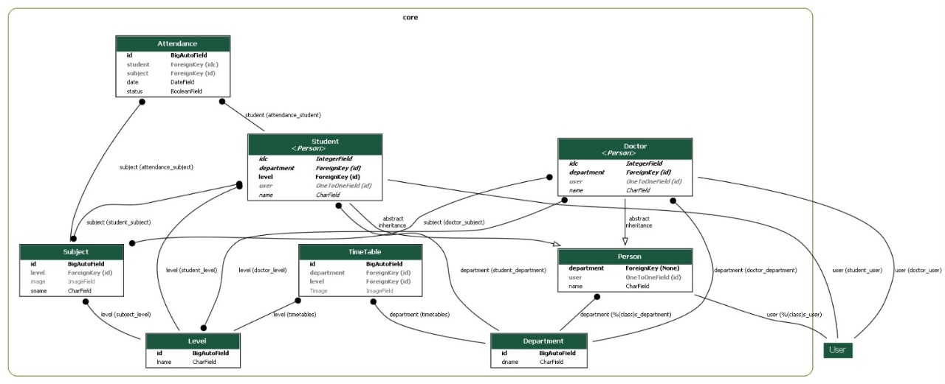

A database schema is the skeleton structure that represents the logical view of the entire database.

It defines how the data is organized and how the relations among them are associated. It formulates all the constraints that are to be applied on the data.

it is important when creating database to make sure to achieve several core principles:

**Minimize redundancy**: To save resources and create efficient database, and simplify how the database works, data redundancy is minimized and duplication is avoided and we made sure the name of table represents what inside each table, also keep the naming of the column the same across all table to make easy to keep track.

**Protect accuracy**: we design the database to keep information accurate and reduce the likelihood of accidentally damaging information and to make sure that no one can access information that the user doesn't have authorization to access.

**Meet expectations**: we made sure that the database fulfills specific purpose-so the database design must successfully support data processing expectations for being the foundation to create full university system.

As we determent in the requirement analysis the authorization for each users group who can access, add, modify or delete certain processors.

**4.3 Other Tools:**

**4.3.1GitHub**:

GitHub is a place where programmers and designers work together. They collaborate, contribute, and fix bugs together. It hosts plenty of open source projects and codes of various, programming languages. It allow us to easily share the issue we found and assign them to the person who would fix it, and easy way to keep up with the updates on any issue.

**4.3.2 discord**:

Discord is a free communications app that lets you share voice, video, and text chat. Discord can be used on almost every popular platform and device, including Windows, macOS, Linux, Android, and via web browsers. It easy way to have everything at one place, and you can create chatbot to share information that belong to anther page like GitHub without needing to type every time the updates.

**Chapter 5:**

**Testing Feature**

**5.1 Testing Features**

Feature testing can be considered as making change to add or modify the new functionality to the existing project. To testthe features and functionality, a new test set is to be written fortesting purpose. Almost every feature and functionalityhave different characteristics. Those aredesigned to make the application more **useful, intuitive, reliable,** secured, scalable,effective and efficient.

5.1.1 Unit testing and Blackbox testing

Unit testing and Blackbox testing are method of testing that need to be done throw out the live cycling of the application

unit testing is a white boxtechnique. It's one of the best ways to break down and inspect your code for bugs or other errors that might be hiding in there.

Unit tests should always come before refactoring because it will tell if any changes have broken anything.

As for Black box testing is a testing type that tests the functionality ofan application without knowledge of the internal implementation,which make it great way of testing the application like the user would

**5.1.1.1 Unit testing**

Unit testing is the first step of software development process and it been done in the early stages of developing in which the smallest testable parts of an application, called units, are individually scrutinized for proper operation.

The main objective of unit testing is to isolate written code to test and determine if it works as intended.

Unit testing is an important step in the development process. unit tests can detect early flaws in code which may be more difficult to find in later testing stages.

**5.1.1.2 Black box testing**

As forBlack box testing is a methodology of performing tests. These tests can be designed to accomplish a few different goals and that the one would be focus in this chapter, which include:

**Functional Testing:** Functional testing is intended to that an application does what it is supposed to do. For example, functional tests may test an application's authentication mechanism to check that legitimate userscan authenticate successfully while invalid login attempts are rejected. Common types of functional testingincludesanity checks, integration testing, and system testing.

**Non-Functional Testing:**

Non-functional testing evaluates how well an application performs its core functions. Examples of tests include performance, usability, scalability, and security testing.

**Regression Testing:**

Regression testing is designed to ensure that a change to an application does not break functionality. For example, regression testing should be performed after patching a vulnerability inan application ensure the patch has not caused the application to fail functional or non-functional tests.**5.1.2 Features to be tested:**

1.login page.

2.admin (dash board)

3.Attendances page from Admin Interface

4.Department page in Admin Interface

5.Doctor in Admin

6.levels in Admin

7.Student in Admin

8.Students in Admin Interface

9.Subjects in Admin

10.Time Tables in Admin

11.Feedback

12. Users in Admin

13. Doctor Interface

14. Subject in Doctor Interface

15. **when Doctor take Attendance**

**16. Time Table in Doctor Interface**

**17. Student Interface**

**18. Subject in Student Interface**

19. **Time Table in Student**

20. **feedback in Student**

**Chapter 6:**

**User Manual**

**6.1 login page**

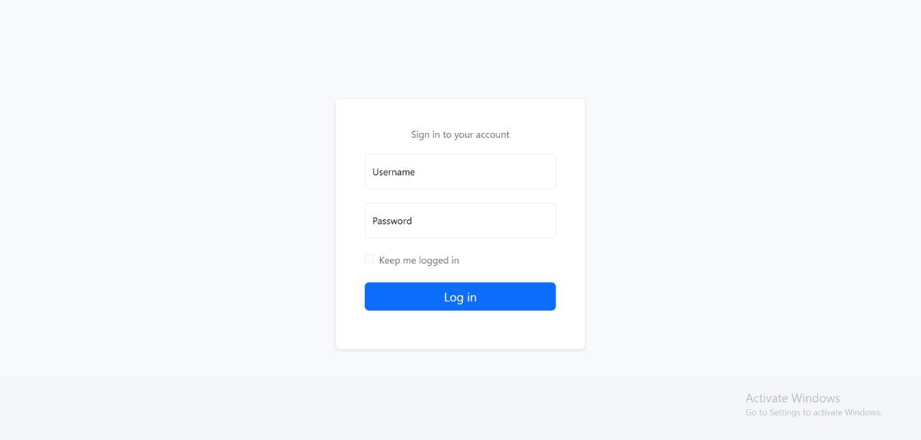

**6.2 Admin**

**6.2.1 Dashboard**

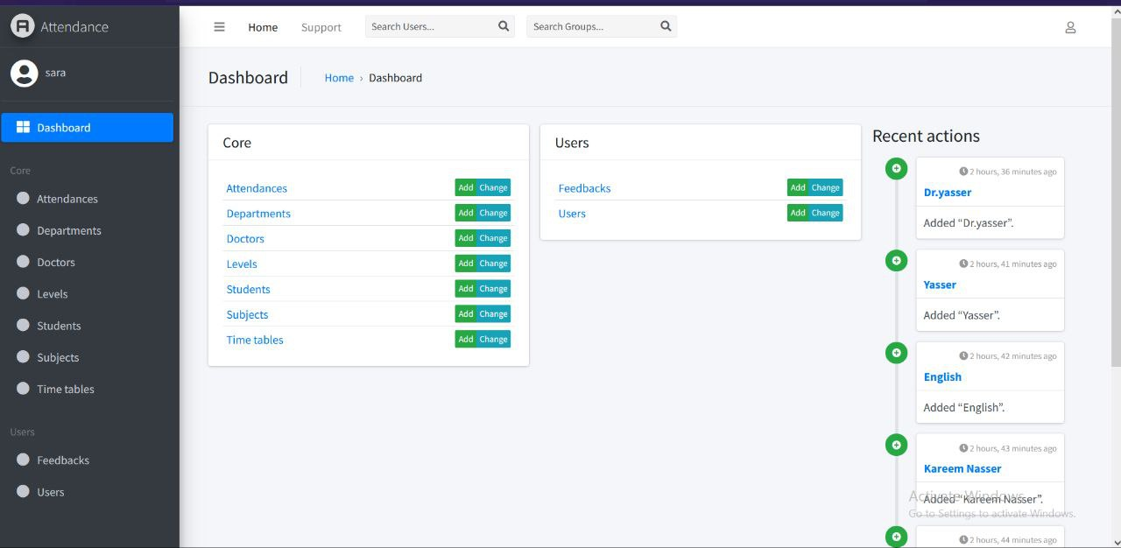

**6.2.2 Attendances page from Admin Interface**

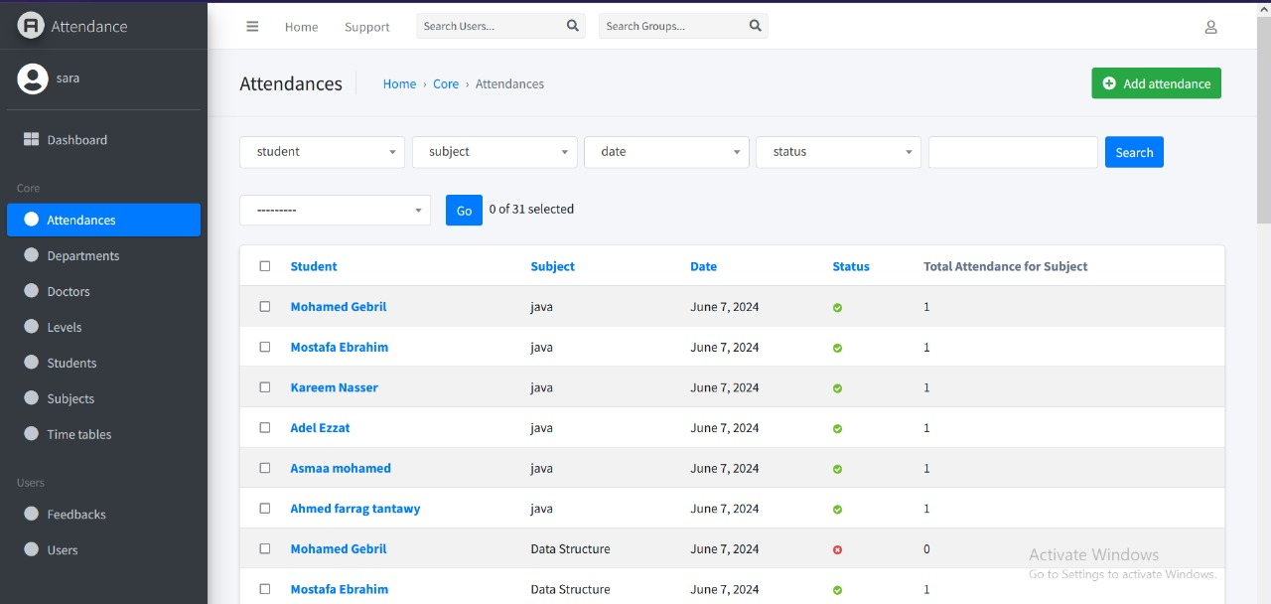

**6.2.3 Department page in Admin Interface**

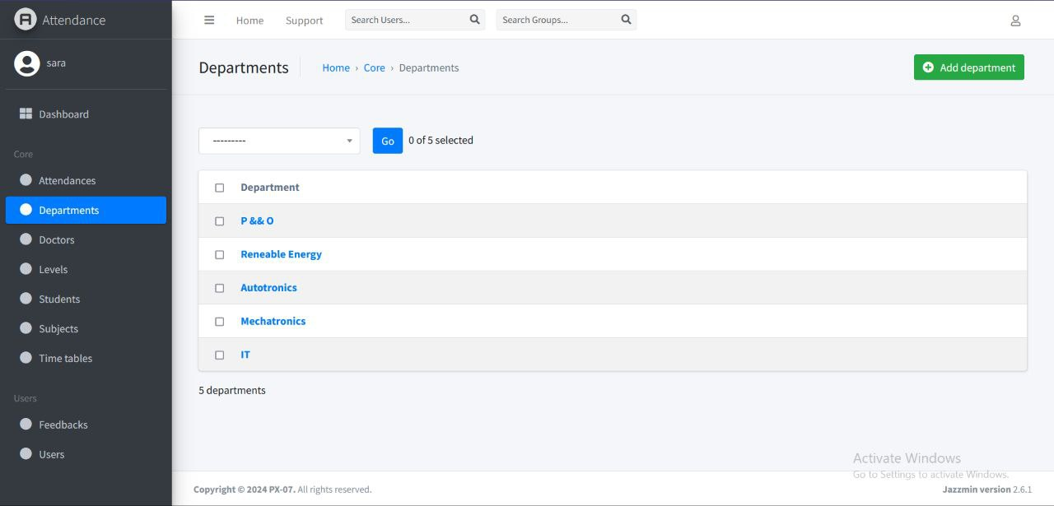

**6.2.4 Doctor in Admin**

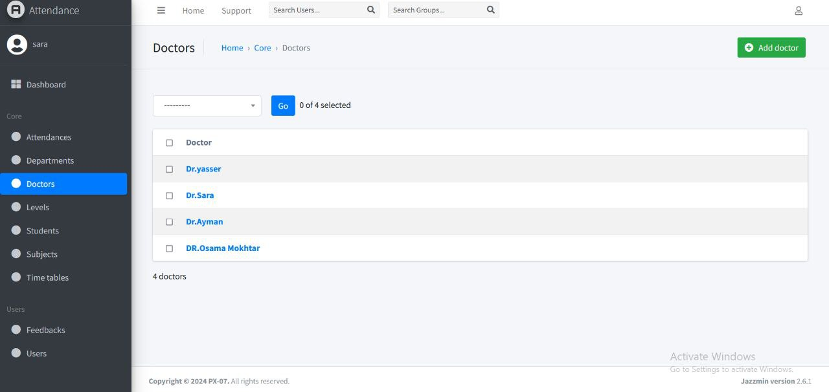

**6.2.5 levels in Admin**

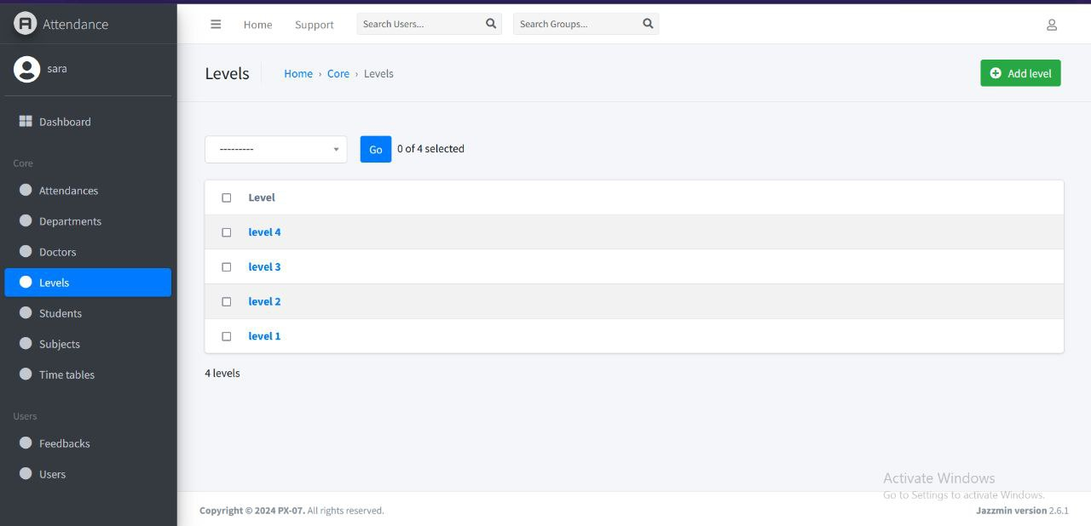

**6.2.6 Student in Admin**

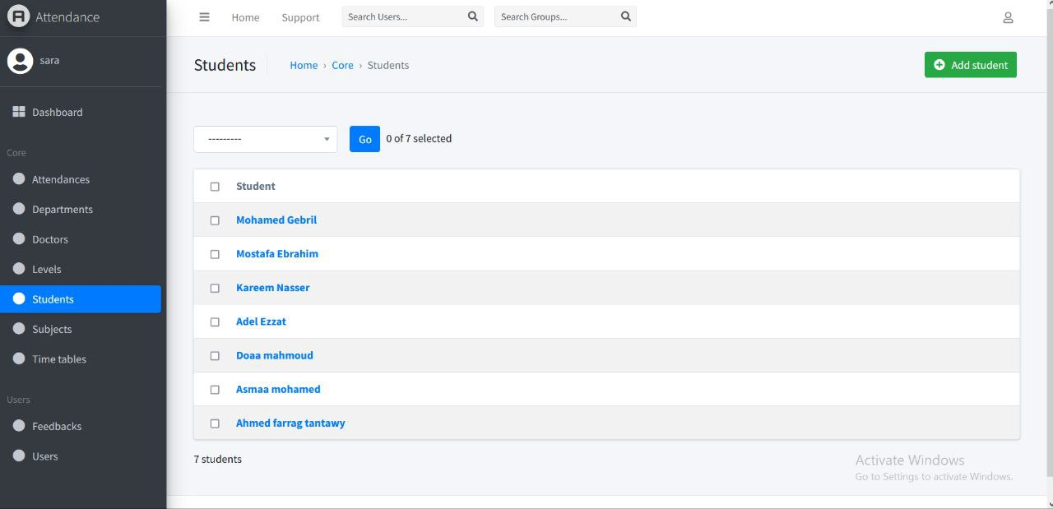

**6.2.7 Students in Admin Interface**



**6.2.8 Subjects in Admin**

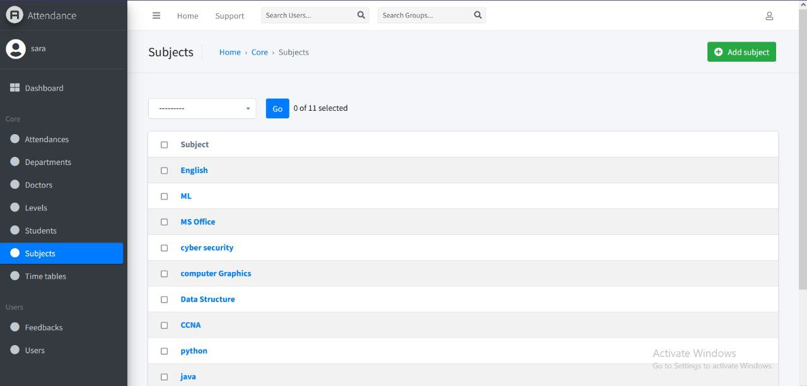

**6.2.9 Time Tables in Admin**

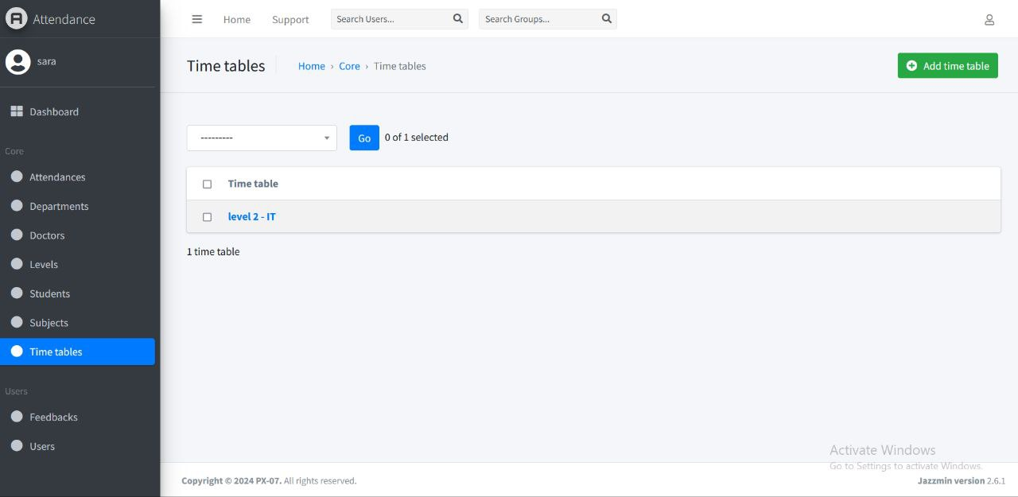**6.2.10 Feedback**

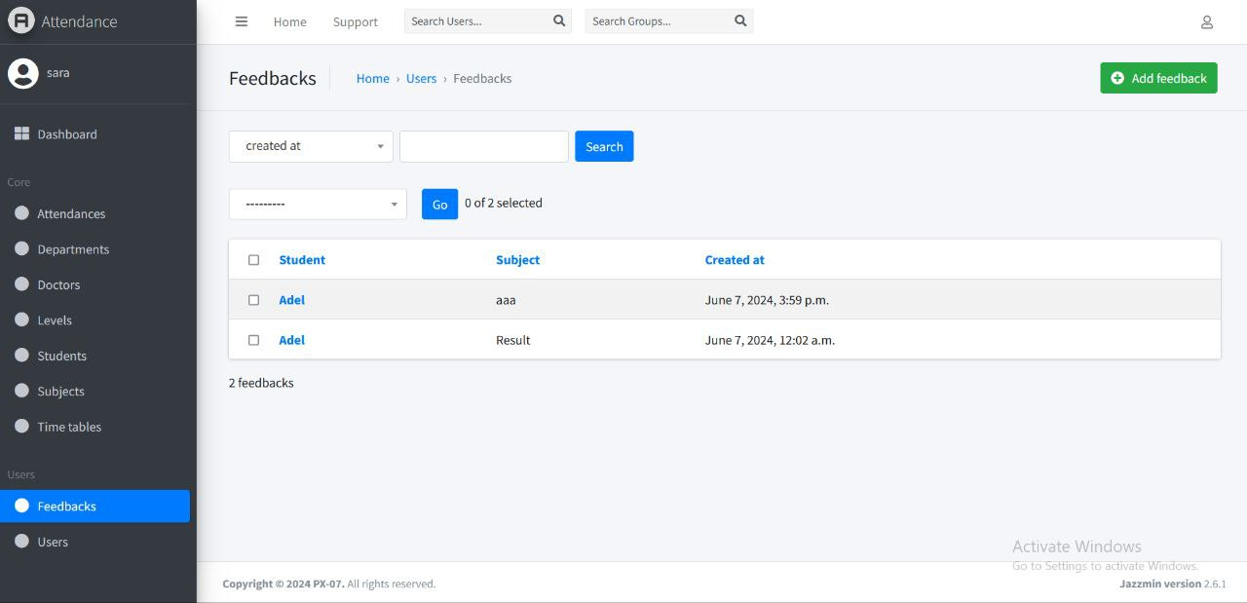

**6.2.11 Users in Admin**

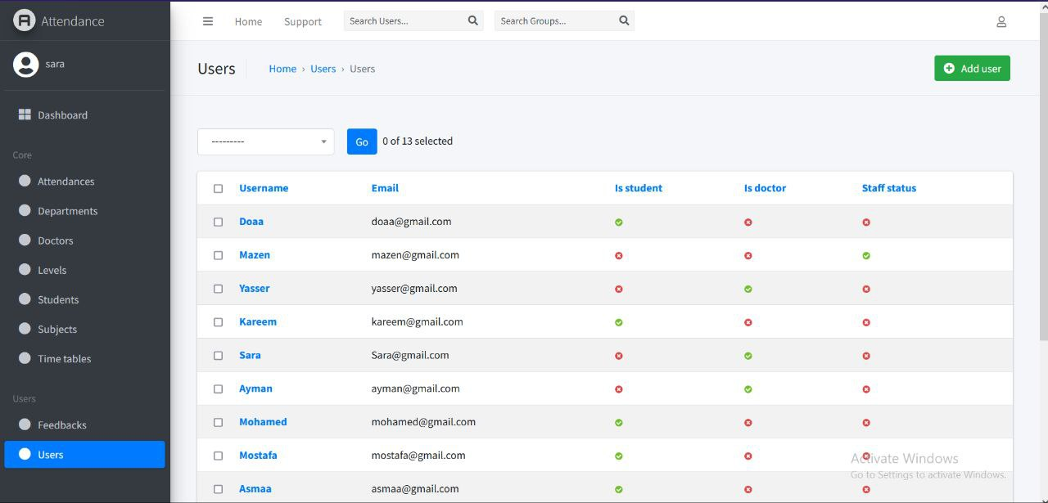

**6.3 Doctor Interface**

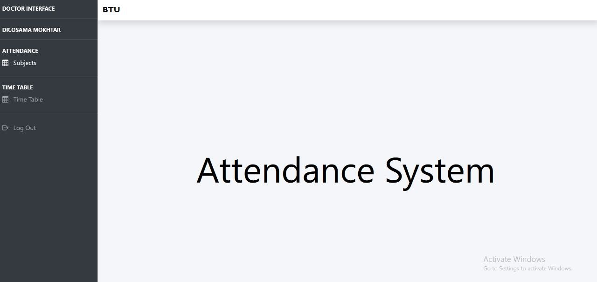

**6.3.1 Subject in Doctor Interface**

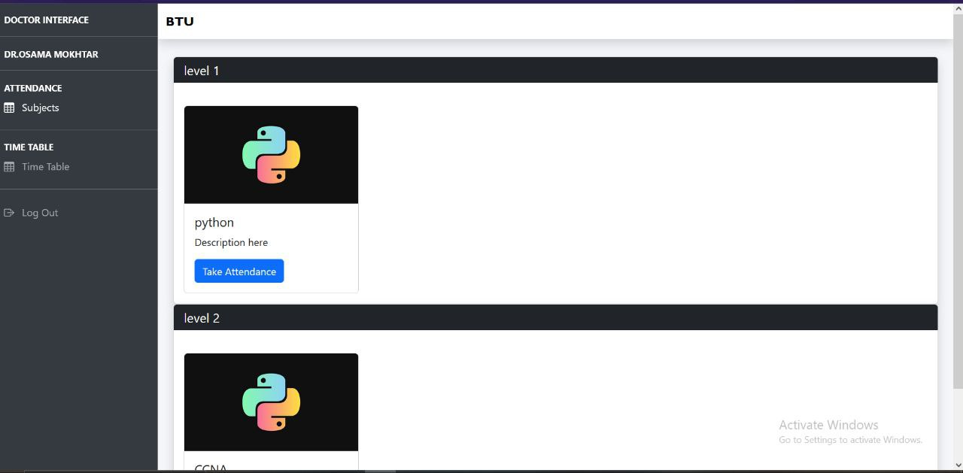

**6.3.2 when Doctor take Attendance**

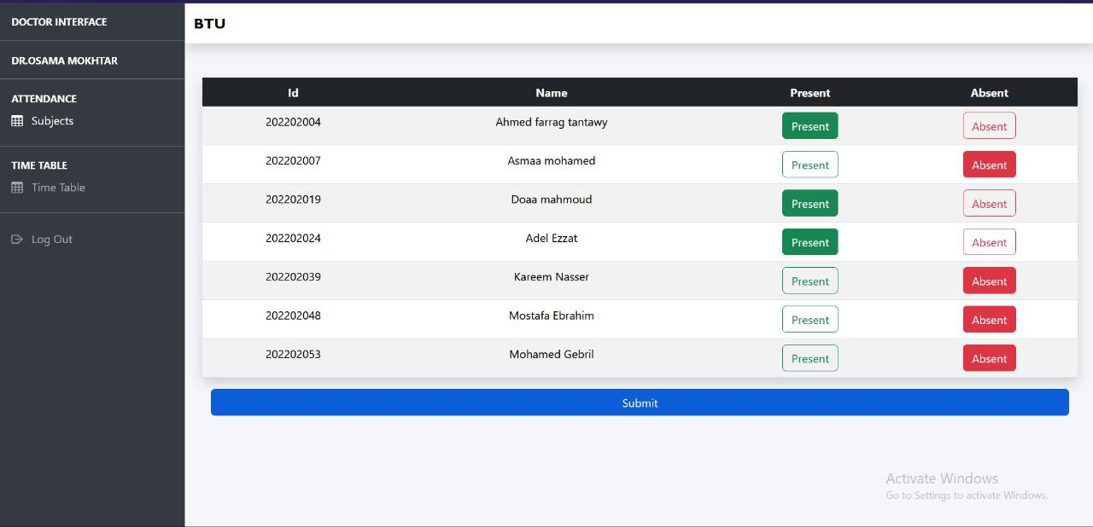

**6.3.3 Time Table in Doctor Interface**

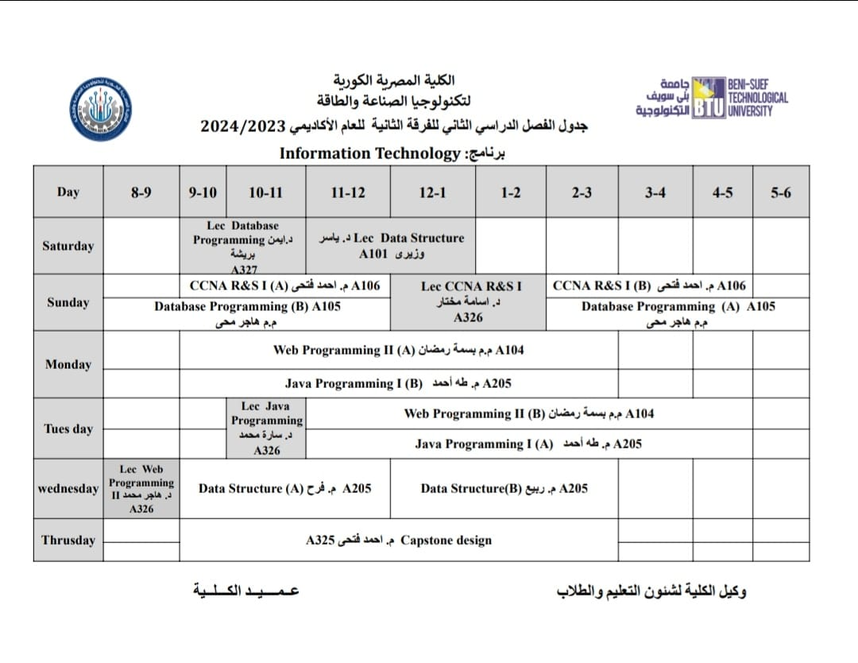

**6.4 Student Interface**

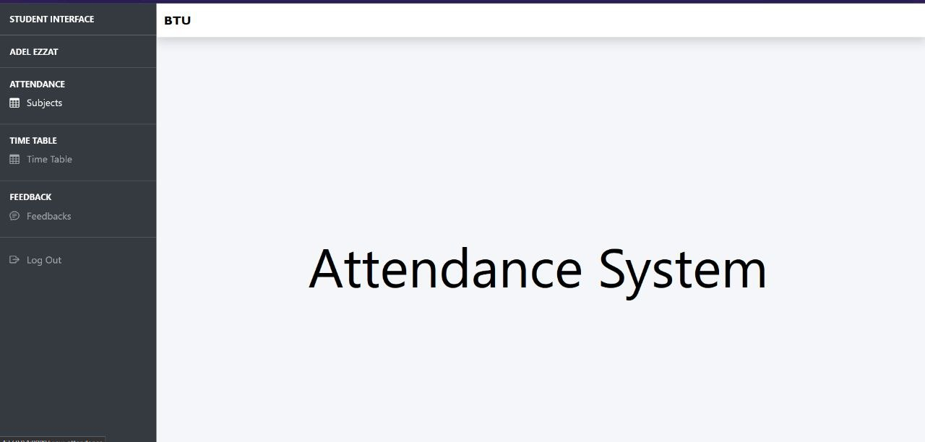

**6.3.1 Subject in Student Interface**

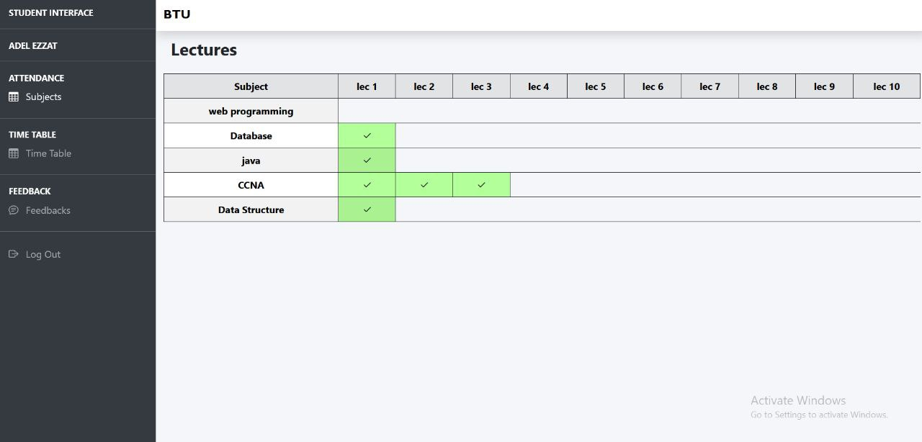

**6.3.2 Time Table in Student**



**6.3.3 feedback in Student**

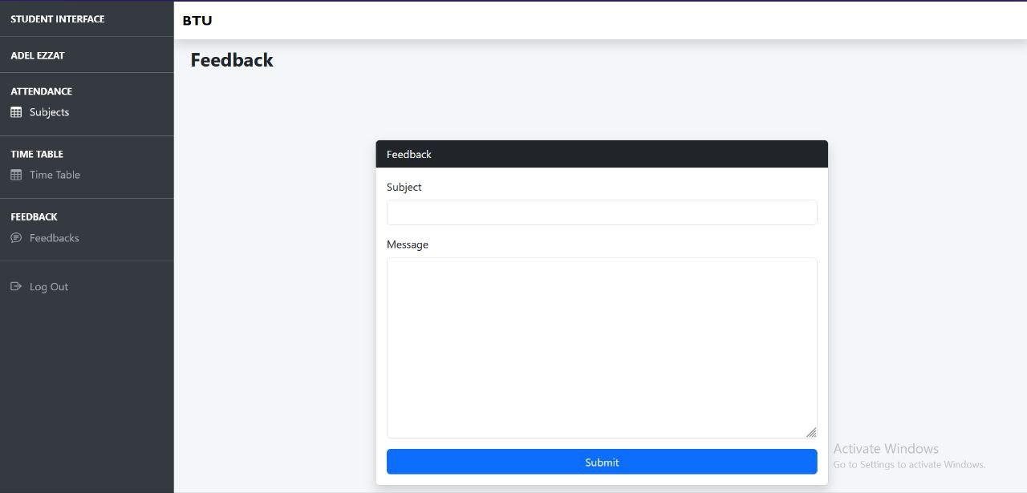

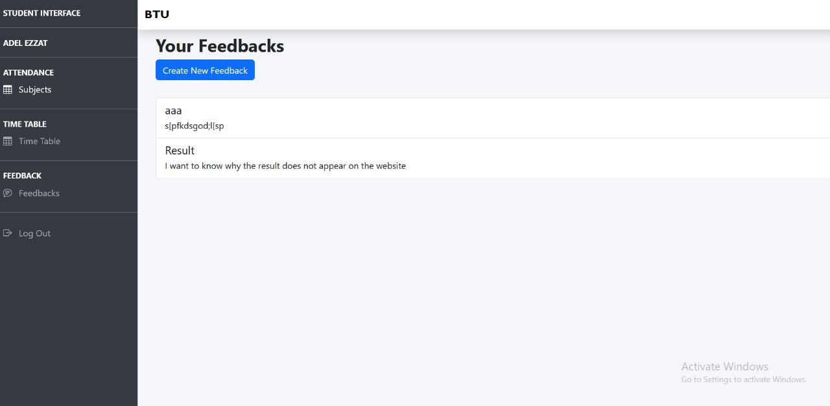

**Chapter 7:**

**Future Work**

**1. Digital Payment System**:

Develop a web application or mobile app that allows students and families to make direct payments through secure online payment gateways. Provide multiple payment options such as credit/debit cards, bank transfers, or popular e-payment platforms (e.g., PayPal, Stripe) Implement a flexible payment plan feature, enabling students to pay in installments or on a semester/yearly basis based on their needs. Integrate the payment management system with the university's student information and academic management systems.

**2. Library Management System:**

The implementation of a Library Management System in our project will change the way our university library operates. This feature will provide an integrated platform for efficient management of library resources, including books, journals, and digital materials. With this system, students and faculty will be able to easily search and access library resources, check availability, and place holds or reservations. The system will also automate tasks such as borrowing, returning, and renewing materials, streamlining the overall library experience. Furthermore, the Library Management System will generate insights through data analytics, allowing for better collection development and resource

allocation decisions. This future addition will enhance accessibility, convenience, and effectiveness in utilizing library resources, supporting a vibrant academic environment within our project.

**3. Full University Management System (UMS):**

will be a significant milestone for our project. This comprehensive system will integrate various administrative functions, including student enrollment, course registration, academic records management, financial transactions, and faculty/staff management. By centralizing and automating these processes, the UMS will streamline administrative operations, improving efficiency and reducing manual workloads for university staff. The Full UMS will enhance communication and collaboration among students, faculty, and administrative personnel by providing a unified platform for information sharing, announcements, and academic support services. It will offer features such as online course materials, grade tracking, and student feedback mechanisms, enriching the learning experience and fostering student engagement. Additionally, the UMS will provide powerful analytics and reporting capabilities, allowing university administrators to make data-driven decisions, identify trends, and improve institutional

performance. It will facilitate strategic planning, resource allocation, and quality assurance processes, promoting continuous improvement across all aspects of the university. By implementing a Full University Management System, our project will transform the way the university operates, creating a more efficient, transparent, and student-centered environment. It will empower stakeholders with access to comprehensive information, simplify administrative processes, and elevate the overall management and academic experience within the university.

**4. Labs and Classes System:**

in our project will provide a comprehensive platform for managing laboratory sessions and classes. This feature will enable efficient scheduling, organization, and tracking of lab sessions and classes, ensuring optimal resource allocation and utilization. It will facilitate seamless communication between instructors and students, allowing for the dissemination of important information, resources, and updates related to labs and classes. The system will enhance collaboration, hands-on learning experiences, and effective teaching methodologies within the laboratory and classroom settings. By incorporating the Labs and Classes System, our project will support the overall learning experience and create a conducive environment for practical learning and academic growth.