**K230607 ABDULLAH KHAN 7 OCT,2024**

**BCS-3F**

**Note : also provided a .txt in case .cpp gets corrupt**

**BASIC SUMMARY OF ALL WHOLE PROGRAM**

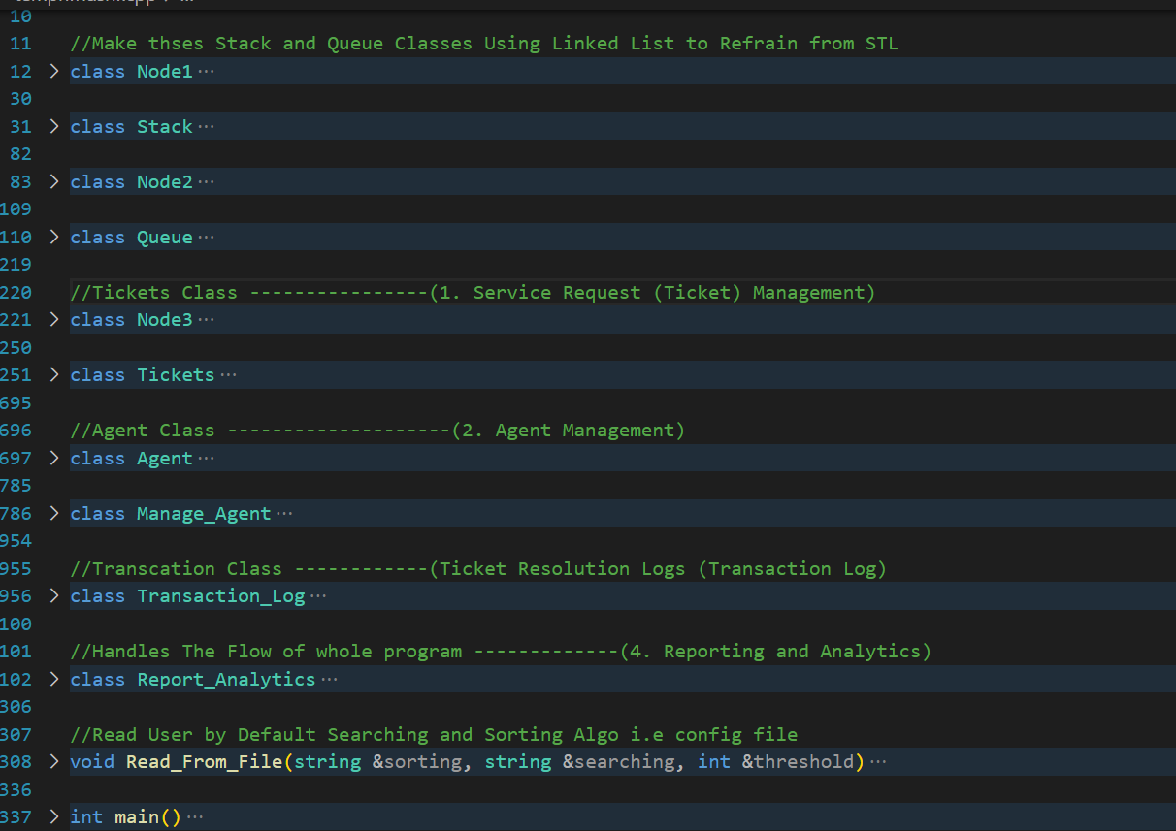

**IMPLEMENT ALL THE FUNCTIONALITIES MENTIONED IN ASSIGNMENT**

**TICKET CLASS**

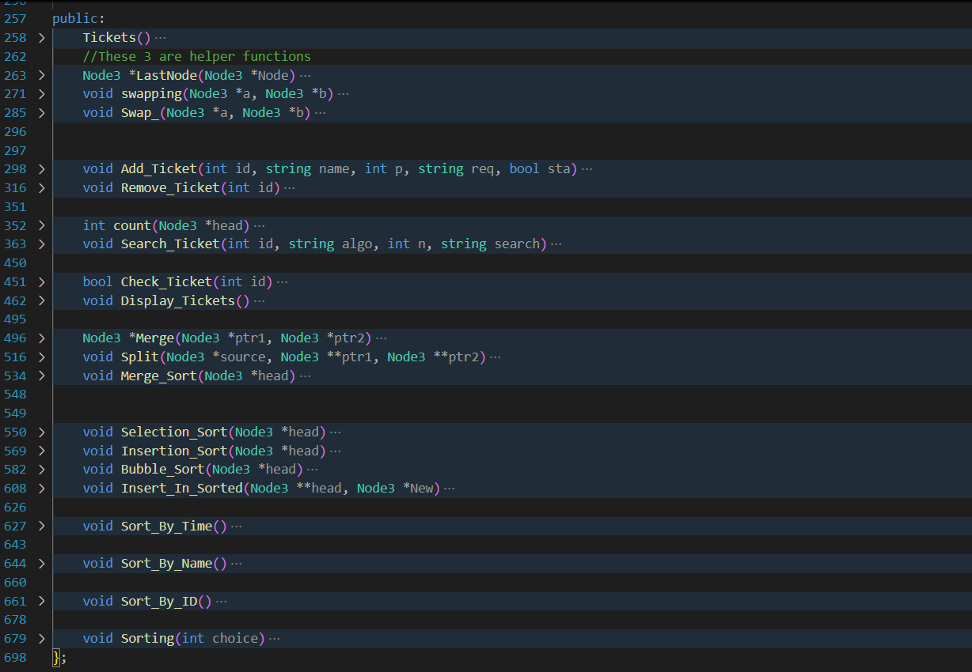

**IMPLEMENT ALL THE FUNCTIONALITIES MENTIONED IN ASSIGNMENT**

**AGENT CLASS**

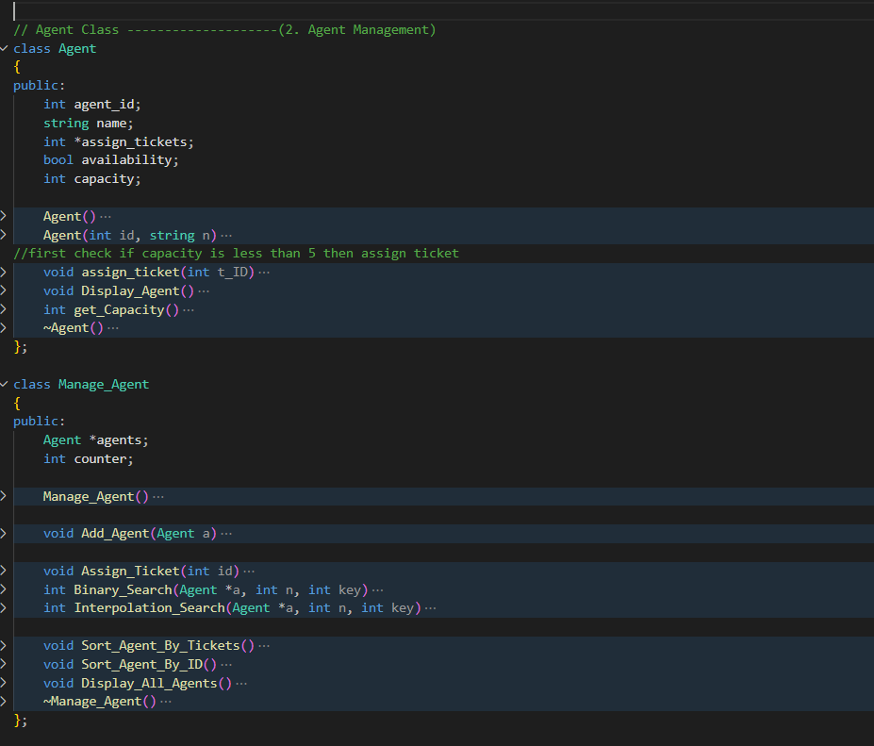

**IMPLEMENT ALL THE FUNCTIONALITIES MENTIONED IN ASSIGNMENT**

**TICKET RESOLUTION LOGS CLASS**

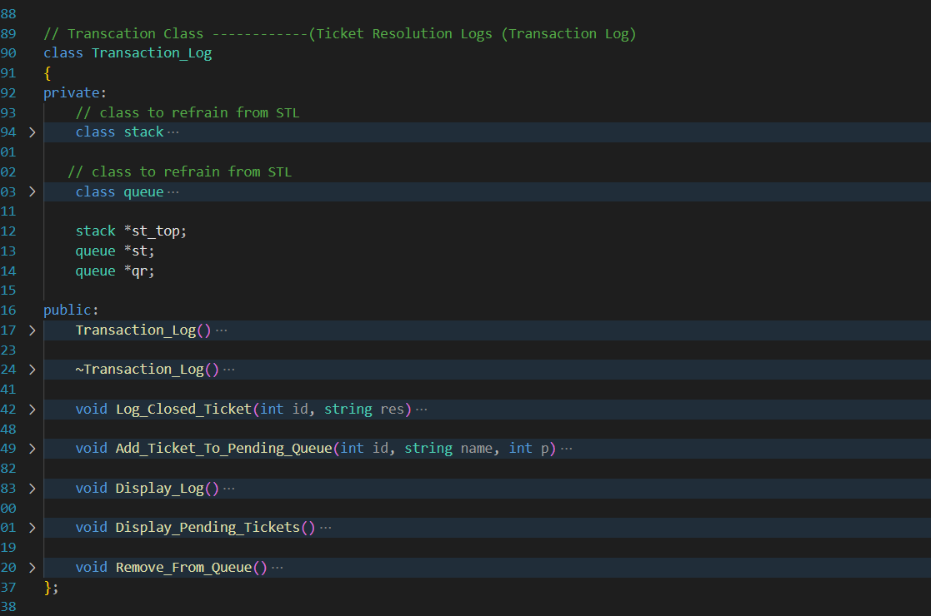

**IMPLEMENT ALL THE FUNCTIONALITIES MENTIONED IN ASSIGNMENT**

**REPORT AND ANALYTICS CLASS**

IT CONTROLS THE FLOW OF WHOLE PROGRAM

**IT READS THE USER DEFINED SEARCHING ALGORITHM AND SORTING ALGORITHM AND THE THRESHOLD**

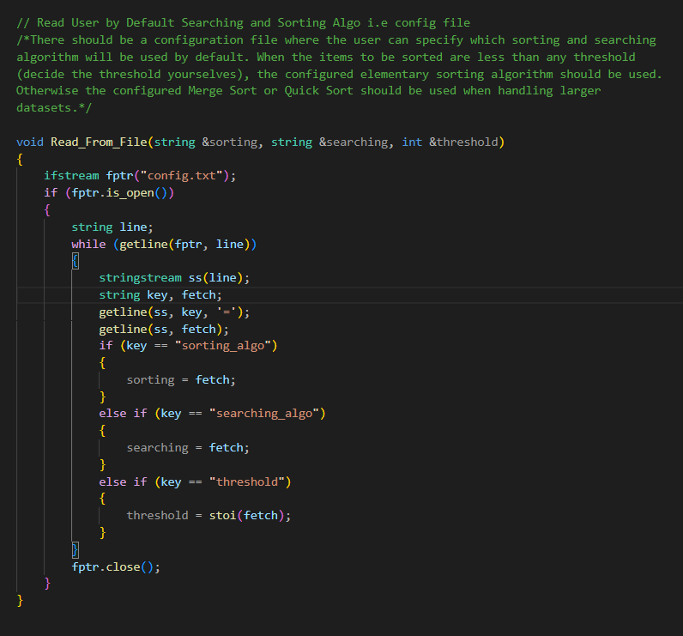

**THE CODE RUNS PERFECTLY WITH ALL THE MENTIONED THINGS TO IMPLEMENT**

**ALONG WITH THE TIME COMPLEXITIES OF EACH OPERATION**

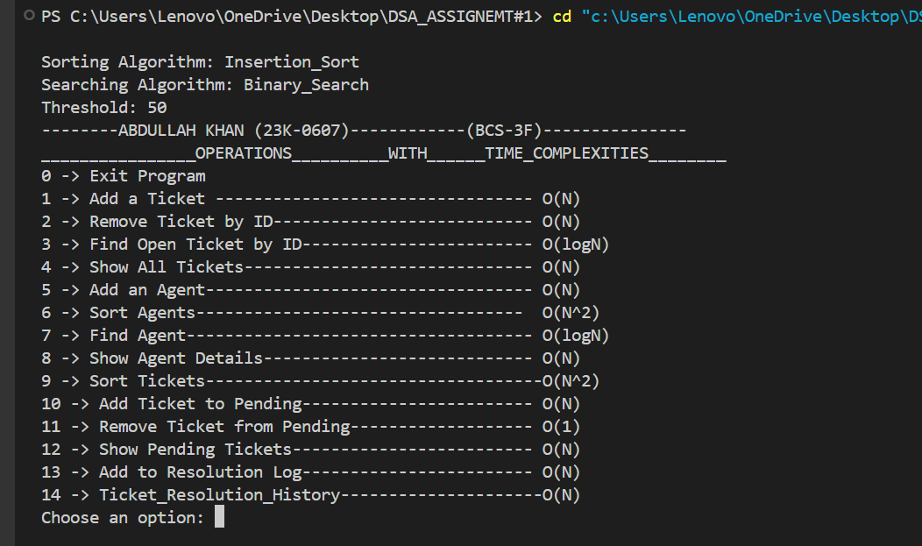

**Conclusion : I have tried my best in providing Well-documented source code with clear comments explaining the logic.**

**\*\*\*\*\*\*\*\*\*\*\*END\*\*\*\*\*\*\*\*\*\*\*\*\*\*\*\*\***