**23K-0607 DS ASSIGNMENT#2 21 NOV , 2024**

**BCS – 3F**

**ALSO PROVIDED A .TXT FILE IN CASE .CPP GETS CORRUPT**

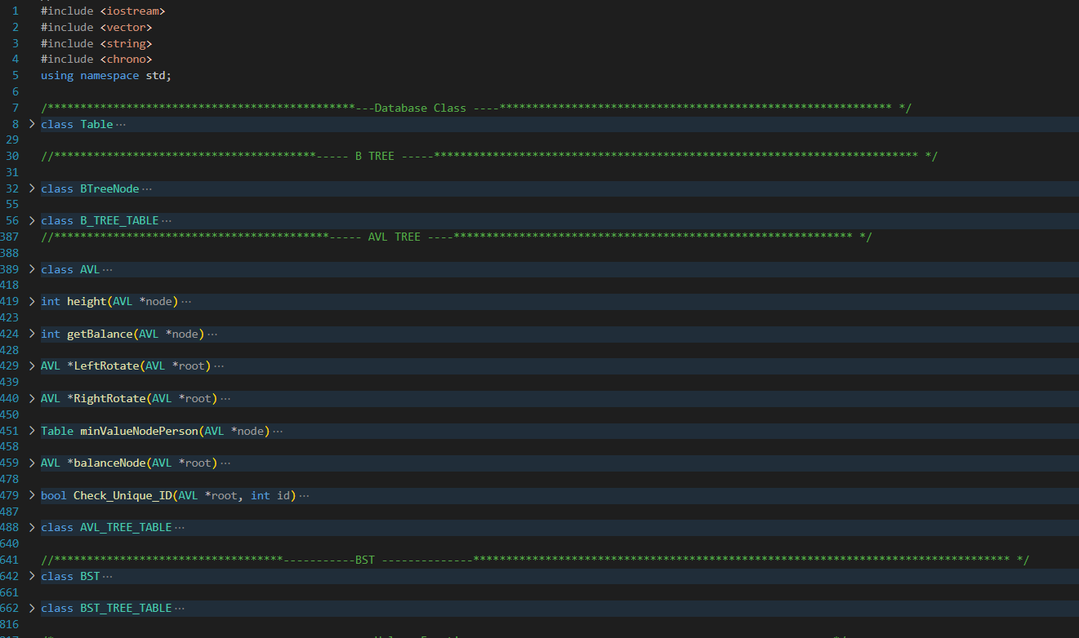

**THE CODE IS RUNNING PERFECTLY WITH ALL THE FUNCTIONALITIES MENTIONED IN THE MANUAL**

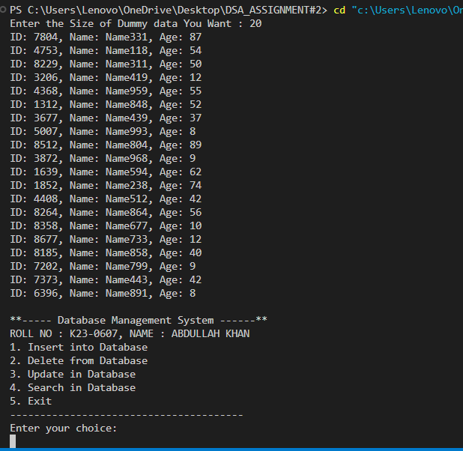

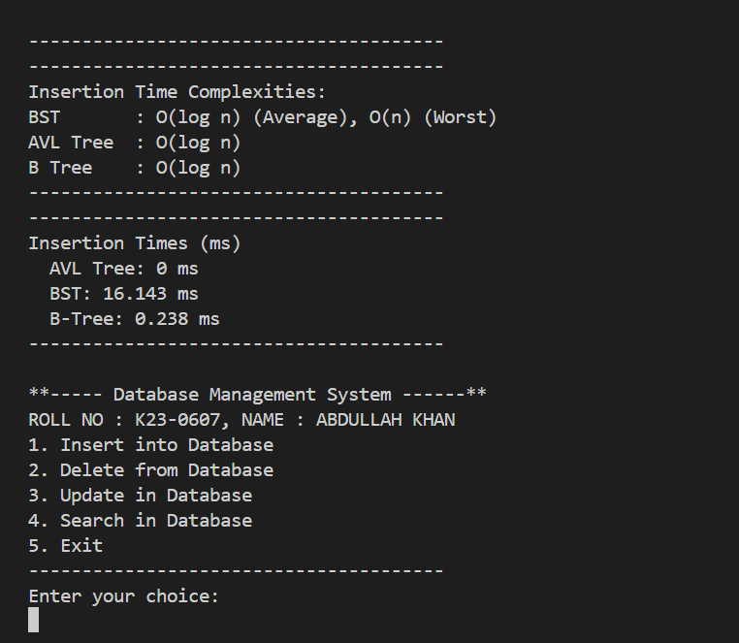

THE END