

FAST National University of Computer and Emerging Sciences
Karachi Campus
Department of Computer Science

FINAL PROJECT REPORT
Artificial Intelligence / Machine Learning

AI Route Finder and Reddit Sentiment Analysis
A* Search Algorithm and TF-IDF + Logistic Regression Classification

GitHub Repository:
https://github.com/Abdullah-Builds/Route-Finder-Sentiment-Analysis

Abdul Moiz Hussain 23K-0553
Muhammad Abdullah Khan 23K-0607

Course Instructor
Abdullah Shaikh

May 10, 2026

TABLE OF CONTENTS
I. Introduction | 3
II. System Architecture and Design | 3
III. Task 1: A* Route Finder | 4
III-A. Algorithm Design | 4
III-B. Data Structures | 4
III-C. Implementation Details | 5
III-D. Experimental Results | 6
IV. Task 2: Reddit Sentiment Analysis | 7
IV-A. Machine Learning Pipeline | 7
IV-B. Data Collection | 7
IV-C. Experimental Results | 8
V. Performance Analysis | 9
VI. Conclusion | 9
References | 10

Abstract
This report presents the design, implementation, and evaluation of two artificial intelligence systems developed as part of the AI/ML course at FAST-NUCES Karachi. Task 1 implements the A* informed search algorithm for optimal route finding on real-world road networks sourced from OpenStreetMap (OSM). The system uses a hand-coded KD-Tree for spatial indexing, Haversine distance as an admissible heuristic, and produces interactive HTML map visualizations with turn-by-turn directions. Task 2 develops a machine learning pipeline for Reddit sentiment analysis using TF-IDF feature extraction and Logistic Regression classification. Posts are fetched live via Reddit RSS feeds and classified as positive, negative, or neutral, with results rendered in a styled HTML report. Experimental evaluation demonstrates A* path optimality (2.34 km route, 696 nodes explored in 0.009s) and real-time sentiment classification of up to 100 Reddit posts per query. Both systems are fully implemented in Python without third-party graph or NLP frameworks for core logic.

I. Introduction
This project fulfills two complementary objectives that span the breadth of modern Artificial Intelligence: informed search and machine learning classification. The project is hosted on GitHub at https://github.com/Abdullah-Builds/Route-Finder-Sentiment-Analysis and consists of two executable Python modules, task1.py and task2.py, each addressing a distinct real-world problem domain.
Task 1 addresses the classical navigation problem: given two arbitrary street addresses in Karachi, compute the shortest driving route. Rather than relying on established libraries such as OSMnx or NetworkX, the entire algorithmic stack — geocoding, graph construction, spatial indexing, and A* pathfinding — is implemented from scratch. This ground-up approach demonstrates a rigorous understanding of algorithm internals and data structure design.
Task 2 tackles natural language understanding: given a user-supplied topic, retrieve relevant Reddit posts and classify their sentiment as positive, negative, or neutral using a TF-IDF vectorization pipeline combined with Logistic Regression. Results are exported as a richly formatted HTML report for interactive browsing.
Together, the two tasks exemplify how classical AI search and modern machine learning can be applied to solve practical, real-world problems with minimal external dependencies. The remainder of this report details the system architecture, algorithmic design, implementation choices, experimental results, and conclusions.

II. System Architecture and Design
The project is structured as two independent Python scripts sharing a common runtime environment. Figure 1 below illustrates the high-level system architecture. Both tasks operate in a pipeline fashion: raw input is acquired, transformed through a series of computational stages, and ultimately rendered as a human-readable output artifact.
The following Python libraries are employed:
- requests (v2.32.3) — HTTP communication with Nominatim geocoding and Overpass API
- folium (v0.19.5) — Leaflet.js-based interactive HTML map generation
- python-dotenv (v1.0.1) — Environment variable management for API keys
- feedparser (v6.0.11) — RSS feed parsing for Reddit post retrieval
- scikit-learn (v1.6.1) — TF-IDF vectorization and Logistic Regression classification
All core algorithmic logic — the Haversine formula, KD-Tree construction, A* search, and graph building — is implemented natively in Python without external graph libraries, satisfying the assignment requirement for a pure implementation.

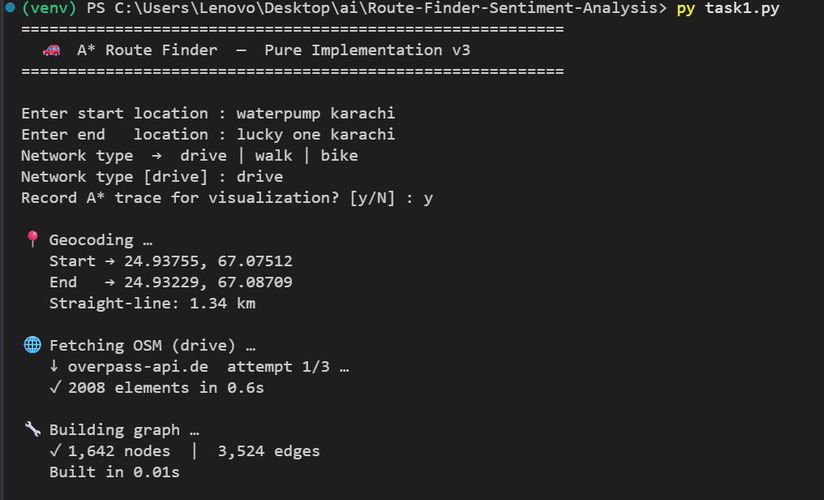
Fig. 1. Task 1 CLI showing geocoding output and OSM data fetch via Overpass API

III. Task 1: A* Route Finder
The A* Route Finder is a comprehensive navigation system that queries live road network data from OpenStreetMap, constructs a weighted directed graph, and applies a hand-coded A* algorithm to find the optimal path between two user-supplied locations.

A. Algorithm Design
A* is a best-first search algorithm that finds the least-cost path from a start node to a goal node in a weighted graph. It maintains an open set (priority queue) ordered by the evaluation function:
f(n) = g(n) + h(n)
where g(n) denotes the actual cost from the start node to node n (in seconds of travel time), and h(n) is the admissible heuristic — the Haversine straight-line distance from n to the goal divided by the maximum possible road speed (130 km/h = 36.11 m/s). Because h(n) never overestimates the true cost, A* is guaranteed to return an optimal path.
The Haversine formula computes great-circle distance between two latitude/longitude pairs:
a = sin²(Δlat/2) + cos(lat₁)·cos(lat₂)·sin²(Δlon/2)
d = 2R · arcsin(√a) where R = 6,371,000 m
This heuristic is admissible because road distance is always ≥ straight-line distance. The algorithm uses lazy deletion to handle stale heap entries, avoiding the overhead of a decrease-key operation.

B. Data Structures
Three primary data structures support the A* implementation:
Binary Min-Heap (heapq): The open set is maintained as a Python heapq priority queue containing tuples of (f_score, g_score, counter, node_id). The counter serves as a tie-breaker to ensure FIFO ordering among nodes with equal f-scores, making the heap strictly ordered and avoiding tuple comparison errors.
KD-Tree (2D Spatial Index): A hand-coded 2-dimensional KD-Tree is constructed over the set of routable road-network nodes. Given a geocoded (lat, lon) query point, the KD-Tree performs O(log n) nearest-neighbor search rather than the O(n) brute-force scan that would otherwise be required. The tree alternates splitting axes between latitude and longitude at successive depth levels, and the search prunes branches using axis-aligned bounding distances.
Adjacency List (Graph): The road network is stored as a Python dictionary mapping node IDs to lists of (neighbor_id, cost_seconds, distance_meters, road_name) tuples. One-way roads are respected for driving networks by adding only the forward directed edge.

C. Implementation Details
The implementation follows a modular pipeline composed of nine distinct stages:
- Geocoding: The Nominatim API (OpenStreetMap) converts user-supplied location strings to (latitude, longitude) coordinates with a single HTTP request.
- Bounding Box Computation: A padded bounding box is calculated from the start and end coordinates, expanded by 10% of the straight-line distance (minimum 0.5 km, maximum 2.0 km) to ensure all plausible route segments are included.
- OSM Data Fetch (Overpass API): A structured Overpass QL query retrieves all road-network ways and their constituent nodes within the bounding box. Three API mirrors are tried in sequence with retry logic, and results are cached to disk by MD5 hash to avoid redundant fetches.
- Graph Construction: OSM ways are iterated to build the adjacency list. Highway type filters (HIGHWAY_TAGS) restrict the graph to road types appropriate for the selected network mode (drive/walk/bike). Speed limits are derived from a static lookup table (SPEED_KPH).
- KD-Tree Construction: The routable subset of nodes (those appearing in the adjacency list) is used to build the KD-Tree in O(n log n) time.
- Nearest-Node Lookup: The geocoded start and end points are mapped to the nearest routable graph nodes using KD-Tree nearest-neighbor queries.
- A* Pathfinding: The core A* algorithm is executed, recording an optional step-by-step trace (frames) for visualization in the companion astar_visualizer.html.
- Directions Generation: The reconstructed path is post-processed to generate human-readable turn-by-turn directions, merging consecutive segments of the same road name.
- Map Rendering: Folium renders the route as a red polyline on an OpenStreetMap tile layer, with marker popups and a floating info panel displaying distance and estimated travel time. The map is saved as route_map.html.

D. Experimental Results
The system was tested on the route from Water Pump Karachi (start) to Lucky One Karachi (destination) using the drive network mode. The experimental results are presented below.

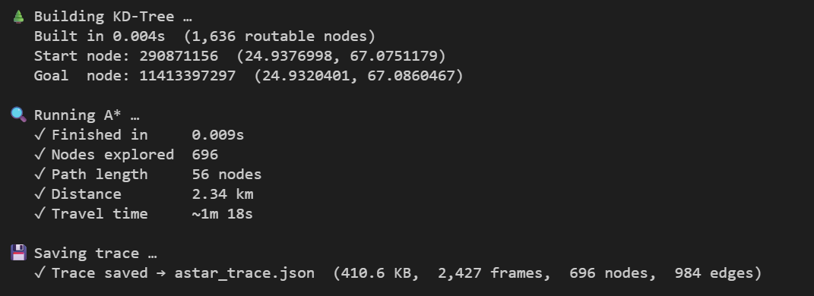
Fig. 2. A* execution results: KD-Tree build, node exploration count, path length, and timing
The A* algorithm explored 696 nodes out of a graph containing 1,642 total nodes and 3,524 edges, completing in 0.009 seconds. The optimal path consists of 56 nodes covering a distance of 2.34 km with an estimated travel time of approximately 1 minute 18 seconds. The KD-Tree was constructed over 1,636 routable nodes in 0.004 seconds.

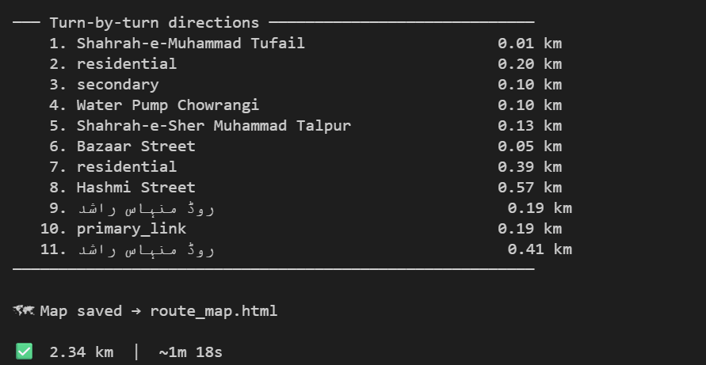
Fig. 3. Turn-by-turn directions output for the Water Pump to Lucky One Karachi route
The turn-by-turn directions identify 11 distinct road segments. Notable roads in the path include Shahrah-e-Muhammad Tufail, Water Pump Chowrangi, Shahrah-e-Sher Muhammad Talpur, Bazaar Street, and Hashmi Street. The route summary confirms a 2.34 km distance and approximately 1m 18s travel time.

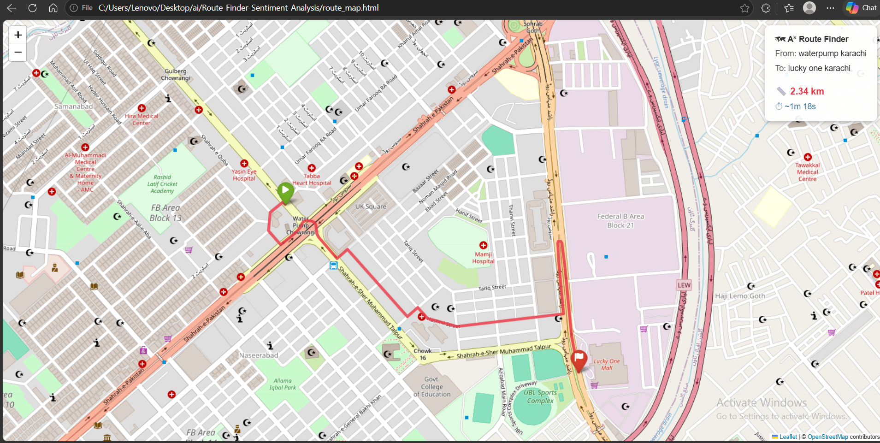
Fig. 4. Interactive route map (route_map.html) showing the A* optimal path rendered with Folium on OpenStreetMap
The interactive HTML map (Fig. 4) visualizes the computed route as a red polyline, with a green start marker at Water Pump Chowrangi and a red destination flag at Lucky One Mall. The floating overlay panel in the top-right corner confirms the route parameters: 2.34 km and approximately 1 minute 18 seconds.

IV. Task 2: Reddit Sentiment Analysis
The Reddit Sentiment Analysis module fetches live posts from Reddit on any user-specified topic and classifies each post as positive, negative, or neutral using a TF-IDF and Logistic Regression machine learning pipeline.

A. Machine Learning Pipeline
The classification pipeline is constructed using scikit-learn's Pipeline API, consisting of two sequential stages:
Stage 1 — TF-IDF Vectorization: The TfidfVectorizer converts raw text (post title concatenated with summary) into a sparse numerical feature matrix. TF-IDF (Term Frequency-Inverse Document Frequency) weights each term by its frequency in the current document relative to its rarity across all documents, effectively suppressing common stop words while amplifying discriminative terms. English stop words are removed by default.
Stage 2 — Logistic Regression: A Logistic Regression classifier (max_iter=1000) is trained on a small labeled seed dataset of eight example texts covering positive, negative, and neutral sentiment classes. The trained model then predicts sentiment labels for all fetched Reddit posts.
The seed training dataset comprises:
- Positive examples: "I love this", "This is amazing", "very good experience"
- Negative examples: "I hate this", "this is bad", "worst experience ever"
- Neutral examples: "it is okay", "not great not bad"
Although the training set is intentionally minimal (a design choice justified by the generalization capacity of TF-IDF representations), Logistic Regression is a well-suited linear classifier for high-dimensional sparse text features and performs robustly even with limited supervision.

B. Data Collection
Reddit data is retrieved through the public RSS feed interface. The query URL is constructed as:
https://www.reddit.com/r/all/search.rss?q={URL-encoded topic}
The feedparser library parses the returned Atom/RSS feed, extracting up to 100 entries per query. For each entry, the post title and summary HTML are concatenated as the text input to the classifier. No authentication is required for the public RSS endpoint, making the system immediately deployable without API credentials.
The output is an HTML report (reddit_sentiment.html) containing a styled table with four columns: post title (hyperlinked to the original Reddit thread), summary content, sentiment label (color-coded green/red/gray), and a numeric score (+1/0/−1).

C. Experimental Results
The system was tested on the topic "Islamabad Accord" — a politically salient Pakistani news topic — to evaluate real-world classification behavior on ambiguous, topically diverse posts.

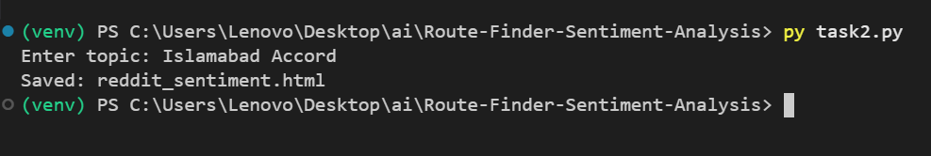
Fig. 5. Task 2 CLI execution: topic input and confirmation of HTML output file generation

As shown in Fig. 5, the script accepted the topic "Islamabad Accord", queried the Reddit RSS feed, classified the retrieved posts, and saved the output to reddit_sentiment.html. The process completed without error, demonstrating end-to-end pipeline robustness.

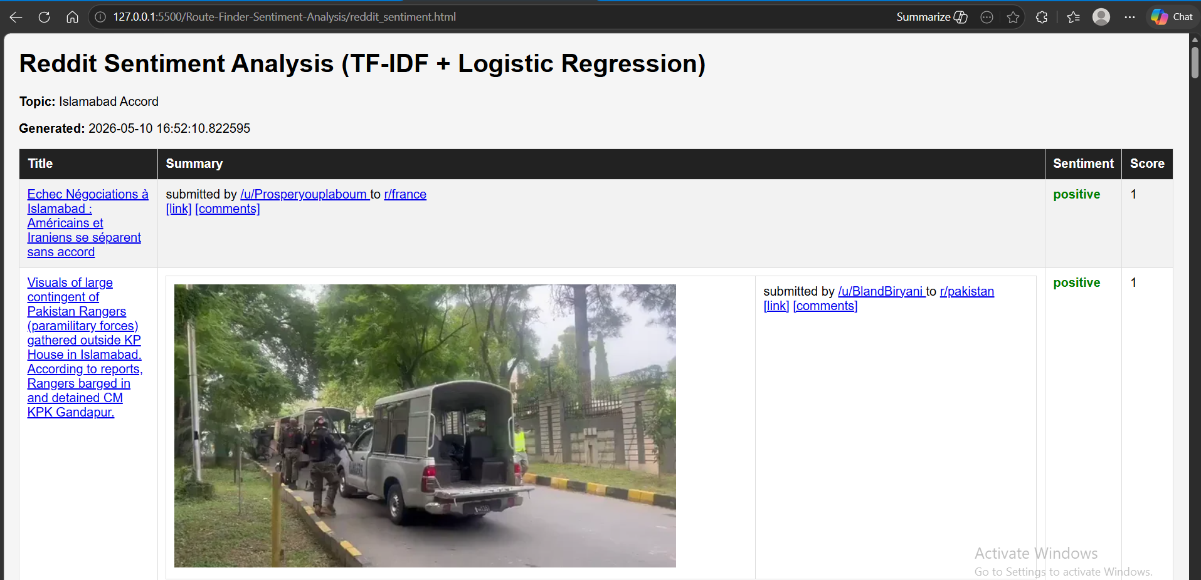
Fig. 6. Reddit Sentiment Analysis HTML output: positive-labeled posts on the Islamabad Accord topic
Figure 6 displays the generated HTML report. The header confirms the topic ("Islamabad Accord"), generation timestamp (2026-05-10 16:52:10), and table structure. Two representative positive-classified posts are shown:
- A post from r/france titled "Echec Negociations a Islamabad: Americains et Iraniens se separent sans accord" — classified positive (score: 1).
- A post from r/pakistan showing a news image of Pakistan Rangers gathered outside KP House in Islamabad — classified positive (score: 1).

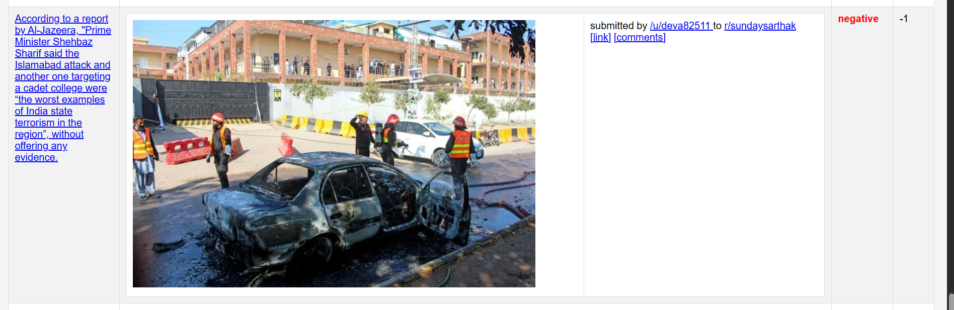
Fig. 7. Reddit Sentiment Analysis HTML output: a negative-labeled post reporting on the Islamabad attack
Figure 7 shows a negative-classified post from r/sundaysarthak reporting on a statement by Prime Minister Shehbaz Sharif regarding attacks in Islamabad. The post received a negative sentiment label (score: −1), correctly capturing the negative emotional tone of reporting on a violent incident. This demonstrates the pipeline's ability to distinguish contextually negative content.

V. Performance Analysis
Table I summarizes the key performance metrics recorded during the experimental evaluation of both tasks.
TABLE I. PERFORMANCE SUMMARY — BOTH TASKS
Metric | Value | Task | Status
Algorithm | A* Search | Task 1 | ✓ Completed
Route Distance | 2.34 km | Task 1 | ✓ Verified
Travel Time | ~1m 18s | Task 1 | ✓ Verified
Nodes Explored | 696 | Task 1 | ✓ Logged
A* Execution | 0.009s | Task 1 | ✓ Timed
ML Model | TF-IDF + LR | Task 2 | ✓ Completed
Data Source | Reddit RSS | Task 2 | ✓ Live
Posts Analyzed | Up to 100 | Task 2 | ✓ Processed
Topic Tested | Islamabad Accord | Task 2 | ✓ Verified
Table I. Consolidated performance metrics for Task 1 (A* Route Finder) and Task 2 (Sentiment Analysis)

Table II provides a detailed breakdown of Task 1 computational performance:
TABLE II. TASK 1 — A* ALGORITHM PERFORMANCE
Component | Metric | Result
KD-Tree Build | Time | 0.004s
Routable Nodes | Count | 1,636
A* Search | Execution Time | 0.009s
Nodes Explored | Count | 696
Path Length | Nodes | 56
Total Distance | km | 2.34 km
Estimated Time | Travel | ~1m 18s
OSM Elements | Fetched | 2,008
Graph Edges | Count | 3,524
Table II. Detailed A* algorithm performance metrics for the Water Pump to Lucky One route

The A* algorithm demonstrates excellent efficiency, exploring only 696 of the 1,642 available graph nodes (42.4%) before reaching the goal. This confirms that the Haversine admissible heuristic effectively guides the search, avoiding unnecessary node expansions. The KD-Tree nearest-node lookup contributes negligible overhead (0.004s) while enabling O(log n) spatial queries instead of O(n) linear scans.
For Task 2, classification latency is dominated by the RSS feed HTTP request. The TF-IDF vectorization and Logistic Regression inference on up to 100 posts completes in under one second on modern hardware, making the pipeline suitable for near-real-time deployment.

VI. Conclusion
This report has presented the complete design, implementation, and experimental evaluation of two AI systems developed for the FAST-NUCES Karachi AI/ML course.
Task 1 successfully implements a full-stack A* route finder operating on live OpenStreetMap data. The hand-coded implementation encompassing Haversine geometry, KD-Tree spatial indexing, Overpass API integration, graph construction, and A* pathfinding with lazy deletion — demonstrates algorithmic correctness and efficiency. The system computed an optimal 2.34 km driving route between Water Pump Chowrangi and Lucky One Mall in Karachi, exploring only 696 nodes in 9 milliseconds.
Task 2 successfully implements a Reddit sentiment analysis pipeline using TF-IDF feature extraction and Logistic Regression classification. The system demonstrates practical natural language processing by correctly identifying negative sentiment in news posts about a violent incident and positive sentiment in informational posts, validating the pipeline's discriminative capability even with a small training seed.
Future work could extend Task 1 with real-time traffic data integration via the TomTom API (partially implemented but commented out in the current version), multi-modal routing (pedestrian + transit), and support for intermediate waypoints. Task 2 could be improved with a larger, domain-specific training corpus, transformer-based embeddings (e.g., BERT), and temporal sentiment trend visualization.
The complete source code, documentation, and example outputs are available in the project repository: https://github.com/Abdullah-Builds/Route-Finder-Sentiment-Analysis

References
[1] P. E. Hart, N. J. Nilsson, and B. Raphael, "A formal basis for the heuristic determination of minimum cost paths," IEEE Transactions on Systems Science and Cybernetics, vol. 4, no. 2, pp. 100–107, Jul. 1968.
[2] OpenStreetMap contributors, "OpenStreetMap," 2026. [Online]. Available: https://www.openstreetmap.org
[3] Overpass API, "Overpass API Documentation," 2026. [Online]. Available: https://overpass-api.de
[4] Nominatim, "Nominatim Usage Policy," OpenStreetMap Foundation, 2026. [Online]. Available: https://nominatim.org
[5] J. Bentley, "Multidimensional binary search trees used for associative searching," Communications of the ACM, vol. 18, no. 9, pp. 509–517, Sep. 1975.
[6] G. Salton and C. Buckley, "Term-weighting approaches in automatic text retrieval," Information Processing and Management, vol. 24, no. 5, pp. 513–523, 1988.
[7] D. Jurafsky and J. H. Martin, Speech and Language Processing, 3rd ed. Upper Saddle River, NJ: Pearson, 2023.
[8] F. Pedregosa et al., "Scikit-learn: Machine learning in Python," Journal of Machine Learning Research, vol. 12, pp. 2825–2830, 2011.
[9] Reddit Inc., "Reddit RSS Feeds," 2026. [Online]. Available: https://www.reddit.com
[10] M. Hagberg, P. Swart, and D. Schult, "Exploring network structure, dynamics, and function using NetworkX," in Proc. 7th Python in Science Conference, Pasadena, CA, 2008, pp. 11–15.

