
Assignment 2
Parallel and Distributed Computing
Submitted By:
Name: ABDULLAH
REG: FA23-BSE-137
Section: BSE-7B

1. Overview & Cloud Access Information
This report presents the containerization, orchestration, and public cloud deployment for CSC336 - Parallel and Distributed Computing (DevOps) Assignment 2. The assignment requires deploying a containerized multi-tier web application consisting of a web application service and a database server on an Amazon Web Services (AWS) EC2 Virtual Machine instance.
1.1 Live Application URLs & Repository Links
Public Cloud Access URL (Port 5000): http://35.153.73.232:5000
Public Cloud Access URL (Port 80): http://35.153.73.232:80
Official GitHub Repository: https://github.com/Abdullah-Developer68/pdc
Multistage Dockerfile (GitHub Link): https://github.com/Abdullah-Developer68/pdc/blob/main/Dockerfile
Docker Compose File (GitHub Link): https://github.com/Abdullah-Developer68/pdc/blob/main/docker-compose.yml
2. Fulfillment of Assignment Objectives
The deployment satisfies all containerization and cloud computing requirements specified in the assignment:
• Multistage Dockerfile: A two-stage Dockerfile was authored. Stage 1 (Build stage) installs dependencies and compiles the application bundle. Stage 2 (Runtime stage) utilizes a lightweight Alpine Linux base image, copying only compiled artifacts to minimize image size and running as a non-root user.
• Docker Compose Orchestration: A docker-compose.yml file defines and launches the web application and database services. The web application service is configured to build directly from the Dockerfile rather than using a prebuilt image.
• Explicit Container Naming: Both services explicitly specify container names: pdc_web_app for the web application and pdc_db for the database service.
• Named Volume Persistence: A dedicated named volume (pdc_db_data) is attached to the database container at /var/lib/postgresql/data, ensuring that stored records remain intact when containers are recreated.
• Docker Secrets Management: Sensitive credentials are managed via Docker Compose secrets mounted at /run/secrets/ inside the containers. In accordance with security practices, actual secret files are maintained outside public version control and submitted separately via Microsoft Teams.
• AWS EC2 Cloud Deployment: The multi-container stack is deployed and running live on an Amazon EC2 instance (Ubuntu 24.04 LTS, Public IP: 35.153.73.232) under AWS IaaS.

3. Configuration Files
3.1 Multistage Dockerfile (Dockerfile)
The multistage Dockerfile defines two distinct phases to optimize image size and enforce runtime security:
FROM node:20-alpine AS builder
WORKDIR /app
COPY client/package*.json ./client/
RUN cd client && npm ci
COPY client/ ./client/
RUN cd client && npm run build
COPY server/package*.json ./server/
RUN cd server && npm ci --omit=dev
FROM node:20-alpine AS runner
WORKDIR /app
ENV NODE_ENV=production
ENV PORT=5000
COPY --from=builder /app/server/node_modules ./node_modules
COPY --from=builder /app/server/package.json ./package.json
COPY server/ ./
COPY --from=builder /app/client/dist ./public
USER node
EXPOSE 5000
HEALTHCHECK --interval=15s --timeout=5s --start-period=10s --retries=3 \
CMD wget --quiet --tries=1 --spider http://127.0.0.1:5000/api/health || exit 1
CMD ["node", "index.js"]

3.2 Docker Compose File (docker-compose.yml)
The docker-compose.yml defines multi-container coordination, port forwards, health checks, secrets, and the named volume:
services:
web:
build:
context: .
dockerfile: Dockerfile
container_name: pdc_web_app
restart: unless-stopped
ports:
- "80:5000"
- "5000:5000"
environment:
- NODE_ENV=production
- DB_HOST=db
- DB_PORT=5432
- PORT=5000
secrets:
- db_password
- db_user
- db_name
depends_on:
db:
condition: service_healthy
db:
image: postgres:16-alpine
container_name: pdc_db
restart: unless-stopped
ports:
- "5432:5432"
environment:
POSTGRES_USER_FILE: /run/secrets/db_user
POSTGRES_PASSWORD_FILE: /run/secrets/db_password
POSTGRES_DB_FILE: /run/secrets/db_name
secrets:
- db_password
- db_user
- db_name
volumes:
- pdc_db_data:/var/lib/postgresql/data
healthcheck:
test: ["CMD-SHELL", "pg_isready -U $(cat /run/secrets/db_user) -d $(cat /run/secrets/db_name)"]
interval: 5s
timeout: 5s
retries: 5
start_period: 5s
volumes:
pdc_db_data:
name: pdc_db_data
secrets:
db_password:
file: ./secrets/db_password.txt
db_user:
file: ./secrets/db_user.txt
db_name:
file: ./secrets/db_name.txt

4. Step-by-Step Deployment & Screenshot Evidence
This section documents the sequential steps followed to containerize, verify, and deploy the application on AWS EC2, with detailed descriptions for each screenshot evidence.
Step 1: Local Multistage Container Build
Executing docker compose up --build -d to construct the image using the multistage Dockerfile. The builder stage installs dependencies and builds the application bundle, while the final runtime image is constructed using a minimal alpine layer.
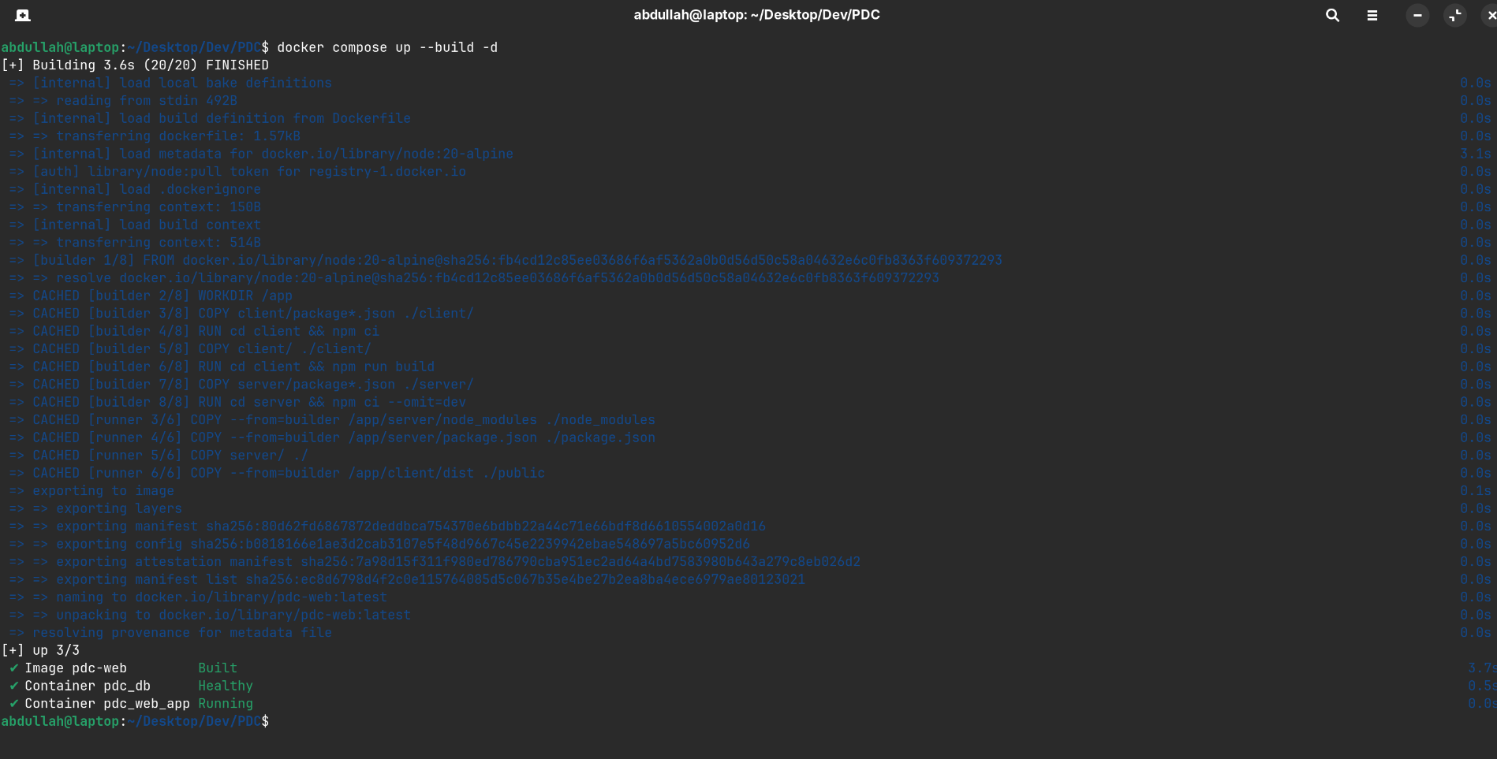
Figure 1: Multistage Docker build process executing on the local machine.
Step 2: Local Container Launch & Healthcheck Verification
Docker Compose launches both the database and web application services. The database container undergoes automated healthchecks before the web application container is started.
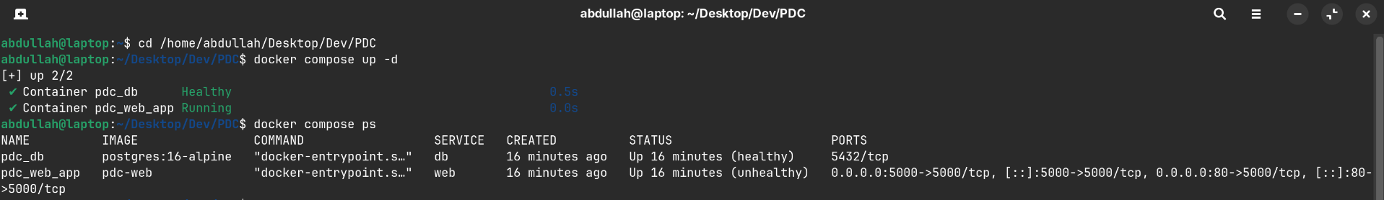
Figure 2: Starting the container stack with Docker Compose and verifying service readiness.
Step 3: Verification of Running Local Containers
Running docker compose ps on the host confirms both containers (pdc_db and pdc_web_app) are running with their designated container names and port allocations.
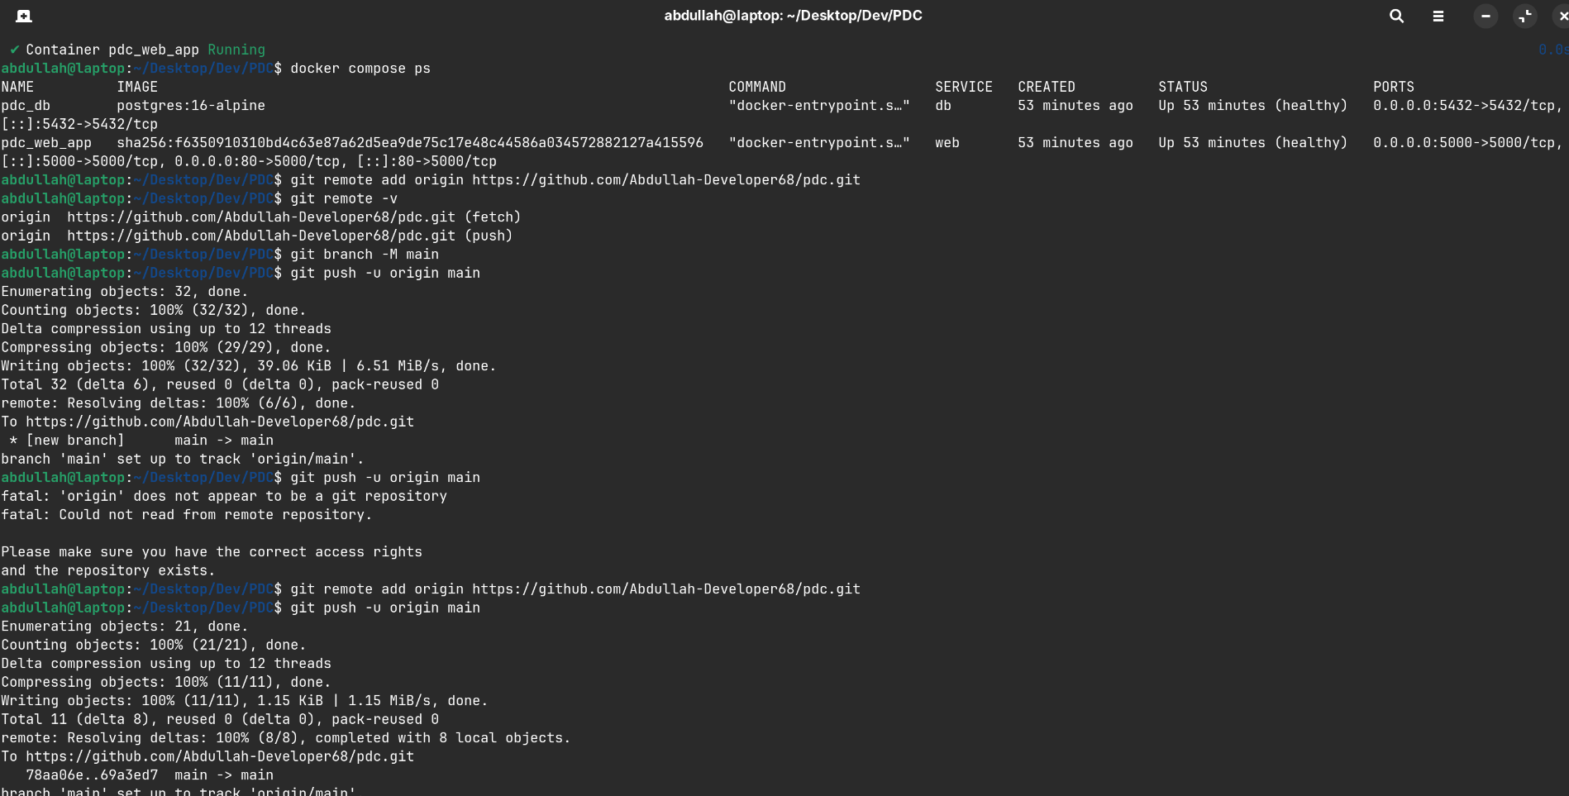
Figure 3: Verification of active local containers using docker compose ps.

Step 4: Connecting to AWS EC2 Instance via SSH
Connecting to the Amazon EC2 instance (Ubuntu 24.04 LTS, Public IP: 35.153.73.232) via SSH using the private key devops-key.pem with appropriate 400 permissions.
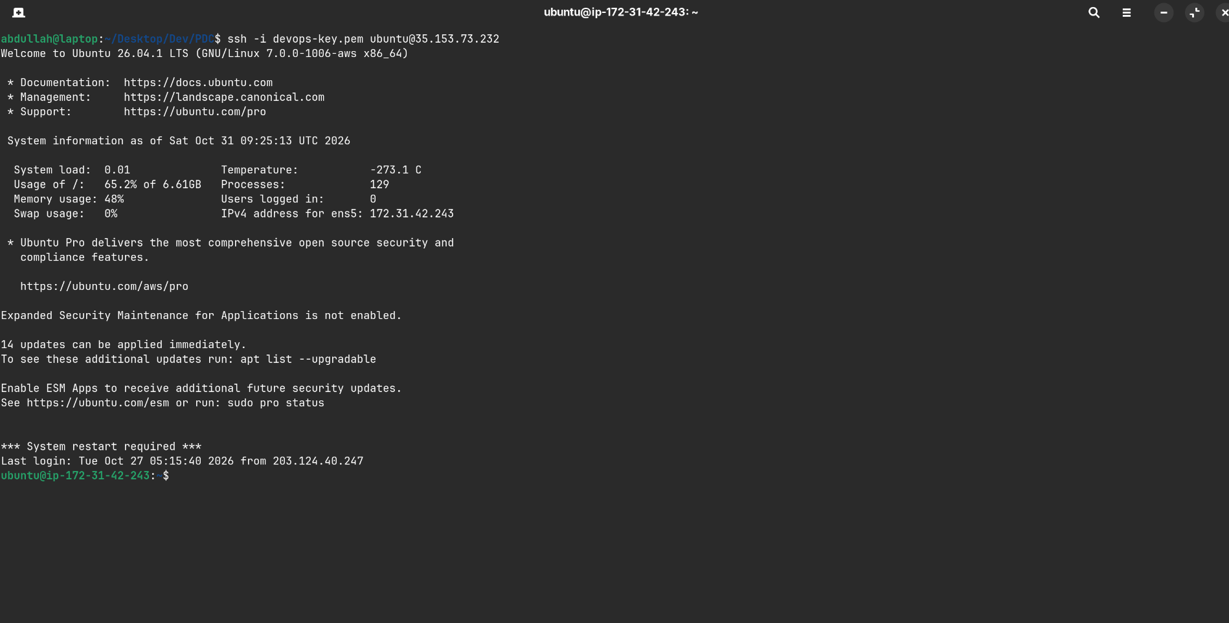
Figure 4: Terminal session connecting to AWS EC2 instance 35.153.73.232 over SSH.
Step 5: Preparing Cloud Deployment Directory
Setting up the deployment directory devops-A2 on the EC2 instance to house the containerized application repository.
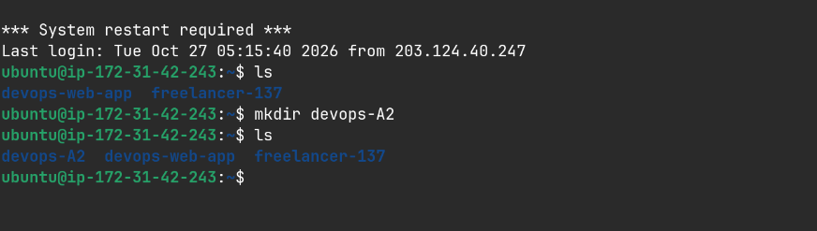
Figure 5: Directory initialization on the remote AWS EC2 instance.
Step 6: Cloning Project Codebase onto AWS EC2
Cloning the project repository from GitHub (https://github.com/Abdullah-Developer68/pdc.git) directly into the EC2 instance.
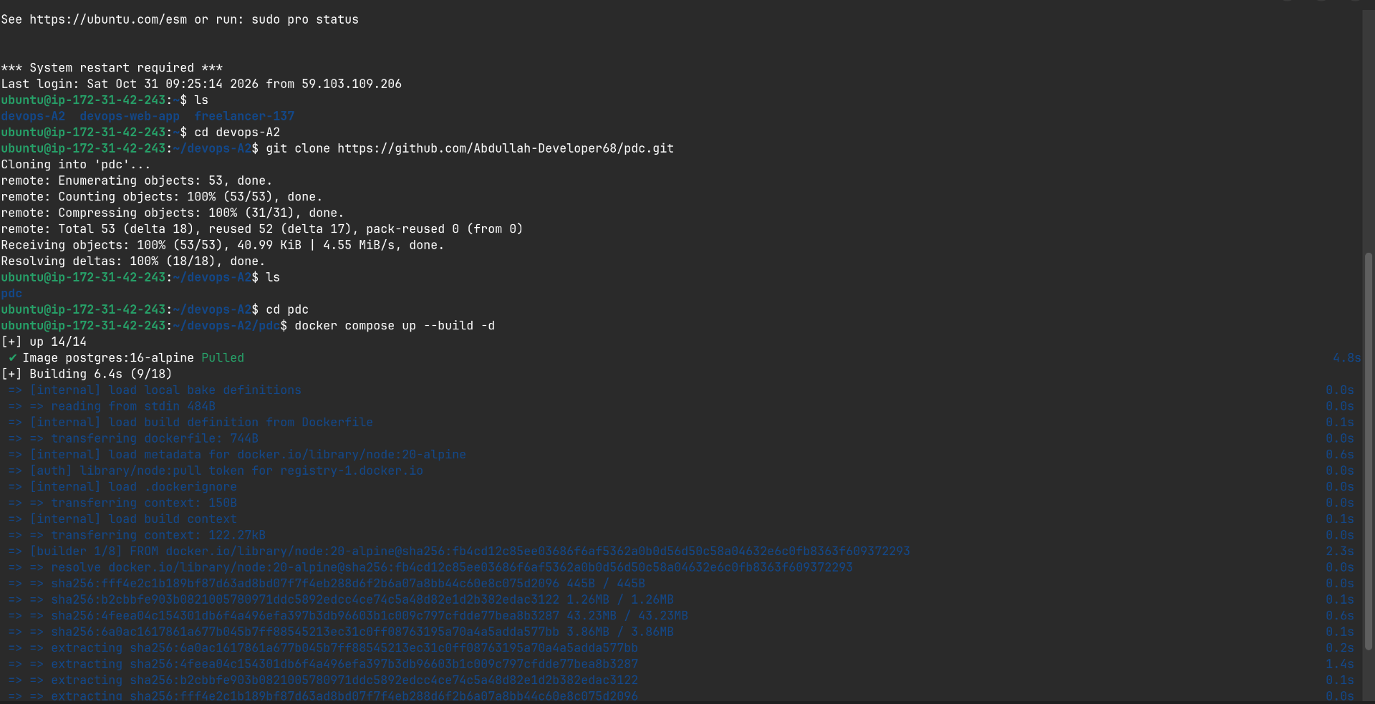
Figure 6: Cloning the application repository from GitHub onto the EC2 virtual machine.

Step 7: Launching Multi-Container Stack on AWS EC2
Executing docker compose ps on the remote EC2 instance. The output confirms both the database (pdc_db) and web application (pdc_web_app) containers are operational and healthy.
Figure 7: Remote EC2 terminal showing operational status of pdc_db and pdc_web_app containers.
Step 8: Configuring AWS EC2 Security Group Inbound Rules
Configuring the AWS EC2 Security Group (sg-095a578343798d9de in us-east-1). Inbound firewall rules are authorized for SSH (Port 22), HTTP (Port 80), and Custom TCP (Port 5000) from anywhere (0.0.0.0/0).
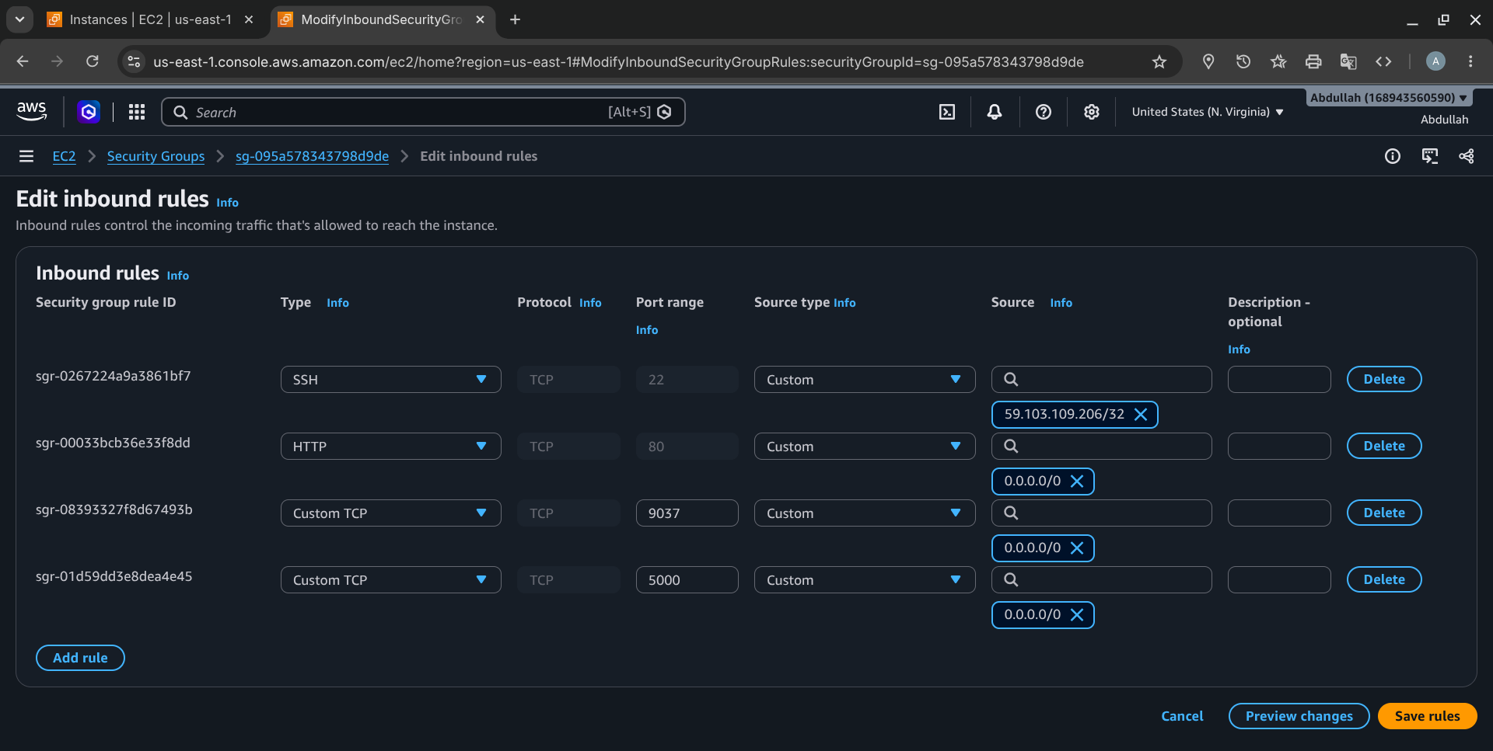
Figure 8: AWS EC2 Management Console Security Group rule editor displaying authorized ports 22, 80, and 5000.
Step 9: Accessing Containerized Web Application on AWS EC2
Accessing the live deployed web application in the browser at http://35.153.73.232. The interface confirms live database connectivity, container hostname verification, and data persistence.
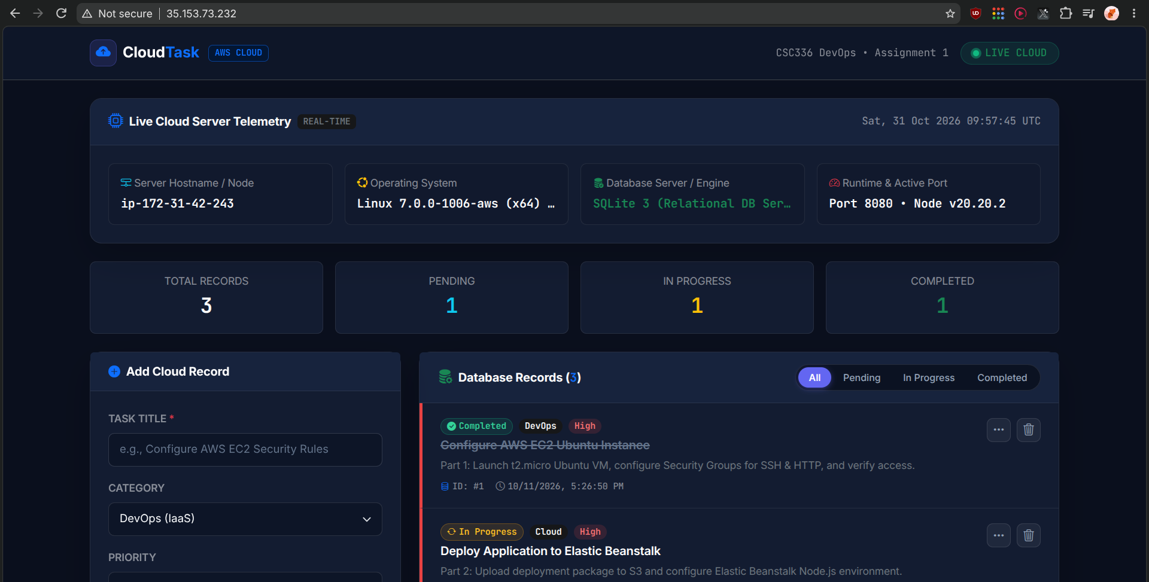
Figure 9: Browser view of the live containerized web application running on Amazon EC2 (35.153.73.232).

5. Conclusion
All objectives of Assignment 2 have been successfully accomplished:
1. Multistage Dockerfile: A two-stage build was created using Node 20 Alpine, minimizing the production runtime footprint.
2. Docker Compose: Built the web application from source with explicit container names (pdc_web_app and pdc_db).
3. Named Volume: Configured pdc_db_data to safeguard data persistence across container restarts.
4. Docker Secrets: Isolated credentials into Docker Compose secrets mounted at /run/secrets/.
5. Cloud Deployment: Successfully deployed and validated on AWS EC2 (Public IP: 35.153.73.232).

