1. Different between filter mask of CAN-Controller and filter mask of CAN-Trcv?
2. Difference between Callback and Callout?
3. At init Phase, when exactly the Comm Signals get initialized with the init value in K-Matrix?
4. Why do we enter Signal Init value and Invalid value in the configuration?

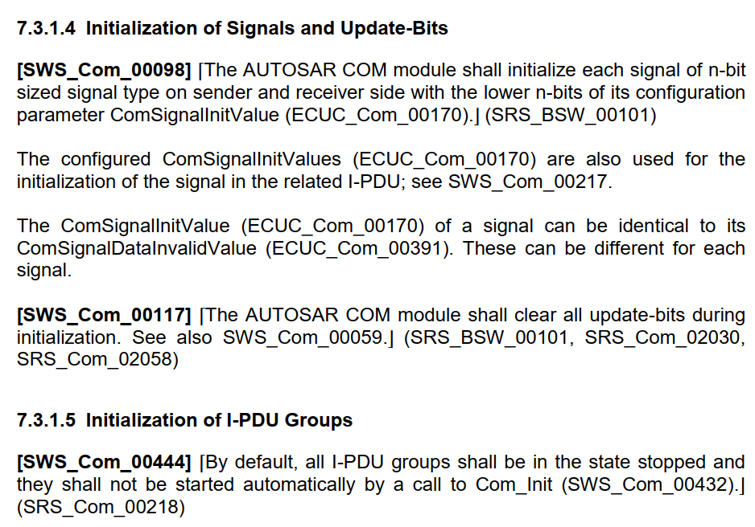

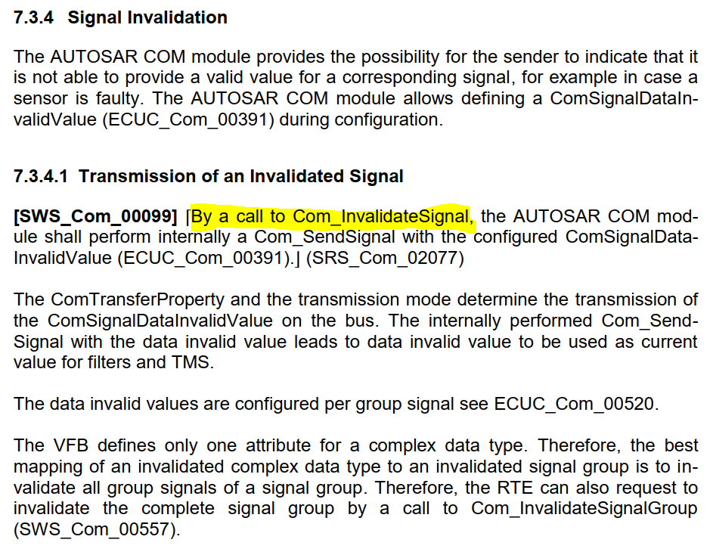

How the application can notify the RTE about invalid signal, so that RTE calls “**Com_InvalidateSignal**”?

