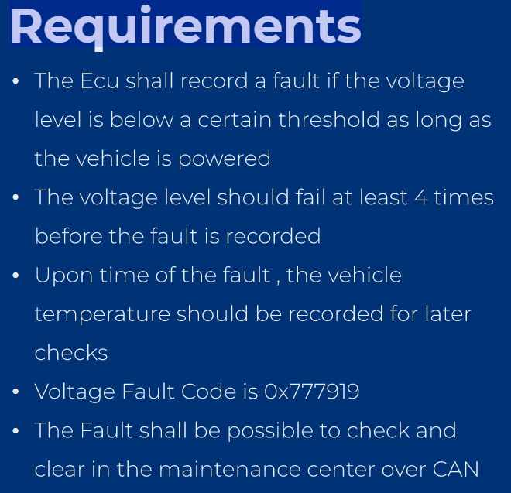

**Req_1:** The ECU Shall record a fault if the voltage level is below a certain threshold as long as the vehicle is powered.

**Analysis:**

* Monitored unit: the voltage level
* Monitoring result to be considered in the **PowerCycle**

**Configs:**

Dem🡪 DemGeneral🡪DemOperationCycles🡪 **PowerCycle**

|  |  |
| --- | --- |
| name | PowerCycle |
| Operation Cycle Type | DEM_OPCYC_POWER |

**Req_2:** The voltage level should fail at least four times before the fault is recorded.

**Analysis:**

* Debouncing counter = 4 times

**Configs:**

* Dem🡪 DemConfigSet🡪 DemEventParameters🡪 VoltageMonitor_Event

|  |  |
| --- | --- |
| DemDebounceAlgorithmClass | DemDebounceCounterBased |
| Counter Decrement Step Size | 1 |
| Counter Failed Threshold | 4 |
| Counter Increment Step Size | 1 |
| Counter Passed Threshold | 4 |
| Counter Jump Down | True |
| Jump Down Value | 0 |
| Counter Jump Up | True |
| Jump Up Value | 0 |
|  |  |

**Req_3:** Upon time of the fault, the vehicle temperature should be recorded for later checks

**Analysis:**

* Freeze Frame Data: the vehicle temperature

**Configs:**

* Dem🡪 DemGeneral🡪 DemDataClass🡪 VehicleTemperature_DataElement
* Dem🡪 DemGeneral🡪 DemDidClass🡪 DID_ VehicleTemperature

|  |  |
| --- | --- |
| name | DID_ VehicleTemperature |
| ID | Ox55 |
| DemDataClass Reference | Ref. to VehicleTemperature_DataElement |

* Dem🡪 DemGeneral🡪DemFreezeFrameClass 🡪 VehicleTemperature_Frame

|  |  |
| --- | --- |
| name | VehicleTemperature_Frame |
| Did Class Reference | Ref. to DID_ VehicleTemperature |

**Req_4:** The Fault code is 0x777919

**Analysis:**

* DTC number: 0x777919

**Configs:**

* Dem🡪DemConfigSet🡪 DemDTCClass🡪 DTC_0x777919_VoltageMonitor

|  |  |
| --- | --- |
| name | DTC_0x777919_VoltageMonitor |
| Uds DTC | 0x777919 |

**Req_5:** The Fault shall be possible to check and clear in the maintenance center over CAN.

**Analysis:**

* We must use following UDS services over CAN
  + Read DTC Information (0x19)
  + Clear Diagnostic Information (0x14)

**Configs:**

**DcmDsl:**

1. Dsl Protocl ID : DCM_UDS_ON_CAN
2. Dsl Protocol SID Table : Reference to Service Table in DSD

**DcmDsd:**

1. DcmDsdServiceTable
   1. DcmDsdServices
      1. ClearDiagInfo:
         1. Service ID: 0x14
         2. Session References: Extended Sessions
      2. ReadDTCInformation:
         1. Service ID: 0x19
         2. Session References: Extended Sessions