SEMESTER PROJECT PROPOSAL
CareerCompass
An Explainable, Multi-Stakeholder Career Consultation Platform
Item | Details
Student | M. Abdullah Hussain
Student ID / Section | F-24-BSSE-099 / Section 5B
Program | BS Software Engineering, 5th Semester
University | Foundation University Islamabad
Course | Scd Lab
cd | Individual semester project
Submission | Project Proposal and Presentation
Date | 5 October 2026

1. Background and Introduction
Choosing a degree, a specialization or a first career direction is one of the most consequential decisions a student makes. Many students in Pakistan make this decision using family expectations, peer influence or merit-list outcomes, with little structured assessment of their own interests, skills and the job market. Professional career counsellors exist, but access is limited by cost, location and availability.
CareerCompass is a web-based career consultation platform that brings the whole guidance journey into one system: a structured self-assessment (Holland RIASEC interests, skill ratings and academic profile), a hybrid recommendation engine that ranks suitable careers with a visible explanation, a skill-gap analysis with a learning roadmap, and booking of sessions with human counsellors. Administrators and industry experts keep the career knowledge base accurate and current.
The system serves four stakeholder groups (students, counsellors, administrators and industry experts) and is designed to balance personalised accuracy, transparency, privacy and usability.

2. Problem Statement
Students who need career guidance face four connected problems:
- Generic guidance: free online assessments are built around foreign job markets and give a list of occupations without considering the student's degree, semester or skills.
- No explanation: results rarely show why a career was suggested, so students cannot judge whether to trust the result.
- No path forward: job portals list vacancies, but nothing tells a student which skills are missing or what to learn first.
- Limited human support: counsellors are scarce, and booking depends on phone calls or personal contacts.
Problem to solve: There is no single accessible system that takes a student from self-assessment to explained career recommendations, to a concrete skill roadmap, to a booked human consultation, while protecting the student's data and serving every stakeholder's needs.

3. Complex Computing Problem (CCP) Justification
This project is not a form-and-database website. Its complexity comes from the modelling, the trade-offs, the number of stakeholders and the consequences of wrong output. The table below lists each characteristic that genuinely applies, with project-specific evidence. "Familiarity of issues" is not claimed, because career guidance itself is a well-known problem domain.
CCP characteristic | Why it applies | Project-specific evidence
1. Depth of knowledge | Requires advanced concepts beyond a textbook CRUD application. | Psychometric scoring of the Holland RIASEC model (scale normalisation to 0-100).  Hybrid recommender: vector representation of students and careers, cosine similarity, rule-based eligibility filters, weighted scoring.  Cold-start handling for new users with no history.  Explainability: per-recommendation factor contributions.  Evaluation with precision@k, nDCG and user-rated relevance.
2. Conflicting requirements | Several requirements compete and must be balanced. | Personalisation vs privacy: richer data gives better matches but increases exposure; mitigated by optional fields and data minimisation.  Accuracy vs explainability: complex models score better but are harder to explain; compared experimentally.  Assessment depth vs completion rate: more questions improve reliability but cause drop-off; capped at 15 minutes.  Instant self-service vs human depth: automated results are fast, counsellors are scarce; handled by consent-based sharing and booking.
3. Depth of analysis | There is no single correct career for a student; the problem is not fully defined. | Must decide which attributes describe a career (interests, skills, degree eligibility, market demand).  Three scoring alternatives will be compared: interest-only, skill-only and hybrid.  Selection criteria: relevance rating by pilot users, top-5 hit rate, explanation clarity and response time.
4. Extent of stakeholder involvement | Four groups with different needs, permissions and expectations. | Students want fast, private results.  Counsellors want relevant student context but only with consent.  Administrators want data quality and analytics.  Industry experts want to contribute career data without direct publishing rights (see Table 3.1).
5. Interdependence | Several sub-systems pass data to one another. | Assessment output feeds the recommender.  Recommender output feeds skill-gap analysis and the counsellor view.  Authentication and RBAC control every module.  Admin-approved career data changes recommendations system-wide.
6. Consequences | Wrong output can have lasting personal impact. | A mismatched recommendation can influence degree or specialization choice, costing years and tuition.  Biased scoring (for example by gender) would be unfair; gender is excluded as a model input.  A data leak would expose sensitive academic and personal information; mitigated by hashing, HTTPS, RBAC and account deletion.
Table 3.0: CCP characteristics claimed and evidence

3.1 Stakeholder analysis
Stakeholder | Main needs | Access | Possible conflict
Student | Fast, accurate, explained recommendations; roadmap; easy booking; privacy. | Own data only; can delete account. | Wants privacy, but counsellors need context.
Counsellor | View student results; manage availability; record session notes. | Student results only after student consent for that booking. | Wants full profile; student wants minimum sharing.
Administrator | Accurate career data; user management; analytics. | Full system access except raw passwords. | Wants more data collected for analytics; privacy limits it.
Industry expert | Submit updates on skills and trends for their field. | Submit only; publication needs admin approval. | Wants quick publishing; admin needs quality control.
Table 3.1: Stakeholder needs, permissions and conflicts

4. Business Objectives and Preliminary Requirements

4.1 Business objectives
ID | Objective
BO-1 | Provide a free career assessment that students can complete online at any time.
BO-2 | Give every student a ranked list of careers with a visible reason for each match.
BO-3 | Show students the skills they lack for a chosen career and an ordered plan to acquire them.
BO-4 | Let students book a counsellor session in no more than four steps.
BO-5 | Reach a pilot-user relevance rating of at least 4 out of 5 for at least 70% of participants (target, 20 or more pilot users).
Table 4.1: Business objectives

4.2 Functional requirements
Requirements are written to be specific, testable and measurable, avoiding vague verbs and conditionals, as recommended in the lab manual. Priority: M = Must, S = Should.
ID | Requirement | Priority
FR-1 | The system shall allow a visitor to register with a unique email address and a password of at least 8 characters. | M
FR-2 | The system shall assign exactly one role (Student, Counsellor, Administrator or Industry Expert) to each account. | M
FR-3 | The system shall present a 48-item RIASEC interest questionnaire (8 items per type) rated on a 5-point scale. | M
FR-4 | The system shall calculate a score from 0 to 100 for each of the six RIASEC types when the questionnaire is submitted. | M
FR-5 | The system shall let a student rate at least 10 listed skills from 1 to 5. | M
FR-6 | The system shall store degree program, semester and CGPA as optional student profile fields. | S
FR-7 | The system shall generate a ranked list of the top 10 careers within 3 seconds after assessment completion. | M
FR-8 | The system shall display a match score from 0 to 100 percent for each recommended career. | M
FR-9 | The system shall display the top 3 factors that contributed to each career's match score. | M
FR-10 | The system shall list the skills for which the student's rating is below the career's required level. | M
FR-11 | The system shall generate an ordered learning roadmap with one milestone per missing skill, using curated resources. | S
FR-12 | The system shall let a counsellor publish availability slots of 30 minutes. | M
FR-13 | The system shall let a student book an available slot and shall reject a second booking of the same slot. | M
FR-14 | The system shall show an in-app notification to both parties within 1 minute of a booking. | S
FR-15 | The system shall show a student's assessment results to a counsellor only after the student grants consent for that booking. | M
FR-16 | The system shall let an industry expert submit a career data update that remains unpublished until an administrator approves it. | S
FR-17 | The system shall let an administrator add, edit and deactivate career entries. | M
FR-18 | The system shall show administrators the number of completed assessments, the 10 most recommended careers and the average feedback rating. | S
FR-19 | The system shall let a student mark each recommendation as relevant or not relevant. | M
FR-20 | The system shall delete all of a student's personal and assessment data when the student requests account deletion. | M

4.3 Non-functional requirements
ID | Attribute | Requirement
NFR-1 | Performance | The recommendation page shall load within 3 seconds for 95% of requests with 50 concurrent users.
NFR-2 | Security | The system shall store passwords as bcrypt hashes, serve all traffic over HTTPS and expire access tokens after 30 minutes.
NFR-3 | Authorization | A student account shall receive an access-denied response when requesting another student's data (verified by negative tests).
NFR-4 | Privacy | The system shall not collect national ID numbers; phone number shall be optional.
NFR-5 | Usability | At least 80% of first-time test users shall complete the assessment without assistance in 15 minutes or less.
NFR-6 | Availability | The deployed instance shall be available at least 99% of the time during the evaluation period.
NFR-7 | Maintainability | Career data and scoring weights shall be editable through the admin interface without a code change.
NFR-8 | Compatibility | The interface shall work on the latest versions of Chrome, Edge and Firefox and on screens 360 px wide or larger.
NFR-9 | Fairness | The recommendation model shall not use gender as an input feature.

4.4 Scope boundaries
- In scope: web application, assessment, hybrid recommender, skill-gap roadmap, counsellor booking, admin and expert modules.
- Out of scope for this semester: video calling, payments, mobile app, and deep-learning collaborative filtering (needs outcome data that does not yet exist; a candidate extension for the Final Year Project).

5. Current Situation and Opportunity Statement
Current problem | Effect on the student | Opportunity (proposed solution)
Assessments are generic and foreign-market oriented. | Suggested careers may not match local degrees or jobs. | Career knowledge base tailored to Pakistani degree programs and local roles.
Results are unexplained. | Low trust; the student cannot act on the result. | Top 3 contributing factors shown for every match.
Job portals show vacancies, not skill gaps. | The student does not know what to learn. | Skill-gap list and ordered learning roadmap.
Counsellors are hard to reach. | Delay or no guidance at all. | Online availability slots and booking in four steps.
Career data goes out of date. | Advice based on old information. | Industry expert updates with admin approval.

6. Benchmarking with Existing Systems and Literature

6.1 Comparison with existing systems
The systems below were compared on publicly visible features. Ratings should be re-verified against each website before final submission.
System | Interest test | Personal ranking | Explains why | Skill gap | Human counsellor | Local (PK) fit | Cost
O*NET Interest Profiler / My Next Move (US Dept. of Labor) | Yes | Yes | Partial | No | No | No | Free
LinkedIn Career Explorer | No | Partial | Partial | Partial | No | Partial | Free / paid tiers
Rozee.pk (job portal) | No | No | No | No | No | Yes | Free for seekers
ADPList (mentorship platform) | No | No | No | No | Yes | Partial | Free / paid tiers
CareerCompass (proposed) | Yes | Yes | Yes | Yes | Yes | Yes | Free

Finding: each existing system covers one part of the journey. None combines an interest assessment, explained personalised ranking, skill-gap roadmap and human counsellor booking for the local context. This is the gap CareerCompass addresses.

7. Options and Recommendations
Option | Description | Advantages | Disadvantages | Verdict
A. Static questionnaire | Fixed quiz that maps answers to a career list using if-else rules. | Fast to build; low risk. | Not personalised; little analysis; weak CCP justification. | Rejected
B. Hybrid recommender with explanation and booking | RIASEC + skill vectors, cosine similarity, eligibility rules, weighted score, gap analysis, counsellor booking. | Meets all objectives; explainable; achievable alone in one semester; supports CCP evidence. | Weights need tuning; career data must be curated manually. | Recommended
C. Deep-learning collaborative filtering | Neural model trained on student-career outcome history. | Potentially higher accuracy over time. | No outcome dataset exists; hard to explain; high risk for one semester. | Future work
Recommendation: Option B. It delivers a working, explainable system within the semester and keeps the architecture open for Option C as a Final Year Project extension once real feedback data has been collected through FR-19.

8. Proposed System: Features and Architecture

8.1 Main features
- Assessment: RIASEC interest questionnaire, skill self-rating and optional academic profile.
- Recommendation engine: top 10 careers with a 0-100 match score and the top 3 reasons.
- Skill-gap and roadmap: missing skills against a chosen career, with ordered learning milestones.
- Counsellor booking: availability slots, double-booking prevention, notifications and consent-based sharing of results.
- Admin and expert tools: career data management, approval workflow and analytics dashboard.
- Feedback loop: relevant / not relevant marking that feeds evaluation and later model improvement.

8.2 System architecture
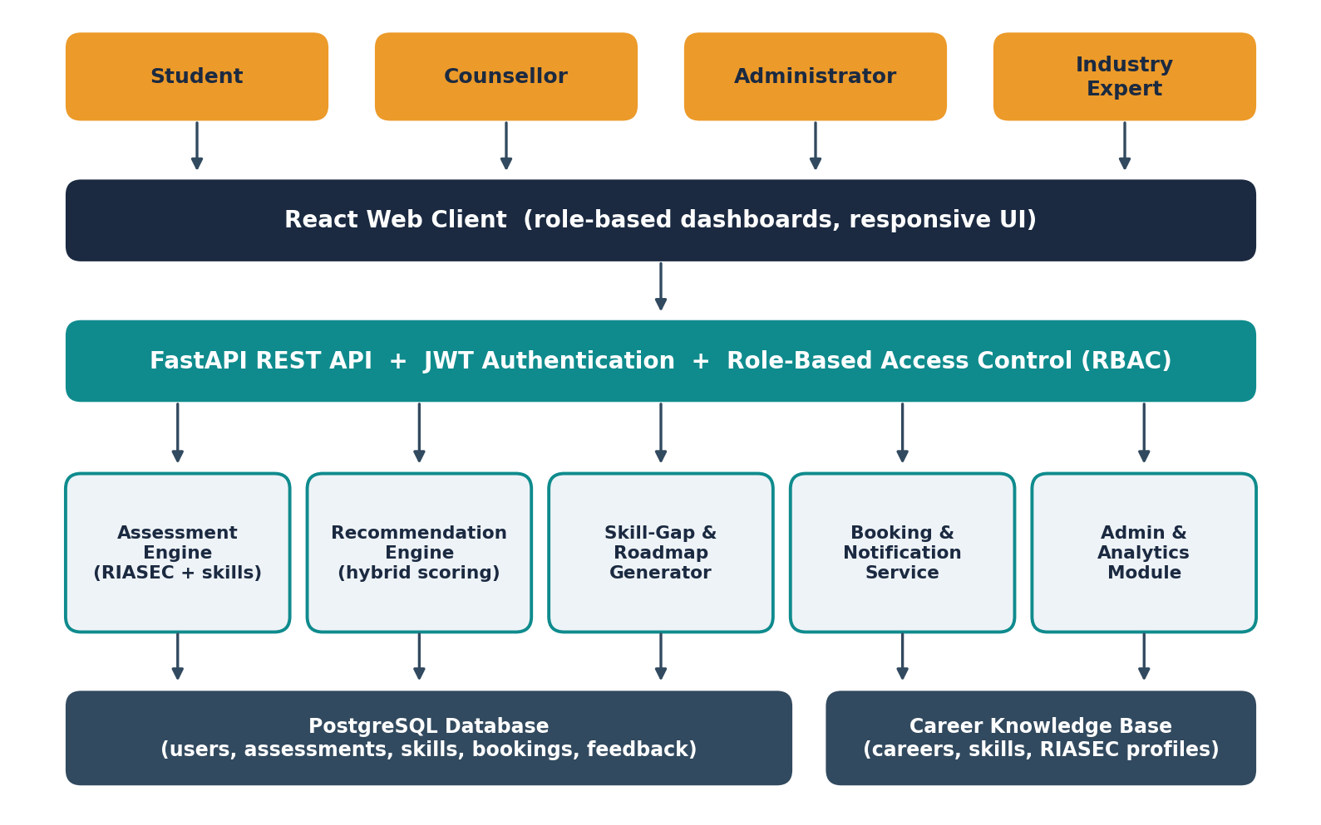
Component dependencies: the React client talks only to the REST API. The API checks the user's token and role before calling any module. The assessment engine writes scores to the database; the recommendation engine reads those scores and the career knowledge base to produce ranked results; the skill-gap generator reads the selected career and the student's skill ratings; the booking service reads the student's consent flag before exposing results to a counsellor.

8.3 Recommendation approach
Each student is represented as a vector of six RIASEC scores plus skill ratings. Each career has a RIASEC profile, required skill levels and eligible degree programs. The match score is a weighted combination:
Match = w1 x InterestSimilarity + w2 x SkillCoverage + w3 x DegreeEligibility
InterestSimilarity is the cosine similarity between the student's and the career's RIASEC vectors. SkillCoverage is the share of required skill level the student already meets. DegreeEligibility is a rule-based filter or penalty. Weights are stored in the database and can be changed by an administrator (NFR-7). The top 3 terms with the largest contribution form the explanation shown to the student.

8.4 Evaluation approach
- Pilot with at least 20 students from the department; each rates the top 5 recommendations from 1 to 5.
- Compare interest-only, skill-only and hybrid scoring on precision@5 and average relevance rating.
- Measure response time (NFR-1) and assessment completion time (NFR-5).
- Run security checks: access-denied tests across roles (NFR-3) and an OWASP Top 10 review checklist.

9. Tools and Technologies
Layer | Technology | Purpose
Frontend | React, Vite, Tailwind CSS, Recharts | Responsive role-based dashboards and result charts.
Backend | Python, FastAPI, SQLAlchemy, Pydantic | REST API, validation and business logic.
Data and ML | PostgreSQL, pandas, NumPy, scikit-learn | Storage, career dataset preparation, similarity scoring and evaluation.
Security | JWT, bcrypt, HTTPS, RBAC middleware | Authentication, password protection and authorization.
Design and testing | Figma, Postman, pytest | Wireframes, API testing and unit tests.
DevOps | Git and GitHub, Docker, free-tier cloud hosting | Version control, reproducible builds and deployment for demo.

10. Schedule Estimate
Estimated completion time: 14 weeks (one semester).
Phase | Weeks | Deliverable
1 | Weeks 1-2 | Requirements finalised, proposal and presentation submitted.
2 | Weeks 3-4 | Architecture, ER diagram, UI wireframes and career dataset structure.
3 | Weeks 5-6 | Database, authentication and role-based access control working.
4 | Weeks 7-8 | Assessment module and career knowledge base (initial 40+ careers).
5 | Weeks 9-10 | Recommendation engine with explanations; comparison of three scoring variants.
6 | Weeks 11-12 | Skill-gap roadmap, counsellor booking, admin and expert modules.
7 | Week 13 | Testing, security checks and pilot evaluation with 20+ students.
8 | Week 14 | Final report, deployment and demonstration.

11. Potential Risks and Mitigation Plan
Risk | Likelihood | Impact | Mitigation (Plan B)
Career data is incomplete or inaccurate | Medium | High | Start with 40 well-researched careers; admin and expert review workflow; cite sources for each entry.
Too few pilot users | Medium | Medium | Recruit from several sections early; fall back to evaluation with smaller n and report the limitation.
Scope too large for one developer | High | High | Build Must requirements first; Should requirements (FR-11, FR-14, FR-16, FR-18) are dropped first.
Biased or unreliable recommendations | Medium | High | Exclude gender from the model; show explanations; add a disclaimer and a counsellor referral option.
Security flaw or data leak | Low | High | bcrypt, HTTPS, RBAC, negative tests, no sensitive identifiers collected, account deletion.
Hosting or deployment problems | Medium | Low | Containerise with Docker; keep a local demo build ready.
Assessment too long, users drop off | Medium | Medium | Cap at 15 minutes; allow saving progress; test with first users and shorten if needed.

