SMART PUBLIC TRANSPORT
ANALYTICS DASHBOARD
A Power BI Business Intelligence Dashboard Project
INTERNSHIP PROJECT REPORT
Data Analytics Internship Program
Prepared By
Abdullah Javed
Data Analytics Intern
Reference ID:
TC-INT-18991230-740
Submitted to:
TEYZIX CORE Internship Program
Submission Date: July 7, 2026
Tool Used: Power BI Desktop

Table of Contents
Table of Contents 2
2. Executive Summary 2
3. Project Overview 4
4. Project Objectives 5
5. Tools and Technologies 6
6. Dataset Description 7
7. Data Preparation 8
8. Data Model 10
9. DAX Measures 11
10. Dashboard Design Principles 12
11. Dashboard Walkthrough 13
12. Interactive Features 16
13. Business Insights 18
14. Business Recommendations 20
15. Challenges Faced 21
16. Future Enhancements 22
17. Conclusion 23
Appendix A: Supporting Data Visualizations 23

2. Executive Summary
Public transport networks generate large volumes of operational data every day, covering routes, trips, revenue, passenger movement, and vehicle performance. In most transit organizations, this data remains scattered across separate systems and spreadsheets, making it difficult for management to obtain a consolidated view of performance. The Smart Public Transport Analytics Dashboard was built to close this gap by converting raw operational data into a structured, interactive reporting tool built on Power BI Desktop.
The core business problem addressed by this project is the lack of visibility into route-level and operator-level performance. Transport managers typically rely on manual reports that are time-consuming to prepare and offer limited ability to drill into specific routes, cities, or time periods. Delays, occupancy issues, and revenue leakage often go unnoticed until they accumulate into larger operational problems.
To resolve this, the dashboard consolidates trip-level data — including route information, operator details, passenger counts, revenue, delay minutes, occupancy percentage, fuel consumption, and weather conditions — into a single connected data model. Power Query was used to clean and standardize the raw dataset, while DAX measures were built to calculate key performance indicators such as total revenue, average delay, completion rate, and average occupancy.
The final solution is delivered across three dedicated dashboard pages: an Executive Summary Dashboard for high-level monitoring, a Route Performance Dashboard for route and operator comparison, and an Operations Analysis Dashboard for traffic, weather, and fuel-related analysis. Each page supports slicers, cross filtering, drill down, drill through, and tooltip-based exploration, allowing users to move from a summary view to a granular one without leaving the report.
The dashboard enables management to identify high-performing and underperforming routes, understand the operational impact of weather conditions, monitor fuel efficiency trends, and track service completion rates in real time. As a result, decisions that previously depended on manual data compilation can now be made directly from live visuals, reducing reporting turnaround time and improving the accuracy of operational planning.
Based on the consolidated dataset of 620 trips across ten Pakistani cities and eight operators, the network generated total ticket revenue of PKR 8.8 million from approximately 16,228 passengers, at an average delay of 27.6 minutes, average occupancy of 61.2 percent, and an overall trip completion rate of 87.1 percent. These figures form the baseline KPIs surfaced on the Executive Summary Dashboard.
From a business value perspective, the project demonstrates how a well-structured Power BI solution can support data-driven decision-making in the transport sector — improving route efficiency, controlling operating costs, and enhancing passenger service levels.

3. Project Overview

3.1 Why Transport Analytics Matters
Public transport systems operate under continuous pressure to balance service quality with operating cost. Every trip generates data on ridership, revenue, delays, and fuel usage, and this data holds direct insight into where the network is performing well and where it is not. Without structured analysis, transport operators are left reacting to complaints and breakdowns rather than anticipating them.

3.2 Common Operational Challenges
- Inconsistent on-time performance across routes and operators.
- Uneven passenger demand leading to overcrowding on some routes and underutilization on others.
- Rising fuel costs with limited visibility into consumption patterns.
- Weather-related disruptions that are not tracked systematically.
- Revenue leakage caused by low occupancy or cancelled trips.
- Manual, spreadsheet-based reporting that is slow and error-prone.

3.3 Why Business Intelligence Helps
Business Intelligence tools convert transactional trip data into structured insight by combining data cleaning, relational modeling, and calculated metrics into a single reporting layer. Rather than reviewing raw records, decision-makers interact with pre-calculated KPIs and visuals that update automatically as new data is loaded. This shortens the distance between data collection and decision-making.

3.4 Why Dashboards Support Decision-Making
Dashboards present multiple KPIs and trends on a single screen, allowing managers to scan performance at a glance and then filter into specific routes, cities, or time periods when something requires attention. Compared with static reports, an interactive dashboard lets different stakeholders — operations managers, finance teams, and route planners — explore the same underlying data from their own perspective without requesting a separate report each time.

4. Project Objectives
The dashboard was designed around a defined set of business objectives rather than as a generic data exploration exercise. Each objective below maps directly to a KPI or visual within the final report.
- Monitor overall operational performance through consolidated KPIs covering revenue, passengers, delays, and completion rate.
- Analyze revenue generation across routes, operators, and cities to identify high- and low-earning segments.
- Track passenger volumes to understand demand patterns and route popularity.
- Monitor vehicle occupancy to detect overcrowding and underutilization.
- Analyze delay patterns and their root causes, including weather conditions.
- Improve route efficiency by comparing performance metrics across similar routes.
- Support management decision-making with a single, reliable source of operational truth.
- Reduce dependency on manual, spreadsheet-based reporting cycles.

5. Tools and Technologies
The project relies on a compact but complete Power BI toolchain — spanning data preparation, modeling, and geographic visualization — rather than a mix of unrelated platforms. This keeps the solution maintainable and easy to hand over to another analyst.
Tool | Purpose in This Project
Power BI Desktop | Primary platform used to build the data model, DAX measures, and all three dashboard pages.
Power Query | Used for importing, cleaning, transforming, and standardizing the raw transport dataset before it entered the data model.
DAX (Data Analysis Expressions) | Used to create calculated measures such as total revenue, average delay, occupancy rate, and completion rate.
Microsoft Excel | Used for initial dataset review, quick validation checks, and cross-verification of totals against Power BI outputs.
Bing Maps (Power BI Map Visual) | Used to plot routes and cities geographically, enabling location-based analysis of delays and trip volume.

6. Dataset Description
The dataset used for this project represents daily trip-level operations of a public transport network spanning ten Pakistani cities and eight operators. It combines scheduling, financial, and environmental data points for each trip, allowing performance to be analyzed from operational, financial, and service-quality angles simultaneously.

6.1 Dataset Overview
- Granularity: one row per trip.
- Record volume: The dataset contains 620 trip records representing public transport operations over a simulated one-year period.
- Cities covered: Karachi, Lahore, Islamabad, Rawalpindi, Faisalabad, Multan, Peshawar, Quetta, Sialkot, and Hyderabad.
- Operators covered: Blue Line Transit, Capital Bus Service, City Metro Bus, Green Line Express, National Express PK, Pak Urban Transport, Punjab Transit, and Sindh Rapid Transit.
- Bus types covered: Standard, AC, Mini Bus, Hybrid, and Electric.
- Currency: all fare and revenue figures are recorded in Pakistani Rupees (PKR).
- Time span: continuous daily records across 2025, supporting trend and seasonal analysis.
A dataset preview showing the raw structure — column headers and sample trip rows as loaded into Power BI — belongs here.

6.2 Key Fields
Column | Description
Trip ID | Unique identifier for each recorded trip.
Route ID / Route Name | Identifies the specific route travelled, used for route-level aggregation.
Operator | Transport operator or company responsible for running the trip.
City | City in which the trip took place, used for geographic and regional analysis.
Bus Type | Vehicle category (e.g., standard, articulated, electric), used to compare efficiency across fleet types.
Trip Date / Time | Timestamp of the trip, used to build the date hierarchy and time-based trends.
Passengers Boarded | Number of passengers recorded for the trip, used for demand and occupancy analysis.
Vehicle Capacity | Maximum passenger capacity of the vehicle, used with boarding count to calculate occupancy percentage.
Revenue | Fare revenue generated by the trip.
Delay (Minutes) | Difference between scheduled and actual arrival/departure time.
Weather Condition | Weather recorded at the time of the trip (e.g., clear, rain, fog), used to analyze delay causes.
Trip Status | Indicates whether a trip was completed, delayed, or cancelled.
]Fuel Consumption | Fuel used during the trip, used to evaluate operating cost and vehicle efficiency.

7. Data Preparation
Raw trip data, like most operational exports, contained formatting inconsistencies, missing entries, and mixed data types that had to be resolved before it could support reliable KPI calculation. All cleaning was performed inside Power Query so that the transformation steps remain visible, repeatable, and refreshable whenever new data is loaded.

7.1 Data Import
The dataset was imported into Power BI through Power Query, with each source table loaded into a staging query before being profiled for structural issues using the column quality and column distribution tools.

7.2 Data Type Corrections
Several columns were loaded with incorrect data types — dates stored as text, numeric fields such as revenue and delay recognized as text due to inconsistent formatting, and identifier columns mistakenly typed as numbers. Each column was reassigned its correct type (date, whole number, decimal number, or text) to ensure DAX calculations would evaluate correctly.

7.3 Removing Duplicates
Trip ID was used as the uniqueness key. Duplicate rows, which typically resulted from repeated export cycles, were identified and removed to prevent revenue and passenger counts from being double-counted.

7.4 Handling Missing Values
- Missing delay values were treated as zero, since a blank value represented an on-time trip rather than an unknown one.
- Missing weather entries were replaced with a standardized "Not Recorded" category rather than being left blank.
- Rows with missing revenue or passenger counts, where the trip status indicated cancellation, were retained but flagged, since they carry operational meaning.

7.5 Standardizing Values
Text fields such as city names, operator names, and weather conditions contained inconsistent casing and spacing (for example, "new york" versus "New York"). These were standardized using trimming, capitalization, and value-mapping steps to ensure that grouping and filtering operations in the dashboard produce accurate, non-duplicated categories.

7.6 Creating Calculated Columns
Additional columns were derived within Power Query to support downstream analysis, including an occupancy percentage column (passengers boarded divided by vehicle capacity) and a trip-completion flag derived from the trip status field.

7.7 Date Hierarchy
A dedicated date table was created and marked as the official date table in the model, with Year, Quarter, Month, and Day levels. This enables drill-down navigation across all time-based visuals without relying on the auto date hierarchy generated by Power BI.

7.8 Final Validation
After transformation, row counts, revenue totals, and passenger totals were cross-checked against the original source file in Excel to confirm that no records were lost or duplicated during the cleaning process.
A screenshot of the Power Query Editor, showing the applied steps panel for the main trips table, fits naturally at this point.

8. Data Model

8.1 Tables Used
- Fact_Trips — the central transactional table containing one row per trip, including revenue, passengers, delay, occupancy, and fuel consumption.
- Dim_Route — route reference table containing route name, origin, and destination.
- Dim_Operator — operator reference table containing operator name and details.
- Dim_City — city and regional reference table used for geographic analysis.
- Dim_Date — dedicated date table supporting the date hierarchy and time intelligence.

8.2 Relationships and Primary Keys
Each dimension table connects to Fact_Trips through a single-direction, one-to-many relationship, with the dimension table's unique identifier (Route ID, Operator ID, City ID, Date) acting as the primary key and the corresponding foreign key sitting in the fact table. This mirrors standard star-schema design and keeps filter direction predictable across all visuals.

8.3 Star Schema Design
The model follows a star schema, with Fact_Trips at the center surrounded by the four dimension tables. This structure was chosen over a single flat table because it reduces data redundancy, improves refresh performance, and allows filters applied on any dimension (route, operator, city, or date) to propagate correctly to every visual built on the fact table.

8.4 Why This Model Supports Reporting
Because dimensions are separated from the fact table, slicers built on route, operator, city, or date filter the entire report simultaneously without requiring duplicate logic in each visual. This also keeps DAX measures simpler, since aggregation always happens against a single fact table rather than across multiple overlapping tables.
A screenshot of the Model View, showing the star schema layout and relationship lines between Fact_Trips and its dimension tables, belongs here.

9. DAX Measures
All KPIs displayed on the dashboards are built as explicit DAX measures rather than implicit column aggregations. This keeps calculations centralized, consistent across visuals, and easier to audit or modify without altering the underlying data model.
Measure | Business Purpose
Total Revenue | Sums fare revenue across all trips to track overall financial performance and support route- and city-level revenue comparison.
Total Passengers | Sums passenger boardings across trips to measure ridership demand at network, route, and operator level.
Average Delay | Calculates the mean delay in minutes to monitor on-time performance and flag routes needing schedule review.
Average Occupancy | Calculates mean occupancy percentage to identify overcrowded or underutilized services.
Completion Rate | Calculates the percentage of trips completed versus scheduled, used as a core reliability indicator.
Average Fuel Consumption | Calculates average fuel used per trip to assess vehicle and route-level operating efficiency.
Average Trip Duration | Calculates mean trip duration to support scheduling accuracy and route-planning decisions.
A screenshot of the Measures pane, listing the DAX measures created within Fact_Trips, fits naturally at this point.

10. Dashboard Design Principles
Design decisions throughout the report were guided by usability and business readability rather than visual novelty. Each choice below was made to reduce the time a manager needs to locate and interpret a metric.

10.1 KPI Cards
KPI cards are placed at the top of every dashboard page so that the most critical figures — revenue, passengers, delay, and completion rate — are visible immediately, without requiring the user to interpret a chart first.

10.2 Color Consistency
A single color palette is applied across all three pages, with a consistent color reserved for positive performance, another for warning indicators, and neutral tones for standard values. This allows users to recognize performance status by color alone, even before reading the underlying number.

10.3 Icons
Icons accompany KPI cards and navigation buttons to support faster visual scanning, particularly for reviewers who are not regular Power BI users.

10.4 White Space and Layout
Visuals are deliberately spaced rather than packed edge-to-edge, which prevents the report from feeling cluttered and makes it easier to focus on one chart at a time.

10.5 Logical Visual Grouping
Related visuals are grouped together — for example, revenue and passenger trends are placed side by side, while delay and weather visuals are grouped on the operations page — so that users can compare related metrics without switching pages.

10.6 Interactive Filtering and Navigation
Slicers and navigation buttons are placed in consistent positions across all pages, so that users build a predictable mental model of where to filter and where to move next, regardless of which page they are viewing.

11. Dashboard Walkthrough

11.1 Executive Summary Dashboard
Purpose: Provide senior management with a single-screen view of overall network performance, without requiring navigation into route- or operator-level detail.
Key KPIs displayed:
- Total Revenue
- Total Passengers
- Average Delay
- Completion Rate
Charts included: a revenue trend line by date, a passenger volume trend, and a city-wise revenue comparison chart.
Business value: Gives leadership an immediate read on whether the network is performing within acceptable revenue, ridership, and reliability ranges, without waiting for a periodic report.
User interaction: Users can apply the date slicer to review a specific month or quarter, and cross-filter city-wise charts by clicking directly on a city bar.
Key insight supported: Identification of the periods and cities driving the largest share of network revenue.
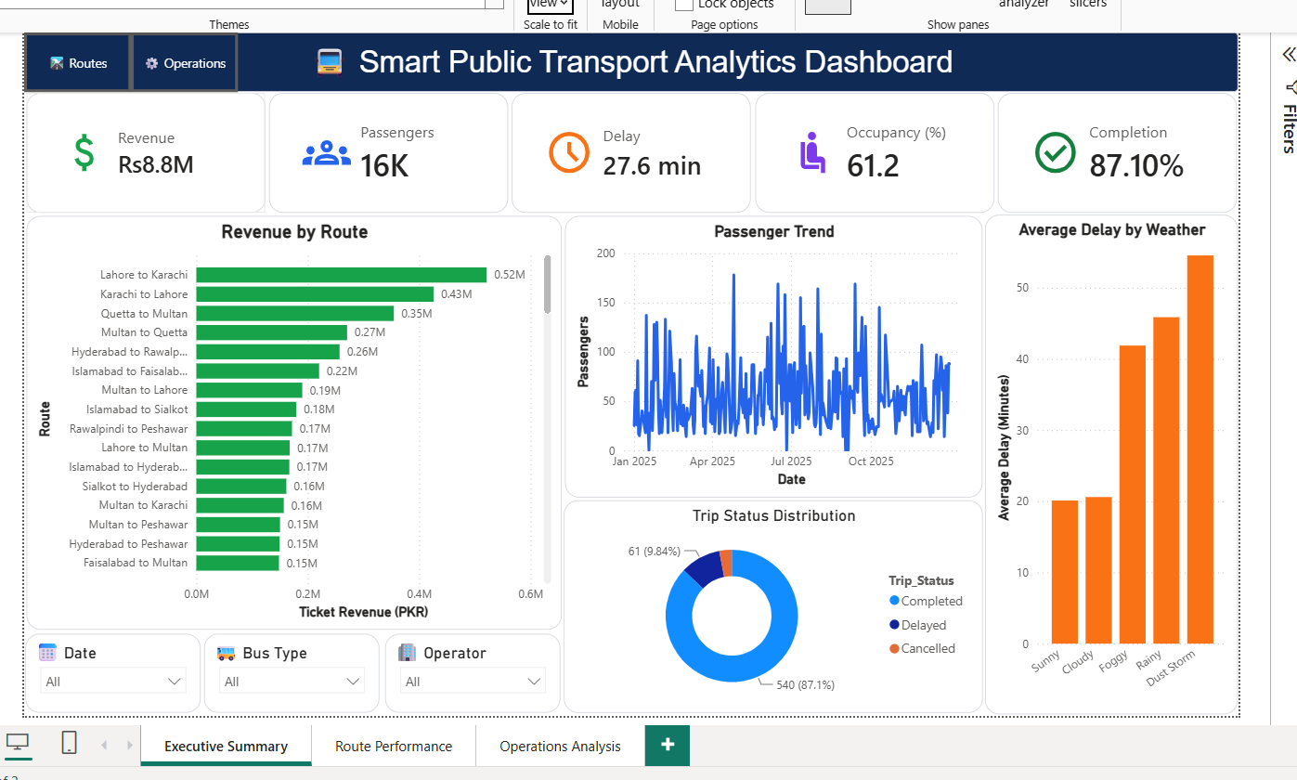
Figure 1: Executive Summary Dashboard — KPI cards, revenue by route, passenger trend, trip status, and delay-by-weather visuals.

11.2 Route Performance Dashboard
Purpose: Allow route planners and operations managers to compare performance across individual routes and operators.
Key KPIs displayed:
- Route-level Revenue
- Route-level Passenger Count
- Average Occupancy by Route
- Average Delay by Route
Route analysis: A ranked bar chart displays routes from highest to lowest revenue, allowing immediate identification of top- and bottom-performing routes.
Operator comparison: A separate visual compares operators on completion rate and average delay, highlighting which operators consistently under-perform.
Business value: Supports decisions on which routes to expand, which to restructure, and which operators may require performance review.
Key insight supported: Clear separation between high-revenue, high-occupancy routes and low-performing routes that may be candidates for schedule adjustment.
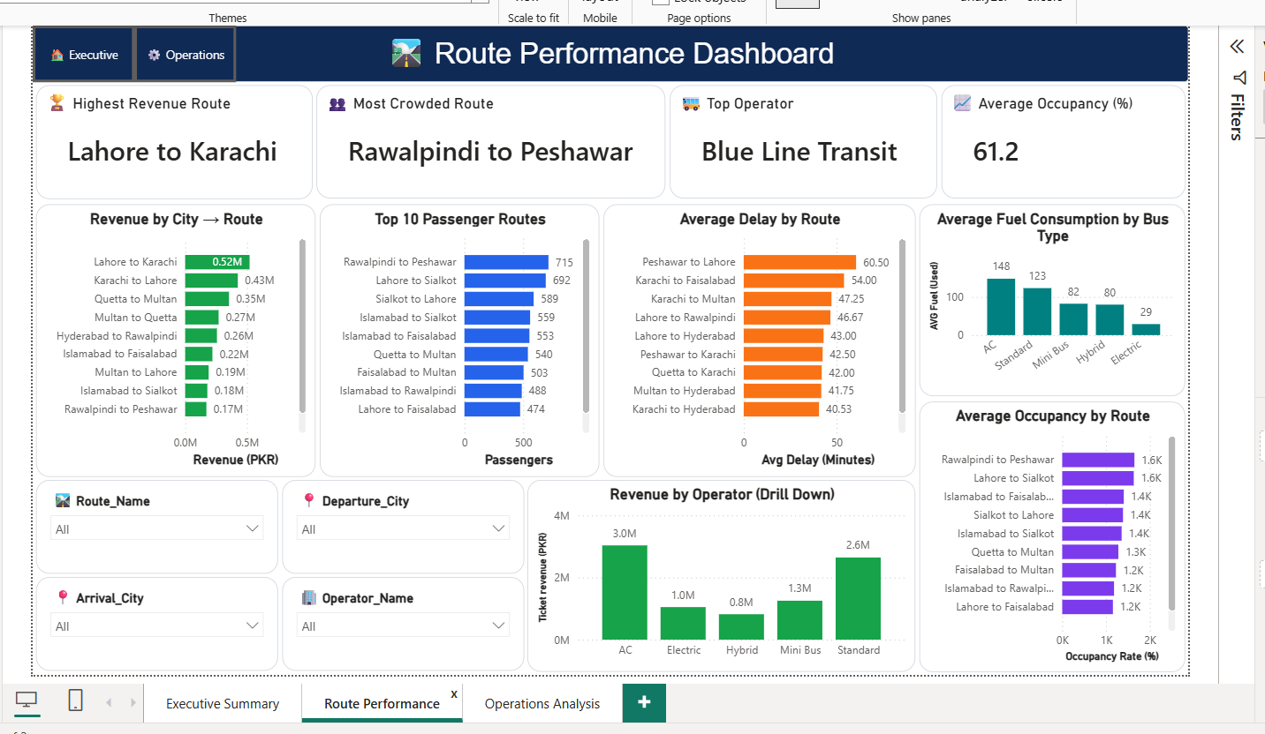
Figure 2: Route Performance Dashboard — highest revenue route, most crowded route, top operator, and route/operator comparison visuals.

11.3 Operations Analysis Dashboard
Purpose: Examine the operational and environmental factors affecting service delivery, including traffic patterns, weather, and fuel usage.
Traffic analysis: A time-of-day chart shows trip volume across peak and off-peak hours, highlighting periods of highest demand.
Weather impact: A comparison chart shows average delay grouped by weather condition, isolating weather as a delay driver from other causes.
Map visualization: A geographic map plots trip volume and average delay by city, allowing quick identification of regions with recurring service issues.
Fuel consumption: A chart compares average fuel consumption by bus type, supporting fleet efficiency evaluation.
Peak travel hours: Hourly trip distribution highlights the specific windows requiring additional vehicle capacity.
Business value: Connects weather, traffic, and fuel data to delay and cost outcomes, supporting more resilient scheduling and fleet planning.
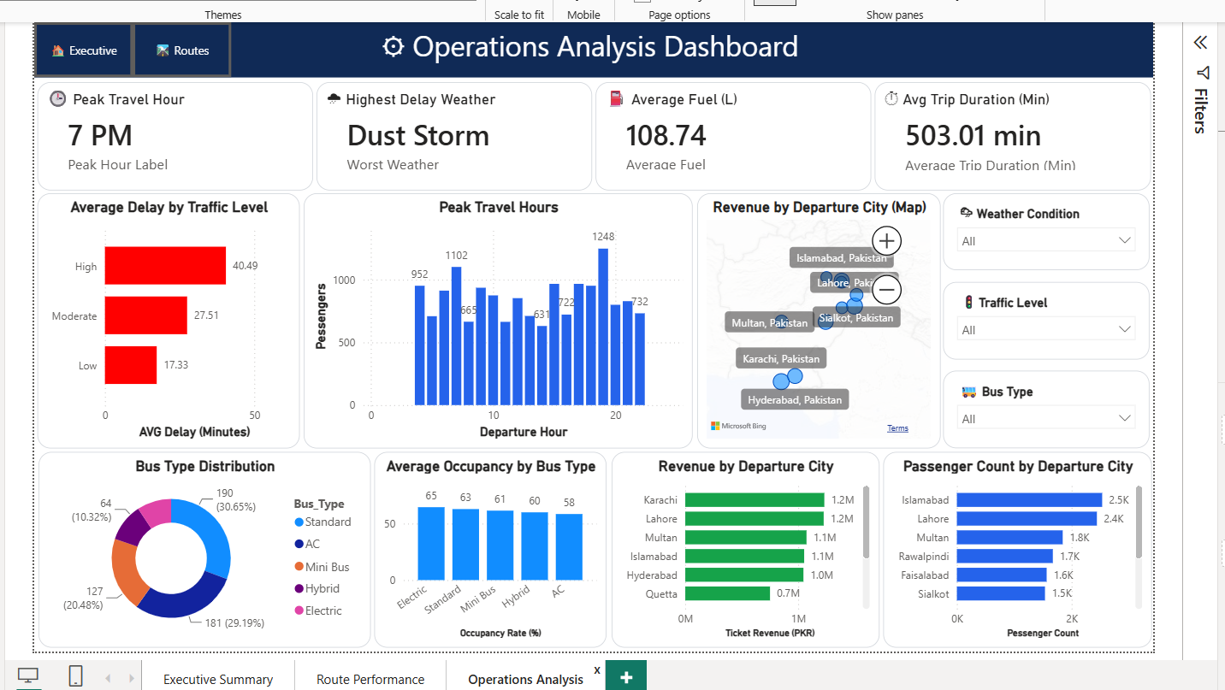
Figure 3: Operations Analysis Dashboard — peak travel hour, weather impact, traffic-delay relationship, and city-level map visualization.

12. Interactive Features

12.1 Cross Filtering
Selecting a data point on one visual automatically filters all related visuals on the same page. This lets a user click a single route or city and instantly see how every other KPI and chart responds, without manually adjusting individual filters.
A cross filtering screenshot, showing a selected city and its effect on related visuals, fits here.

12.2 Slicers
Slicers for date, city, operator, and bus type are placed on each dashboard page, giving users direct control over the scope of analysis without editing the underlying report.

12.3 Drill Down
The date hierarchy allows users to drill from Year down to Quarter, Month, and Day directly within a single visual, supporting both high-level trend review and detailed day-level investigation.
A drill down screenshot, showing the date hierarchy expanded to month level, belongs here.

12.4 Drill Through
A dedicated drill-through page allows users to right-click a specific route on the Route Performance Dashboard and navigate directly to a detailed view filtered to that route alone, avoiding the need to manually re-filter the report.
A drill through screenshot, showing the route detail page reached from the main dashboard, fits here.

12.5 Tooltips
Custom tooltips display additional context — such as operator name, occupancy percentage, and trip count — when a user hovers over a chart element, without requiring extra visuals on the page.
A tooltip screenshot, captured while hovering over a chart data point, belongs here.

12.6 Map Visual
The map visual plots trips geographically by city, using bubble size to represent trip volume and color to represent average delay, giving an immediate spatial view of network performance.

12.7 Navigation Buttons
Custom navigation buttons allow users to move between the Executive Summary, Route Performance, and Operations Analysis dashboards without relying on the default page tabs, giving the report a more guided, application-like feel.

12.8 Why These Features Improve Usability
Together, these features let a single report serve multiple audiences — executives who want a summary view, planners who need route-level comparison, and operations staff who need cause-level detail — without maintaining three separate reports.

13. Business Insights
The following insights were derived directly from the KPIs and visuals within the three dashboard pages. Each is stated in business terms rather than as a raw statistic, reflecting how the finding would be communicated to management.
# | Insight | Business Relevance
1 | Highest revenue route | Lahore to Karachi generates the highest ticket revenue on the network at approximately PKR 0.52 million, making it the single largest contributor to total network income and a priority for schedule protection.
2 | Most crowded route | Rawalpindi to Peshawar records the highest passenger volume (715 trips-worth of boardings) and the highest average occupancy, indicating strong demand and a candidate for additional vehicle capacity.
3 | Top performing operator | Blue Line Transit is flagged as the top operator on the Route Performance Dashboard, combining strong revenue contribution with reliable service, and provides a performance benchmark for other operators.
4 | Weather causing maximum delay | Dust storm conditions are associated with the highest average delay on the network, exceeding 55 minutes, confirming severe weather as the most disruptive environmental factor.
5 | Peak travel hour | Passenger volume peaks at 7 PM (19:00 departure hour), with 1,248 recorded passengers in that hour alone, indicating when additional fleet capacity delivers the greatest service benefit.
6 | Best performing city | Karachi and Lahore lead the network on departure-city revenue, each contributing approximately PKR 1.2 million, making them reference markets for scaling operations elsewhere.
7 | Most efficient bus type | Electric buses record the lowest average fuel consumption at 29 litres per trip, far below AC buses at 148 litres, supporting a case for gradual fleet transition toward electric vehicles.
8 | Average occupancy trend | Network-wide average occupancy stands at 61.2 percent, with the top ten routes by passenger volume ranging between 1.2K and 1.6K in occupancy-rate terms, indicating healthy but not saturated demand.
9 | Fuel usage trend | Fuel consumption scales directly with bus type: AC (148L) and Standard (123L) buses consume markedly more fuel per trip than Hybrid (80L), Mini Bus (82L), and Electric (29L) vehicles.
10 | Completion performance | Overall completion rate is 87.1 percent, with 9.8 percent of trips delayed and 3.1 percent cancelled — a reliability level that is acceptable but leaves room for targeted improvement.
11 | Operational bottlenecks | Peshawar to Lahore records the highest average delay on the network at 60.5 minutes, followed closely by Karachi to Faisalabad, indicating concentrated rather than network-wide scheduling issues.
12 | Traffic-delay relationship | Average delay rises directly with traffic level — from 17.3 minutes under low traffic to 27.5 minutes under moderate traffic and 40.5 minutes under high traffic — confirming traffic congestion as a measurable delay driver.
13 | Passenger demand pattern | Demand is concentrated on a limited set of high-frequency routes such as Rawalpindi to Peshawar and Lahore to Sialkot, while a long tail of routes carries comparatively low ridership below 50 passengers.
14 | Revenue opportunity | Standard and AC bus categories generate the highest revenue by operator (PKR 3.0 million and PKR 2.6 million respectively), suggesting scope to expand these categories on high-demand routes.
15 | Service improvement opportunity | Routes with both high average delay and high occupancy — such as Rawalpindi to Peshawar and Lahore to Sialkot — represent the clearest candidates for near-term schedule or capacity intervention.

14. Business Recommendations
The recommendations below translate the insights in Section 13 into actions that operations and planning teams can evaluate for implementation.
- Review scheduling on low-performing routes identified through completion rate and delay metrics, prioritizing routes with the highest complaint potential.
- Reallocate fleet capacity toward high-occupancy routes to reduce overcrowding without increasing total fleet size.
- Investigate root causes of delay on the routes contributing most to network-wide delay minutes, rather than applying uniform schedule buffers network-wide.
- Introduce targeted promotions on underutilized but reliable routes to improve occupancy and revenue per trip.
- Establish weather-contingency schedules for routes shown to be most sensitive to rain and fog conditions.
- Prioritize fleet renewal or reassignment toward the most fuel-efficient bus type on high-mileage routes.
- Increase preventive maintenance frequency for vehicle categories associated with higher fuel consumption and delay.
- Expand service frequency on consistently high-revenue, high-occupancy routes where demand exceeds current capacity.
- Standardize scheduling practices used by the top-performing operator across other operators in the network.
- Introduce passenger communication measures, such as real-time delay updates, on routes with recurring weather-related disruption.

15. Challenges Faced

15.1 Data Inconsistencies
The raw dataset contained inconsistent text casing, mixed date formats, and occasional blank fields that required careful profiling in Power Query before any measure could be trusted.

15.2 Power BI Modeling
Establishing correct relationship cardinality between the fact table and dimension tables required verification, since incorrect relationship direction initially caused slicers to filter only part of the report.

15.3 DAX Calculations
Measures such as completion rate and average occupancy required careful handling of blank and zero values so that cancelled or incomplete trips did not distort the calculated averages.

15.4 Dashboard Layout Optimization
Balancing KPI cards, charts, and slicers within a single screen without crowding the layout required several rounds of resizing and repositioning across all three pages.

15.5 Visual Alignment
Achieving consistent alignment and spacing across visuals on each page required use of the alignment and distribution tools in Power BI, since default placement is not automatically aligned to a grid.

15.6 Map Configuration
The map visual initially plotted several cities incorrectly due to naming inconsistencies between the dataset and the underlying Bing Maps geocoding service; this was resolved by standardizing city names during data preparation.

15.7 Interactive Filtering Conflicts
Cross filtering and drill-through initially produced conflicting results when applied together on the same page, which was resolved by adjusting interaction settings between specific visuals.

15.8 Performance Optimization
Early versions of the report loaded slowly due to unnecessary calculated columns in the data model; moving calculations into measures rather than columns improved report responsiveness.

16. Future Enhancements
The current dashboard is built on static, periodically refreshed data. The following enhancements represent a natural next stage of maturity for this solution.
- Real-time dashboard refresh using scheduled or streaming datasets.
- Live GPS integration to track vehicle location and delay in real time.
- Predictive delay forecasting using historical trip and weather data.
- IoT sensor integration for real-time fuel and engine performance monitoring.
- Automated alerts for routes breaching delay or occupancy thresholds.
- Deployment to Power BI Service for scheduled refresh and wider organizational access.
- A mobile-optimized dashboard layout for field and operations staff.
- Cloud data warehouse integration to support larger historical datasets.
- Advanced analytics, including route clustering and anomaly detection.
- AI-powered forecasting for passenger demand and revenue planning.

17. Conclusion
The Smart Public Transport Analytics Dashboard consolidates trip-level operational data into a structured Power BI solution that supports route, operator, and network-level decision-making. Through Power Query data cleaning, a star-schema data model, and a focused set of DAX measures, the raw dataset was converted into a reliable source of KPIs covering revenue, ridership, delay, occupancy, and fuel efficiency.
Across the three dashboard pages, the project delivers value to distinct audiences: executives gain a summary view of network health, route planners gain the ability to compare performance across routes and operators, and operations teams gain visibility into weather, traffic, and fuel-related factors affecting service delivery. Interactive features — including slicers, cross filtering, drill down, drill through, tooltips, and map-based visualization — allow each audience to move from summary to detail within the same report.
From a skills perspective, the project demonstrates practical competency across the full Power BI workflow: data import and cleaning, relational data modeling, DAX measure development, dashboard design, and business interpretation of analytical output.
The dashboard, in its current form, already reduces dependency on manual reporting and gives management a faster, more reliable view of operational performance. With the enhancements outlined in Section 16 — particularly real-time data integration and predictive analytics — the solution has a clear path toward becoming a scalable, enterprise-grade transport intelligence platform.

Appendix A: Supporting Data Visualizations
The exploratory charts below were produced during dataset validation and analysis, ahead of dashboard development. They are included to support the KPI values and business insights referenced throughout this report.

A.1 Revenue by Route
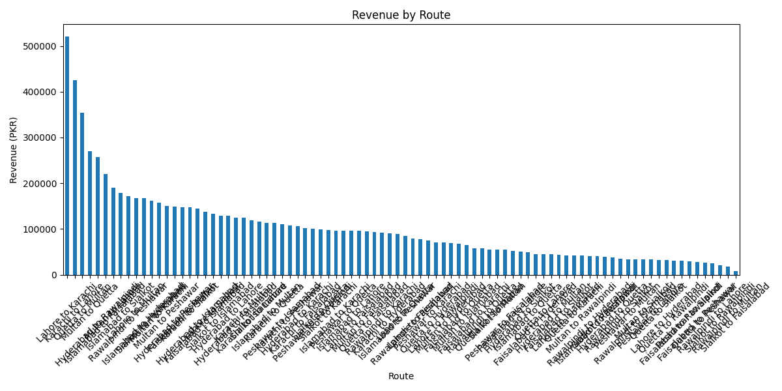
Figure A1: Ticket revenue (PKR) by route across the full network, confirming Lahore to Karachi as the top revenue route.

A.2 Total Passengers by Route
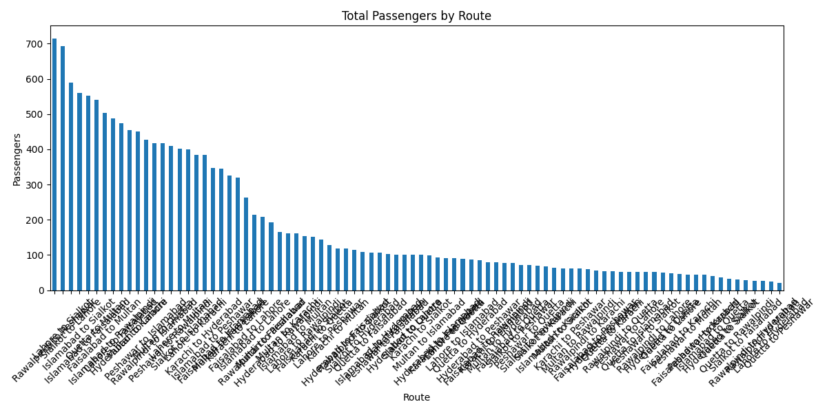
Figure A2: Total passengers by route, confirming Rawalpindi to Peshawar as the most crowded route.

A.3 Passenger Distribution
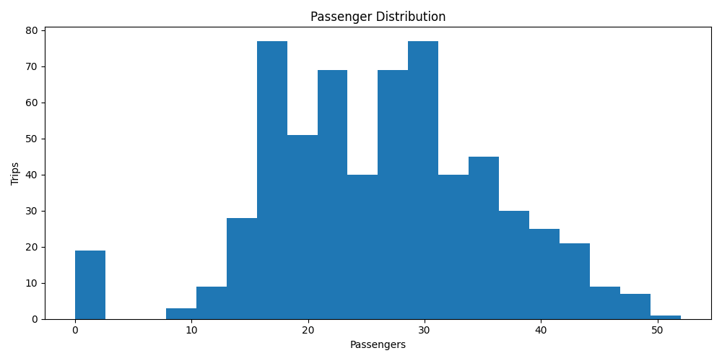
Figure A3: Distribution of passenger counts per trip across the dataset.

A.4 Delay Distribution
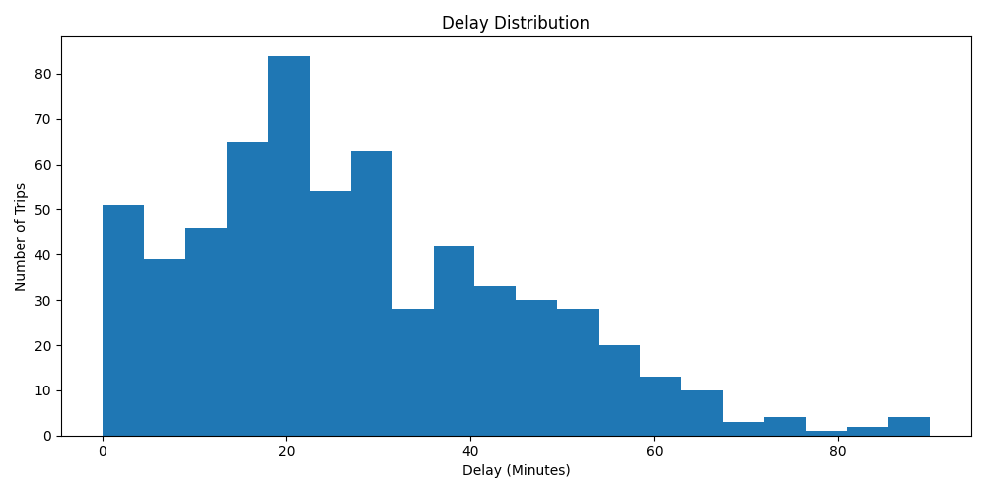
Figure A4: Distribution of delay minutes across all recorded trips.

A.5 Average Fuel Consumption by Bus Type
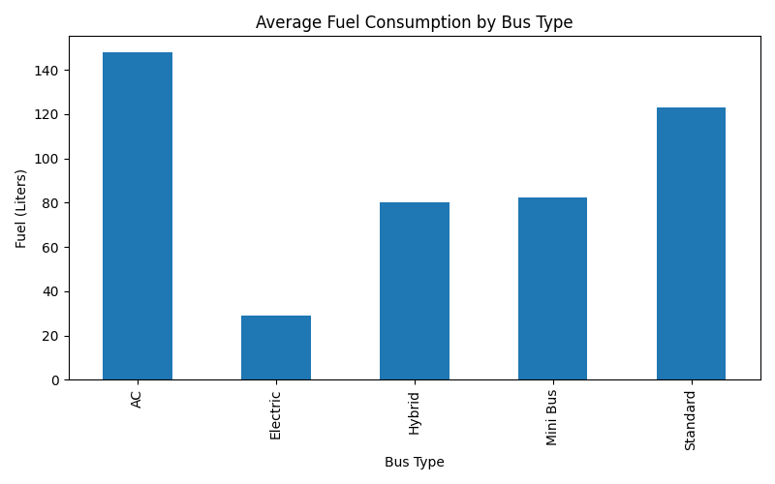
Figure A5: Average fuel consumption (litres) by bus type, confirming Electric as the most fuel-efficient category.

A.6 Average Delay by Traffic Level
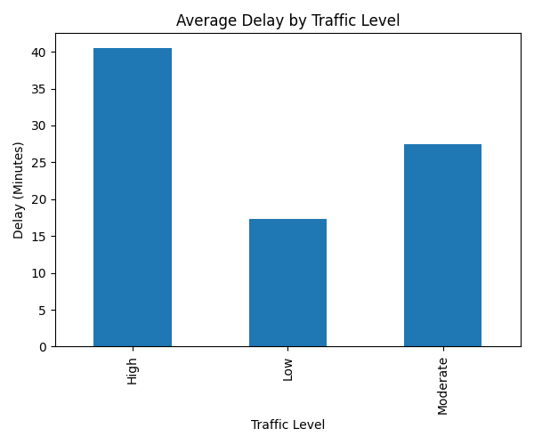
Figure A6: Average delay minutes grouped by traffic level, showing a direct relationship between congestion and delay.

A.7 Trip Status Distribution
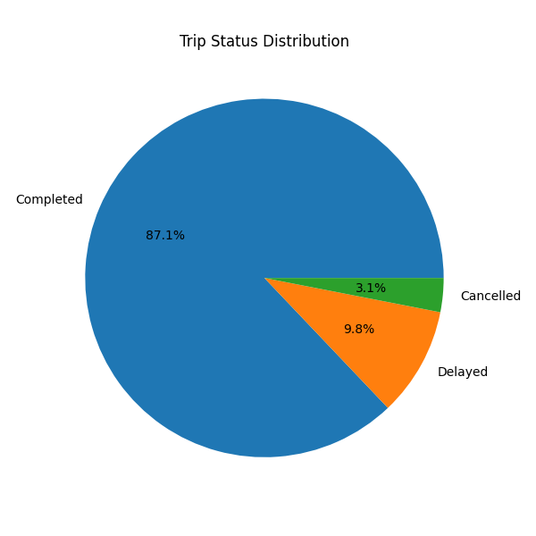
Figure A7: Proportion of completed, delayed, and cancelled trips across the network.

A.8 Trips by Weather Condition
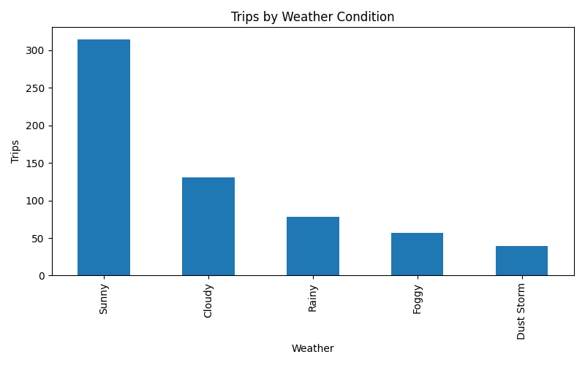
Figure A8: Trip volume by recorded weather condition, used to assess exposure to weather-sensitive conditions.

A.9 Correlation Matrix
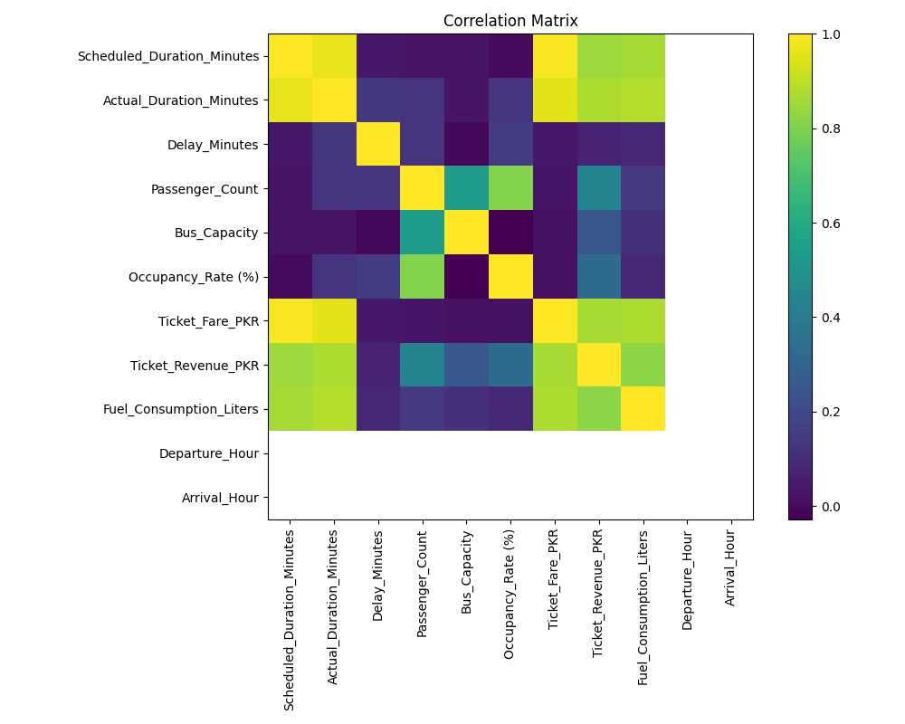
Figure A9: Correlation matrix across numeric trip attributes, used during data preparation to validate relationships between duration, revenue, fuel consumption, and occupancy.

