Retail Business Intelligence Dashboard
Retail Store Sales & Customer Behavior Analysis
Data Analytics Internship Project Report
Prepared by: Data Analyst Intern | Period: January 2025 – December 2025

Executive Summary
This report presents an end-to-end data analytics project built around a retail sales dataset covering 1,489 cleaned transactions recorded across eight major Pakistani cities between January 2025 and December 2025. The project replicates a real-world business intelligence engagement: starting from raw, imperfect transactional data and progressing through cleaning, exploratory analysis, machine learning-based customer segmentation, statistical forecasting, and the delivery of an interactive multi-page dashboard built in Streamlit.
The final deliverable combines a cleaned and validated dataset, a redesigned eight-page interactive dashboard, a K-Means based customer segmentation model validated using the Elbow Method, and a Linear Regression revenue forecasting module.
The analysis generated PKR 14,616,609 in total revenue across 1,489 orders, at an average order value of PKR 9,816. Electronics is the dominant revenue category, the Laptop is the single best-performing product, and Multan — not the larger metro centers — generated the highest revenue of any city. UPI is the most widely used payment method, and the customer base splits into three behaviorally distinct segments: Budget, Regular, and High Value Customers, with Budget Customers forming the largest group by count. A three-month forward revenue forecast points to a stable-to-gradually-increasing trend into the first quarter of 2026.
Collectively, this project demonstrates practical, end-to-end proficiency in data cleaning, exploratory data analysis, data visualization, applied machine learning, dashboard engineering, and business insight generation — skills directly transferable to a professional data analyst role.

Project Overview
Retail businesses generate large volumes of transactional data every day, but raw transaction logs rarely translate directly into business value. This project simulates the analytics function of a retail organization seeking to understand its own sales performance, customer base, and growth trajectory using a structured, repeatable analytical pipeline.
The project was carried out in eight stages:
- Creation of a realistic retail sales dataset spanning multiple cities, categories, and payment methods
- Cleaning and preprocessing of the dataset to remove inconsistencies and ensure analytical reliability
- Exploratory Data Analysis (EDA) to uncover sales trends, product performance, and customer behavior
- Development of an interactive, multi-page Streamlit dashboard for business stakeholders
- Construction of a Customer Segmentation module using K-Means Clustering
- Cluster validation using the Elbow Method to determine the optimal number of customer segments
- Development of a Revenue Forecasting module using Trend-Based Linear Regression
- Synthesis of the above into executive-level business insights and actionable recommendations
Each stage builds on the previous one, mirroring the workflow followed by data analytics teams in real retail and e-commerce organizations — from data engineering through to executive reporting.

Tools & Technologies Used
The project was implemented entirely in Python, using an established data science toolchain selected for its reliability, performance, and suitability for both analysis and deployment.
Tool / Library | Purpose in This Project
Python | Core programming language used for the full analytics pipeline
Pandas | Data cleaning, transformation, aggregation, and feature engineering
NumPy | Numerical operations supporting statistical and ML computations
Plotly | Interactive charts embedded throughout the Streamlit dashboard
Matplotlib | Supplementary static visualizations during exploratory analysis
Scikit-learn | K-Means Clustering, StandardScaler, and Linear Regression modeling
Streamlit | Development of the multi-page interactive web dashboard
VS Code | Primary development environment for scripting and debugging

Machine Learning Techniques Applied
Technique | Application
K-Means Clustering | Unsupervised segmentation of customers into behaviorally distinct groups
StandardScaler | Feature normalization prior to clustering to ensure equal weighting
Linear Regression | Trend-based modeling of historical revenue to forecast future performance

Dataset Description
The dataset represents retail sales transactions collected across eight major cities in Pakistan, spanning a complete twelve-month operating cycle. It reflects realistic retail patterns, including seasonal demand fluctuations, category-level pricing differences, and a mix of online and in-store sales channels.
Attribute | Detail
Total Records (post-cleaning) | 1,489 transactions
Date Range | January 2025 – December 2025
Geographic Coverage | 8 cities (Karachi, Lahore, Islamabad, Rawalpindi, Faisalabad, Multan, Peshawar, Quetta)
Product Categories | 5 categories (Electronics, Fashion, Home & Kitchen, Groceries, Beauty & Personal Care)
Payment Methods | 5 methods (Cash, Credit Card, Debit Card, UPI, Wallet)
Sales Channels | In-Store and Online
Missing Values (final dataset) | 0

Dataset Fields
Each transaction record contains the following fields, providing sufficient granularity for product-level, customer-level, and regional analysis:
Field | Description
Transaction ID | Unique identifier for each sales transaction
Customer ID | Unique identifier used to link repeat purchases to a single customer
Product Category | High-level grouping of the purchased item
Product Name | Specific item sold within a category
Quantity | Number of units purchased in the transaction
Unit Price | Price per unit before discount
Total Amount | Final transaction value after quantity and discount are applied
Purchase Date | Date the transaction occurred
Customer City | City in which the customer is based
Payment Method | Mode of payment used for the transaction
Customer Age | Age of the purchasing customer
Customer Gender | Gender of the purchasing customer
Sales Channel | Whether the sale occurred in-store or online
Discount Percentage | Discount applied to the transaction, if any

Data Cleaning Process
Raw retail data is rarely analysis-ready. Before any exploratory work began, the dataset was passed through a structured cleaning pipeline to ensure that downstream analysis, segmentation, and forecasting were built on a reliable foundation.
Metric | Value
Initial Dataset Size | 1,500 records
Final Dataset Size | 1,489 records
Records Removed | 11 records (0.73%)
Final Missing Values | 0

Cleaning Steps Performed

1. Duplicate Removal
Exact and near-duplicate transaction records were identified using Transaction ID and key attribute matching, then removed. Duplicate entries can artificially inflate revenue and order counts, so eliminating them was essential to ensure all KPIs reflect genuine transaction volume.

2. Missing Value Handling
Missing numerical fields, such as Unit Price and Customer Age, were imputed using the median of their respective distributions, since the median is resistant to the influence of outliers common in pricing and age data. Missing categorical fields, such as Payment Method, were imputed using the mode (most frequent value), preserving the natural distribution of the category rather than introducing an artificial 'unknown' bucket that would distort category-level analysis.

3. Category Standardization
Inconsistent text entries (for example, varying capitalization or spacing in city names and category labels) were standardized into a single consistent format. This step was critical for accurate grouping and aggregation — without it, the same city or category could be counted as multiple distinct entries during analysis.

4. Date Conversion
The Purchase Date field was converted from raw text into a proper datetime format, enabling reliable extraction of month, week, and seasonal features used throughout the EDA and forecasting stages.

5. Validation of Transaction Values
Each transaction's Total Amount was cross-checked against the product of Quantity, Unit Price, and Discount Percentage. Records with mathematically inconsistent totals were corrected or removed, ensuring that all revenue figures reported in this document are internally consistent — city-level revenue, for example, sums exactly to the reported total revenue of PKR 14,616,609.

6. Data Consistency Checks
Final consistency checks confirmed that all categorical fields contained only valid, expected values, and that numerical fields fell within plausible business ranges. The cleaned dataset used in the Data Explorer module contains 1,489 rows, 15 columns, and zero missing values.
Together, these steps improved the reliability, consistency, and analytical integrity of the dataset, ensuring that every downstream metric — from average order value to cluster assignment — is built on trustworthy data.

Exploratory Data Analysis (EDA)
With a clean dataset in place, exploratory analysis was conducted to surface patterns in sales performance, product demand, and customer behavior. Each analysis combines a quantitative technique with a business interpretation, rather than treating EDA as a purely descriptive exercise.

Monthly Sales Trends
Revenue and order volume were aggregated by month to identify seasonality. Rather than following a single smooth seasonal curve, monthly revenue was highly volatile: March 2025 produced the single highest month of the year (close to PKR 1.8 million), while June 2025 was the weakest month (just under PKR 0.6 million). Revenue trended upward again in the final quarter, closing the year on a high note in November and December.
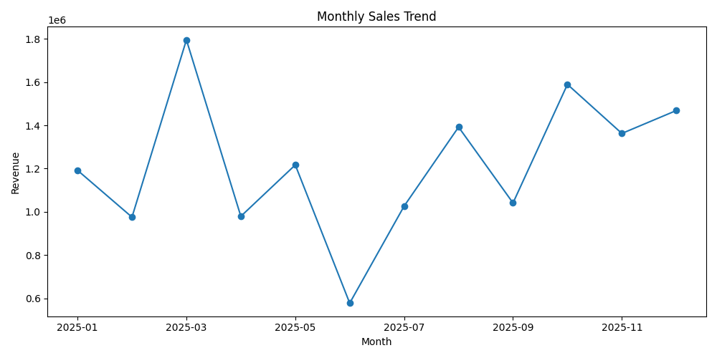
Figure 1: Monthly Sales Trend (January 2025 – December 2025)

Top Selling Products
Products were ranked by total revenue contribution. Three Electronics items — Laptop (PKR 4,627,499), Smartphone (PKR 3,023,763), and Tablet (PKR 1,966,360) — together account for the majority of total revenue, far outpacing the rest of the catalog. Mid-tier products such as the Smart Watch, Microwave, and Water Purifier each contributed in the PKR 0.5–0.8 million range, while smaller-ticket items like Headphones and Cookware Set rounded out the top ten.
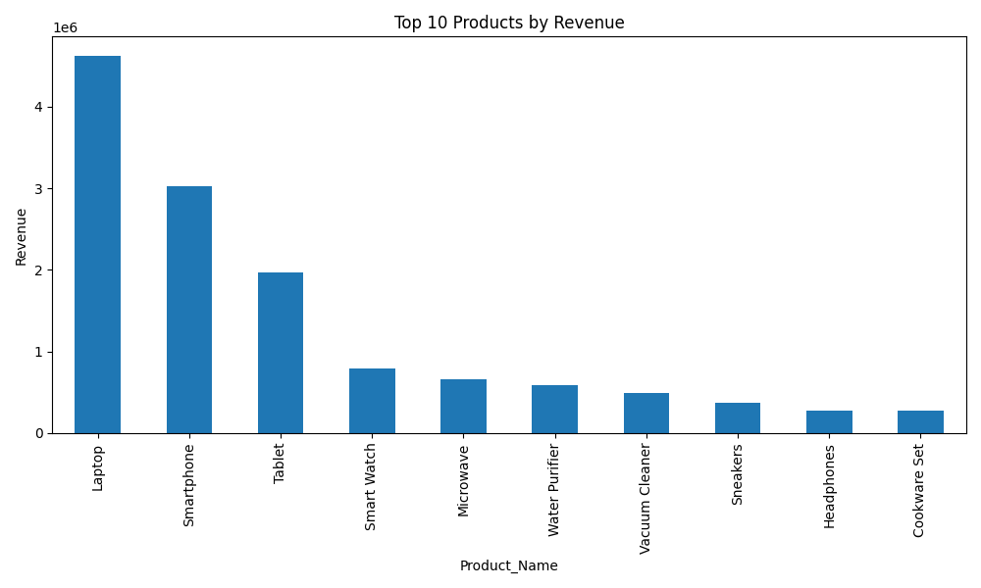
Figure 2: Top 10 Products by Revenue

Category Performance
Aggregating revenue by Product Category showed Electronics as the overwhelmingly dominant contributor — generating roughly PKR 10.2 million, or close to 70% of total revenue — followed by Home & Kitchen at approximately PKR 2.2 million. Fashion, Beauty & Personal Care, and Groceries each contributed smaller shares, with Groceries the lowest-revenue category despite consistent transaction volume.
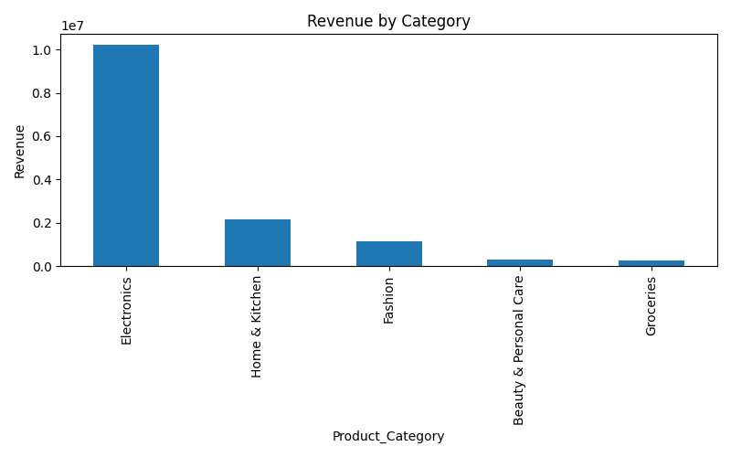
Figure 3: Revenue by Product Category

Revenue by City
City-level aggregation produced a result that runs counter to simple population-based assumptions: Multan generated the highest revenue of any city (PKR 2,268,409), narrowly ahead of Lahore (PKR 2,165,844) and Faisalabad (PKR 2,133,666). Karachi, despite being the largest metro area, ranked sixth (PKR 1,652,482), behind Quetta and Rawalpindi. Peshawar recorded the lowest city-level revenue (PKR 1,249,626). This indicates that revenue performance in this dataset is not simply a function of city size, and that mid-sized cities represent a meaningfully strong market.
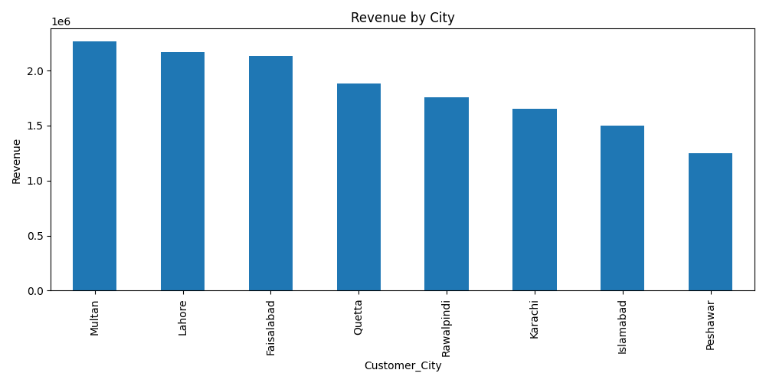
Figure 4: Revenue by City

Customer Purchasing Patterns
Customer-level aggregation of total spending, order count, and average order value formed the basis of the segmentation work described later in this report. Across the customer base, spending and order frequency varied widely — from single-purchase customers with modest baskets to a small group of high-spending repeat customers — supporting the case for a segmented rather than uniform retention strategy.

Customer Age Distribution
Customers were grouped into five age bands. The 36–45 age group was the largest segment of the customer base, closely followed by the 56–65 group, while customers aged 18–25 represented the smallest share. This spread suggests the business appeals broadly across working-age and older adult demographics rather than skewing toward a single age bracket.
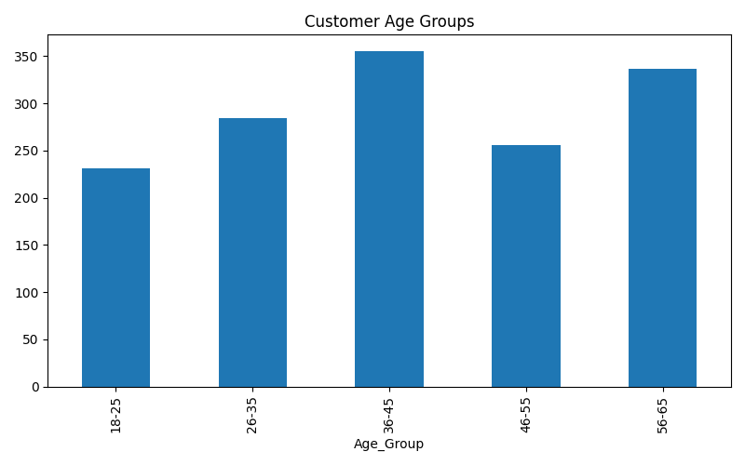
Figure 5: Customer Distribution by Age Group

Payment Method Distribution
Transactions were grouped by Payment Method to assess channel preference. UPI was the clear leader at 40.4% of transactions, followed by Credit Card (21.0%) and Debit Card (17.9%). Cash accounted for only 11.0% of transactions, and Wallet payments made up 9.8%. In total, digital payment methods represent close to 89% of all transactions, confirming a customer base that is highly comfortable with cashless payment.
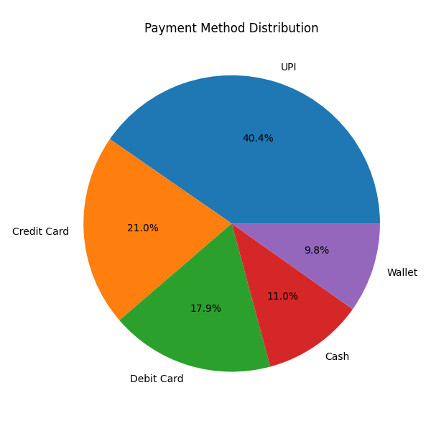
Figure 6: Payment Method Distribution

Sales Channel Distribution
Transactions were also split by Sales Channel. In-Store purchases accounted for the larger share of orders (approximately 930 transactions) compared to Online purchases (approximately 558 transactions), indicating that despite strong digital payment adoption, the physical store remains the primary point of purchase for this customer base.
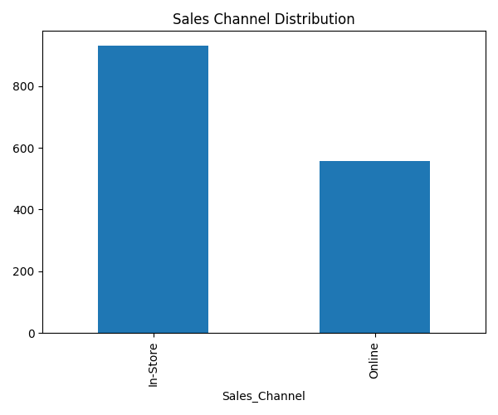
Figure 7: Sales Channel Distribution (In-Store vs. Online)

Average Order Value
The overall Average Order Value (AOV) across all transactions is PKR 9,816. AOV varies substantially by category: Electronics carries a far higher AOV than any other category, consistent with its high per-unit price points, while categories such as Groceries operate on a high-frequency, low-basket-size model.

Peak Sales Periods
Combining the monthly trend with category and city analysis identified March 2025 as the single highest-revenue month of the year, with a secondary uplift in the final quarter (November–December). These findings directly inform the timing of promotional campaigns, inventory build-up, and staffing levels, and are revisited in the Revenue Forecasting section below.

Dashboard Development
To translate the analysis into a usable business tool, a redesigned, multi-page interactive dashboard was developed using Streamlit. The dashboard is structured around how a retail business stakeholder — from store operations to executive leadership — would actually consume sales intelligence, rather than as a single, dense report. Screenshots of each page, captured directly from the deployed dashboard, are included below.

Executive Overview
A high-level landing page presenting top-line KPI cards (Total Revenue, Total Orders, Average Order Value) alongside a Monthly Revenue Trend chart, designed for at-a-glance executive consumption. With all cities selected, the page confirms the dataset's headline numbers: PKR 14,616,609 in total revenue across 1,489 orders, at an average order value of PKR 9,816.
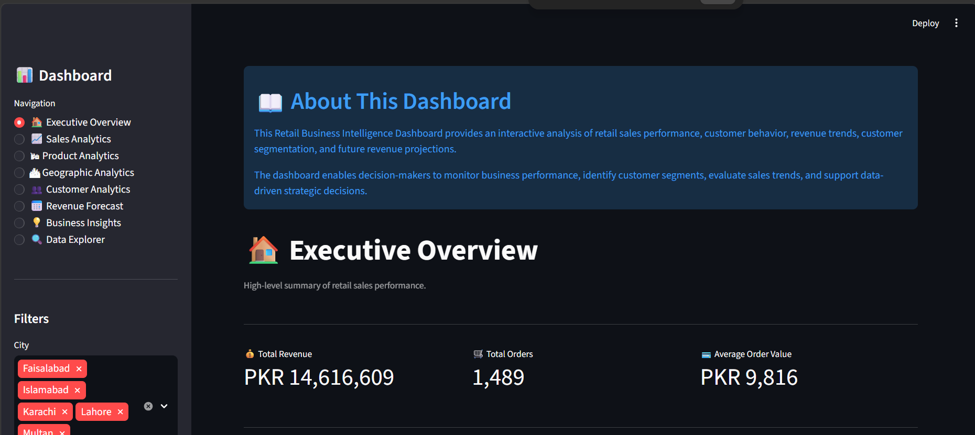
Figure 8: Executive Overview — KPI Summary
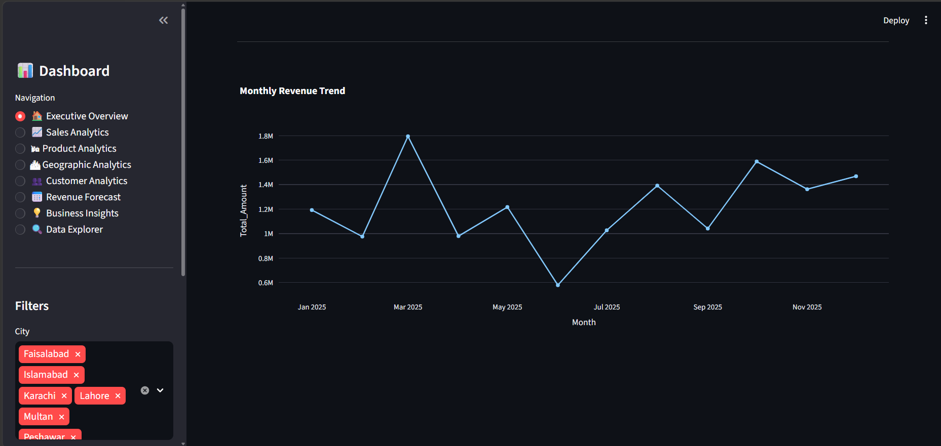
Figure 9: Executive Overview — Monthly Revenue Trend

Sales Analytics
A deeper, filterable view into revenue trends, category performance, and payment distribution, supporting month-over-month and category-over-category comparison.
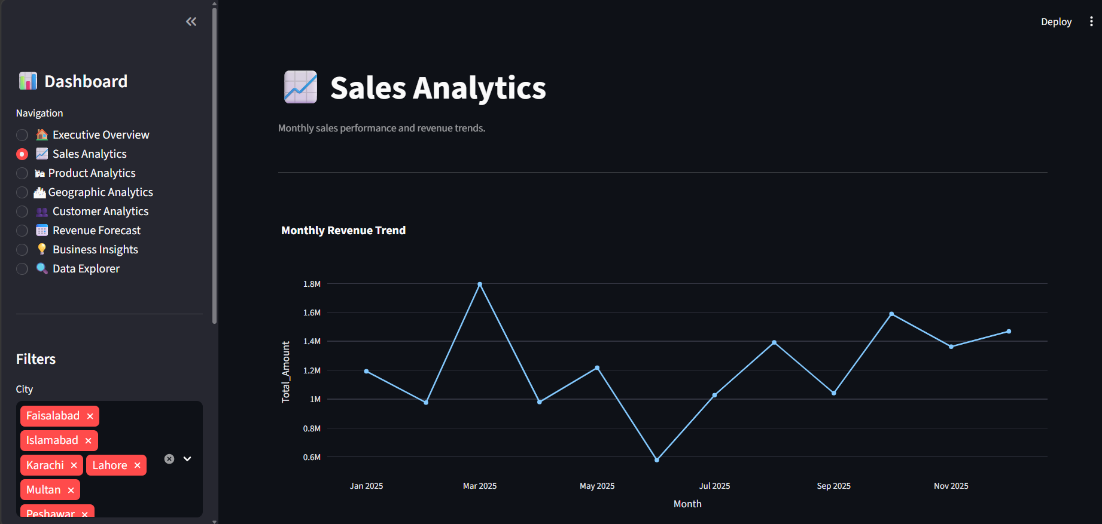
Figure 10: Sales Analytics — Monthly Revenue Trend
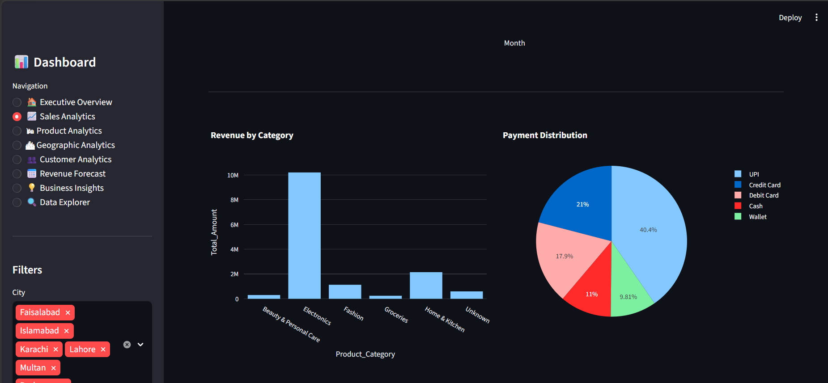
Figure 11: Sales Analytics — Revenue by Category and Payment Distribution

Product Analytics
Product-level performance, including the top ten products by revenue and a corresponding revenue table, supporting inventory and merchandising decisions.
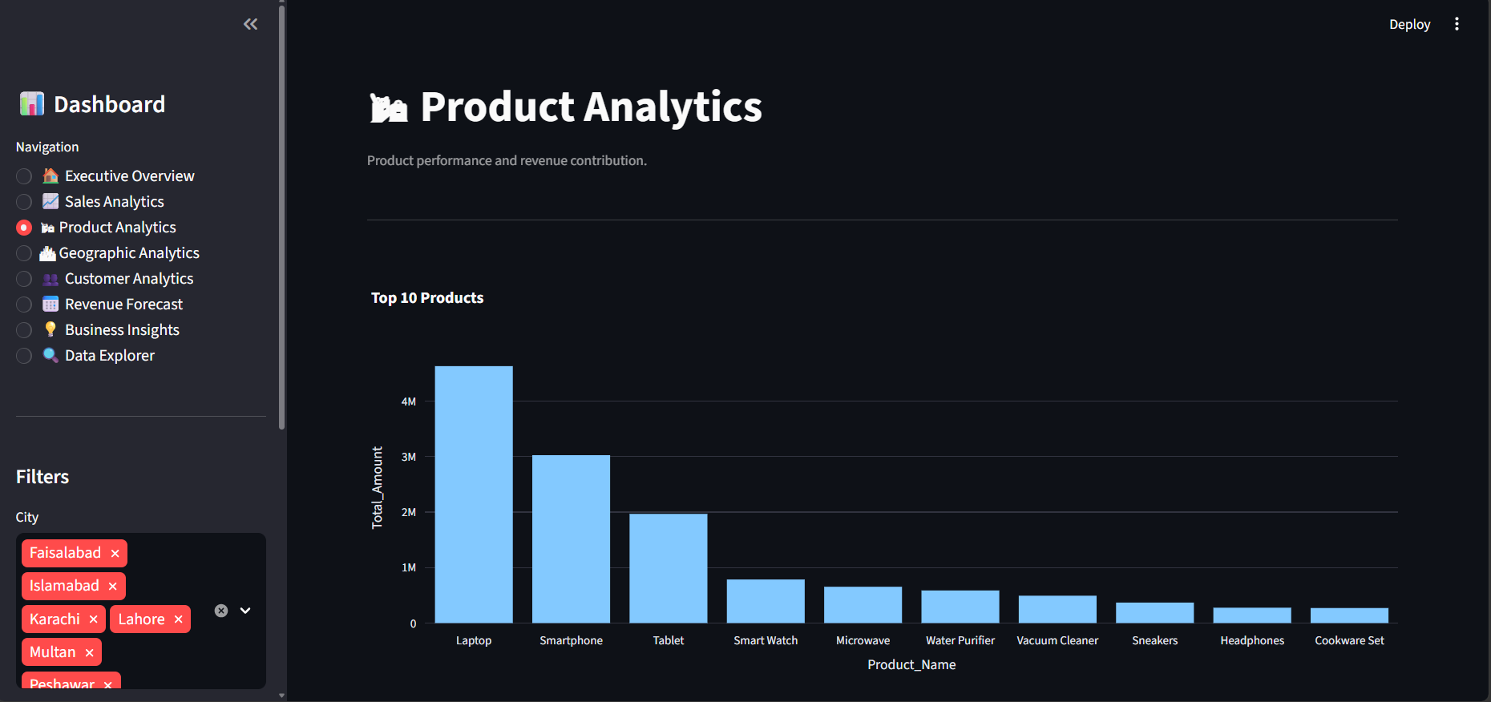
Figure 12: Product Analytics — Top 10 Products
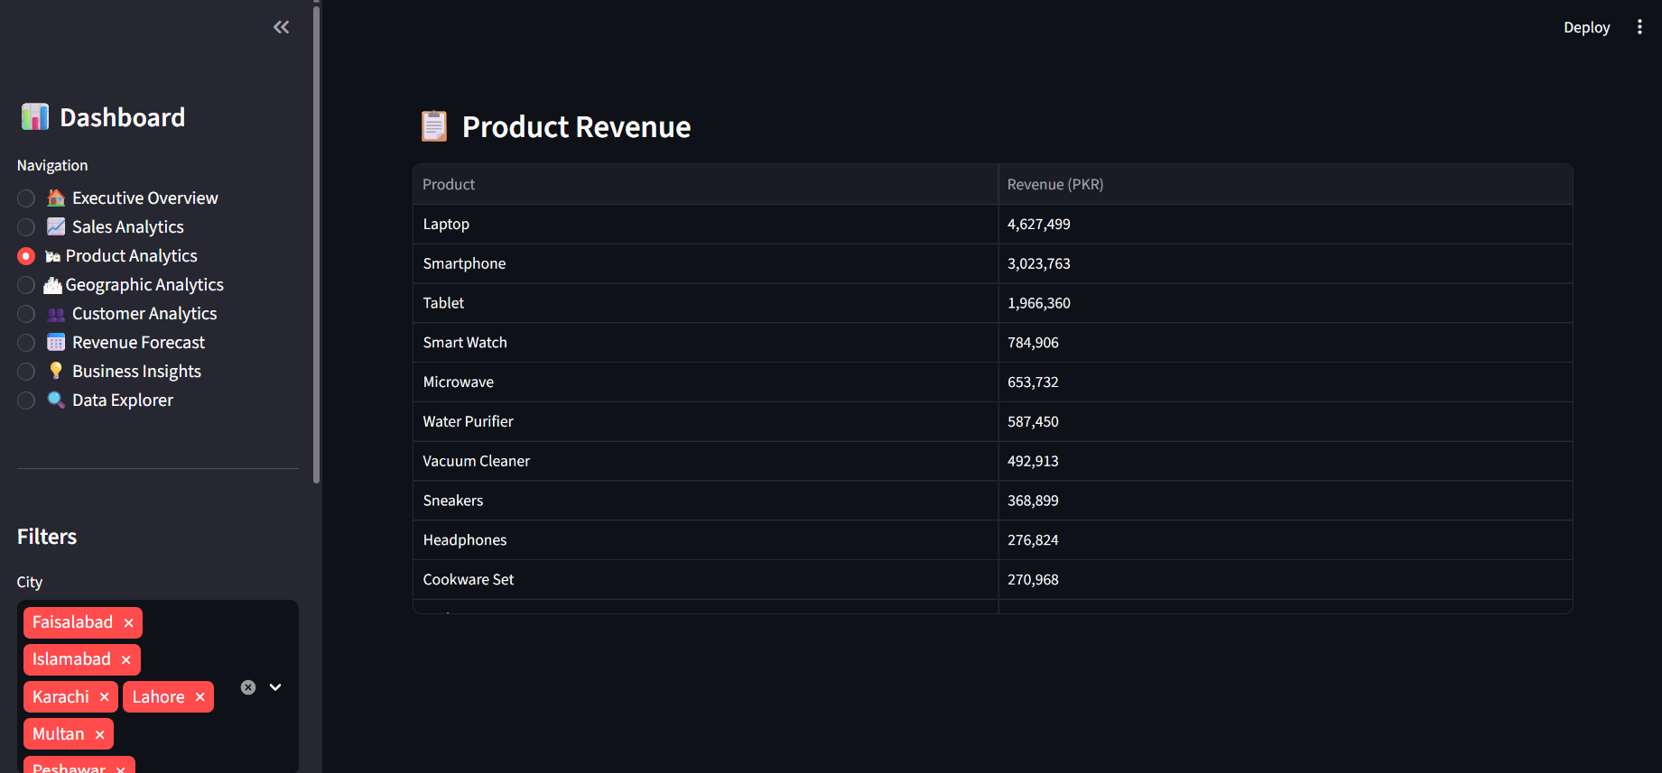
Figure 13: Product Analytics — Product Revenue Table

Geographic Analytics
City-level revenue distribution and ranking, allowing comparison of regional performance and identification of high-potential markets such as Multan.
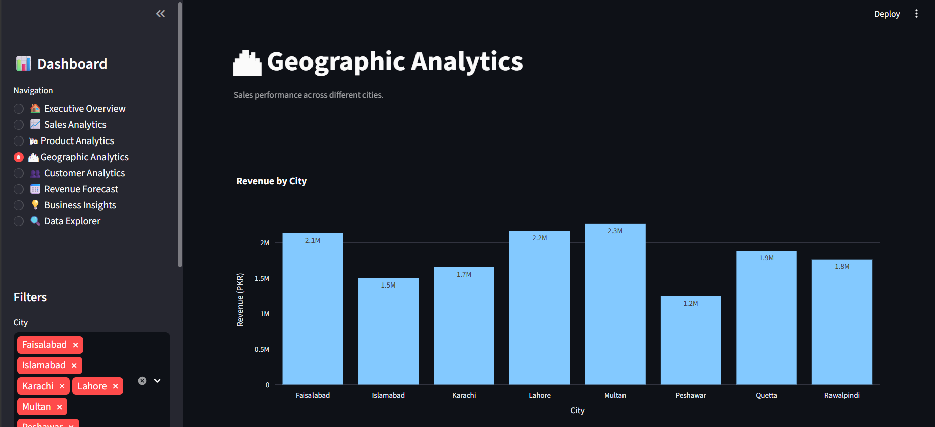
Figure 14: Geographic Analytics — Revenue by City
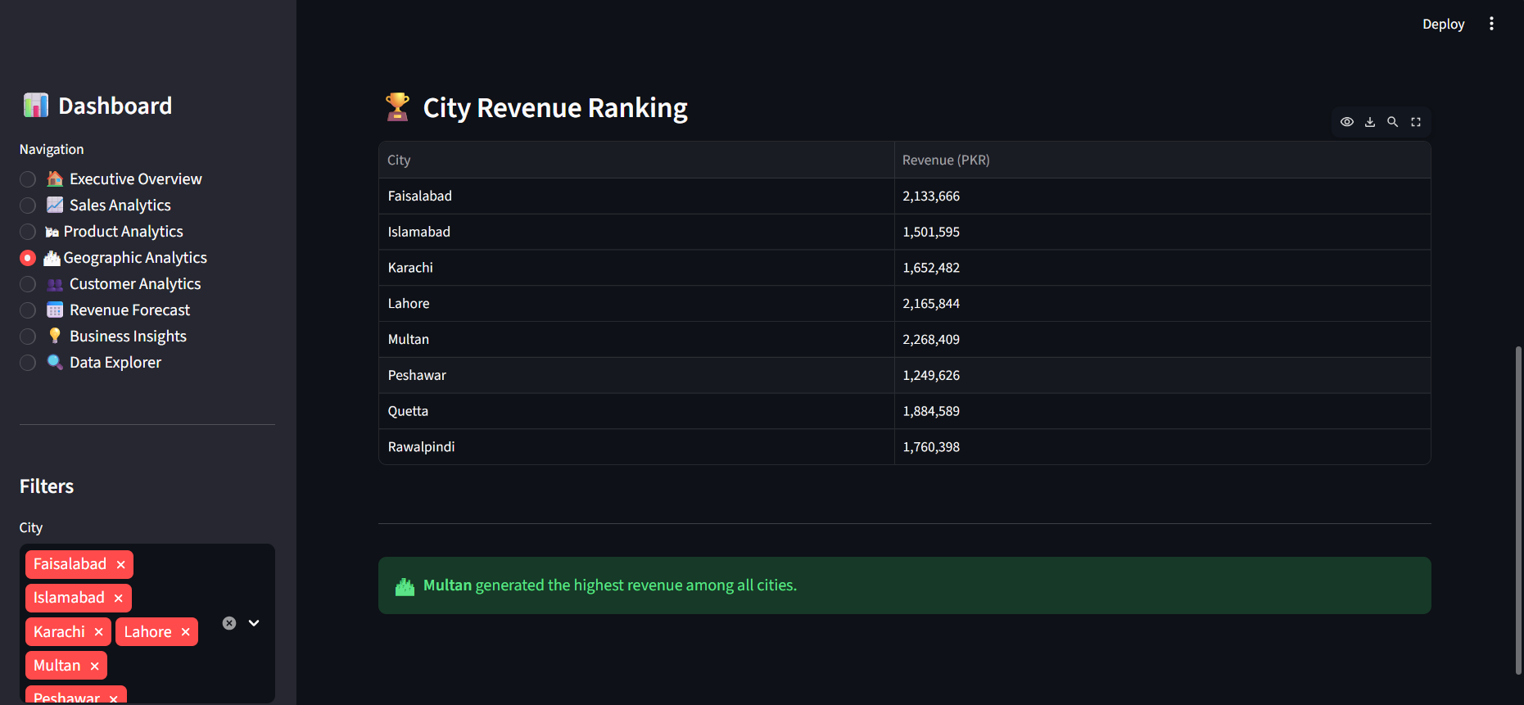
Figure 15: Geographic Analytics — City Revenue Ranking

Customer Analytics
Customer behavior and segmentation metrics, including segment-level KPI cards, a spending-versus-order-value scatter plot, and a segment distribution chart, supporting targeted marketing decisions.
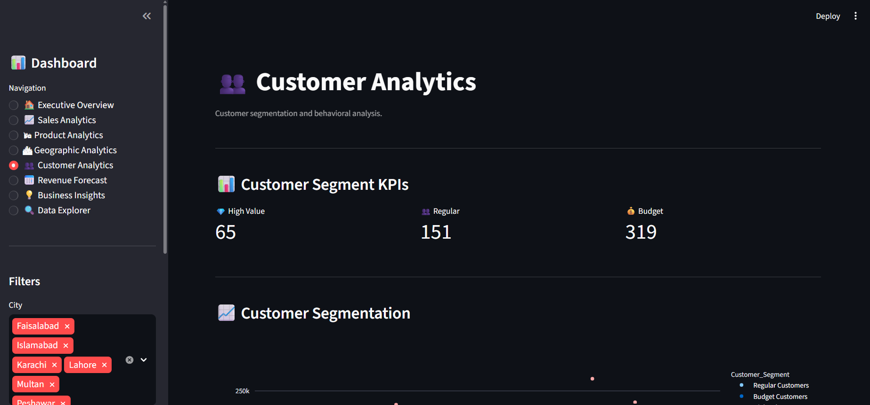
Figure 16: Customer Analytics — Segment KPI Cards
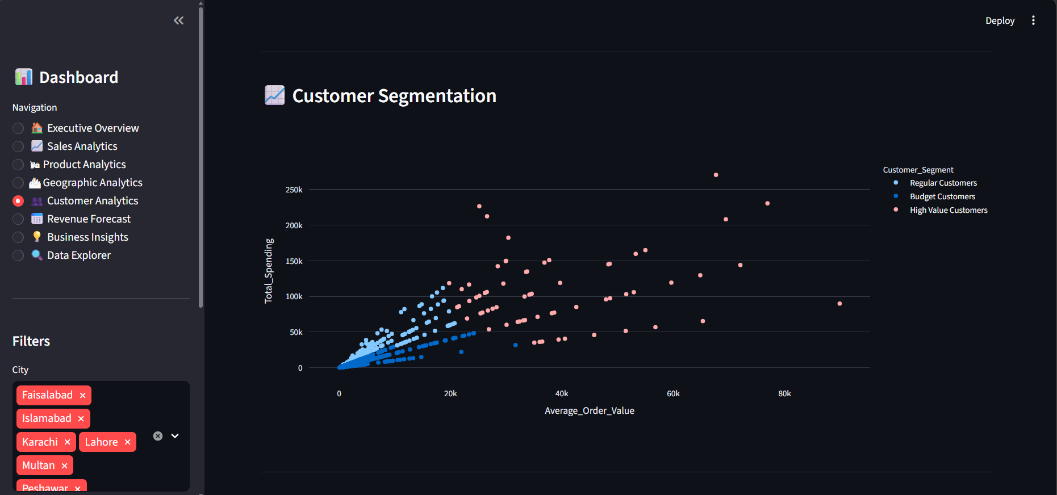
Figure 17: Customer Analytics — Spending vs. Average Order Value by Segment
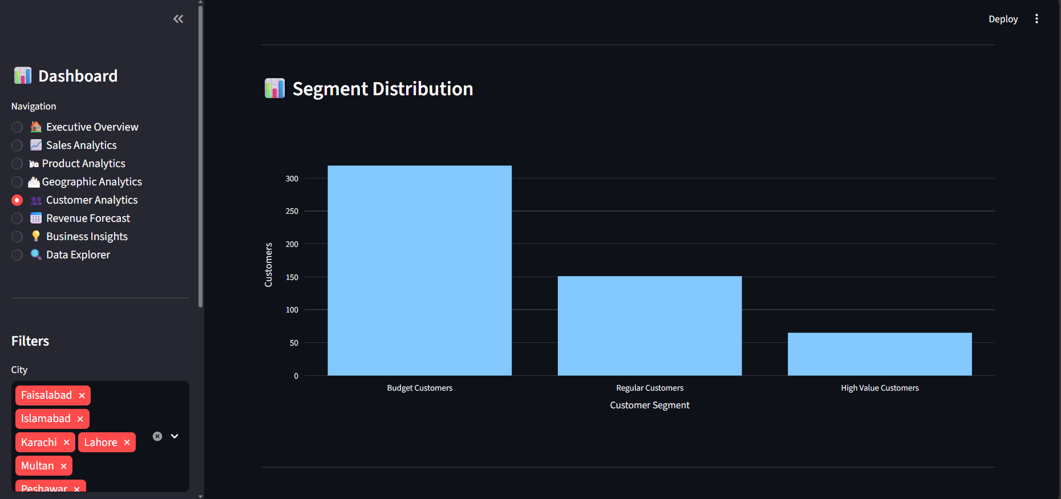
Figure 18: Customer Analytics — Segment Distribution
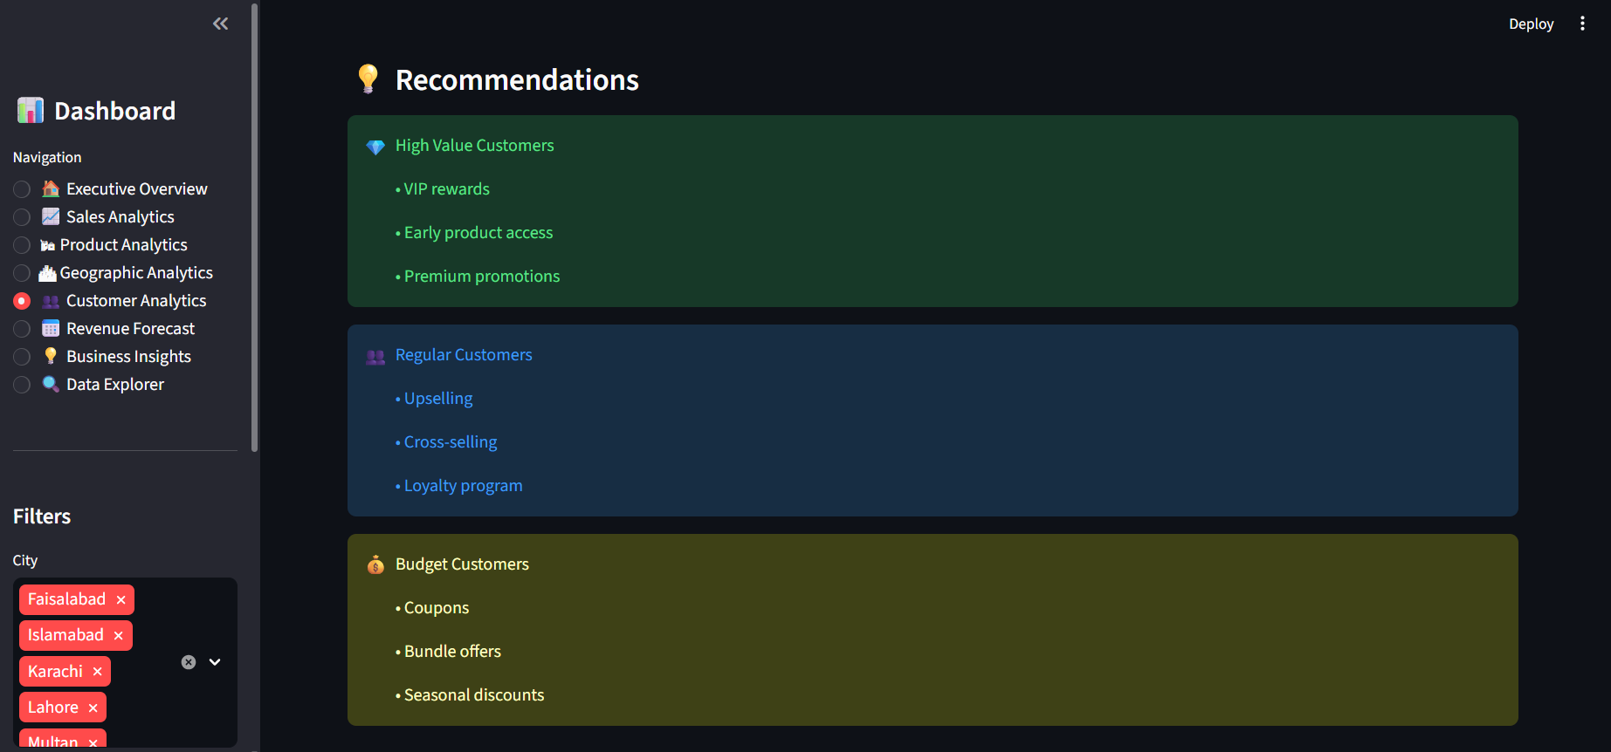
Figure 19: Customer Analytics — Segment-Level Recommendations

Revenue Forecast
An interactive view of the Linear Regression-based forecast, showing historical revenue alongside the projected trend for the next three months, with a supporting forecast table and interpretation.
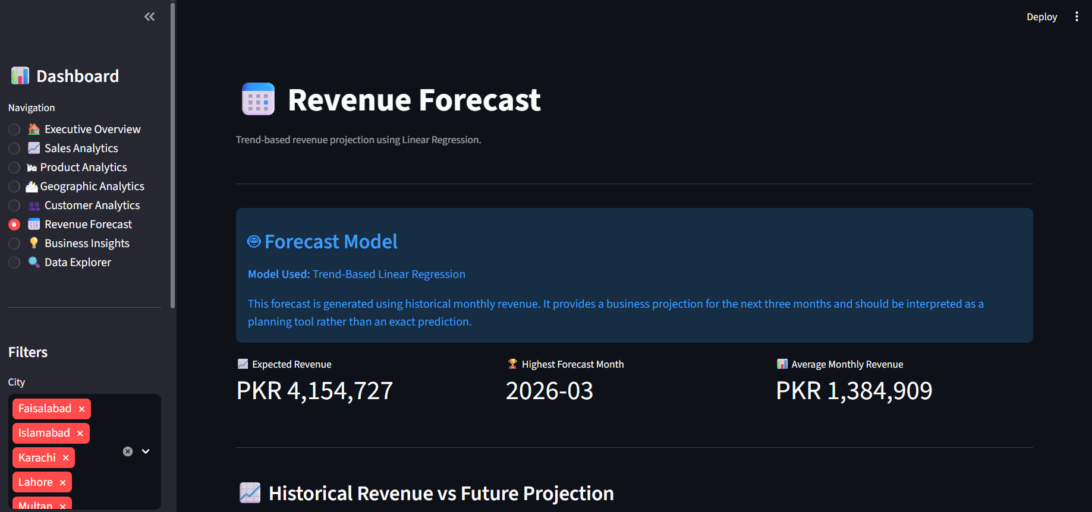
Figure 20: Revenue Forecast — Forecast Model KPIs
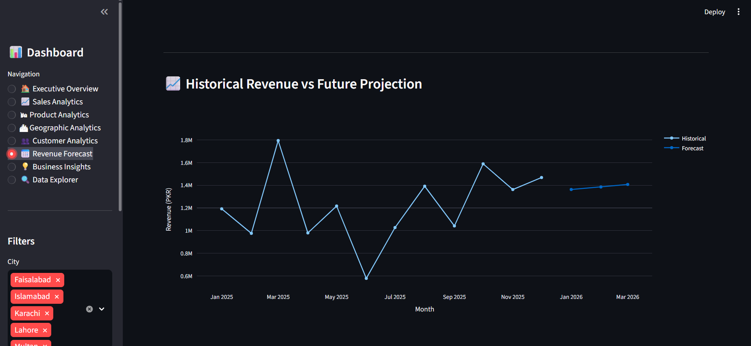
Figure 21: Revenue Forecast — Historical Revenue vs. Future Projection
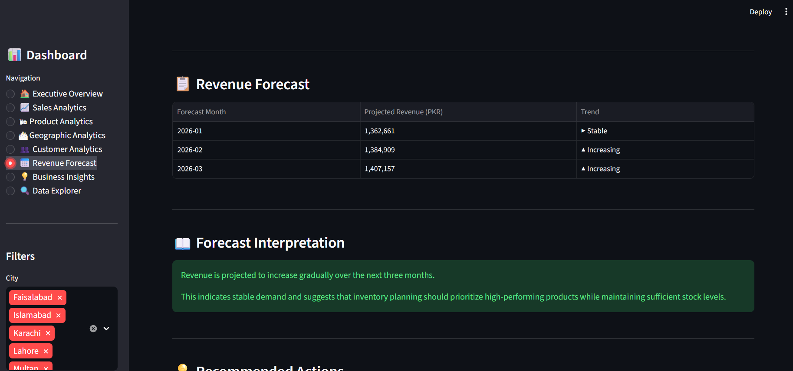
Figure 22: Revenue Forecast — Forecast Table and Interpretation

Executive Business Insights
A curated, narrative summary page translating the underlying data into plain-language insights, strategic recommendations, and an executive conclusion for non-technical stakeholders.
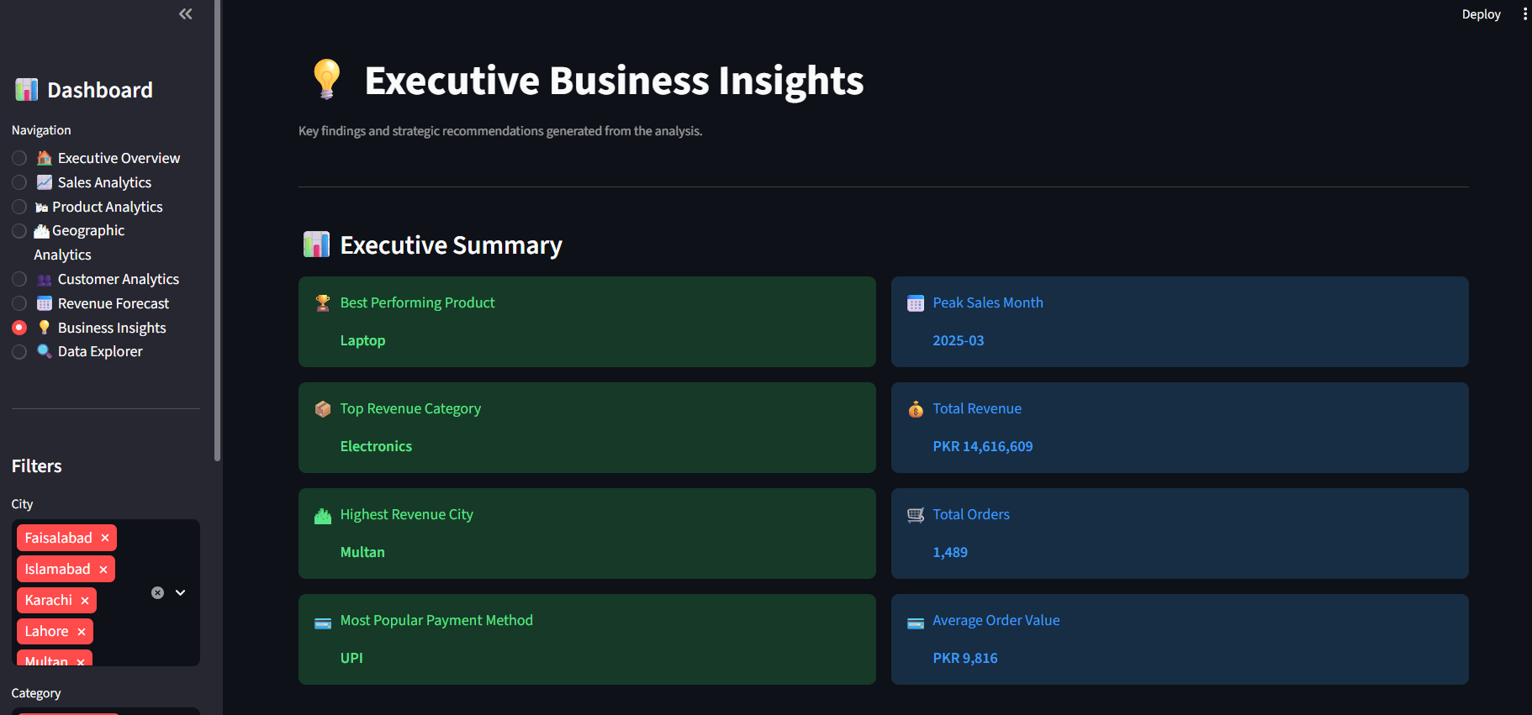
Figure 23: Executive Business Insights — Executive Summary KPIs
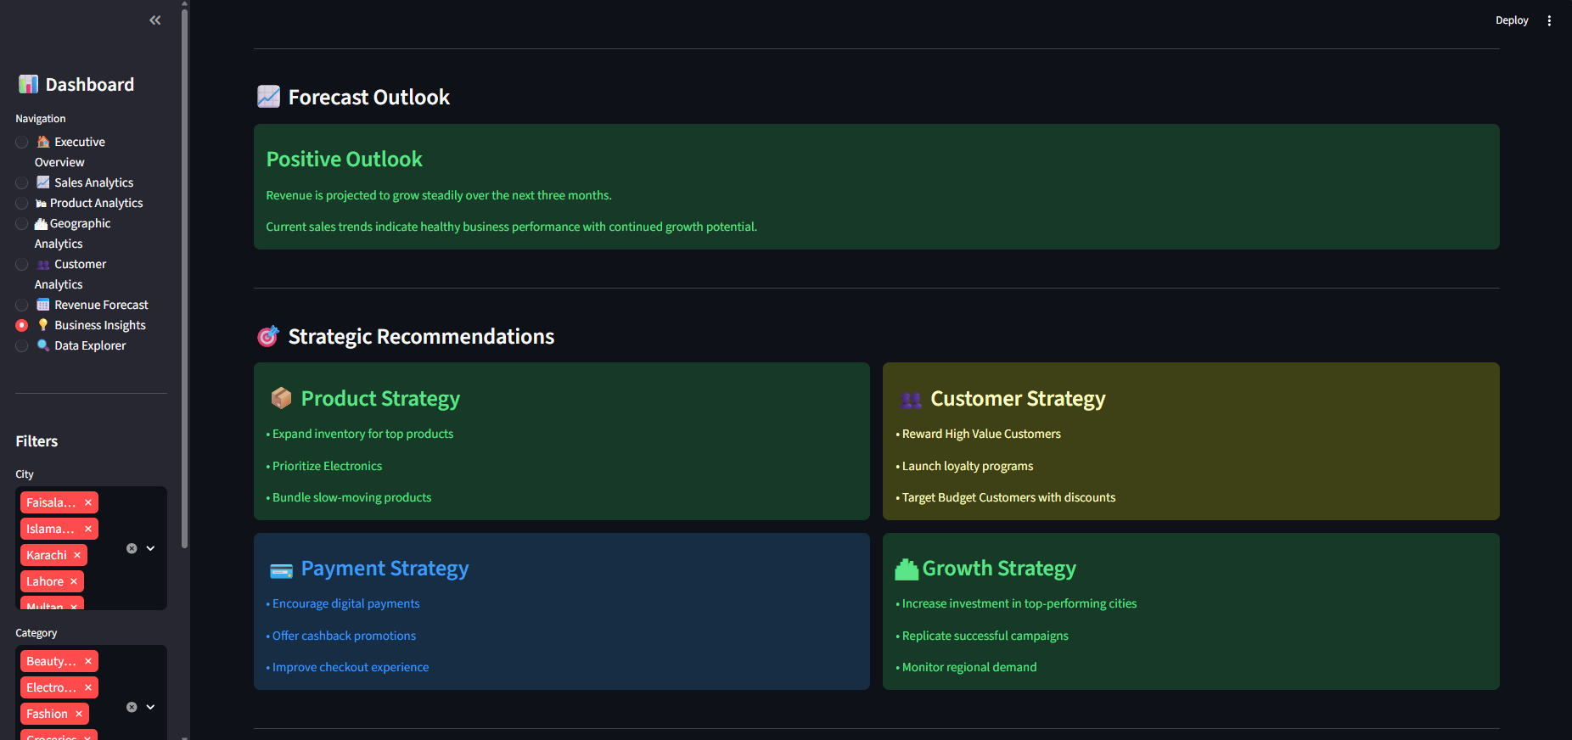
Figure 24: Executive Business Insights — Strategic Recommendations

Data Explorer
A raw data view with search, filter, and column-selection functionality, allowing users to inspect and export the underlying transaction-level data directly. The dataset loaded into this page contains 1,489 rows, 15 columns, and zero missing values.
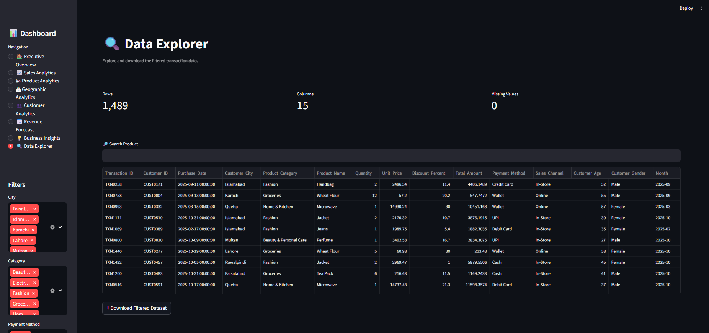
Figure 25: Data Explorer — Filterable Transaction Table

Key Dashboard Features
- Interactive sidebar navigation across all eight pages
- Dynamic filters for city, category, and payment method
- KPI summary cards for instant performance snapshots
- Fully interactive Plotly charts (zoom, hover, and filter-linked updates)
- Downloadable filtered dataset in CSV format for offline analysis
- Built-in search functionality within the Data Explorer page
- Consistent, professional, dark-themed business dashboard layout
By separating executive summaries from operational detail, the dashboard supports decision-making at multiple levels: leadership can review the Executive Overview and Business Insights pages in minutes, while operations and marketing teams can drill into Product, Geographic, and Customer Analytics for tactical planning.

Customer Segmentation
Treating all customers as a single homogeneous group limits the effectiveness of marketing and retention strategy. Customer segmentation addresses this by grouping customers with similar purchasing behavior, allowing the business to tailor messaging, offers, and retention effort to the value and needs of each group rather than applying a one-size-fits-all approach.

Why K-Means Clustering
K-Means was selected because it is well-suited to numerical, continuous behavioral data such as spending and order frequency, scales efficiently to the size of this dataset, and produces clusters that are straightforward to interpret and explain to a non-technical business audience — an important consideration for a customer segmentation deliverable intended for marketing use.

Feature Scaling with StandardScaler
Before clustering, the selected features were standardized using StandardScaler so that each feature contributes equally to the distance calculations underlying K-Means. Without scaling, a feature measured in large currency units (Total Spending) would dominate the clustering result over a feature measured in small counts (Total Orders), producing misleading segments.

Features Used for Segmentation
- Total Spending — cumulative amount spent by the customer across the year
- Total Orders — number of distinct purchase transactions made by the customer
- Average Order Value — total spending divided by total orders, capturing basket size behavior

Customer Segments Identified
The model identified 535 unique customers, split into three segments of meaningfully different size and value:
Segment | Customer Count | Behavioral Profile | Recommended Actions
High Value Customers | 65 | Highest total spending and average order value; the smallest group but disproportionately important to revenue | VIP rewards, early product access, premium promotions
Regular Customers | 151 | Moderate, consistent spending with steady order frequency | Upselling, cross-selling, loyalty program
Budget Customers | 319 | Lower total spending and order value, often price-sensitive or infrequent purchasers; the largest group by count | Coupons, bundle offers, seasonal discounts
Budget Customers form the largest segment by a wide margin — nearly 60% of the customer base — followed by Regular Customers (28%) and High Value Customers (12%). This distribution means that, while High Value Customers should be prioritized for retention, the sheer size of the Budget segment makes it the most important group for volume-driven, discount-led campaigns aimed at increasing order frequency and average basket size.

Cluster Validation: The Elbow Method
K-Means requires the number of clusters (k) to be specified in advance, so a validation step was used to determine the optimal value of k rather than choosing it arbitrarily.

Purpose of the Elbow Method
The Elbow Method evaluates clustering quality across a range of k values by measuring how compact the resulting clusters are, helping identify the point beyond which adding further clusters yields diminishing improvement in segmentation quality.

Within-Cluster Sum of Squares (WCSS)
For each candidate value of k, the Within-Cluster Sum of Squares (WCSS) was calculated — the total squared distance between each customer and their assigned cluster center. WCSS dropped sharply from approximately 1,600 at k = 1 to roughly 575 at k = 3, after which the rate of decline flattened considerably, falling only gradually toward 170 by k = 10.
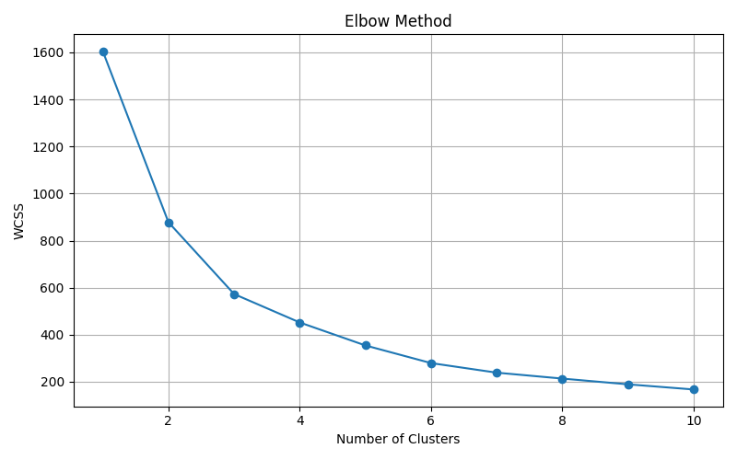
Figure 26: Elbow Method — WCSS vs. Number of Clusters

Selecting the Optimal Number of Clusters
Plotting WCSS against k from 1 through 10 produced a curve with a clear 'elbow' at k = 3 — the point where the rate of decline sharply flattens. This elbow point indicates the value of k beyond which additional clusters primarily split existing groups rather than reveal genuinely new behavioral patterns.

Why Three Clusters Were Selected
The elbow in this dataset occurred at k = 3, aligning closely with the intuitive High Value, Regular, and Budget segmentation used by retail businesses, and confirmed directly within the live dashboard's Cluster Validation view. Three clusters also produced segments of practical, actionable size — none too small to target meaningfully, and none so large as to mask internal variation — making k = 3 both statistically justified and operationally useful.
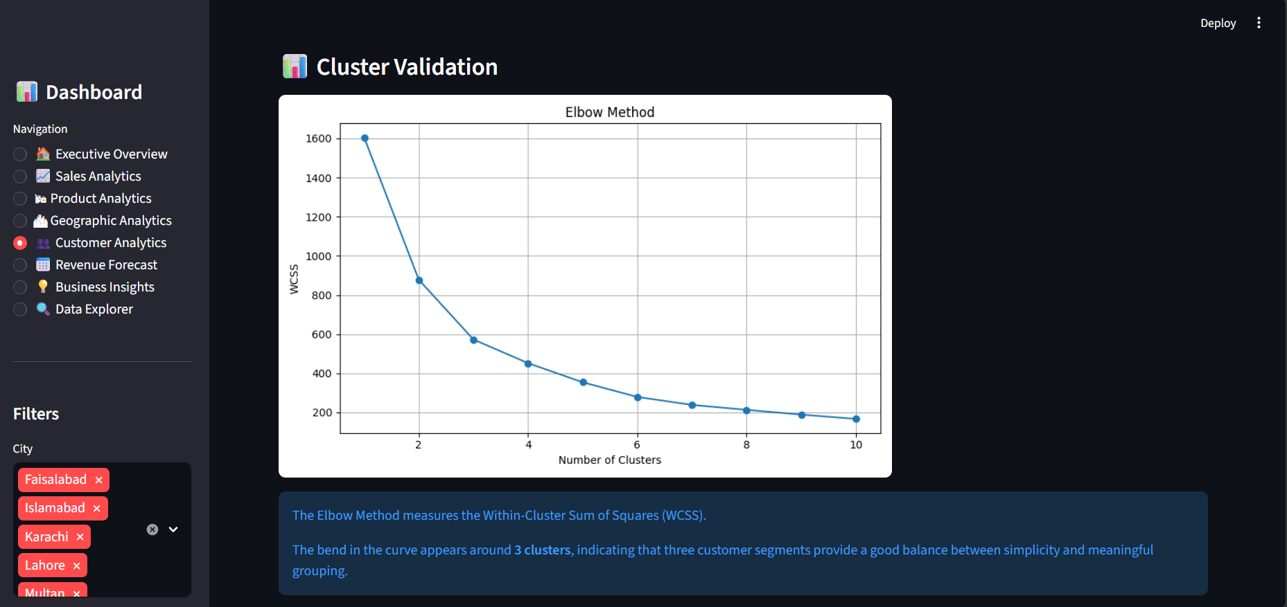
Figure 27: Live Dashboard View — Cluster Validation (Elbow Method)

Sales Forecasting
Understanding past performance is necessary but not sufficient for effective planning; retail businesses also need a forward view of expected revenue to guide inventory, staffing, and cash flow decisions. A forecasting module was built to address this need.

Importance of Sales Forecasting
Forecasting allows a business to anticipate demand rather than simply react to it — informing purchasing decisions, marketing spend timing, and short-term financial planning before the relevant period arrives.

Historical Monthly Revenue Analysis
Twelve months of cleaned transaction data were aggregated into a monthly revenue time series, ranging from a low of approximately PKR 0.58 million in June 2025 to a high of approximately PKR 1.8 million in March 2025. This series, despite its month-to-month volatility, served as the foundation for the forecasting model.

Trend-Based Linear Regression
A Linear Regression model was fitted to the monthly revenue series, using time period as the independent variable and monthly revenue as the dependent variable. This approach captures the dominant linear growth trend across the year, providing a simple, transparent, and easily explainable basis for short-term projection.

Three-Month Revenue Forecast
The fitted model was extended three months beyond the observed data (January–March 2026) to generate a forward revenue projection:
Forecast Month | Projected Revenue (PKR) | Trend
2026-01 | 1,362,661 | Stable
2026-02 | 1,384,909 | Increasing
2026-03 | 1,407,157 | Increasing
This corresponds to an expected three-month revenue total of PKR 4,154,727, an average monthly revenue of PKR 1,384,909, and a highest forecast month of March 2026 — notably the same calendar month that produced the single highest revenue figure in the historical data.

Figure 28: Historical Revenue vs. Future Projection (Dashboard View)

Business Interpretation and Planning Use
The forecast points to a stable Q1 2026 opening month followed by gradual, sustained growth through February and March, consistent with the underlying yearly trend. This supports planning decisions such as setting realistic first-quarter sales targets, sizing inventory orders for top-performing categories, and timing marketing spend to build on momentum heading into the historically strong month of March.
It is important to note that this forecast is intended as a directional planning tool rather than a precise prediction. Linear Regression captures the dominant trend but does not account for one-off events, new product launches, or external market shocks; actual results should be monitored against the forecast and the model refreshed periodically as new data becomes available.

Key Findings
The table below consolidates the core KPI results produced across the EDA, segmentation, and forecasting stages of this project.
KPI | Result | Interpretation
Total Revenue | PKR 14,616,609 | Full-year revenue base across all eight cities and five categories
Total Orders | 1,489 | Final, cleaned transaction count for the analysis period
Average Order Value | PKR 9,816 | Pulled upward by high-ticket Electronics purchases
Best Performing Product | Laptop (PKR 4,627,499) | Single largest revenue contributor in the catalog
Top Revenue Category | Electronics (~PKR 10.2M, ~70% of revenue) | Overwhelmingly dominant category
Highest Revenue City | Multan (PKR 2,268,409) | Outperforms larger metro centers such as Karachi and Islamabad
Most Popular Payment Method | UPI (40.4%) | Strong digital payment adoption, ahead of Credit Card and Cash
Peak Sales Month | March 2025 (~PKR 1.8M) | Single highest-revenue month of the year
Largest Customer Segment | Budget Customers (319 of 535, ~60%) | Majority of the customer base by count, though not by spend
Revenue Forecast (Q1 2026) | PKR 4,154,727 total / PKR 1,384,909 average monthly | Stable to gradually increasing trend

Business Insights

Product Performance
Revenue is heavily concentrated in three Electronics products — Laptop, Smartphone, and Tablet — which together drive the large majority of total revenue. This indicates a business model where premium-category performance materially shapes overall results, and where stockouts in these specific SKUs would have an outsized impact on revenue.

Category Performance
Electronics accounts for roughly 70% of total revenue, an unusually high concentration that makes the business highly dependent on a single category's continued performance. Home & Kitchen is a distant second, while Fashion, Beauty & Personal Care, and Groceries contribute comparatively modest shares.

Customer Behavior
Customer-level analysis shows wide variation in spending and order frequency, from single-purchase, low-value customers to a small group of high-spending repeat customers. This variation is the basis for the three-segment clustering model described above.

Customer Segmentation
The High Value segment (65 customers, 12% of the base) is the smallest group but the most valuable per customer, while Budget Customers (319, ~60%) form the largest segment by count. This is a Pareto-style pattern in reverse for volume: most customers are price-sensitive and lower-spending, making volume-oriented, discount-led campaigns the most scalable lever for revenue growth, even as High Value Customers remain the priority for premium retention investment.

Geographic Performance
Revenue performance does not track city size in this dataset. Multan, Lahore, and Faisalabad — all mid-sized cities — outperform Karachi and Islamabad, the largest metro centers. This suggests either stronger local demand, less competition, or under-leveraged opportunity in major cities, and warrants further investigation into the drivers behind Multan's leading position.

Payment Behaviour
UPI's 40.4% share, combined with Credit Card, Debit Card, and Wallet, means digital payment methods account for roughly 89% of transactions versus just 11% for Cash. This signals a customer base that is well-suited to further digital engagement, including UPI-linked promotions and app-based loyalty incentives.

Seasonal Trends
March 2025 stands out as a clear outlier peak month, with June 2025 as the weakest point in the year. Rather than a single smooth seasonal curve, the data shows sharp month-to-month volatility, which should be investigated further (for example, against historical promotions or one-off events) before being assumed to be a reliable annual pattern.

Revenue Forecast
The Linear Regression forecast suggests revenue will open 2026 close to the trailing average and grow gradually through Q1, with March 2026 — echoing March 2025 — projected as the strongest of the three forecast months.

Business Opportunities
The combination of an outperforming mid-sized city (Multan), a very large but under-monetized Budget Customer segment, and near-universal digital payment readiness together point to clear, low-risk opportunities for incremental revenue growth without requiring entry into entirely new markets or categories.

Business Recommendations

Inventory Management
Prioritize stock availability for the Laptop, Smartphone, and Tablet SKUs given their outsized share of revenue, and expand inventory for top-performing products generally while bundling slow-moving items to reduce holding costs.

Marketing Strategy
Prioritize Electronics in marketing spend given its dominant revenue share, and replicate the conditions that made March such a strong month — whether seasonal, promotional, or pricing-driven — ahead of the next comparable period.

Customer Segmentation
Operationalize the three-segment model within CRM and marketing systems: reward High Value Customers with VIP perks and early access, grow Regular Customers through upselling, cross-selling, and loyalty programs, and activate the large Budget segment with coupons, bundles, and seasonal discounts.

Customer Retention
Launch a structured loyalty program anchored on the High Value segment, while using the scale of the Budget segment to run high-volume, low-cost reactivation campaigns that lift average order value over time.

Digital Payments
Continue to encourage digital payments — particularly UPI, already the leading method — through cashback promotions and an improved checkout experience, to further reduce reliance on Cash.

Regional Expansion
Increase investment in top-performing cities, starting with Multan, Lahore, and Faisalabad, and investigate why these mid-sized markets outperform Karachi and Islamabad so that successful local tactics can be replicated elsewhere.

Revenue Forecast Monitoring
Track actual monthly revenue against the Linear Regression forecast (PKR 1,362,661 / 1,384,909 / 1,407,157 for January–March 2026) on a rolling basis, and refresh the model quarterly to incorporate new data and maintain forecast relevance.

Business Growth
Combine the segmentation, forecasting, and geographic insights into a single quarterly business review process, ensuring that strategic decisions — including the four strategic pillars surfaced on the dashboard's own Business Insights page (Product, Customer, Payment, and Growth Strategy) — are consistently grounded in the underlying data.

Conclusion
This project set out to analyze retail sales transactions in order to understand customer behavior, identify revenue drivers, and generate forward-looking business intelligence — and it delivers on each of these objectives through a complete, end-to-end analytics pipeline.
Beginning with a structured data cleaning process, the project reduced a raw 1,500-record dataset to a validated, analysis-ready set of 1,489 transactions with zero missing values. Exploratory Data Analysis then surfaced clear, and at times counter-intuitive, patterns: a heavy concentration of revenue in Electronics and in three specific products, a volatile monthly trend peaking in March, and a city-level ranking led by Multan rather than the larger metro centers. These findings were made accessible and actionable through a redesigned, eight-page interactive Streamlit dashboard built for use by both executive and operational stakeholders.
Beyond descriptive analysis, the project applied machine learning to generate genuine business value: K-Means Clustering, supported by StandardScaler normalization and validated through the Elbow Method, produced a three-segment customer model — High Value (65 customers), Regular (151), and Budget (319) — that can directly inform marketing and retention strategy. A Linear Regression-based forecasting module extended this forward-looking capability, projecting a three-month Q1 2026 revenue total of PKR 4,154,727 as a planning aid rather than a guarantee.
As the dashboard's own Executive Conclusion summarizes: the retail business generated PKR 14,616,609 from 1,489 completed orders; Electronics is the strongest revenue-driving category, while Laptop remains the highest-performing product; and the business demonstrates healthy sales performance with clear opportunities for further growth through customer retention, inventory optimization, and strategic marketing.
Overall, this project demonstrates practical, hands-on proficiency across the full data analytics lifecycle: data cleaning, exploratory data analysis, data visualization, machine learning, business intelligence, dashboard development, customer segmentation, sales forecasting, and insight generation. Together, these skills reflect the core capabilities expected of a professional data analyst working in a retail or e-commerce analytics environment.

