**Name: Abdullah Niazi**

**Roll No: 23F-0017**

**Task#3**

**Code:**

#include<iostream>

using namespace std;

class Time{

private:

int hours, minutes, seconds;

public:

Time() {

cout << "Default Constructor Called" << endl;

hours = 0;

minutes = 0;

seconds = 0;

}

~Time() {

cout << "Default Destructor Called" << endl;

}

void setTime(int h, int m, int s) {

hours = h;

minutes = m;

seconds = s;

}

int getHours() {

return hours;

}

int getMinutes() {

return minutes;

}

int getSeconds() {

return seconds;

}

void displayTime12() {

cout << "Time in 12-Hour Format : " << hours %12<< " : " << minutes << " : " << seconds << endl;

}

void displayTime24() {

cout << "Time in 24-Hour Format : " << hours << " : " << minutes << " : " << seconds << endl;

}

void addMin(int min) {

minutes = minutes + min;

if (minutes >= 60) {

minutes = minutes % 60;

hours = hours + 1;

}

}

void addTime(Time t) {

hours = hours + t.hours;

minutes = minutes + t.minutes;

seconds = seconds + t.seconds;

if (seconds >= 60) {

seconds = seconds % 60;

minutes = minutes + 1;

}

if (minutes >= 60) {

minutes = minutes % 60;

hours = hours + 1;

}

if (hours >= 24) {

hours = hours % 24;

}

}

void subtractTime(Time t) {

hours = hours - t.hours;

minutes = minutes - t.minutes;

seconds = seconds - t.seconds;

if (seconds < 0) {

seconds = seconds + 60;

minutes = minutes - 1;

}

if (minutes < 0) {

minutes = minutes + 60;

hours = hours - 1;

}

if (hours < 0) {

hours = hours + 24;

}

}

};

int main() {

Time* t = new Time;

Time* t1 = new Time;

cout << "Time Object#1 : " << endl;

int h = 0 , m = 0, s = 0;

cout << "Enter Hours : "; cin >> h;

cout << "Enter Minutes : "; cin >> m;

cout << "Enter Seconds : "; cin >> s;

if (h < 0 || h >= 24 || m < 0 || m >= 60 || s < 0 || s >= 60) {

cout << "Invalid Input" << endl;

}

else{

t -> setTime(h, m, s);

t1-> setTime(11, 59, 59);

cout << "Time Object#1 : " << endl;

t-> displayTime12();

t-> displayTime24();

cout << endl;

cout << "Time Object#2 : " << endl;

t1-> displayTime12();

t1-> displayTime24();

int temp = 0;

cout << endl;

cout << "Enter Minutes to Add : "; cin >> temp;

t-> addMin(temp);

cout << endl;

cout << "After Addition of Minutes : " << endl;

t-> displayTime12();

t-> displayTime24();

cout << endl;

cout << "After Adding Time Object#1 to Time Object#2 : " << endl;

t-> addTime(*t1);

t-> displayTime12();

t-> displayTime24();

cout << endl;

cout << "After Subtracting Time Object#1 to Time Object#2 : " << endl;

t-> subtractTime(*t1);

t-> displayTime12();

t-> displayTime24();

cout << endl;

delete t;

delete t1;

}

return 0;

}

**Output:** 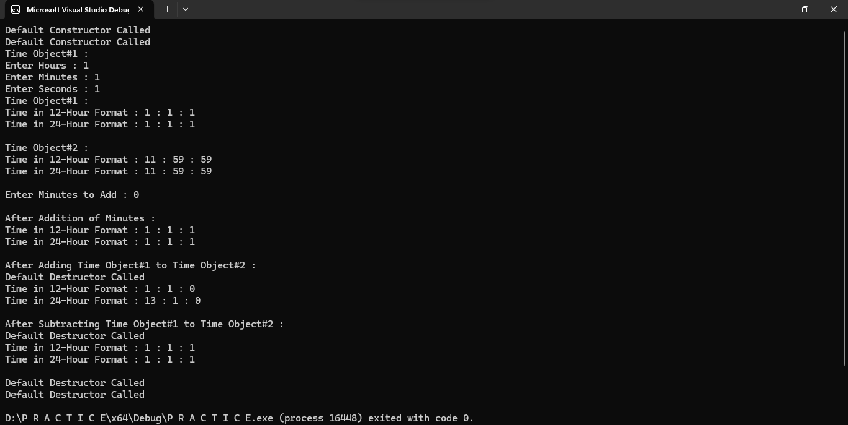

**Calling Destructor Explicitly**

Time t;

t.~Time();

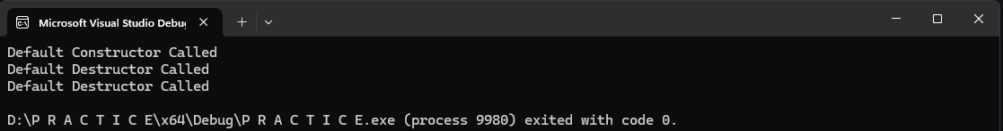

**Infinite Loop of Constructor and Destructors**

~Time() {

cout << "Default Destructor Called" << endl;

Time(); //constructor called

}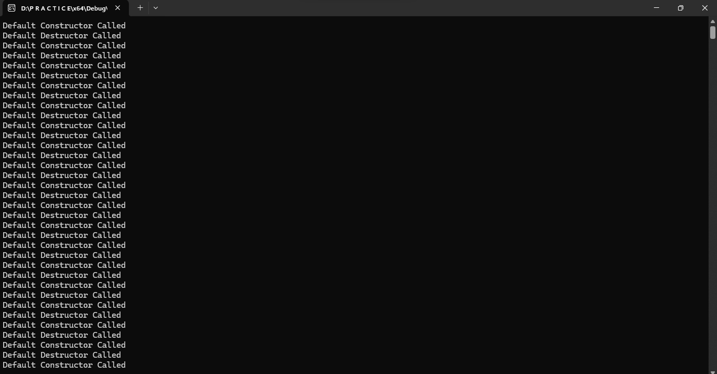

**Anonymous Object**

Time(1, 1, 1);

