**Name : Abdullah Niazi**

**Roll No : 23F0017**

**Question#2**

#include<iostream>

#include<cstring>

using namespace std;

int main() {

const int size = 50;

char arr[size];

cout << "Enetr a Sentence Max 40 Characters Only: "; cin.getline(arr, size);

if(strlen(arr)>40){

cout << "Sentence Should Not contain More than 40 Characters" << endl;

}

for (int i = 0; i < size; i++) {

for (int j = i + 1; j < size; j++) {

if (arr[i] == ' ') {

char temp = arr[i];

arr[i] = arr[j];

arr[j] = temp;

}

}

}

for (int i = 0; i < strlen(arr); i++) {

cout << arr[i];

}

cout << endl;

system("pause");

return 0;

}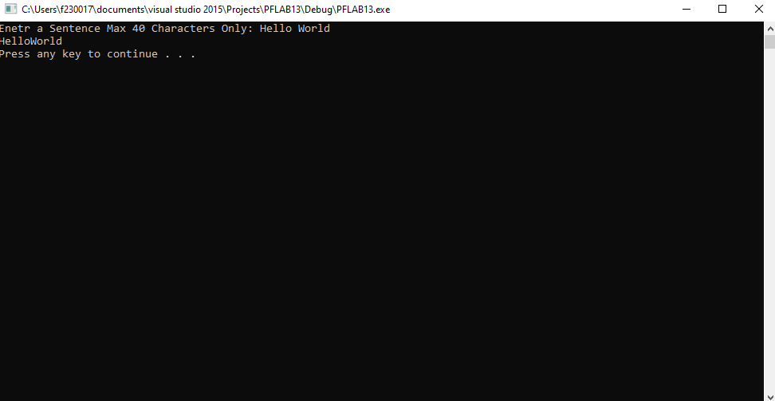

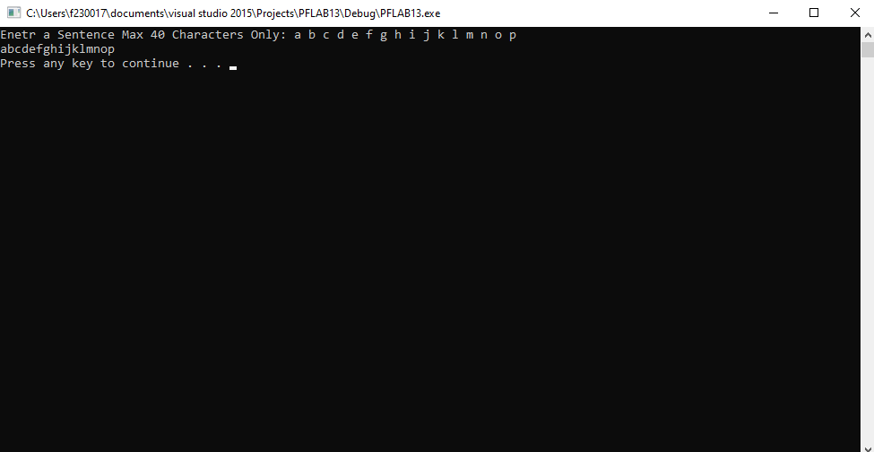

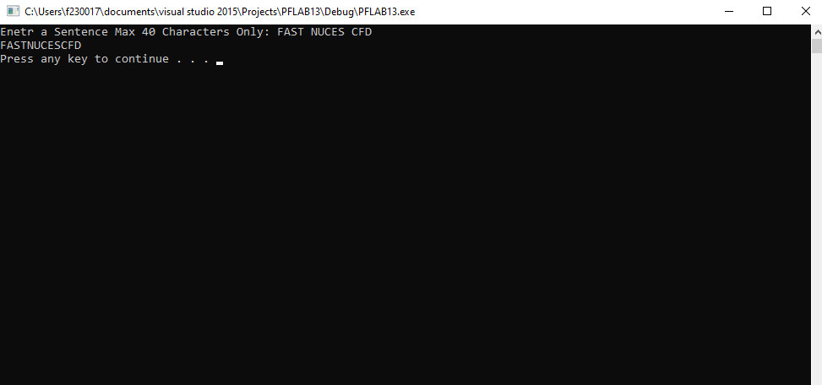

**Question#4**

#include<iostream>

#include<cstring>

using namespace std;

int main() {

char arr1[15];

char arr2[15];

cout << "Enter First String :"; cin.getline(arr1, 15);

cout << "Enter Second String :"; cin.getline(arr2, 15);

int len1 = 0,len2 = 0;

len1 = strlen(arr1);

len2 = strlen(arr2);

if (len1 != len2) {

cout << "The Strings Are Not Anagrams" << endl;

}

else {

int count = 0;

for (int i = 0; i < len1; i++) {

for (int j = 0; j < len1; j++) {

if (arr1[i] == arr2[j]) {

count++;

}

}

}

if (count == len1) {

cout << "The Strings Are Anagrams" << endl;

}

else {

cout << "The Strings Are Not Anagrams" << endl;

}

}

system("pause");

return 0;

}

