Name: Abdullah Khan Niazi

Roll No: 23F-0017

PF_LAB#7

Question#1

#include <iostream>

using namespace std;

int main() {

int score;

cout << "Enter in score in range of 0-100 :"; cin >> score;

if (score <0, score>100) {

cout << "Invalid input, please enter in the range of 0-100.";

}

else if (score <60) {

cout << "Grade is F";

}

else if (score <70) {

cout << "Grade is D";

}

else if (score < 80) {

cout << "Grade is C";

}

else if (score < 90) {

cout << "Grade is B";

}

else if (score <= 100) {

cout << "Grade is A";

}

cout << endl;

system("pause");

}

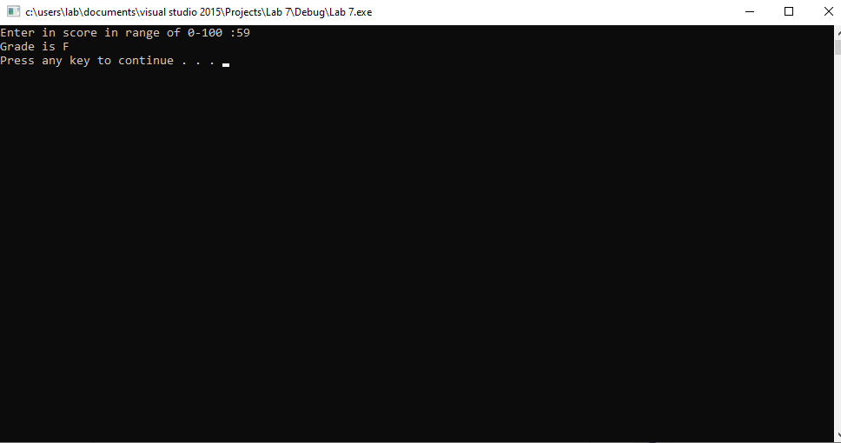

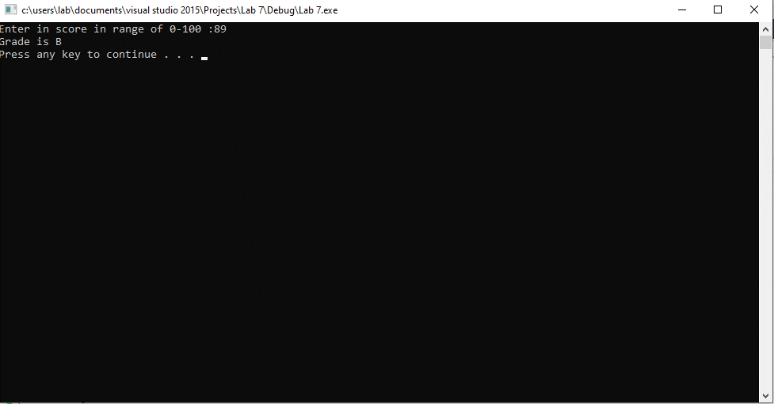

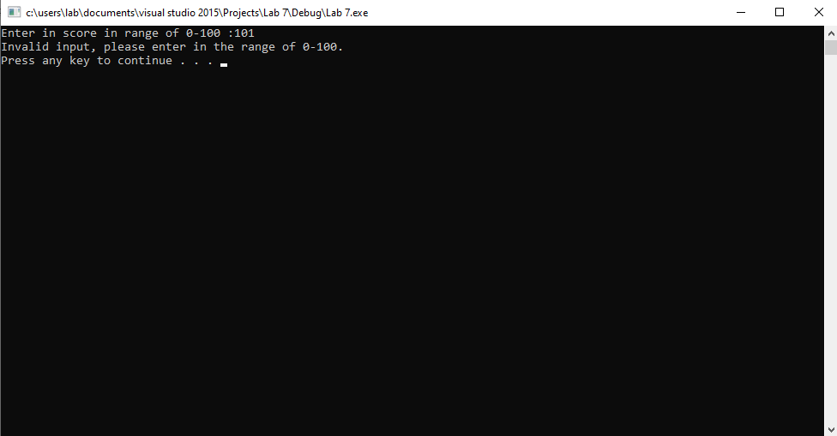

Question#3

#include <iostream>

using namespace std;

int main() {

int val;

float area, base, height, lenght, side, radius, width;

cout << "Choose a Shape :\n Press 1 for Circle,\n Press 2 for Rectangle,\n Press 3 for Triangle,\n Press 4 for Square \n";

cout << "Enter Shape Number :"; cin >> val;

switch (val)

{

case 1:

cout << "Enter Radius : "; cin >> radius;

cout << "Area =" << 3.14*(radius*radius);

break;

case 2:

cout << "Enter Lenght :"; cin >> lenght;

cout << "Enter Width :"; cin >> width;

cout << "Area = " << lenght*width;

break;

case 3:

cout << "Enter Height"; cin >> height;

cout << "Enter Base :"; cin >> base;

cout << "Area =" << 0.5*(base*height);

break;

case 4:

cout << "Enter Side :"; cin >> side;

cout << "Area =" << side*side;

break;

}

cout << endl;

system("pause");

}

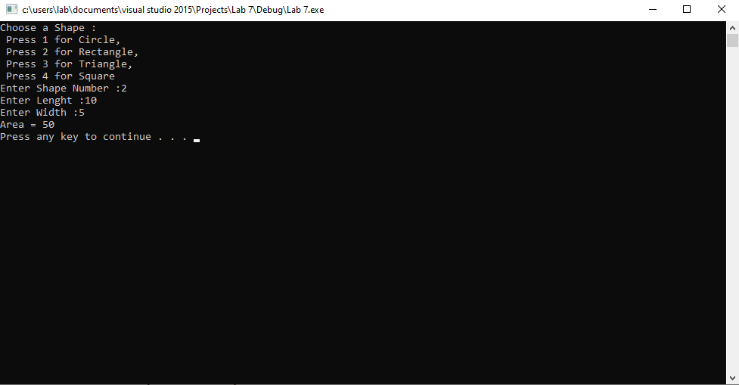

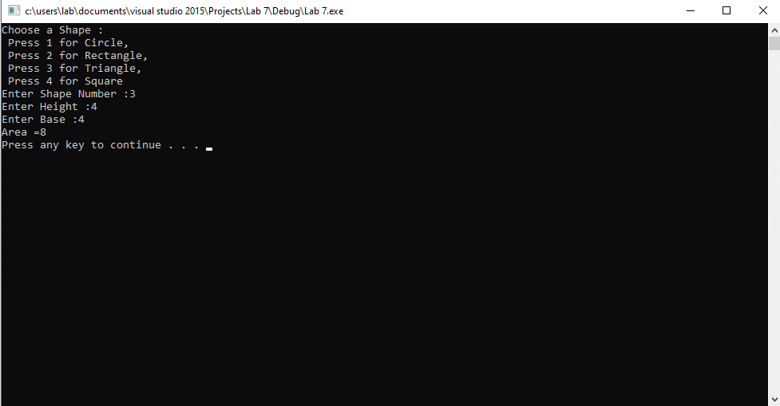

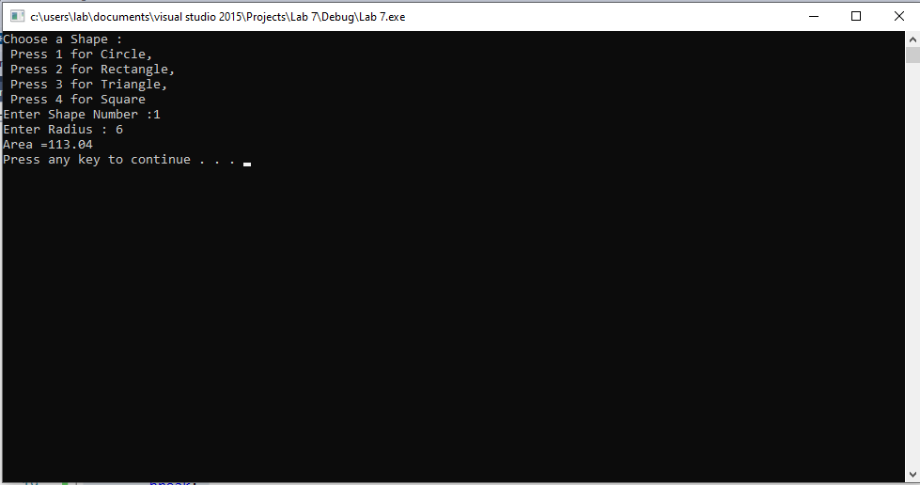

Question#4

#include <iostream>

using namespace std;

int main() {

float tsa, ip, exp_points, ap, exp,total,aqaddpoints;

cout << "Enter Marks Obtained in Technical Skills Assessment :"; cin >> tsa;

cout << "Enter Score Obtained in Interview Performance :"; cin >> ip;

cout << "Enter Experience in years :"; cin >> exp;

cout << "Enter Number of Additional Certificates and Qualifications :"; cin >> ap;

if (tsa < 60) {

cout << "You are not Eligible";

}

if (exp < 6) {

exp_points = exp * 10;

}

else if (exp > 5) {

exp_points = 50;

}

total = (tsa*0.4) + (ip*0.3) + (exp_points*0.2) + (10*ap*0.1);

cout << "Total Score :" << total << endl;

if (total < 70) {

cout << "You are not Eligible";

}

cout << endl;

system("pause");

}

