**Name : Abdullah Khan Niazi**

**Roll No : 23F-0017**

**PF_LAB#10**

**Question#1**

#include <iostream>

using namespace std;

int main() {

int n,num,orignal_num = 0, remainder = 0 ,armstrong=0,invalid=0,valid=0,Num=0;

cout << "How Many Numbers You Want To Enter : "; cin >> n;

for (int i = 1; i <= n; i++) {

int digit = 0, sum = 0;

cout << "Enter a Number : "; cin >> num;

if (num < 0) {

cout << "Invalid Input"<<endl;

invalid = invalid + 1;

}

else {

valid = valid + 1;

orignal_num = num;

Num = num;

while (num > 0) {

num = num / 10;

digit = digit + 1;

}

while (Num > 0) {

int power = 1;

int k = 0;

remainder = 0;

remainder = Num % 10;

for ( k = 0; k < digit; k++) {

power = power * remainder;

}

sum = sum + power;

Num = Num / 10;

}

if (orignal_num == sum) {

cout << orignal_num << " is an Armstrong Number" << endl;

armstrong = armstrong + 1;

}

}

}

cout << "Out of Given Inputs There Was " << invalid << " Invalid Input And "<<valid<<" Valid Inputs.";

cout << armstrong << " Were Armstrong Numbers And The Rest Were Not." << endl;

return 0; }

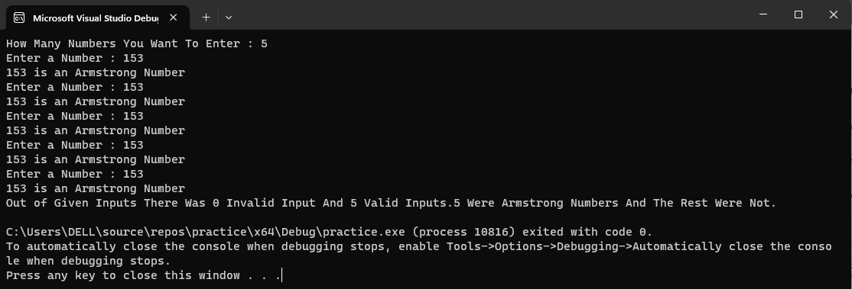

**Question#2**

**1-) Hollow Full Pyramid**

#include <iostream>

using namespace std;

int main() {

for (int i = 1; i <= 6; i++) {

for (int j = 1; j <= 6 - i; j++) {

cout << " ";

}

for (int k = 1; k <= 2 * i - 1; k++) {

if (i == 6 || k == 1 || k == 2 * i - 1) {

cout << "*";

}

else {

cout << " ";

}

}

cout << endl;

}

return 0;

}

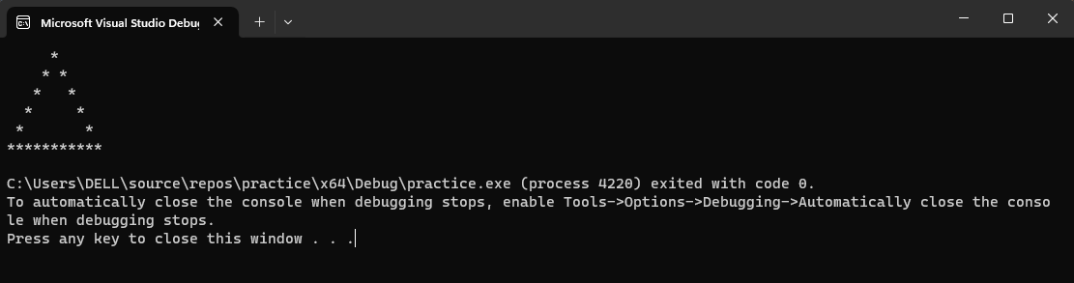

**2-)Pyramid**

#include <iostream>

#include <iomanip>

using namespace std;

int main() {

int i , j;

for (i = 1; i <= 5; i++) {

for (j = 1 ; j <= (5-i) ; j++)

cout << " ";

for (j = 1 ; j <=i ; ++j)

cout << setw(1) << j;

for (j = (i- 1) ; j >= 1 ; j--)

cout << setw(1) << j;

cout << endl;

}

return 0;

}

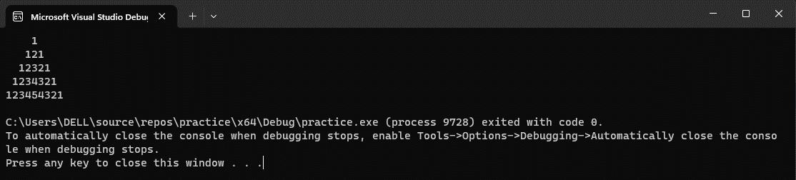

**3-) Solid Half Diamond**

#include <iostream>

using namespace std;

int main() {

int size = 0;

for (int i = 0; i < 5; i++) {

for (int j = 0; j <= i; j++) {

cout << "*";

}

cout << endl;

}

for (int i = 3; i >= 0; i--) {

for (int j = 0; j <= i; j++) {

cout << "*";

}

cout << endl;

}

return 0;

}

