 | National University  of Computer and Emerging Sciences  Chiniot-Faisalabad Campus  Department of Artificial Intelligence and Data Science | 
Course Code | AI3002
Course Title | Machine Learning – Lab
Lab Task | 1
Due Date | 28 August 2025
Instructions:
- Rename this Word file as LT1_23F0007
- If found plagiarism, straight zero will be marked against task.
- Submit task on Due Date. No Late Submission will be Tolerated.

Question 1
Write python code that bits as input and convert to Megabytes, Gigabytes and Terabytes.
Code
def func(bytes):
megabytes = bytes // (1024 * 1024)
gigabytes = bytes // (1024 * 1024 * 1024)
terabytes = bytes // (1024 * 1024 * 1024 * 1024)
return megabytes, gigabytes, terabytes
bytes = 1234567890000000
mb, gb, tb = func(bytes)
print("Megabytes:", mb)
print("Gigabytes:", gb)
print("Terabytes:", tb)

Screenshot
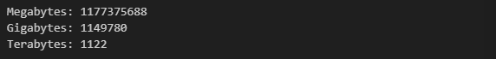

Question 2
Write python program takes in a number and finds the sum of digits in a number.
Code
num = int(input("Enter a Number : "))
sumOfDigits = 0
while num > 0:
sumOfDigits = sumOfDigits + num % 10
num = num // 10
print("Sum of Digits : ",sumOfDigits)

Screenshot
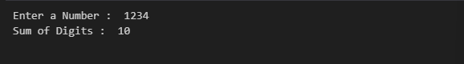

Question 3
Write python program to find common items from two lists.
Code
list1 = [1,2,3,4,5,6,7,8]
list2 = [9,10,11,12,13,14,1]
commonElements = []
for i in list1:
if i in list2:
commonElements.append(i)
print("Common Elements : ",commonElements)

Screenshot

Question 4
Write a python function that accepts a string and calculate the number of upper case letters and lower case letters.
Code
def func(string):
upper_case = 0
lower_case = 0
for char in string:
if char.isupper():
upper_case += 1
elif char.islower():
lower_case += 1
return upper_case, lower_case
string = "Hello World"
upper, lower = func(string)
print("Upper Case Letters:", upper)
print("Lower Case Letters:", lower)

Screenshot

