 | National University  of Computer and Emerging Sciences  Chiniot-Faisalabad Campus  Department of Artificial Intelligence and Data Science | 
Course Code | AI3002
Course Title | Machine Learning – Lab
Lab Task | 2
Due Date | 04 September 2025
Instructions:
- Rename this Word file as LT2_23F0007
- If found plagiarism, straight zero will be marked against task.
- Submit task on Due Date. No Late Submission will be Tolerated.

Question 1
Write python code that frequency of the dice value if dice rolled 500 times. Display the count of each number on a dice as a histogram. Also show the occurrence of max frequency number in percentage of total.
Code
import numpy as np
import matplotlib.pyplot as plt

arr = np.random.randint(1,7,500)

count = [0,0,0,0,0,0]
for i in arr:
if i == 1:
count[i - 1] += 1
elif i == 2:
count[i - 1] += 1
elif i == 3:
count[i - 1] += 1
elif i == 4:
count[i - 1] += 1
elif i == 5:
count[i - 1] += 1
elif i == 6:
count[i - 1] += 1
for i in range(len(count)):
print(f"Value {i+1} : {count[i]}")
print(f"Value {count.index(max(count)) + 1} Occurred Maximum Times With {max(count) * 100 / 500} %")

plt.hist(arr,bins = 15)
plt.xlabel('Dice Value')
plt.ylabel('Frequency')
plt.title('Dice Roll Frequency Histogram')
plt.xticks(np.arange(1, 7))
plt.show()

Screenshot
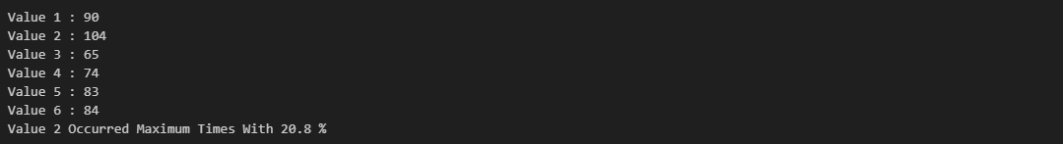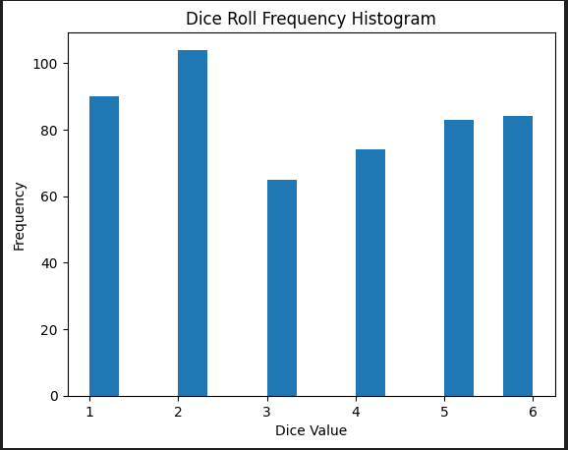

Question 2
Write a python code that implement pandas and numpy basic functions on titanic dataset in csv file. Replace the null values of age with mean using pandas. Display the count of survived passengers older than 70 yrs. Also Find the survival rate grouped by gender.
Code
import pandas as pd
import numpy as np

df = pd.read_csv('Titanic-Dataset.csv')
df.head()
df['Age'] = df['Age'].fillna(df['Age'].mean())
df.isna().sum()
count = df[(df['Survived'] == 1) & (df['Age'] > 70) ]
print("Number of People Survived and Aged Above 70:",len(count))
grouped_df = df.groupby('Sex')['Survived'].sum()
grouped_df
print("Survival Rate For Males: ",grouped_df['male'] * 100 / (df['Sex'] == 'male').sum())
print("Survival Rate For Females: ",grouped_df['female'] * 100 / (df['Sex'] == 'female').sum())
Screenshot
Missing Values
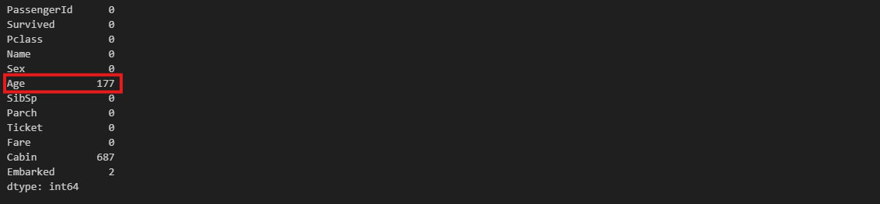
After Data Cleaning
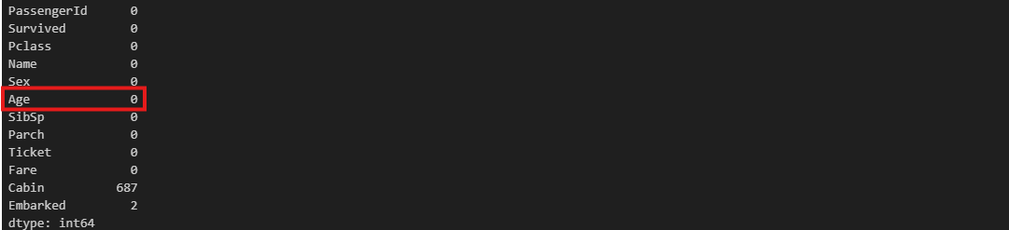
Number of People Survived Aged Above 70
Number of Male & Females Survived
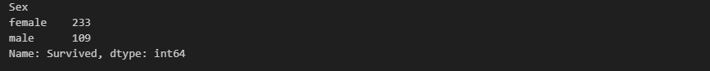
Survival Rate by Gender

