BSc (Hons) Artificial Intelligence and Data Science

Module: CM1605 Web Technology

Module Coordinator: Ms. Janani Harischandra

Group Coursework Report

Tutorial Group : A
Student Details :

Students :
RGU ID | IIT Student ID | Student Name
2330933 | 20231233 | Danishya Shanmuganathan
2330923 | 20230976 | Abdullah Nazly
2330961 | 20232095 | Asjath Nawfel
 | 20231219 | Nethma Gunarathna

Table of Contents
List of Figures 3
1.Introduction 4
2. Technical Discussion. 5
2.1. Student 1. 5
2.1.1. Presentation page 5
2.1.2. Sign Up. 5
2.2. Student 2. 7
2.2.1. Home page. 7
2.2.2. Quiz page. 9
2.2.3. Comment page. 11
2.3. Student 3. 14
2.4. Student 4. 15
3. Navigation Technique. 16

List of Figures

1.Introduction

This report demonstrates the development of an interactive website called Duke Learn, which is a language learning recommendation System. This system provides users with the ability to create personalized profiles, a gallery page to view the pictures and details of the books, Furthermore, the shopping cart allows the user to buy products that are related to books, and there is a quiz to improve their knowledge about books. The names of the group-members are:

• Danishya Shanmuganathan RGU-ID: 2330933 – Student-Role-1

• Abdullah Nazly RGU-ID: 2330923 – Student-Role-2
• Asjath Nawfal RGU-ID: 2330961 – Student-Role-3
• Nawfel Asjath Ahamedh RGU-ID: 23 – Student-Role-4

2. Technical Discussion.

2.1. Student 1.

2.1.1. Presentation page

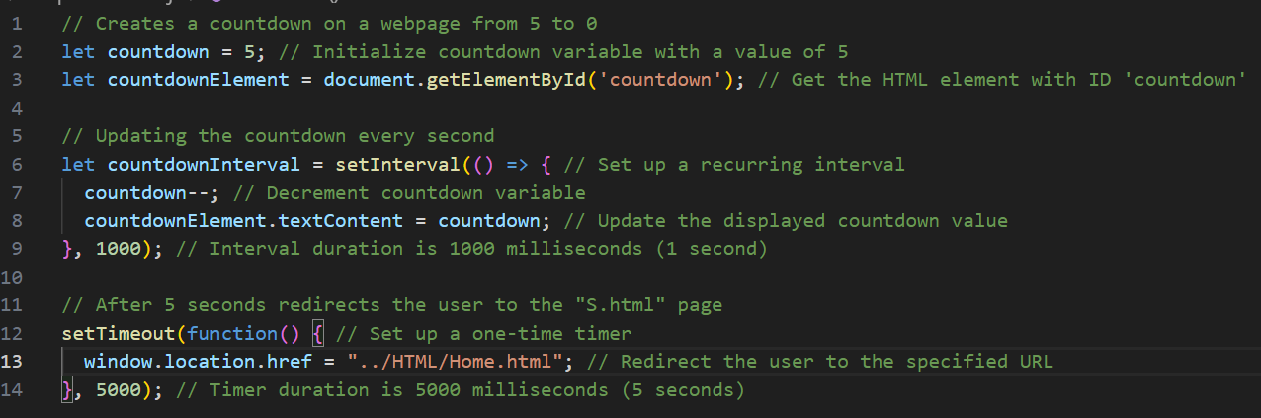
The presentation page is the first page of the website. It has background video playing for 5 seconds in the background. While playing the video, the name of the website “Duke Learn” will be displayed step by step on the presentation page. The countdown is done by few JavaScript codes below.


user navigates to home page automatically after 5 seconds by using the function “setTimeout()” function. Path of the home page also assigned within the function. The presentation page will be look like this.

2.1.2. Sign Up.

The appearance of the sign-up page will look like this.

2.2. Student 2.

2.2.1. Home page.

The home page has a chat box, which will respond according to what user asks. It’s done using the following JavaScript snippets.
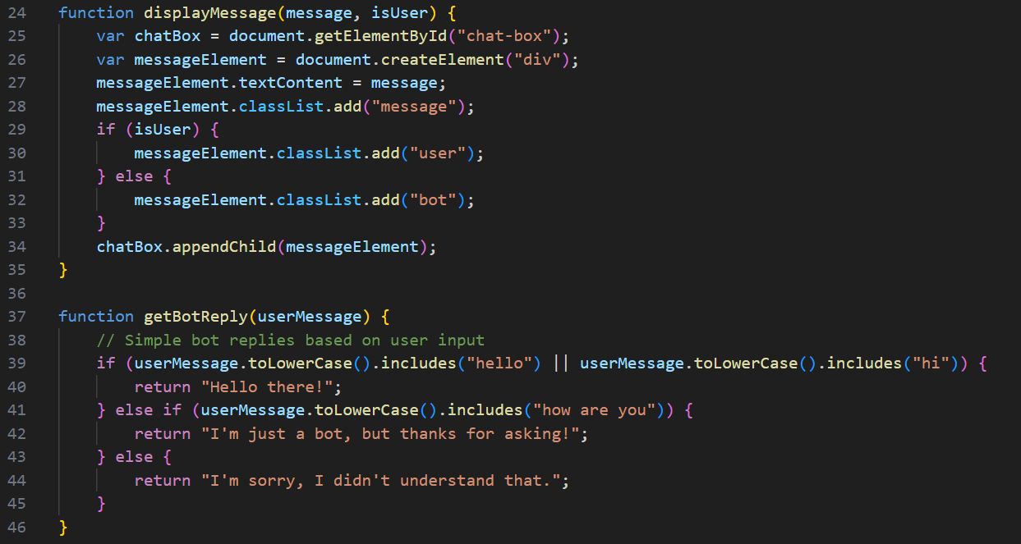
In this code we can see how chatbots respond according to user input. getBotReply() function displays what the chatbot’s response will be. The following function will change the user prompt to lowercase so that chatbot can receive it as lowercase.
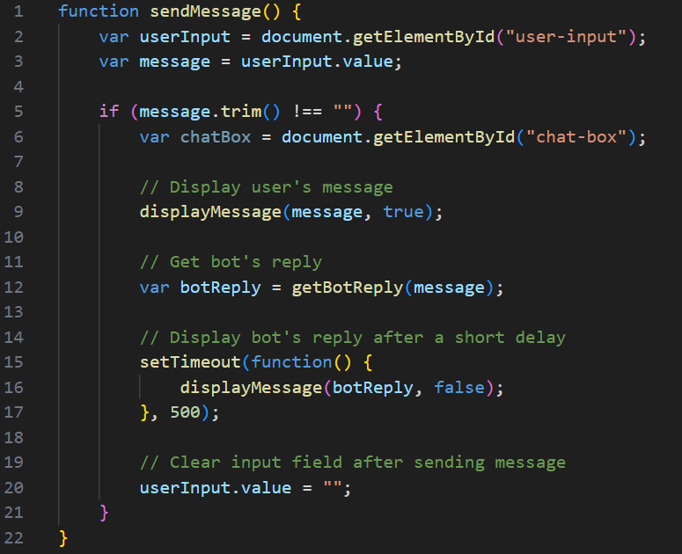
The chatbot will be looked like this.
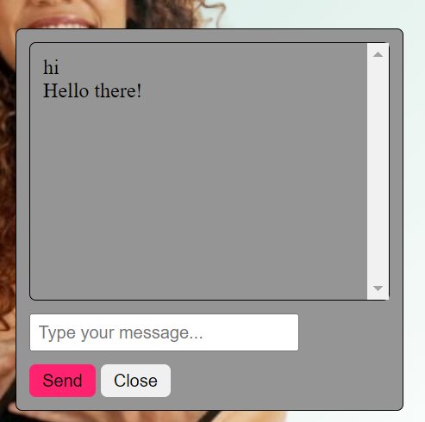
The home page will look like this.
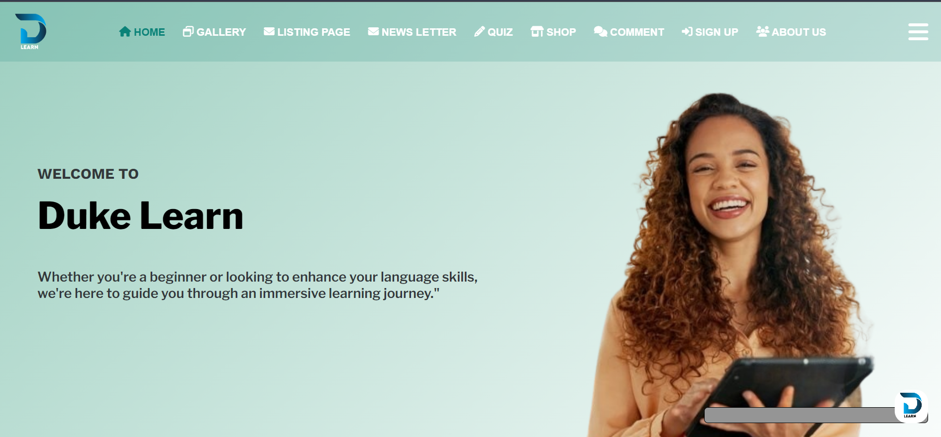

2.2.2. Quiz page.

The functionality of the quiz part starts when the start button is clicked.
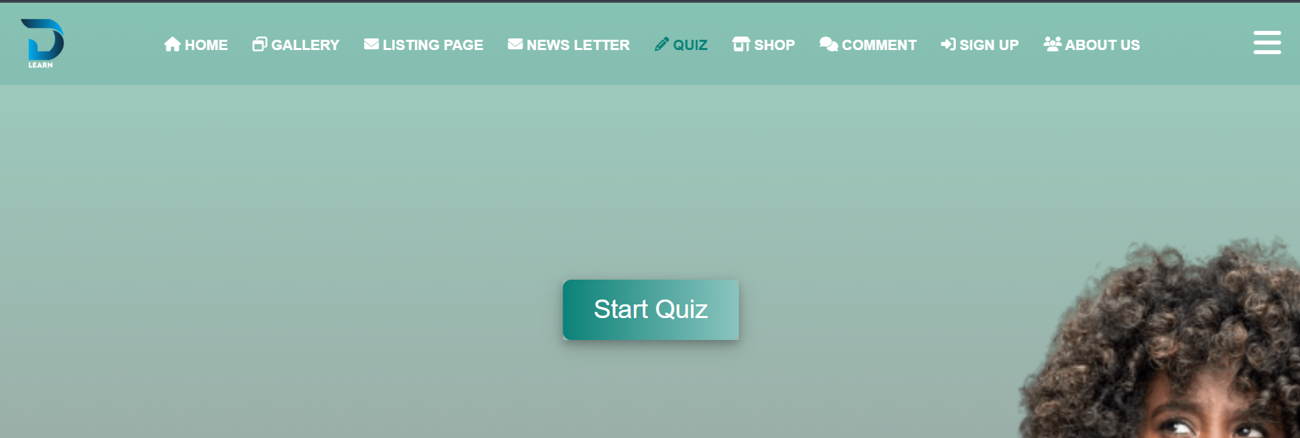
After that the instructions for the quiz game will be displayed like this. If the Exit button is clicked, it will be redirected to the page with start button again. If the continue button is clicked, the quiz will start. The quiz has a limited amount of time for each question as it is mentioned in the instruction box. Question numbers, times, marks are validated in the JavaScript. The Question are stored in a different JavaScript file named “Questions.js”.

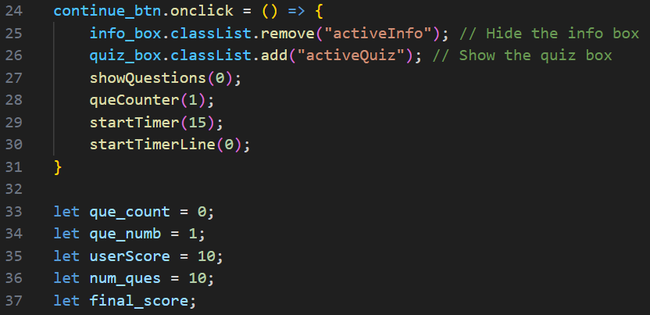
The appearance of the quiz page will look like this.
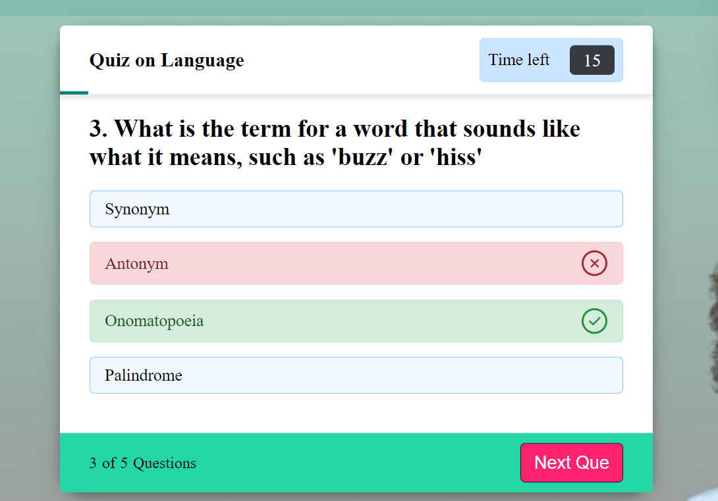
The question will be displayed with the help of following code snippets.
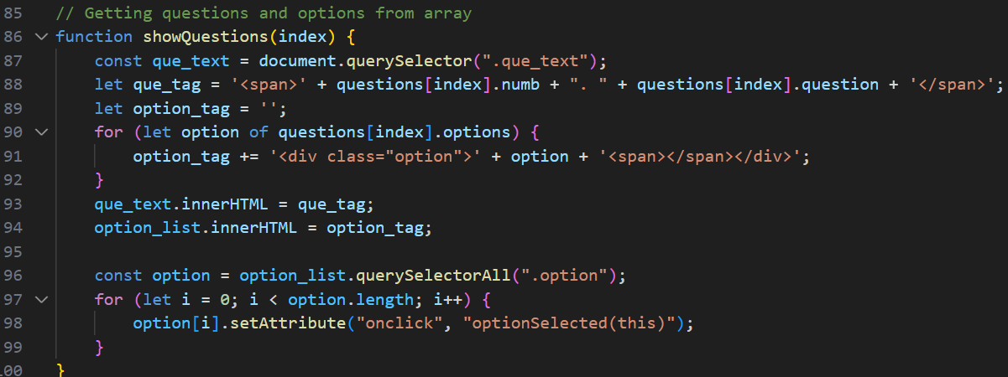

Finally, the results will be displayed by using the following code snippets

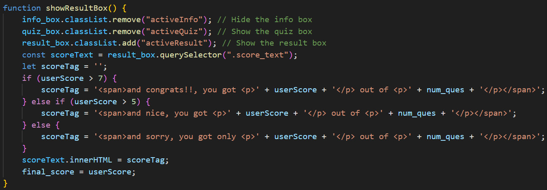

The results will be displayed in the following way.
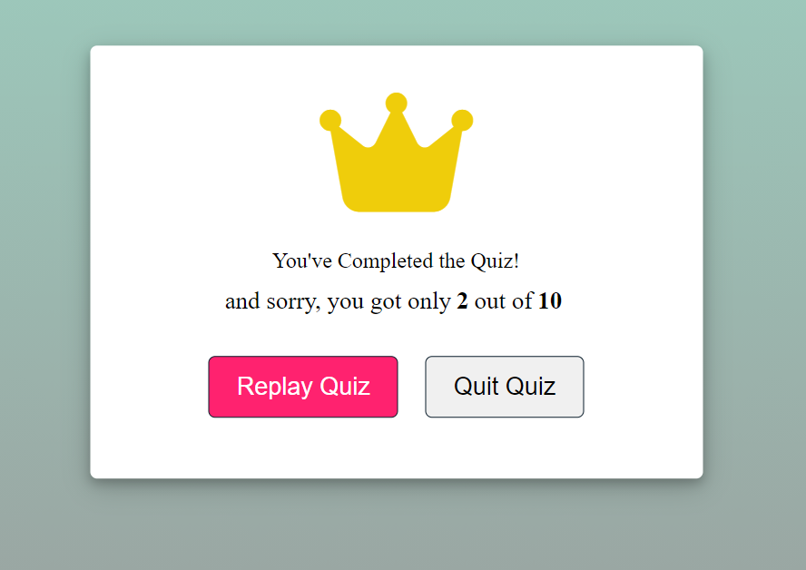

2.2.3. Comment page.

Page for the comment is successfully validated for each field. If any filed is empty it will pop an alert message to fill that field. After the successful inputs of the user. It will display a pop-up message saying that the comment is successfully sent.

The rise validations are done by following codes.

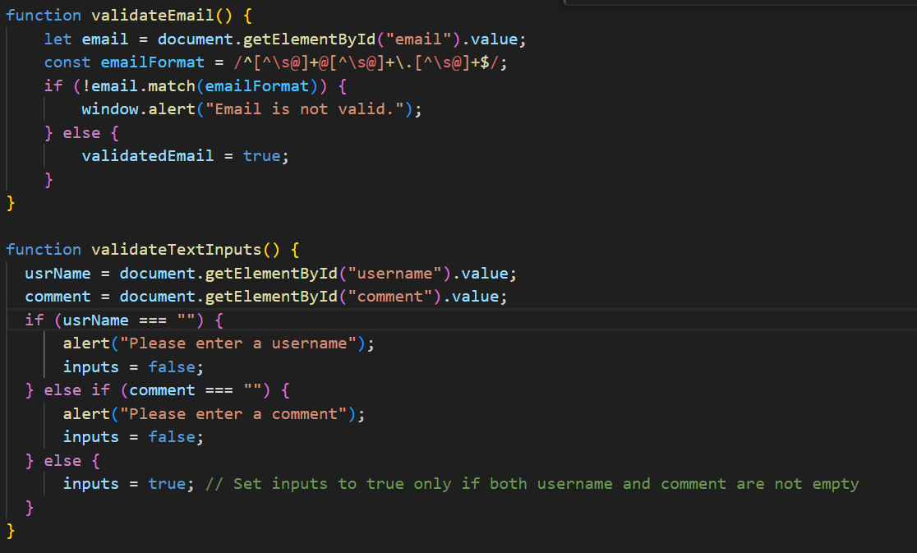
The alert messages are displayed as follows:
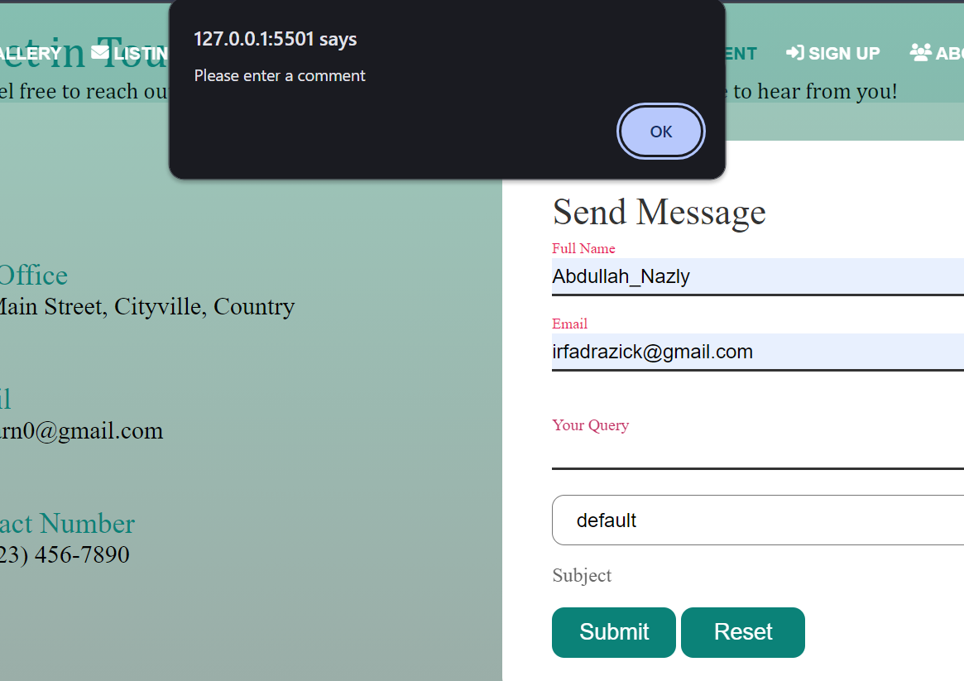

If all the inputs are validated, it will give a pop-up message.
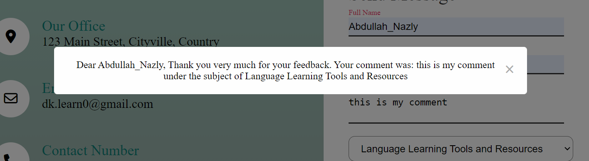

2.3. Student 3

2.3.1 Product page

On my product page, users can select the products, and the quantity depends on their needs. Here is the functionality fo
Add product to Cart

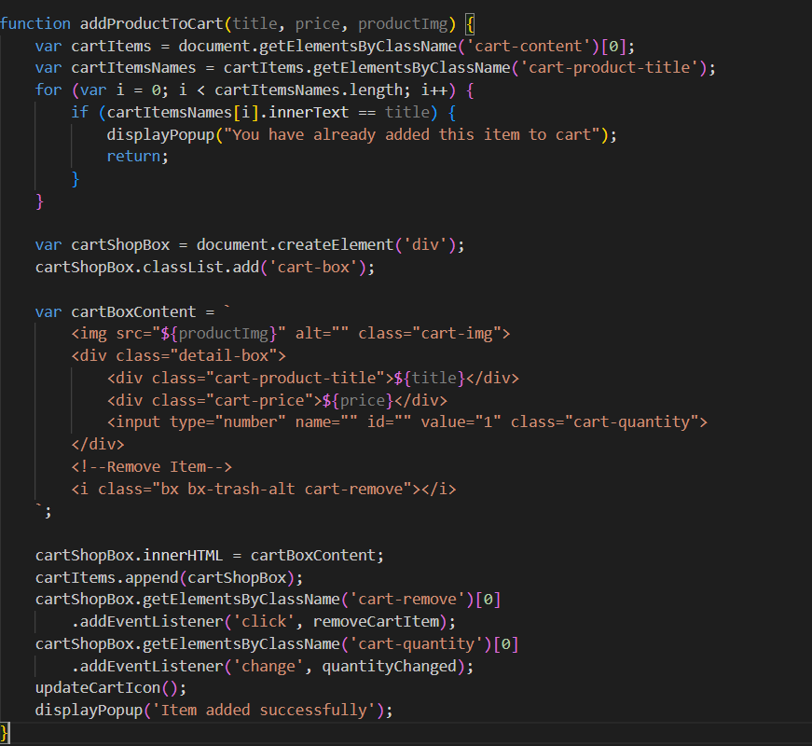

Remove from cart

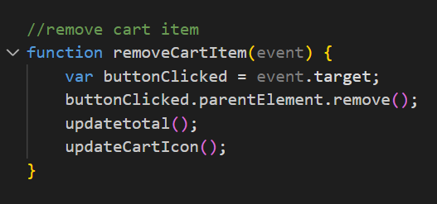

Update total

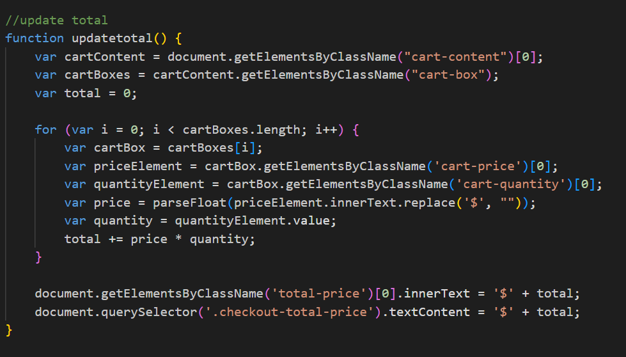

Here are my product page and cart visuals.

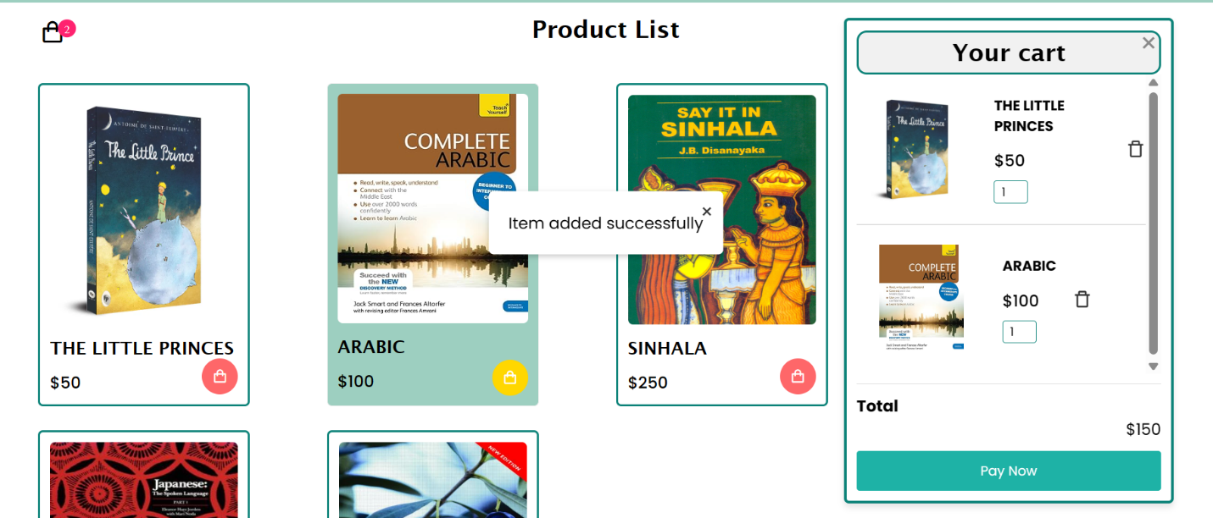

And after the products comes to the cart user should checkout for to place order so here also, I put validation for the checkout form

Here I validate the form fields (name, email, phone number, address, card number, and expiry date) before allowing the user to place an order. It checks for empty fields and formats such as email, phone number, card number, and expiry date.

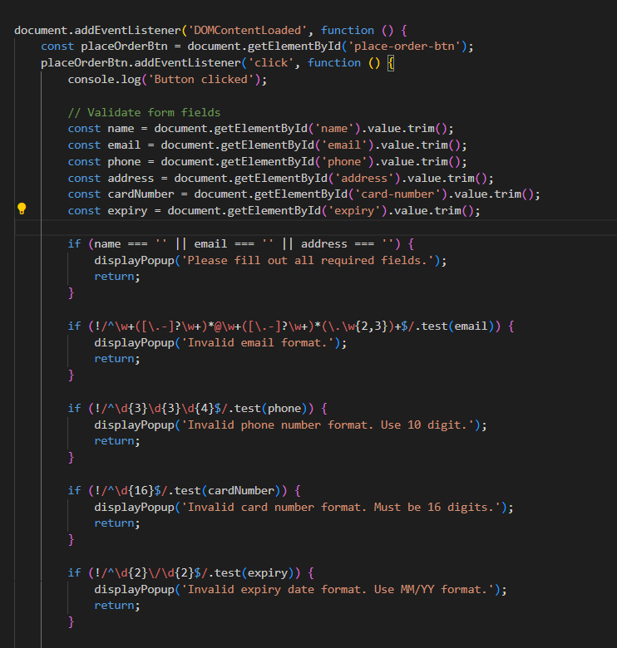
Here is the validation for the visual
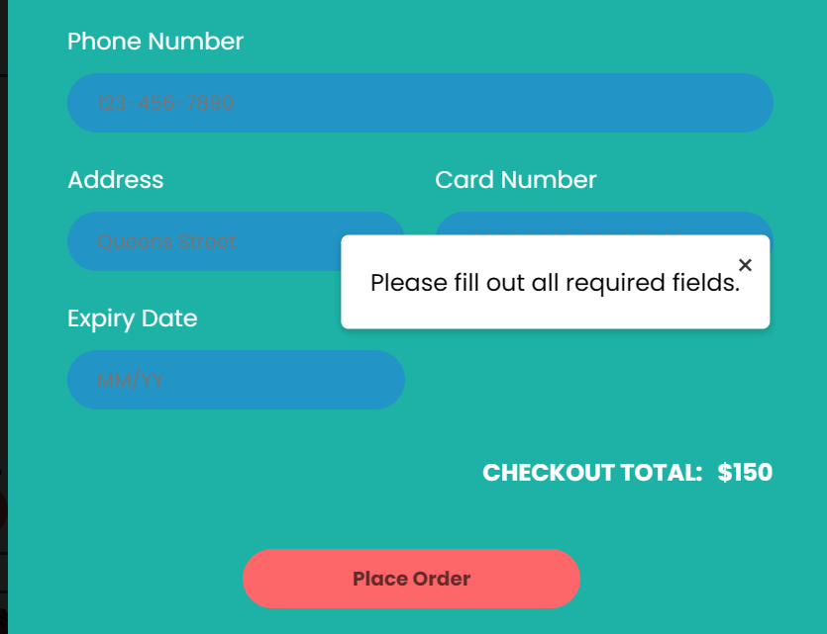

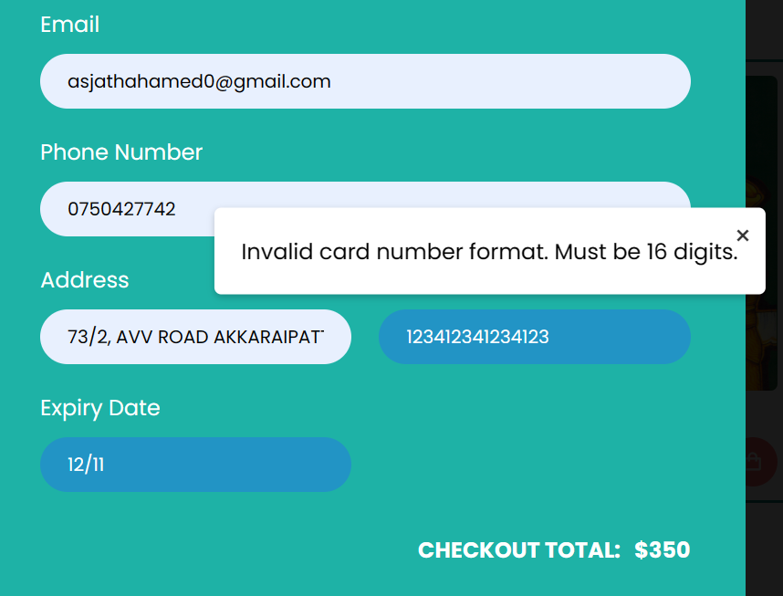

After the user completes the checkout form fields, a summary popup will appear.
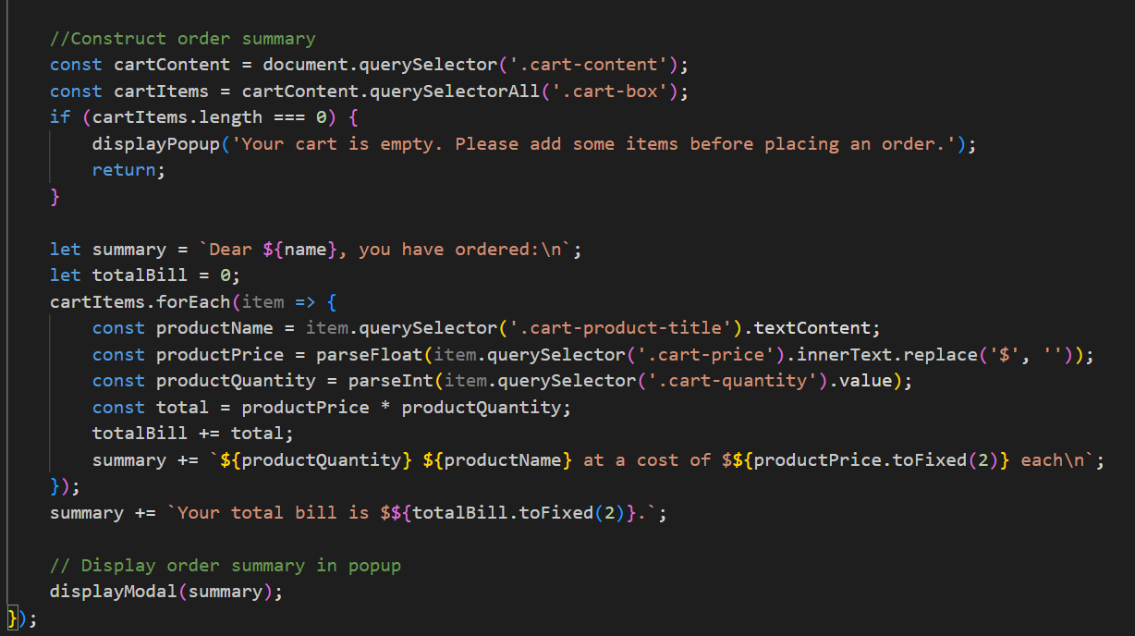

This pop-up summary should display the summary of the products bought by the user. Here is a view of the pop-up summary.

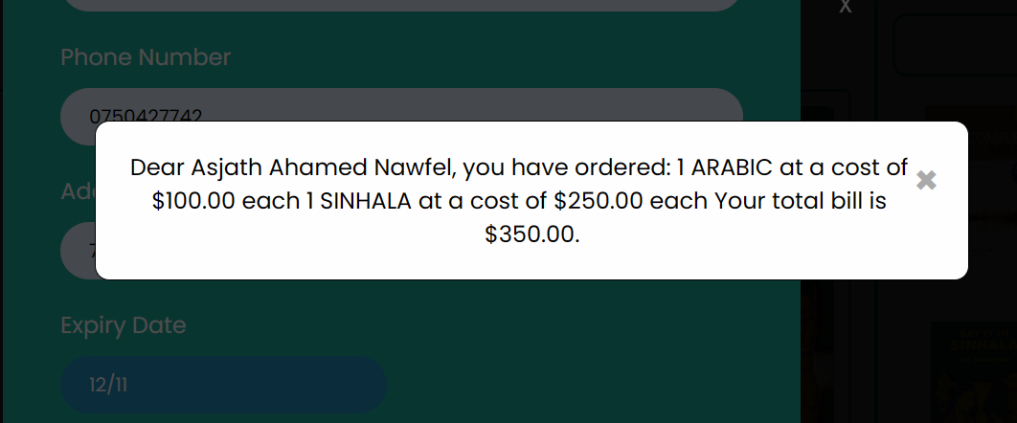

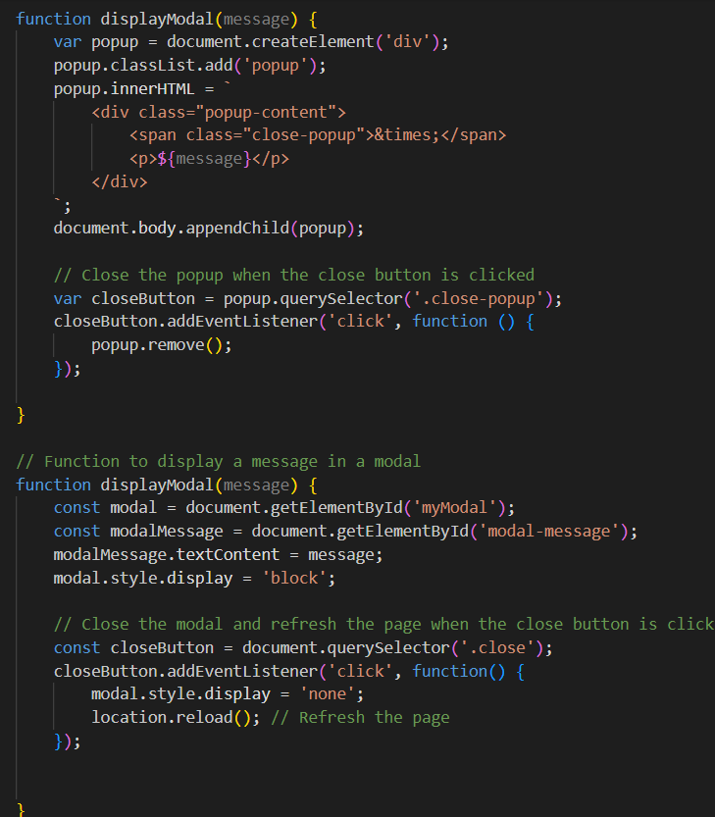
Here, for the validation and summary pop, I used a different function for each.

2.3.2 About Us

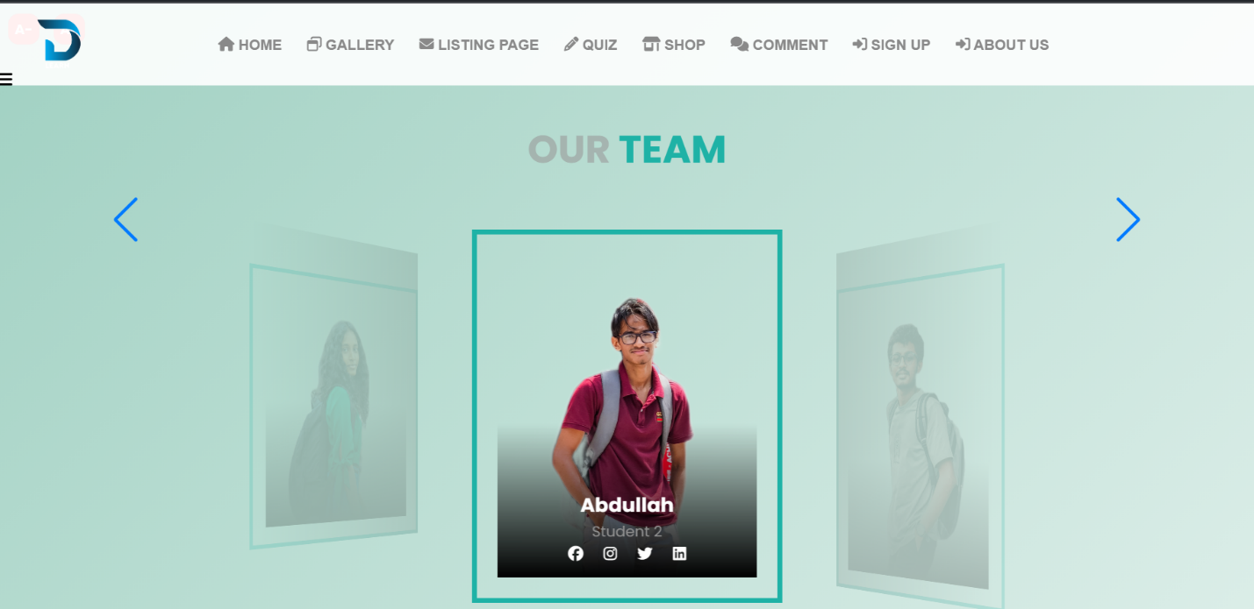
In my about us page, I provide my team members with social links. Also, my about us page is swiper and slidable so users can see the members in two different ways.

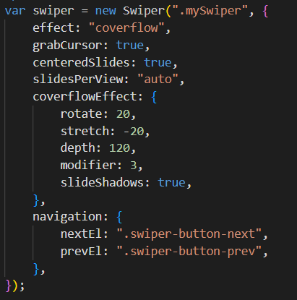
Here I used JavaScript for the swiper function
After that, I used JavaScript for the font size increase and decrease.
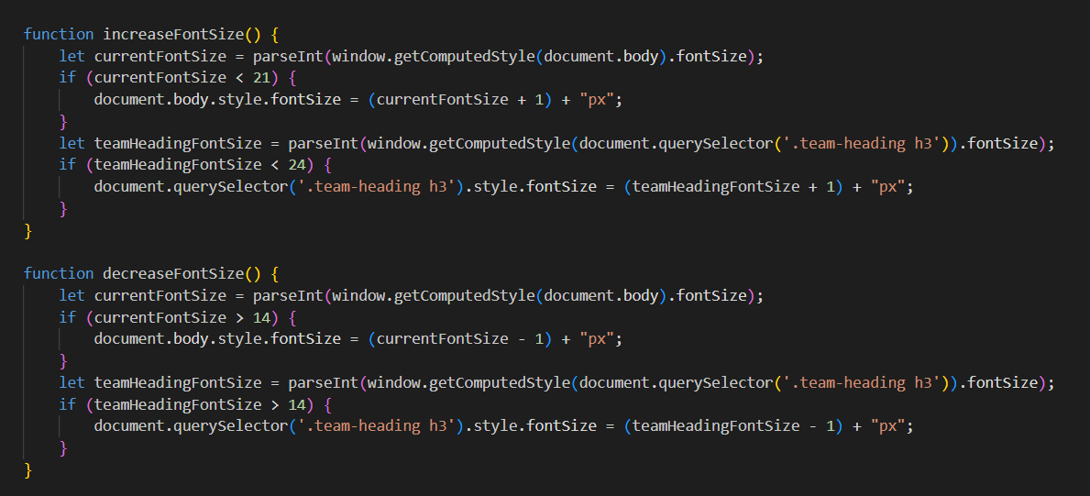

Here is the button for the size increase and decrease.



2.4. Student 4.

3. Navigation Technique.

The navigation bar is successfully created which fits to each page. On the left side it has the logo of the website. The middle area has tabs for each page. right area has the check button which can make it responsive when the window is resized.
Hovering color and active color are the same.
These are the HTML codes for navigation bar.
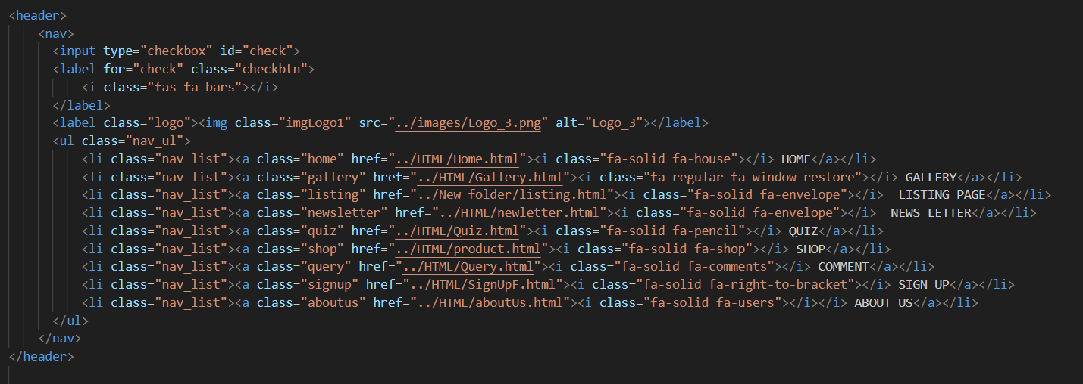

These are CSS codes for navigation bar.
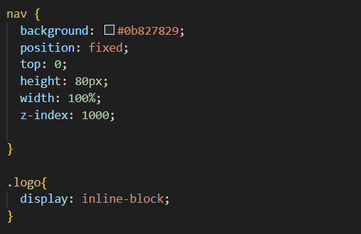
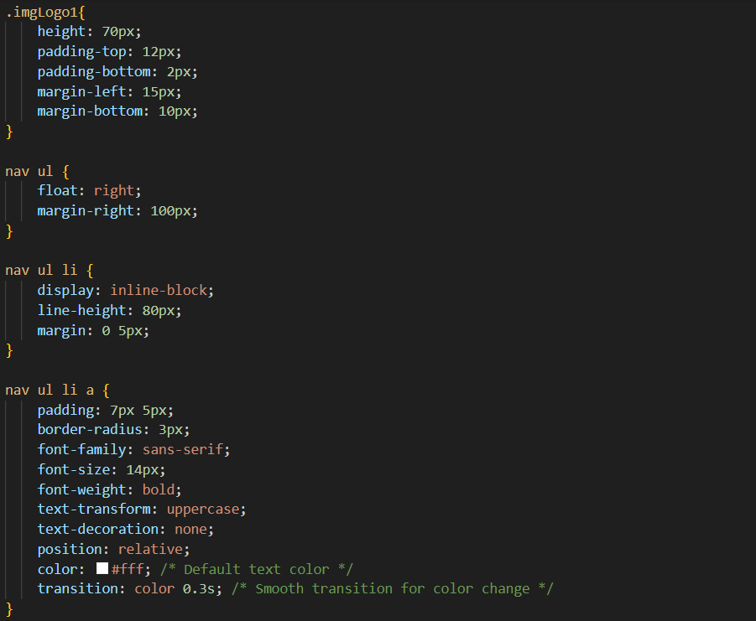
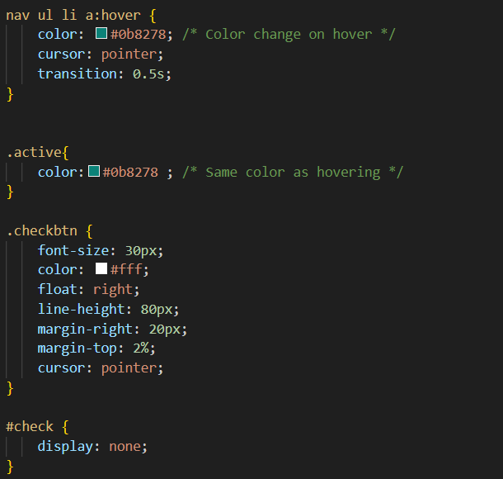

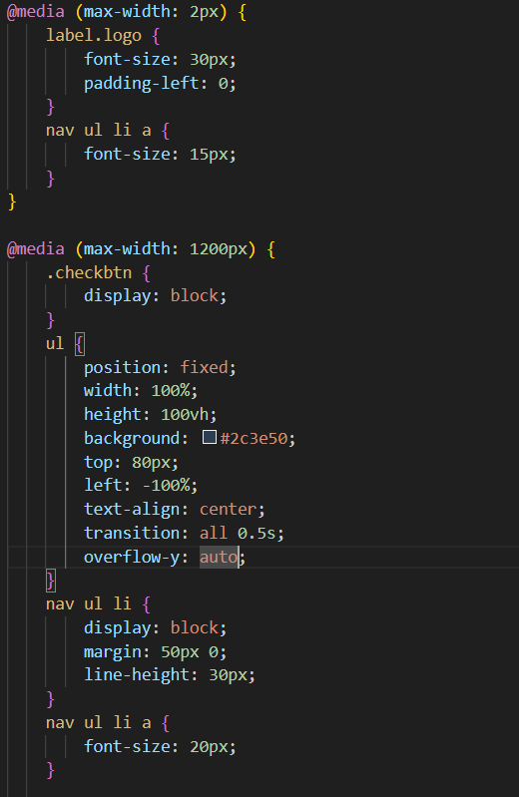
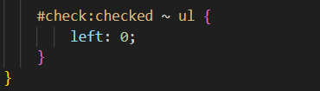

The activation of tabs was done by using the following JavaScript.
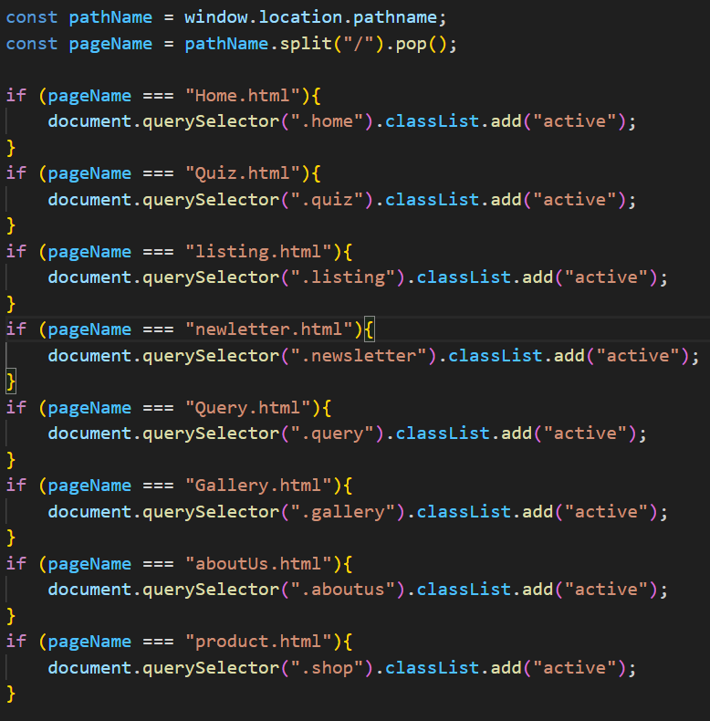
It takes the path of each website and makes it active.Behavior of navigation bar when the window is resized.
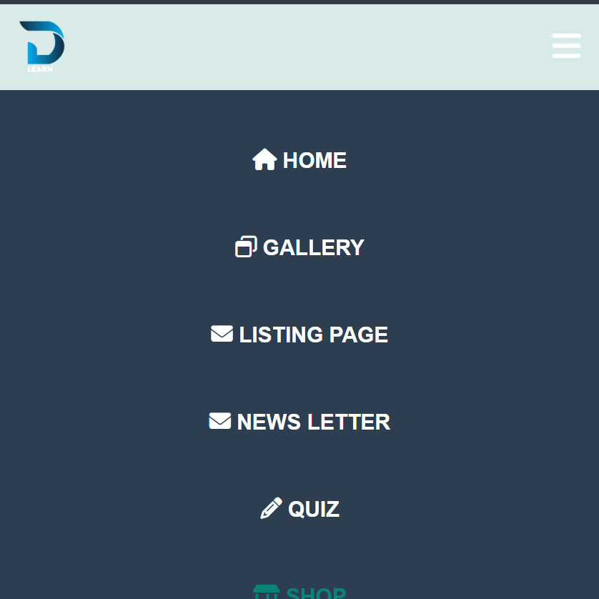

4. Color Balance/Selection.

