**Semester Project Documentation**

**Semester Project Title**: Notification Board App

**Student Details**

|  |  |  |  |
| --- | --- | --- | --- |
|  | Student Name | Student Reg # | Student Degree |
| Student-1 | Abdullah Noor | 2022029 | AI |

**Main Features**

**1: Admin:**

* **Create users and new Notifications.**
* **Delete notifications and edit them.**
* **Login**

**2: Teacher:**

* **Create new Notifications.**
* **Edit own Notifications.**
* **Login**

**3: Students:**

* **Login and view notifications**

**Types of Users**

1: Admin

2: Teacher/Faculty

3: Student

**Requirements Breakdown**

*(Write requirements of each feature by numbering. For example: Requirements of feature # 1. It will be mentioned as 1.1, 1.2. Similarly for feature # 2 it will be 2.1, 2.2, 2.3 … etc.)*

Admin:

1.1 The system must allow the admin to create new user accounts.

1.2 The system must provide the admin with the ability to create new notifications.

1.3 The system must allow the admin to edit and delete notifications.

1.4 The system must allow the admin to login to the system.

Teacher:

2.1 The system must allow the teacher to create new notifications.

2.2 The system must allow the teacher to edit their own notifications.

2.3 The system must allow the teacher to login to the system.

Students:

3.1 The system must allow students to login.

3.2 The system must allow students to view notifications posted by admins or teachers.

**GUI Screens / Design / Wireframes**

*(Think what kind of GUI your application should have. Make a simple and easy one, you do not need to create complex design, copy, and paste screenshot of your design under this heading)*

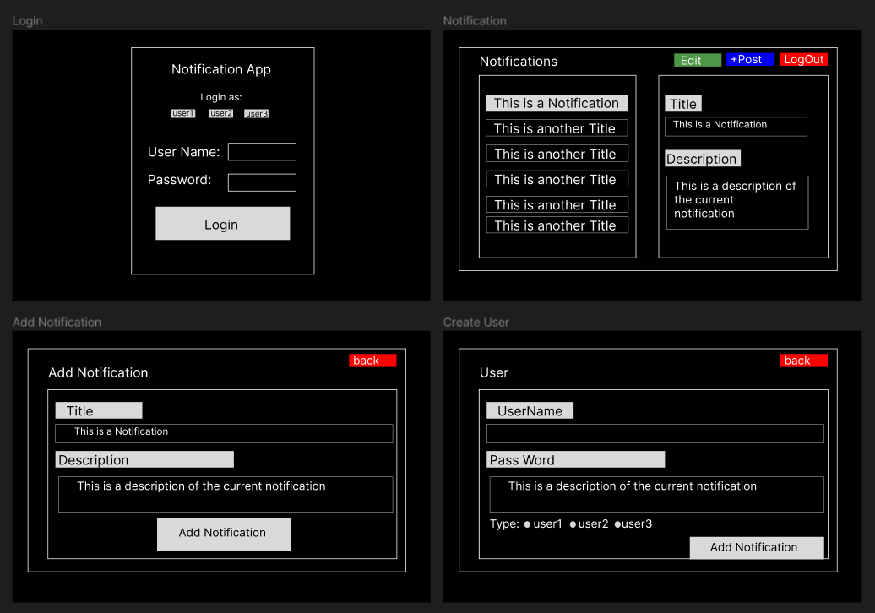

**Features to Codding Matrix**

*(In the following table you will mention the following items for each feature, mention the items in each column for each feature of your application)*

|  |  |  |  |  |  |
| --- | --- | --- | --- | --- | --- |
| Sr  no. | Feature Name | OOP Type Used | Functions Created | Variables / Obj Created | Line of Code Written |
| 1 | Main Window ( Handles UI and Front End Operations / Features ) | Class + polymorphism | 22 | 7 | 82(Base) , 425(Implementation) |
| 2 | Backend (Handles the backend ie: user operations , admin operations , post creation/ deletion etc) | Class + Friend Class | 9 | 6 | 45(Base), 110(class implementation) |
| 3 | App Object(represents all objects created) | Parent Class | 2 | 2 | 14 |
| 4 | Notification Object (represents all notification objects), provides a template for notification Objects | Inheritance (child of App Object) | 3 | 3 | 17 |
|  |  |  |  |  |  |