* Name / Abdullah Salah Abdullah Abouzeid Farag
* Group / 4
* Section /22
* Bench number / 6
* Code /482
* Topic / Artificial Intelligence
* Screenshots /

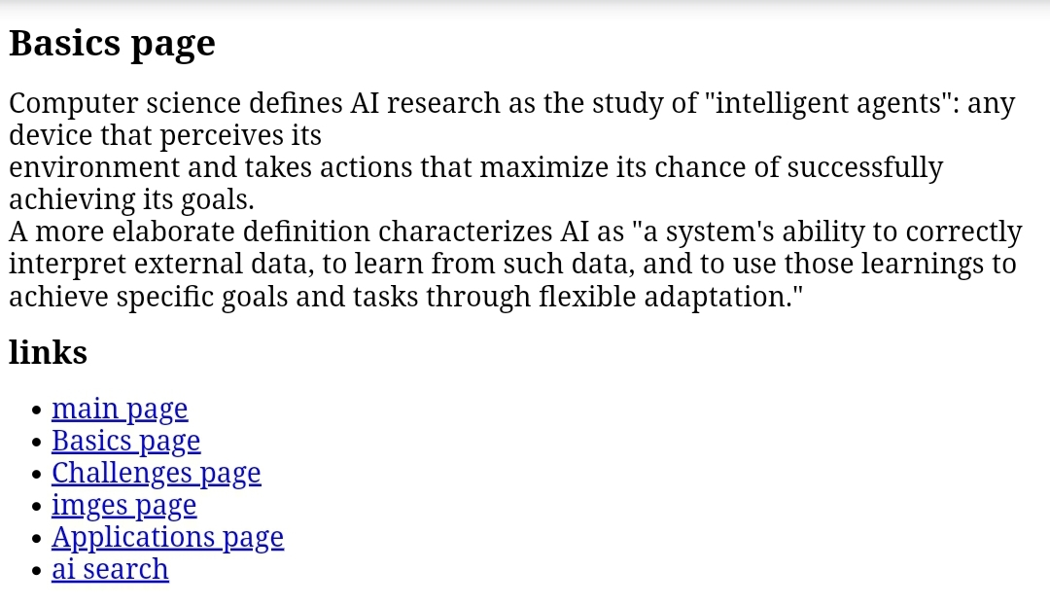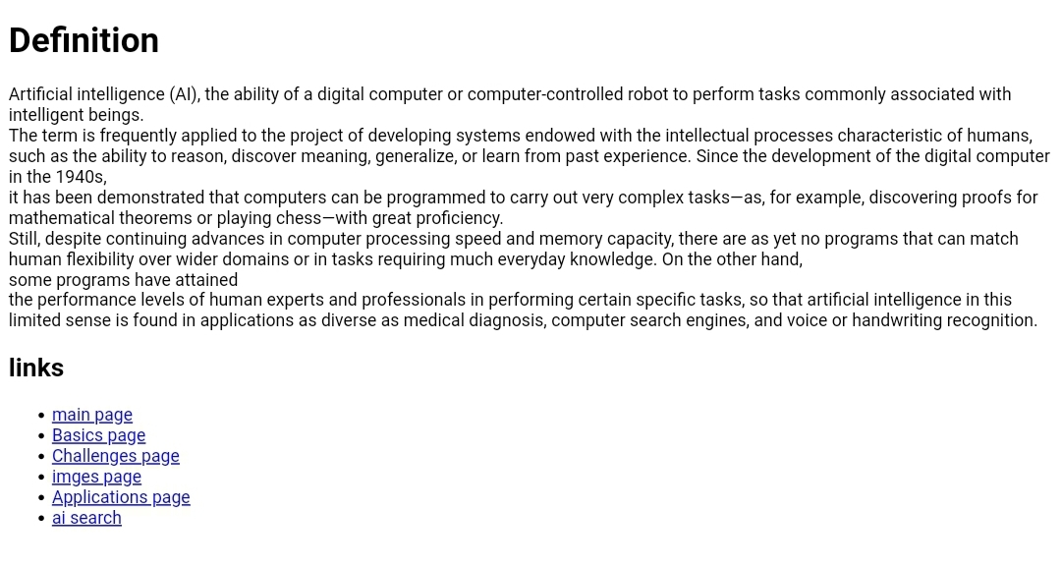

* Source code /