
FACULTY OF ENGINEERING, SCIENCES AND TECHNOLOGY
PROJECT IMPLEMENTATION REPORT
DECOUPLED ARCHITECTURE & HYBRID DATA FALLBACK INTEGRATION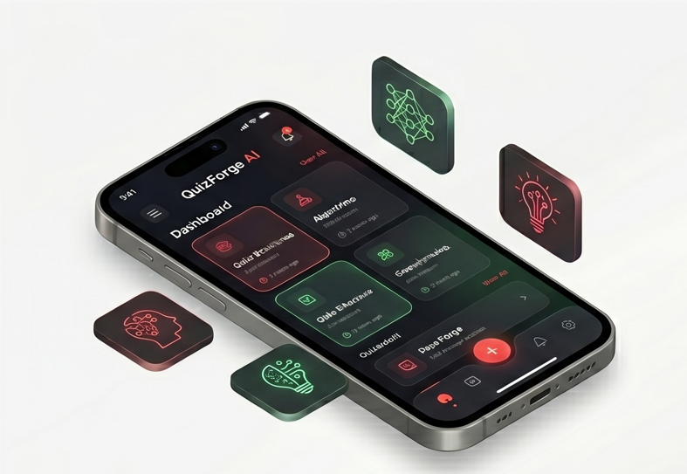

Domain: Full-Stack Mobile Application Development (Python/MS SQL hybrid stack)
Project Title: Quiz Forge AI
PROJECT by:
Abdullah Shah Alam
Muhammad Bilal
Zulqarnain Pasha
Date: June 18, 2026
1. PROJECT OVERVIEW & ARCHITECTURE
This report outlines the successful backend migration and local data synchronization framework developed for QuizForge AI. The application utilizes a highly robust, decoupled architecture designed to bridge a cross-platform frontend with an enterprise-grade backend database.
The core components of the system include:
• Frontend Ecosystem: Developed using React Native and Expo Go, utilizing asynchronous local storage architecture.
• Backend Ecosystem: Engine powered by Python FastAPI (Uvicorn server) implementing high-performance asynchronous REST endpoints.
• Database Management System: Enterprise deployment using Microsoft SQL Server (MS SQL) linked via SQLAlchemy Object-Relational Mapping (ORM).
2. CORE IMPLEMENTATION METHODOLOGY
The primary objective of this implementation stage was to establish a secure multi-tier user authentication flow (Sign Up and Sign In) and deploy a fault-tolerant, hybrid database persistence mechanism for user quiz records. The application prioritizes cloud storage by transmitting REST payloads via Axios to the backend API, but instantly defaults to local storage layers in non-network environments to eliminate runtime exceptions and prevent analytical data loss.
3. SYSTEM ARCHITECTURE & HYBRID DATA FLOW
3.1 High-Level Architecture Design
The QuizForge AI application is built on a modern, decoupled 3-Tier Architecture. This design ensures separation of concerns, making the system highly scalable and easier to debug.
• Tier 1: Client/Presentation Layer (Frontend): Developed using React Native and Expo. This layer manages the user interface, handles input validations, and contains the local AsyncStorage cache for offline operations.
• Tier 2: Business Logic Layer (Backend API): Powered by Python FastAPI and Uvicorn. This asynchronous server acts as the middleman. It receives HTTP requests, processes security hashes (bcrypt), and validates business rules before touching the database.
• Tier 3: Data Access Layer (Database): Managed by Microsoft SQL Server (MS SQL) and connected via SQLAlchemy ORM. This is the central repository where all persistent user identities and analytical quiz records are stored.
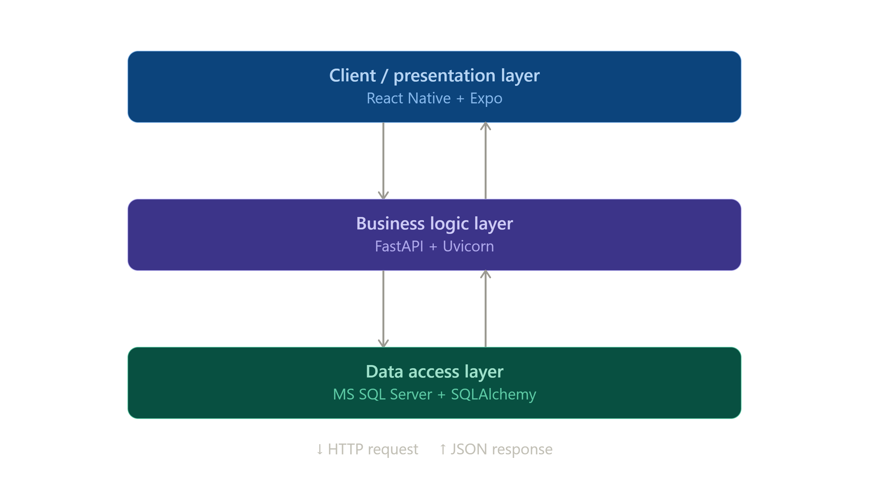

3.2 Project Structure

LmsApp/ (Project Root)
├── backend/ # Python/FastAPI Backend Environment
│ ├── __pycache__/
│ ├── routers/ # API Route Handlers
│ ├── auth_utils.py # Authentication & Hashing Logic
│ ├── database.py # Database Connection Setup
│ ├── databaseStore # MS SQL Server Configuration File
│ ├── dependencies.py # Dependency Injection Logic
│ ├── main.py # Backend Application Entry Point
│ ├── models.py # SQLAlchemy Database Models
│ ├── requirements.txt # Python Dependencies
│ └── schemas.py # Pydantic Data Validation Schemas
│
├── frontend/ # React Native / Expo Mobile App
│ ├── .claude/
│ ├── .expo/ # Expo Build Configuration
│ ├── .vscode/ # Editor Settings
│ ├── assets/ # App Icons and Images
│ ├── node_modules/ # JavaScript Dependencies
│ ├── src/ # Core Source Code (Screens, Components, Services)
│ ├── .gitignore
│ ├── AGENTS.md
│ ├── App.js # Frontend Application Entry Point
│ ├── app.json # Expo App Metadata
│ ├── CLAUDE.md
│ ├── index.js
│ ├── package.json # Project Configuration & Scripts
│ └── package-lock.json
│
├── Screens/ # Project Screenshots & Evidence
├── .env # Global Environment Variables (Hidden)
├── .gitignore # Root Git Ignore Configuration
└── commands.txt # Setup & Execution Commands Guide
└── Readme.md # For Github
3.3 Hybrid Data Synchronization Flow
The most robust feature of this architecture is its Hybrid Fallback Mechanism. The data flow intelligently switches between online and offline states to prevent data loss and ensure a seamless user experience.
A. Online Flow (Network Available):
1. User attempts a quiz on the mobile application.
2. Upon submission, the frontend triggers an Axios POST request.
3. The request travels through the local network to the FastAPI server endpoint (/records).
4. FastAPI validates the payload and injects the record into the MS SQL quiz_records table.
5. When the user visits the 'Track Records' screen, the app fetches data directly from the MS SQL database to display the latest history.
B. Offline Fallback Flow (Network Disconnected):
1. User attempts a quiz using the hardcoded offline question bank.
2. Upon submission, the Axios request detects a network failure.
3. Instead of crashing, the Catch Block executes the fallback function.
4. The system reroutes the quiz score and saves it locally in the mobile device's memory using AsyncStorage.
5. When the user visits the 'Track Records' screen, the system fetches records from the local cache to ensure the user can still view their progress without internet access.
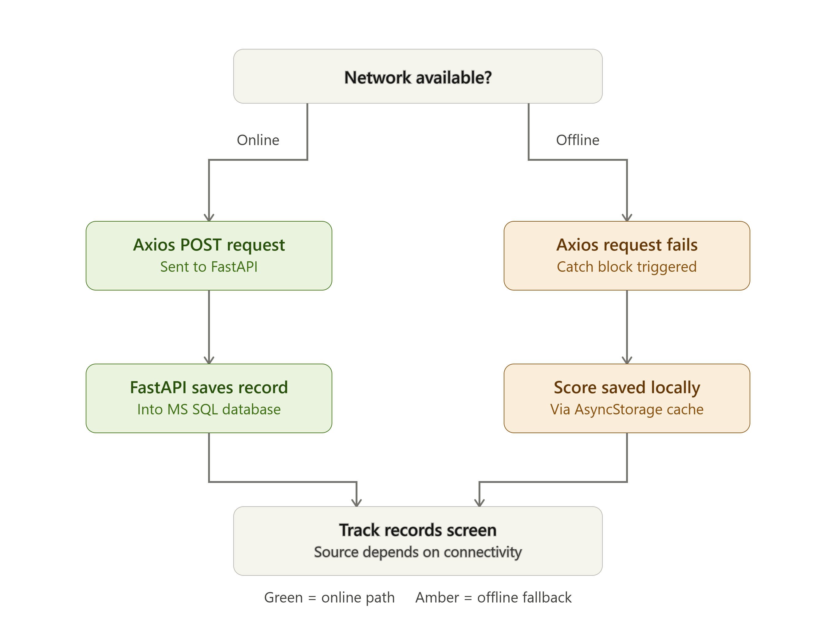

3.4 Data Merging Strategy (Lazy Sync Logic)
To maintain a unified dashboard experience, a data merging strategy is implemented on the Track Records screen. When the network is online, the fetchQuizRecords service executes two parallel tasks:
1. Retrieves global history from the MS SQL API.
2. Retrieves local history from device storage.
The system then combines both datasets into a single array structure. This ensures that users see both their cloud-saved progress and their offline emergency backups on the same screen seamlessly.

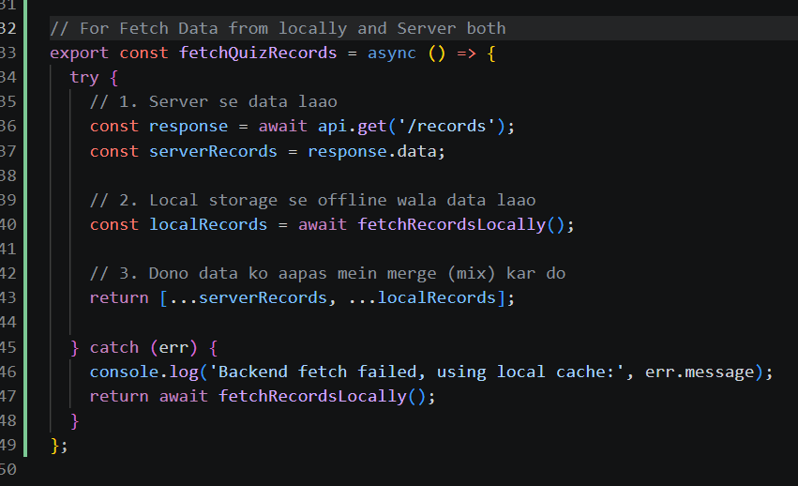

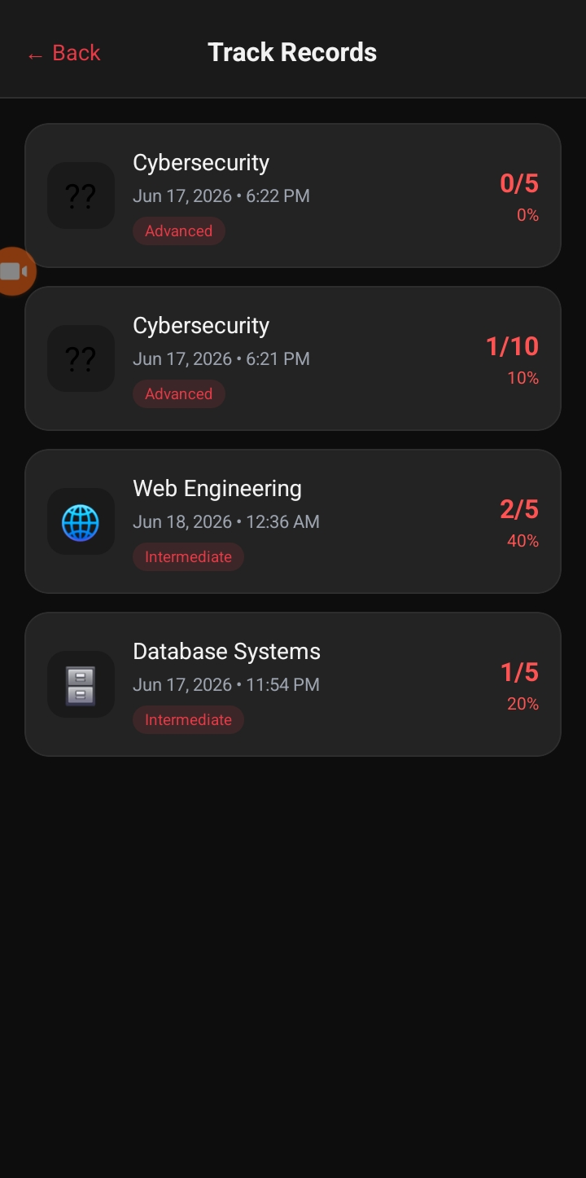

4. CRITICAL CHALLENGES FACED & ADVANCED ENGINEERING SOLUTIONS
During the integration phase, several high-impact software engineering bottlenecks were encountered. Below is a critical analysis of these technical challenges, their root causes, and the engineering methodologies applied to resolve them.
4.1 Challenge 1: Cross-Origin Local Network Resolution Failure (Network Error)
• Symptom: The frontend application persistently generated unhandled 'Network Error' rejections during API transactions on physical mobile devices.
• Root Cause Analysis: Mobile operating systems running within virtual or sandboxed Expo environments treat localhost or loopback addresses (127.0.0.1) as references to the device's internal environment rather than the development workstation hosting the FastAPI server.
• Resolution Strategy: Network topology assessment was conducted via the Windows IP Configuration utility (ipconfig) to isolate the machine's exact local IPv4 address within the wireless subnet (192.168.0.100). The Axios client base configuration was modified to target this explicit network gateway, and the Uvicorn server bindings were exposed globally across the network interface using the --host 0.0.0.0 directive.

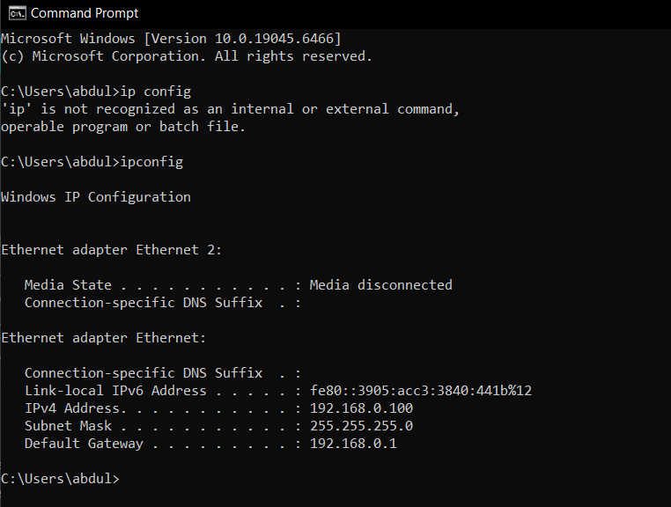

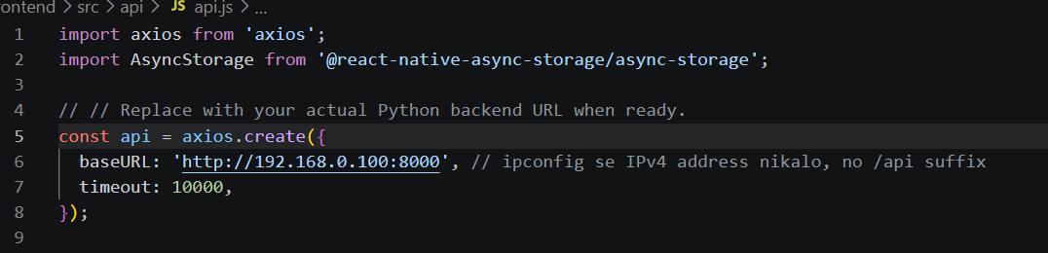

4.2 Challenge 2: Cryptographic Runtime Exception via Library Version Collision (HTTP Status Code 500)
• Symptom: The REST API endpoints responded with an internal server error (HTTP 500) during user registration routines, throwing a ValueError: password cannot be longer than 72 bytes traceback.
• Root Cause Analysis: A critical version mismatch occurred between the latest secure cryptographic hashing package bcrypt (v4.0+) and the underlying security management abstraction layer passlib. The updated runtime constraints of the modern bcrypt library failed to map seamlessly to the legacy input validation hooks inside passlib's helper functions, resulting in memory allocation failures during string hashing.
• Resolution Strategy: The environment dependency tree was re-architected. The incompatible bcrypt module was cleanly purged from the system, and a stable, deterministic micro-version (bcrypt==3.2.2) was manually provisioned into the Python environment. This successfully re-established backward compatibility with the authentication utility routines.

4.3 Challenge 3: Platform Data-Type Mutations & Structural Payload Misalignments
• Symptom: Upon receiving a valid HTTP 200 OK registration response from the database layer, the mobile client crashed immediately, generating an unhandled exception pointing to AsyncStorage: Passing null/undefined as value is not supported.
• Root Cause Analysis: Two fundamental structural misalignments were discovered between the frontend mock database schema and the real SQL engine. First, the backend API schema transformed user identity objects with a username key, whereas the frontend engine looked for a legacy name payload property. Second, MS SQL auto-generates user identifiers as numeric integers, which violated React Native's native AsyncStorage string-only type constraints.
• Resolution Strategy: The data ingestion flow was patched on the frontend. Property pointers were standardized to ingest the new data.user.username payload, and explicit typecasting was implemented using JavaScript's native string conversion wrappers (String(data.user.id)) prior to mutating the device's local memory blocks.
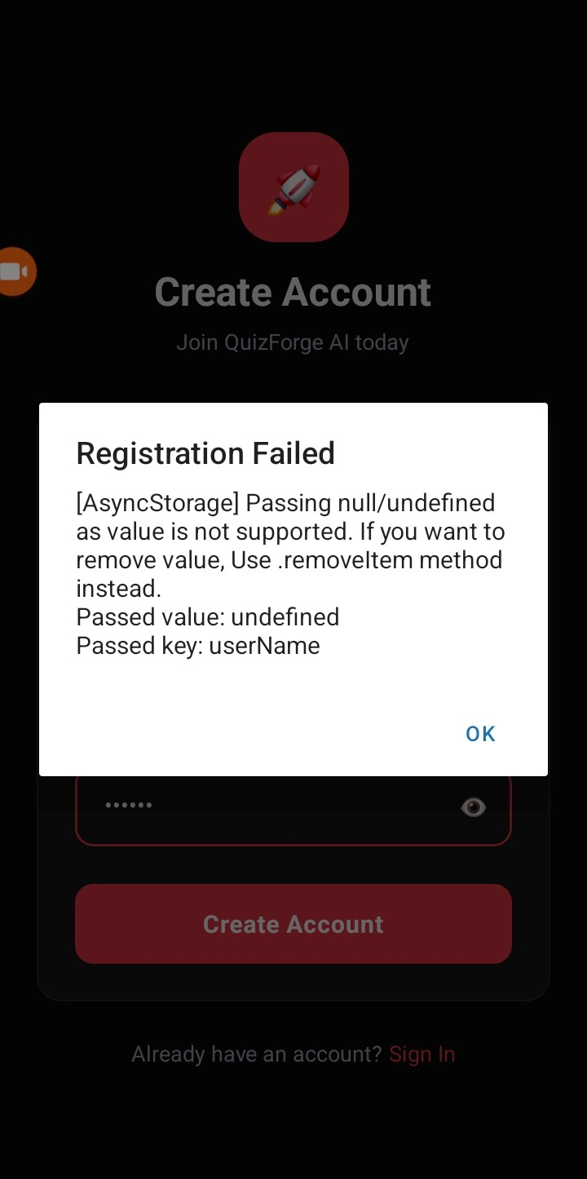
4.4 Challenge 4: Idempotency Validation and Unique Data Constraints (HTTP Status Code 400)
• Symptom: Submitting duplicate user signup profiles resulted in intentional API rejection patterns accompanied by an HTTP Status Code 400 (Bad Request).
• Root Cause Analysis: To enforce absolute data integrity, an explicit database constraint check was engineered into the FastAPI business logic. Before writing records, the engine runs a preventative lookup query against the database index to check for preexisting email records.
• Resolution Strategy: This validation serves as a vital security feature. When a duplicate record injection is intercepted, the transaction is gracefully rolled back at the database connection level, returning a 400 status to prevent index pollution and protect user database unique identity bounds.

Results & Screens
Splash Screen:

Login Screen:
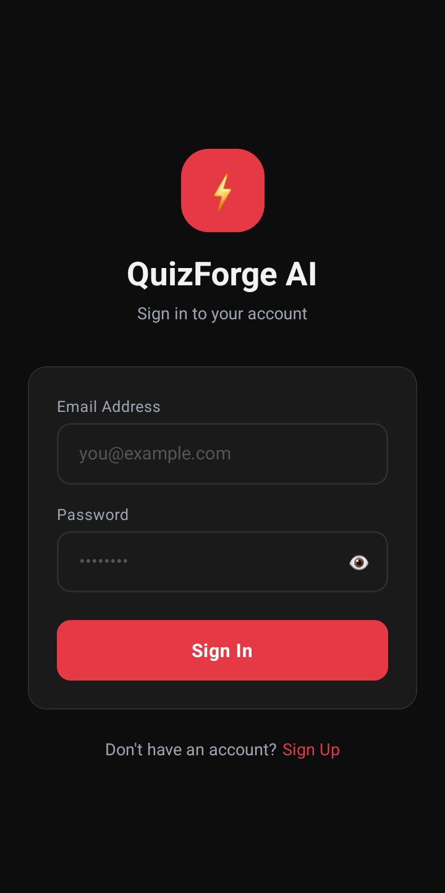
Signup Screen:
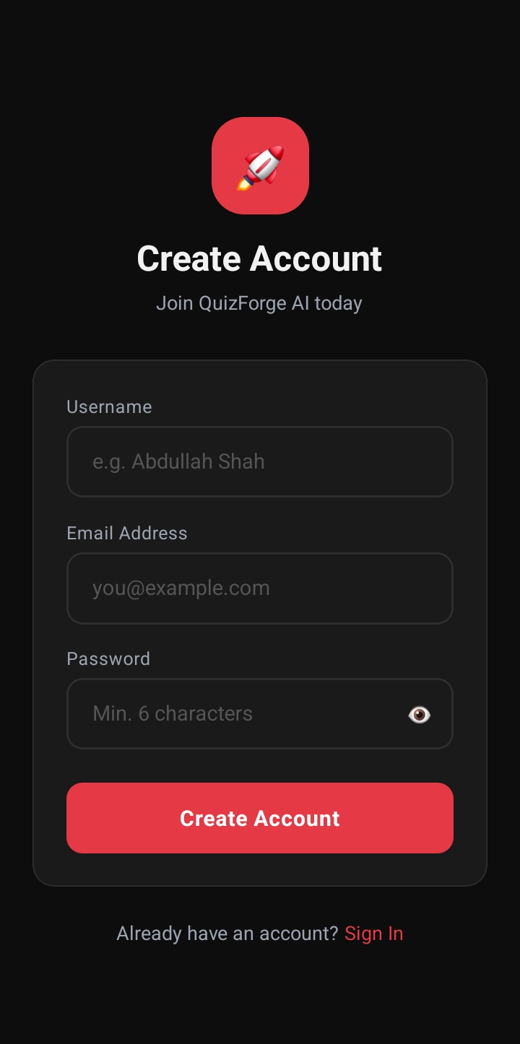

Dashboard Screen:
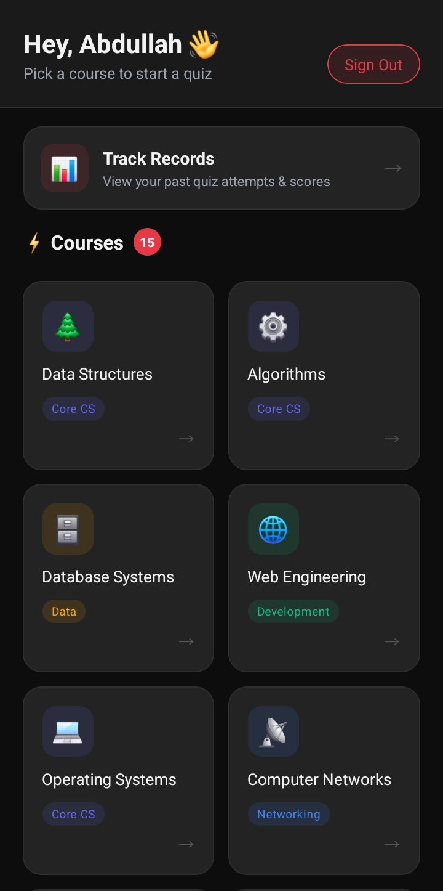

Course’s Screen:
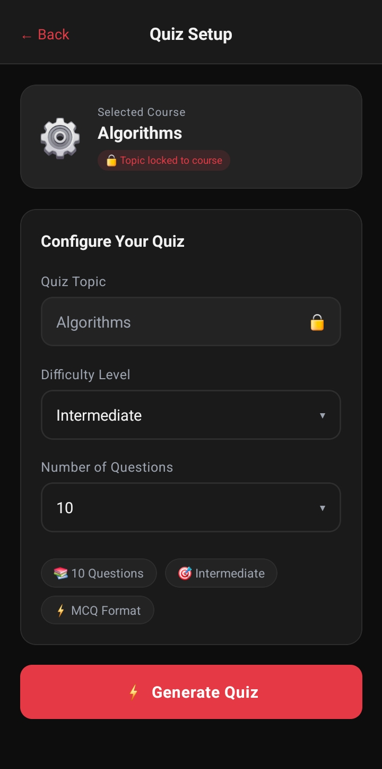

Question’s Screen:
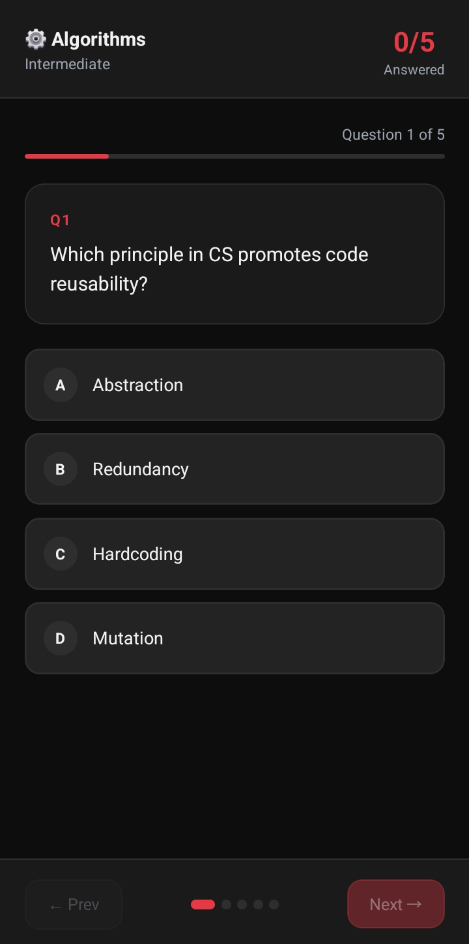

Submit Confirmation Screen:
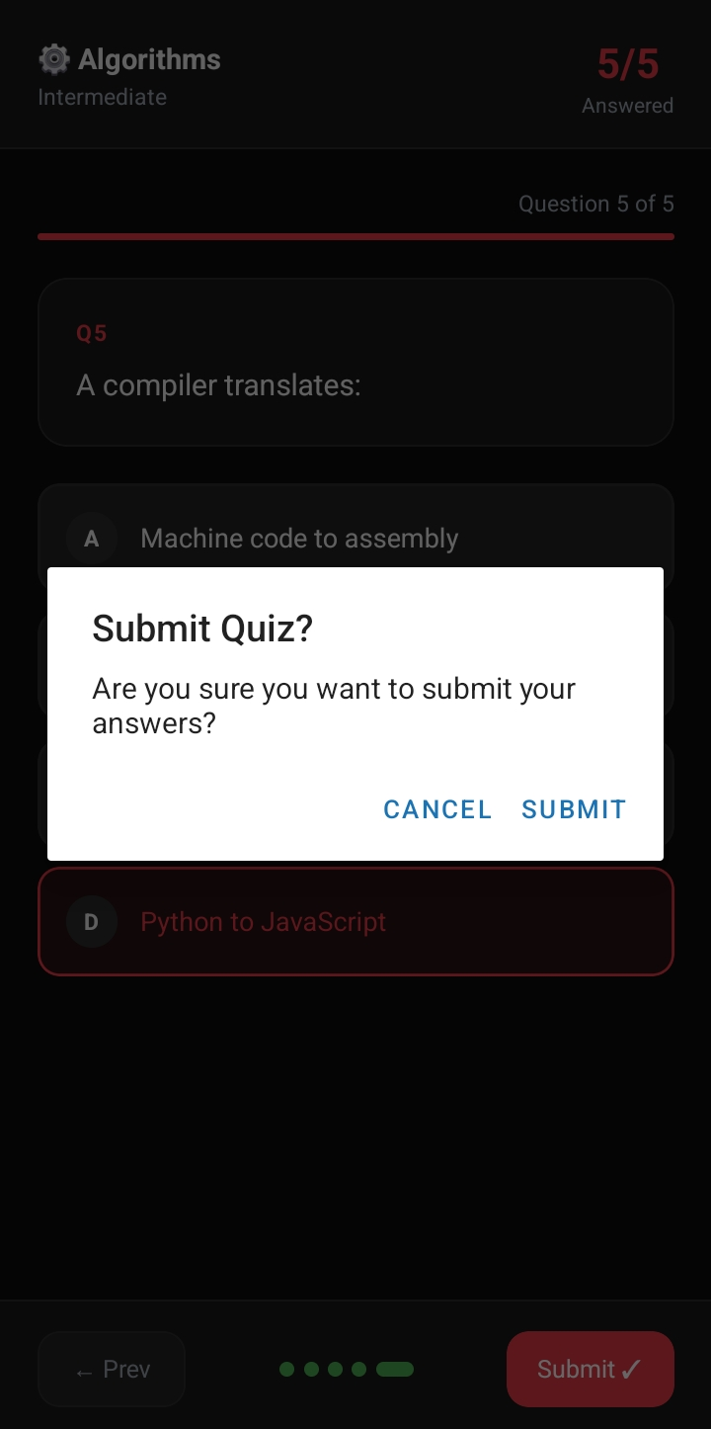
Result Screen:
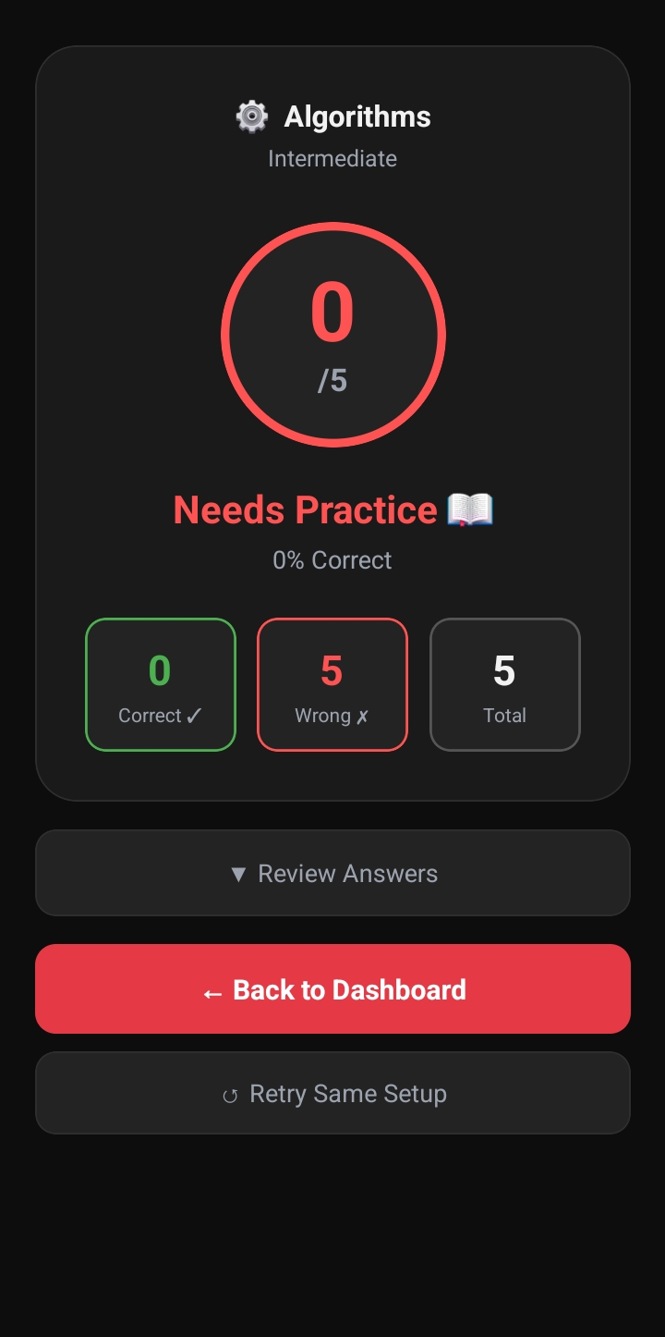
Answers Review Screen:
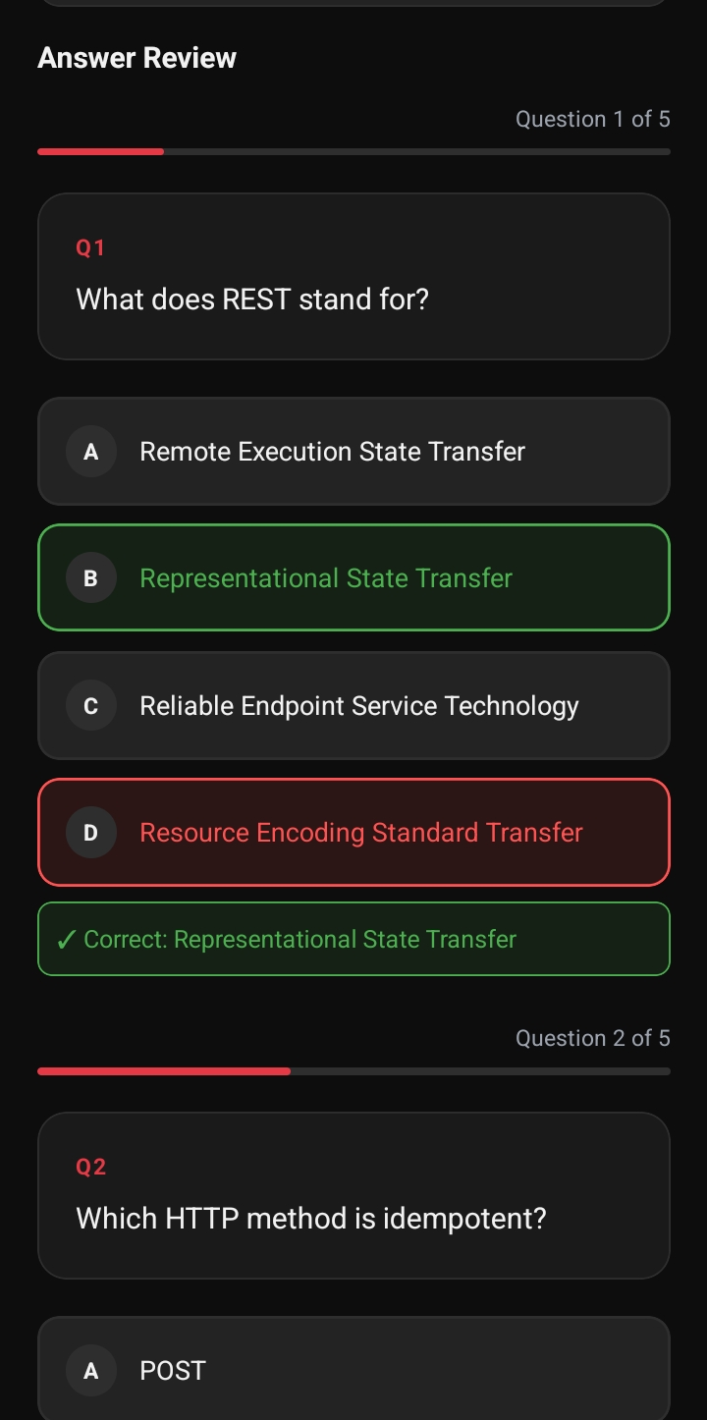
Track Record Screen:
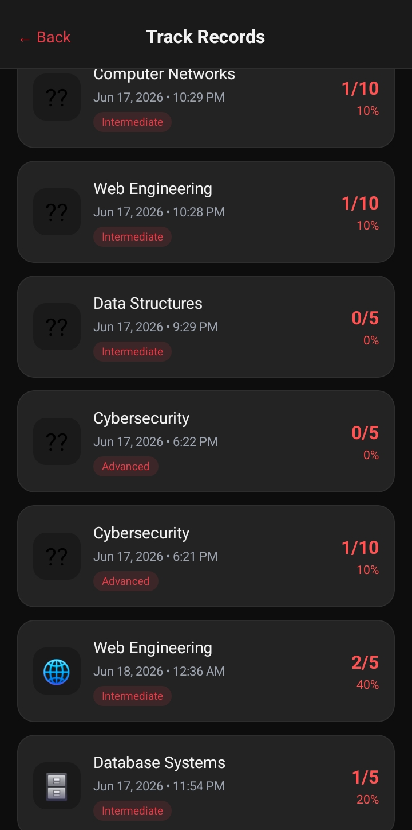
Database: Store Track Records
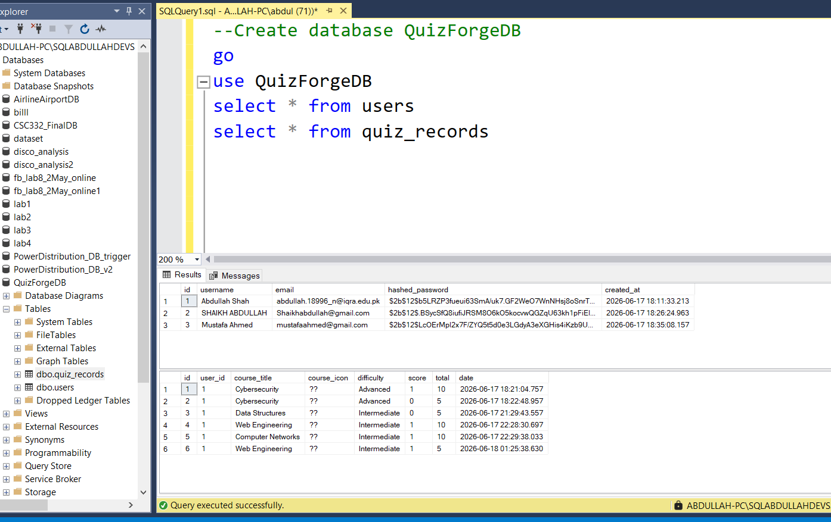

Python Backend:
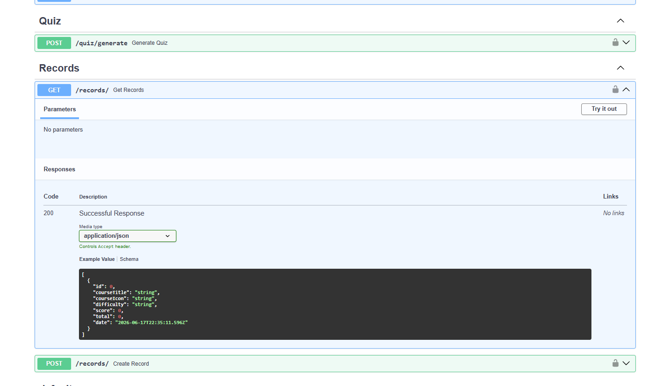5. KEY LEARNINGS & CONCLUSION
The execution of this stage provided deep practical insights into production-level full-stack development patterns. Key takeaways include the absolute necessity of rigorous API contract management, understanding network topology mismatches in cross-platform mobile environments, and configuring robust data resilience strategies. The engineered hybrid local-cache architectural layout successfully guarantees that QuizForge AI remains responsive, data-secure, and operationally reliable under any network configuration.

