Microscale Phase Change Causes Upscale Energy Transfer in Turbulent Clouds: Evidence from DNS

Abdullah Al Muti Sharfuddin¹, Foluso Ladeinde², Yangang Liu³, Fan Yang⁴, Mohammad Atif⁵, Satoshi Endo⁶, and Meifeng Lin⁷
^{1,2}Department of Mechanical Engineering, 113 Light Engineering Building, Stony Brook University, 100 Nicolls Road, Stony Brook, New York, 11794-2300, USA.
^{3,4,6}Environmental Science and Technologies Department, Brookhaven National Laboratory, 2 Center St, Upton, New York, 11973-5000, USA.
^{5,7}Computing and Data Sciences Directorate, Brookhaven National Laboratory, 2 Center St, Upton, New York, 11973-5000, USA.

Corresponding author: Foluso Ladeinde (foluso.ladeinde@stonybrook.edu)

Key Points:
- Microscale phase change injects liquid water variance at the small scales, which cascades upscale.
- Turbulence-driven direct cascade and microphysics-driven inverse cascade intersect and produces a spectral break.
- Spatial inhomogeneity and widely separated timescales contribute to the multiscale complexity of atmospheric clouds.

Abstract
The energy spectrum of cloud water content reveals a distinct break, occurring when turbulence-driven direct cascade is disrupted by another cascade. To understand the mechanism of the second cascade, this study applies particle-based direct numerical simulations and models entrainment-mixing in a turbulent cloud. All turbulence scales are explicitly resolved and cloud droplets are tracked in a Lagrangian framework. It is shown that evaporation injects variance into cloud water content at small scales and creates an inverse cascade. The third-order structure functions confirm that turbulence-dominated direct cascade intersects with microphysics-dominated inverse cascade. Both cascades depend on the intensity of flow turbulence. The gradients of cloud water content follow a trimodal distribution, implying the spatial inhomogeneity of clouds, while the timescales governing turbulence and microphysics vary by up to ten orders of magnitude. The energy transfer and multiscale behavior of ambient clouds have implications for their parameterization in weather models.

1 Introduction
Atmospheric clouds regulate the Earth's radiative budget and hydrological cycle, yet their internal structure remains one of the difficult features to represent in weather and climate models. The key reason is the enormous range of scales involved. Cloud properties vary coherently from the kilometer scale of convection to the sub-millimeter scale at which individual droplets condense and evaporate. A recurring and informative signature of this multiscale behavior is the appearance of a break in the energy spectrum of cloud water field. This suggests that the power-law exponent changes sharply in the Fourier space and that the regimes on either side of the break are governed by different physical processes.
A closer look at the mechanisms behind the break reveals that microscale cloud growth influences liquid water content (LWC) spectrum. Davis et al. (1999) experimentally measured the LWC in clouds at approximately 4 cm resolution. The corresponding energy spectra showed two distinct power-law regimes, separated by a break. They proposed that an additional variance source exists at small scales but it remained unidentified because of insufficient measurement resolution. In order to theoretically analyze the spectral break, Jeffery (2001) solved an advection-diffusion equation for the LWC with inclusion of phase change. The author found that a production subrange is created in the LWC spectrum by condensation and evaporation. The suggestion that microscale phase change injects variance at small scales is supported by Gotoh et al. (2021). They theoretically showed that the LWC spectrum exhibits two scaling ranges as cloud growth or decay modifies the spectrum. Recently, Wang et al. (2026) observed a physical-space break in the size distribution of growing clouds. Based on large-eddy simulations (LES), they concluded that the break originated from dynamical cloud growth.
A break in the scaling laws can be caused by the intersection of direct and inverse energy cascades. In a laboratory investigation, Xia et al. (2011) showed that energy is transferred from the small to large scales in turbulence if a variance is externally imposed at the small scales. To distinguish between direct and inverse energy cascades, they calculated the third-order velocity structure function. Lilly (1983) suggested that Earth’s mesoscale atmosphere has more energy than predicted by theory and the source of extra energy is upscale energy transfer. This hypothesis was tested by Vallis et al. (1997) who performed large-eddy simulations of mesoscale convection and confirmed the presence of inverse energy cascade, although the upscale transfer was reportedly smaller than the downscale transfer. Cabanes et al. (2020) reported that planetary rotation inhibits vertical motion and creates a stratified atmosphere in which energy is transferred from the small-scale sources up to the large-scale jets.
While the abovementioned studies identified upscale energy transfer and consequent break in the scaling behavior, they did not explore how turbulence-cloud microphysics interactions affect these phenomena. Hence, this study examines the energy transfer mechanisms in a turbulent cloud. We apply a particle-based direct numerical simulation (DNS) model which resolves all scales of the flow and tracks cloud droplets individually in Lagrangian fashion. Our model setup is such that it simulates entrainment-mixing between the cloudy and clear air. The grid resolution is much finer than that used in the previous studies of this problem. The objective is to analyze how microscale phase change acts as a localized source of variance and transfers energy from the small to large scales. By contrasting simulations with and without cloud droplets, we isolate the contribution of phase change to upscale energy transfer. We also vary the intensity of flow turbulence and assess its impact on energy cascades.

2 Governing Equations
The turbulent flow of air is governed by the incompressible Navier-Stokes equations:
$$\frac{∂u}{∂t}+\left(u.∇\right)u=-\frac{1}{ρ_{a}}∇p+ν∇^{2}u+F_{b}+F_{c} ,$$ | (1)
$$∇.u=0 .$$ | (2)

Above, $u$ is the instantaneous air velocity vector, $ν$ is the kinematic viscosity of air, $p$ is the instantaneous air pressure, and $ρ_{a}$ is the air density. $F_{c}$ is an external force that maintains flow turbulence and is constructed in the Fourier space following the procedure of Eswaran and Pope (1988). The buoyancy force $F_{b}$ is included but is too weak to sustain turbulence within a small domain. The conservation equations for the temperature ($T$) and water vapor mixing ratio ($q_{v}$) are:
$$\frac{∂T}{∂t}+\left(u.∇\right)T=\frac{L_{h}}{c_{p}}C_{d}+μ_{T}∇^{2}T+F_{T} ,$$ | (3)
$$\frac{∂q_{v}}{∂t}+\left(u.∇\right)q_{v}=-C_{d}+μ_{v}∇^{2}q_{v}+F_{q_{v}} .$$ | (4)
Above, $L_{h}$ is the specific latent heat, $C_{d}$ is the time rate of exchange between water vapor and liquid water, and $c_{p}$ is the specific heat of air. $μ_{T}$ and $μ_{v}$ are the molecular diffusivities while $F_{T}$, and $F_{q_{v}}$ are the external forcing terms in the temperature and water vapor mixing ratio fields, respectively. The definitions of $F_{c}$, $F_{b}$, $F_{T}$, and $F_{q_{v}}$ can be found in Sharfuddin et al. (2026). Note that $F_{T}$ and $F_{q_{v}}$ are necessary to sustain thermodynamic fluctuations in the respective fields. The environmental supersaturation ($S_{e}$) depends on the $T$ and $q_{v}$, and is found as:
$$S_{e}=\frac{q_{v}}{q_{v,s}}-1= \frac{q_{v}}{621.97\frac{p_{sat}}{{p-p}_{sat}}}-1 ,$$ | $$(5)$$
where $q_{v,s}$ is the saturation vapor mixing ratio and $p_{sat}$ is the saturation vapor pressure which can be calculated with respect to water as: (Huang, 2018)
$$p_{sat}=611.2×\exp\left(\frac{17.67\left(T-273.15\right)}{T-29.65}\right) .$$ | $$(6)$$
The equations for the Lagrangian position ($X$) and velocity ($V$) vectors of cloud droplets are written as:
$$\frac{dX_{i}\left(t\right)}{dt}=V_{i}\left(t\right) , \frac{dV_{i}\left(t\right)}{dt}=\frac{1}{{\left(τ_{p}\right)}_{i}}\left[u_{i}\left(X,t\right)-V_{i}\left(t\right)\right]+g , {\left(τ_{p}\right)}_{i}=\frac{2ρ_{l}{\left(r_{i}\right)}^{2}}{9ρ_{a}ν} .$$ | (7)
where the subscript $‘i’$ denotes the $i$-th particle, $r$ is the particle radius, $u_{i}$ is the instantaneous air velocity vector interpolated at the position of particle $i$, $g$ is the gravity vector, $τ_{p}$ is the particle response time, and $ρ_{l}$ is the density of liquid water. Cloud droplets grow or shrink according to the following equation:
$$\frac{d{\left(r\left(t\right)\right)}_{i}}{dt}={\left({\frac{G}{r\left(t\right)}S}_{e}\left(X,t\right)\right)}_{i} , G=\frac{1}{\frac{Lρ_{l}}{k_{T}T}\left(\frac{L_{h}}{R_{v}T}-1\right)+\frac{ρ_{l}R_{v}T}{μ_{v}p_{sat}}} .$$ | (8)
where $G$ is the growth factor, $k_{T}$ is the thermal conductivity in air, and $R_{v}$ is the universal gas constant divided by the molecular weight of water. Then, $C_{d}$ is determined as:
$$C_{d}\left(x,t\right)=\frac{4πρ_{l}G}{ρ_{a}a^{3}}\sum_{i=1}^{n}{{\left({r(t)S}_{e}\left(X,t\right)\right)}_{i} , }$$ | $$(9)$$
where $n$ is the number of cloud droplets within a grid cell having a volume of $a^{3}$. The curvature and solute effects are neglected in the present study because cloud droplets remain much larger than dry aerosols throughout the simulation period. Finally, the liquid water mixing ratio $q_{l}$ is found as:
$$q_{l}\left(x,t\right)=\frac{4πρ_{l}}{{3ρ}_{a}a^{3}}\sum_{i=1}^{n}{r_{i}^{3}\left(t\right) . }$$ | $$(10)$$

The $q_{l}$ denotes cloud (liquid) water content and is directly affected by condensational growth or evaporative decay of cloud droplets.

3 Numerical Details
Flow turbulence is assumed to be homogeneous and isotropic. Two turbulent kinetic energy (TKE) dissipation rates are generated by varying the band of forcing wavenumbers. We denote the two TKE levels as ‘low’ (L) and ‘high’ (H), respectively. The corresponding wavenumber bands are: $1≤k_{f}/k_{min}≤4.12$ and $1≤k_{f}/k_{min}≤13.86$ while the Kolmogorov lengths are: 0.0015 m and 0.00088 m. Note that $k_{min}=2π/L=12.27$ [1/m] is the minimum wavenumber and $k_{f}$ is the forcing wavenumber. The thermodynamic forcing terms ($F_{T}$ and $F_{q_{v}}$) are also constructed in the Fourier space using a wavenumber band of $1≤k_{f}/k_{min}≤4.12$. More details about external forcing and our particle-based DNS model can be found in Sharfuddin et al. (2026).
The physical model is a cube and has a volume of ${0.512}^{3}$ m³, with each side having $L=0.512 m$. The boundary conditions are triply periodic. The domain is equally divided into cloudy and clear-air regions at the start. A slab-like configuration is assumed so that the initial temperature and water vapor mixing ratio change sharply at the cloud/clear-air interface (Gao et al., 2018). The initial vapor mixing ratio is specified as:
$$q_{v}\left(z,t=0\right)=\left\{\begin{matrix}q_{v}^{max}, d-L×0.5×0.5≤z<d+L×0.5×0.5 \\ q_{v,e}, elsewhere\end{matrix}\right. .$$ | $$(11)$$
Above, $q_{v}^{max}=3.949 g/kg$, $q_{v,e}=0.3 g/kg$, and $d≡L/2$ is the width of the cloud slab. $q_{v}^{max}$ and $q_{v,e}$ represent cloudy (supersaturated) and dry (subsaturated) regions, respectively. The initial temperature field is prescribed as:
$$T\left(t=0\right)=〈T\left(t=0\right)〉-0.608〈T\left(t=0\right)〉\left(q_{v}\left(z,t=0\right)-〈q_{v}\left(t=0\right)〉\right) .$$ | $$(12)$$

We simulate three cases: H, L, and H0. The details are provided in Table 1 along with the values of simulated parameters. $16×{10}^{6}$ cloud droplets are initially placed in the cloudy region, giving a droplet number density of 59.6 cm⁻³. Entrainment of dry air and turbulent mixing spread cloud droplets to all over the domain. The dominant phase change process is evaporation. The number of grid points is ${256}^{3}$ and the grid resolution is 2 mm for all cases. We run simulations for a physical time of 20 s. The $k_{max}η$ value is 1.38 for Case H and 2.36 for Case L, where $k_{max}=(256π)/L=1570.27$ [1/m] is the maximum wavenumber. The $k_{max}η$ measures how accurately the viscous dissipation range is captured in a simulation and is prescribed to be at least greater than 1.0 (Pope, 2000).
Table 1
Details of the test cases
Case | TKE dissipation rate ($m^{2}/s^{3}$) |  | Level of momentum forcing $F_{c}$ |  | Initial radius of each cloud droplet $(μm)$ |  | Stokes number $S_{t}$ at initial time | Inclusion of droplets
H | 0.0056 |  | High |  | 15 |  | $$6.42e-2$$ | Yes
L | 0.0006 |  | Low |  | 15 |  | $$2.12e-2$$ | Yes
H0 | 0.0056 |  | High |  | 15 |  | $$6.42e-2$$ | No
Case | Description
H | high (H) level of flow turbulence, cloud droplets included
L | low (L) level of flow turbulence, cloud droplets included
H0 | high (H) level of flow turbulence, cloud droplets excluded (0)
Parameters and their values
Symbol |  | Value |  | Unit |  | Symbol | Value | Unit
$$L_{h}$$ |  | $$2.5×{10}^{6}$$ |  | J/kg |  | $$μ_{T}=μ_{v}$$  $$c_{p}$$ | $$2.2×{10}^{-5}$$  $$1005.0$$ | m²/s  J/kg/K
$$ρ_{l}$$ |  | $$1000$$ |  | kg/m³
$$p(t=0)$$ |  | $$71446$$ |  | N/m² |  | $$〈T(t=0)〉$$ | $$270.75$$ | K
$$ρ_{a}$$ |  | $$0.92$$ |  | kg/m³ |  | $$ν$$ | $$1.5×{10}^{-5}$$ | m²/s
$$R_{v}$$ |  | $$461.5$$ |  | J/kg/K |  | $$k_{T}$$ | $$0.0238$$ | W/m/K

4 Results and Discussion
This section presents the findings from our particle-based direct numerical simulations. We focus on a single timeframe at 10 s, when velocity and thermodynamic fluctuations are statistically stationary. Because the primary insights of this study are spatial in nature, analyzing one temporal snapshot proves sufficient for our analysis. We investigate the energy spectra, third-order structure functions, and derivatives of key quantities. The timescales associated with the flow and cloud droplets are also calculated.
The energy spectra are shown in Figures 1(a)-(f). The $E_{TKE}$ is higher at the large scales for Cases H and H0. This is expected because only the low-wavenumber region is forced. The three $E_{TKE}$ curves converge at the intermediate scales. The difference at the small scales is attributed to the smaller $k_{max}η$ for high-turbulence cases since the grid resolution is kept identical for all cases. The TKE spectra (Figure 1(a)) are identical for Cases H and H0, suggesting that cloud droplets do not influence flow turbulence. The temperature and supersaturation spectra (Figures 1(b)-(c)) do not decay smoothly if phase change is present (Case H and L) but do so otherwise (Case H0). It appears that there is a surge in the high-wavenumber region before the final decay, particularly for Case L. The upscale energy transfer is conspicuous in the $E_{C_{d}}$ (Figure 1(d)) and it intersects with the direct cascade. The intersection is identified as a break. The slope is negative (-2.85) to the left of the break and positive (1.2) to the right. Note that a negative slope is indicative of direct cascade while a positive slope means an inverse cascade. Similarly, a break is observed in the cloud water spectra ($E_{q_{l}}$) (Figure 1(e)). The $E_{q_{l}}$ peaks in the high-wavenumber region because of the energy injected by microscale evaporation. Let $k_{b}$ be the wavenumber corresponding to the break. The physical-space break occurs at wavelength $λ_{b}=(2π/k_{b})$. Based on the data of Figure 1(e), $λ_{b}=(2π/({10}^{-0.25}/0.00088)\sim 9.8$ $mm$ and $λ_{b}=(2π/({10}^{-0.2}/0.00153)\sim 15.23$ $mm$ for Cases H and L, respectively. Also, $λ_{b}/η\sim 11.1$ for Case H and $λ_{b}/η\sim 9.95$ for Case L. Hence, a break occurs in the cloud water field at a length approximately ten times the Kolmogorov length. The observed break at $λ_{b}\sim 10η$ implies that a production subrange exists between the inertial and dissipation regions, thereby quantifying Jeffery’s (2001) prediction. Since the break is directly related to the Kolmogorov scale, its physical-space location will depend on the intensity of flow turbulence. Large-scale and small-scale events are dominated by turbulence and microphysics, respectively, but competition exists at the intermediate scales. We see that the left slope is negative (-0.5) for Case L but positive (0.45) for Case H (Figure 1(e)) while the right slope is positive (2.4 and 2.6) for both cases. This suggests that direct cascade is stronger for Case L. A high level of turbulence leads to stronger mixing and homogenization of the thermodynamic and microphysical fields. Hence, direct cascade is weaker and the $E_{T}$, $E_{S_{e}}$, $E_{C_{d}}$, $E_{q_{l}}$, and $E_{r}$ contain less energy for Case H, indicated by a smaller area under the curve in Figures 1(b)-(e). The radius spectra ($E_{r}$) in Figure 1(f) reaffirm the upscale transfer caused by microscale phase change.
$$E_{TKE}\left(k\right) (m^{3}/s^{2})$$ | (a)  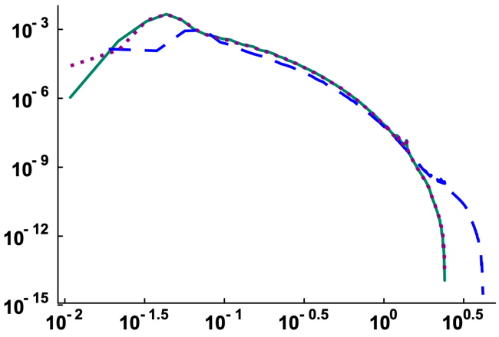   |  | $$E_{T}\left(k\right) (K^{2}m)$$ | (b)  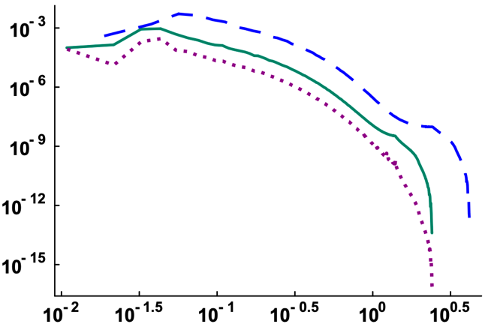  
 | $$kη$$ |  |  | $$kη$$
$$E_{S_{e}}\left(k\right) (m)$$ | (c)  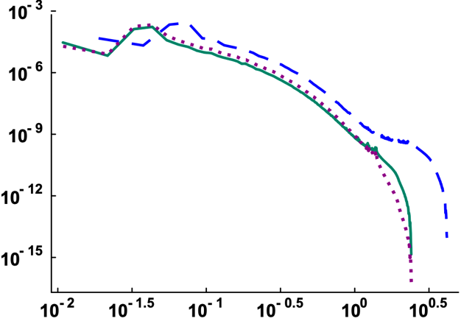   |  | $$E_{C_{d}}\left(k\right) (m/s^{2})$$ | (d)  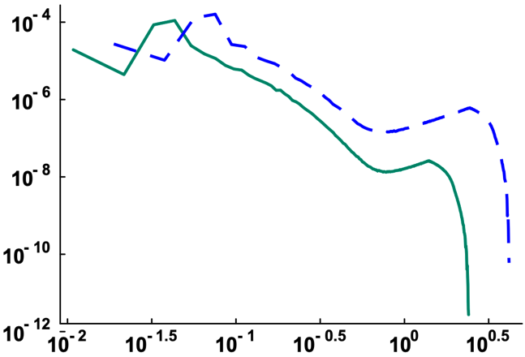  1.2  - 2.85  - 2.85  1.2  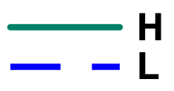
 | $$kη$$ |  |  | $$kη$$
$$E_{q_{l}}\left(k\right) (g^{2}m/{kg}^{2})$$ | (e)  2.4  - 0.5  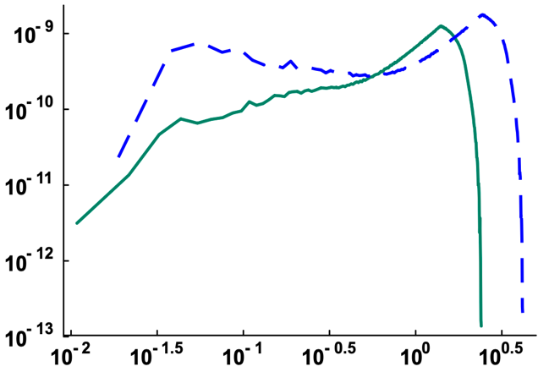  0.45  2.6   | $$E_{r}\left(k\right) ({μm}^{2}m)$$ |  | (f)  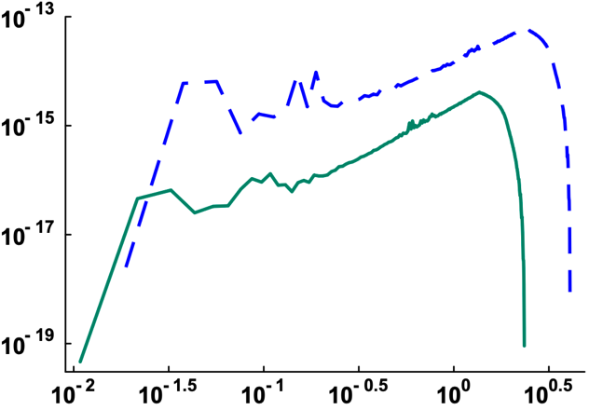  
 | $$kη$$ |  |  | $$kη$$
Figure 1. Energy spectra of the (a) turbulent kinetic energy ($E_{TKE}$), (b) temperature ($E_{T}$), (c) supersaturation ($E_{S_{e}}$), (d) phase change term ($E_{C_{d}}$), (e) liquid water mixing ratio ($E_{q_{l}}$), and (f) particle radius ($E_{r}$). The intersection points in Figures 1(d)-(e) show spectral breaks.
Although an energy spectrum shows how much energy exists at each scale, it does not tell the direction in which energy is flowing. Thus, we calculate the third-order structure function ($S_{3}$) to check the direction of energy transfer. If $S_{3}>0$, it implies a direct energy cascade while $S_{3}<0$ suggests an inverse energy cascade (Frisch, 1995). If $S_{3}=0$, there is no net energy transfer across that scale. The third-order structure function for z-velocity ($S_{3}^{w}$) is (Kerr et al., 2001)
$$S_{3}^{w}\left(d\right)=-\frac{〈{\left(w\left(x+d\right)-w\left(x\right)\right)}^{3}〉}{ϵ_{TKE}d} , d=\left|∆xi+∆yj+∆zk\right|$$ | (13)
where $d$ is the separation distance along the main diagonal and $ϵ_{TKE}$ is the TKE dissipation rate. The third-order structure functions for $C_{d}$ and $q_{l}$ are calculated as
$$S_{3}^{C_{d}}\left(d\right)=-\frac{〈{\left(C_{d}\left(x+d\right)-C_{d}\left(x\right)\right)}^{3}〉}{ϵ_{TKE}d} , S_{3}^{q_{l}}\left(d\right)=-\frac{〈{\left(q_{l}\left(x+d\right)-q_{l}\left(x\right)\right)}^{3}〉}{ϵ_{TKE}d}$$ | (14)
Note that $C_{d}$ and $q_{l}$ are not transported variables and their molecular diffusivities or dissipation rates are not defined. So, $ϵ_{TKE}$ is used in the denominator of Equation (14).
We see that $S_{3}^{w}$ increases with $d$, reaches a peak, and decays, while remaining positive across the entire range of $d$ for all three cases (Figure 2(a)). So, energy flows consistently from the large to small scales in the z-velocity field. The decay of $S_{3}^{w}$ is more rapid when the turbulence level is high (Cases H and H0). When the turbulence level is low (Case L) and the separation distance is very small, $S_{3}^{C_{d}}$ is negative and energy is transferred upscale (Figure 2(b)). This finding complements what is visually evident in Figure 1(d) for Case L. The $S_{3}^{C_{d}}$ changes sign at $d\sim 7 mm$ and turns positive at larger separations for this case. However, $S_{3}^{C_{d}}$ remains marginally positive if the turbulence level is high (Case H), and upscale transfer is not captured by $S_{3}^{C_{d}}$. The $q_{l}$ is directly impacted by microscale phase change, and $S_{3}^{q_{l}}$ is negative at very small separations for both cases (Figure 2(c)). The $S_{3}^{q_{l}}$ appears to be more negative for Case L (-10) than it is for Case H (-6) before reaching zero. Hence, upscale transfer is more intense for the former. The $S_{3}^{q_{l}}$ does not become meaningfully positive for Case H as $d$ increases, implying absence of direct cascade and consistent with Figure 1(e).
$$S_{3}^{w}$$ | (a)  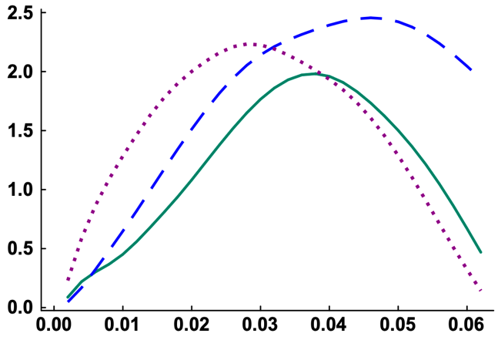   |  | $S_{3}^{C_{d}}(m^{-3})$, Case H | (b)  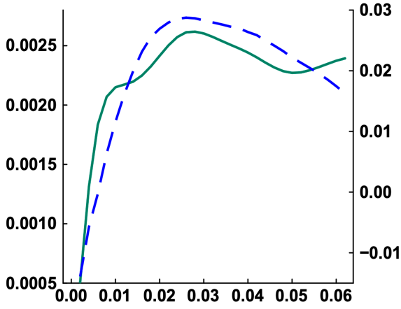   | $S_{3}^{C_{d}}(m^{-3})$, Case L
 | $$d (m)$$ |  |  | $$d (m)$$
$S_{3}^{q_{l}}({\left(g/kg\right)}^{3}{s^{3}m}^{-3})$, Case H | (c)  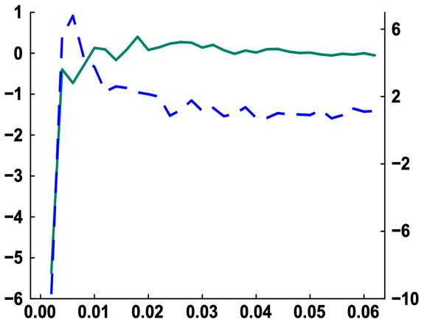   | $S_{3}^{q_{l}}({\left(g/kg\right)}^{3}{s^{3}m}^{-3})$, Case L | PDF $(s)$ | (d)  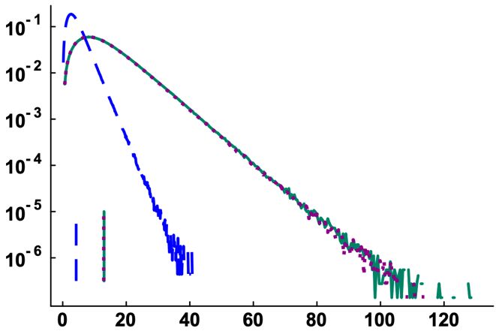  
 | $$d (m)$$ |  |  | $ξ$ $(1/s)$
Figure 2. Third-order structure functions of (a) z-velocity ($S_{3}^{w}$), (b) phase change term ($S_{3}^{C_{d}}$), and (c) liquid water mixing ratio ($S_{3}^{q_{l}}$). The intersection of the straight lines shows where $S_{3}$ changes sign ($S_{3}\sim 0$) in the respective curves. (d) Probability density functions (PDFs) of the vorticity magnitude.
Besides phase change, droplet inertia can produce upscale energy transfer in particle-laden turbulent flows (Brandt & Coletti, 2022). Heavy inertial droplets do not exactly follow the flow and are ejected from high-vorticity regions. So, they concentrate on low-vorticity zones and such clustering can inject variance in the momentum field that cascades upscale. This is a mechanical pathway of upscale transfer while phase change is a thermodynamic pathway. Since the Stokes number is significantly less than unity in our model (Table 1), the inertia effect is expected to be negligible. To verify this, we calculate the magnitude of flow vorticity $ξ$ as
$$ξ=\left|\left(\frac{∂w}{∂y}-\frac{∂v}{∂z}\right)i+\left(\frac{∂u}{∂z}-\frac{∂w}{∂x}\right)j+\left(\frac{∂v}{∂x}-\frac{∂u}{∂y}\right)k \right|.$$ | (15)
The vorticity PDFs are plotted in Figure 2(d). The PDFs are skewed to the right because $ξ$ is always positive. The maximum and mean of $ξ$ are larger if the turbulence level is higher. Most importantly, the PDFs perfectly overlap for Cases H and H0. This confirms that cloud droplets do not affect the local rotation of the fluid.
PDF ($s$) | (a)  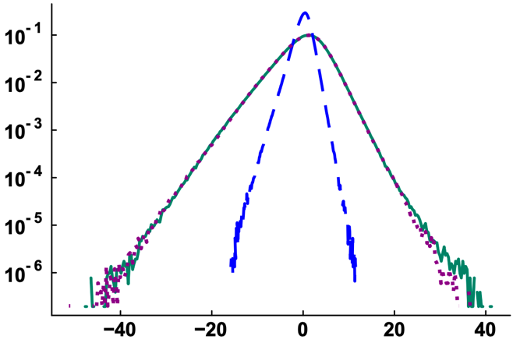   | PDF ($m/K$) | (b)  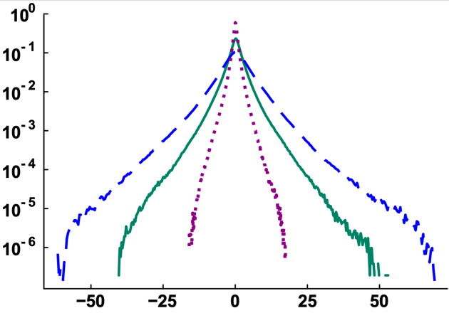  
 | $∂w/∂z$ ($1/s$) |  | $∂T/∂z$ ($K/m$)
PDF ($m$) | (c)  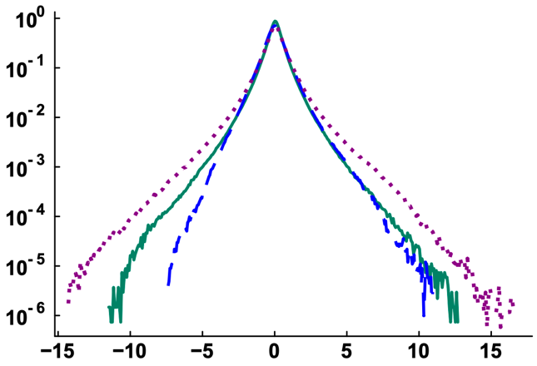   | PDF ($kgm/g$) | (d)    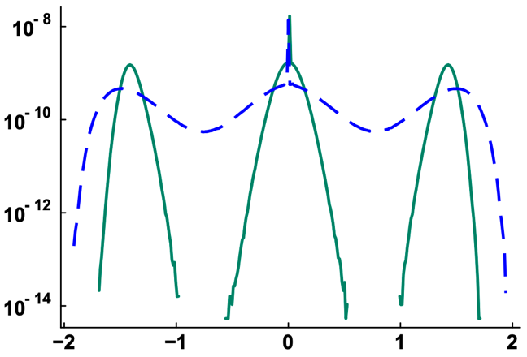
 | $∂S_{e}/∂z$ ($1/m$) |  | $∂q_{l}/∂z$ ($×{10}^{9}$) ($g/kgm$)
Figure 3. PDFs of the derivatives of (a) z-velocity, (b) temperature, (c) supersaturation, and (d) liquid water mixing ratio. The derivatives are calculated in the z-direction using the central difference formula.
Spatial derivatives quantify the local gradients and steepness in a turbulent field. The PDFs of $∂w/∂z$, $∂T/∂z$, $∂S_{e}/∂z$, and $∂q_{l}/∂z$ are shown in Figures 3(a)-(d), respectively. As expected, high turbulence makes velocity gradients stronger (Figure 3(a)). The distributions of $∂w/∂z$ are symmetric, unimodal, and centered at zero for all three cases. But the distributions of $∂T/∂z$ have tails of the stretched-exponential form for Cases H and L (Figure 3(b)). Cloud droplet evaporation generates local gradients and broadens the spread of $∂T/∂z$. In absence of phase change (Case H0), the distribution of temperature derivative is narrower. It appears that the spread of $∂S_{e}/∂z$ follows the order: H0 > H > L (Figure 3(c)), which is opposite to that for temperature. This is because phase change acts as a source for temperature gradients (Equation (3)) but as a sink for supersaturation gradients (Equation (4)). The PDF of $∂q_{l}/∂z$ is found to be trimodal for Cases H and L (Figure 3(d)). The initial domain has 50/50 cloudy/clear air by volume and turbulent mixing leads to pockets of cloudy and clear air regions. The central peak refers to the interior of either the cloudy region ($q_{l}$ is approximately spatially uniform) or the clear air region ($q_{l}$ is close to zero), where the derivative is zero. The side peaks represent the interfaces of these pockets. Specifically, the left peak (negative derivative) corresponds to transitions from a cloudy pocket outward into clear air, where the liquid water content sharply decreases along the spatial coordinate. Conversely, the right peak (positive derivative) corresponds to transitions from clear air into a cloudy pocket, where the liquid water content sharply increases.
PDF ($1/s$) | (a)  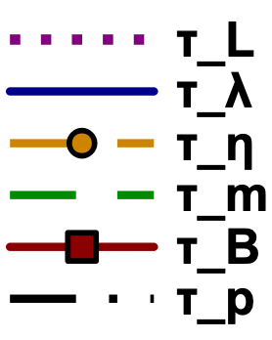  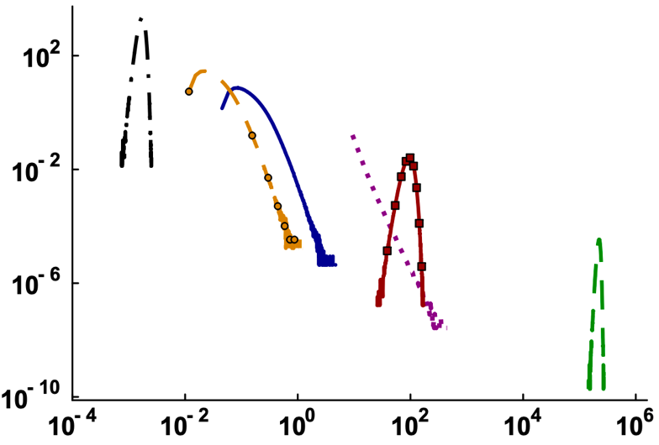  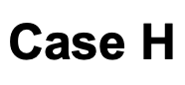 | PDF ($1/s$) | (b)    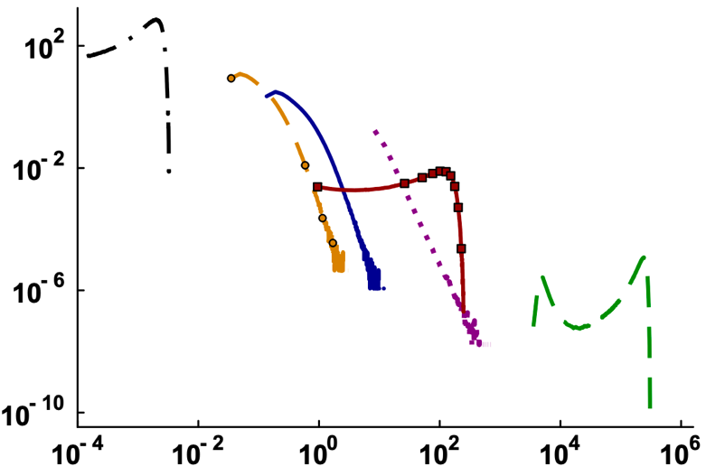  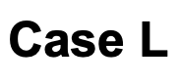
 | Timescale (s) |  | Timescale (s)
Figure 4. PDFs of the six timescales ($τ_{L}$, $τ_{λ}$, $τ_{η}$, $τ_{m}$, $τ_{B}$, and $τ_{p}$) for (a) Case H and (b) Case L.
It is known that cloud turbulence encompasses a broad range of scales. Hence, we compare the characteristic timescales in our model. The timescale for large eddy turnover is calculated as:
$$τ_{l}\left(x,t\right)=\frac{l}{\left|u\left(x,t\right)\right|} .$$ | (16)
where $l$ is the integral length scale (Pope, 2000). The timescale associated with Taylor microscale is: (Pope, 2000)
$$τ_{λ}\left(x,t\right)=\sqrt{\frac{15ν}{ϵ_{TKE}\left(x,t\right)} }, { ϵ}_{TKE}\left(x,t\right)=ν\left(\frac{∂u_{i}}{∂x_{j}}+\frac{∂u_{j}}{∂x_{i}}\right) .$$ | (17)
where $ϵ_{TKE}$ is the TKE dissipation rate. The Kolmogorov timescale is: (Pope, 2000)
$$τ_{η}\left(x,t\right)=\sqrt{\frac{ν}{ϵ_{TKE}\left(x,t\right)}} .$$ | (18)
The timescale for microscale evaporation is:
$$τ_{m}\left(X,t\right)=\frac{{\left(r\left(t\right)\right)}^{2}}{\left|GS_{e}\left(X,t\right)\right|} .$$ | (19)
The timescale for Brownian diffusion is: (Chandrasekhar, 1943)
$$τ_{B}\left(X,t\right)=\frac{{6πμ\left(r\left(t\right)\right)}^{3}}{k_{B}T(X,t)} , k_{B}=1.38×{10}^{-23} J/K$$ | (20)
where $k_{B}$ is the Boltzmann constant. Additionally, Equation (7) defines the timescale for droplet response.
The six timescales shown in Figures 4(a)-(b) differ by up to ten orders of magnitude and demonstrate the multiscale nature of turbulent clouds. The PDFs of flow timescales ($τ_{l}, τ_{λ}, τ_{η}$) are skewed to the right in both figures. We see that $τ_{l}>τ_{λ}>τ_{η}$, which is consistent with $l>λ>η$. The droplet response time ($τ_{p}$) is much smaller than the flow timescales. The flow field completes multiple eddy turnovers before a droplet experiences significant evaporation. So, the surrounding environment is uniformly mixed from the perspective of an individual droplet. This condition mathematically corresponds to a Damköhler number ($Da=τ_{η}/τ_{m}$) of less than unity and signifies a homogeneous mixing scenario. Consequently, the $τ_{m}$ is much larger than the flow timescales, as shown in Figures 4(a)-(b). It also suggests that phase change is quasi-static relative to turbulence and acts as a steady source of variance in the liquid water content. The PDF of $τ_{m}$ appears to be broader and bimodal for Case L but narrower and unimodal for Case H. High turbulence mixes droplets more effectively with the environment, homogenizing their growth histories and keeping radii closer to the mean value. Low turbulence allows droplets to remain in locally supersaturated or subsaturated conditions for a longer time. Some droplets grow while others evaporate, leading to a broader and bimodal size distribution (Manton, 1979). The timescale for Brownian motion ($τ_{B}$) falls between the other two microphysical timescales ($τ_{p}$ and $τ_{m}$). The overlap of $τ_{B}$ and $τ_{l}$ is also observed. That is, the time for Brownian motion to randomly shuffle a droplet by distance $r$ is roughly equal to the time for turbulence to sweep droplets over length $l$. For the macroscale transport, Brownian diffusion is insignificant since $l≫r$. However, turbulence advects droplets along correlated eddies and Brownian motion tends to disrupt spatial correlations between droplet positions at the microscale.

5 Implications and Concluding Remarks
The DNS results presented in Section 4 carry several implications for the modeling and observation of cloud microphysics, which are summarized below.
- Upscale energy transfer is actively present in atmospheric clouds and is driven by microscale phase change (Figures 1(b)-(f) and Figures 2(b)-(d)). Because this inverse cascade originates below the resolution of mesoscale and global models, it is unresolved in those frameworks. Improved parametrization of cloud water mixing ratio ($q_{l}$) in those models must account for the small-scale production of $q_{l}$ variance.
- The energy spectra, structure functions, and gradients of thermodynamic and microphysical fields are sensitive to the intensity of flow turbulence (Figures 1, 2, and 3). Hence, turbulence parameterization schemes designed for strongly turbulent (cumulonimbus) clouds cannot be directly applied to weakly turbulent (stratocumulus) clouds.
- The third-order structure function of $q_{l}$ changes sign at a very small separation (Figure 2(c)). The grid spacing in a numerical model should be such that this crossover from microphysics-dominated inverse cascade to turbulence-dominated direct cascade is captured.
- The trimodal distribution of $∂q_{l}/∂z$ (Figure 3(d)) suggests that cloudy and clear-air pockets exist within a cloud. Turbulent mixing does not erase the spatial inhomogeneity in atmospheric clouds.
- The timescales in a cloud span approximately ten orders of magnitude (Figures 4(a)-(b)). Such extreme scale separation makes it infeasible for a single measurement platform to observe the full spectrum of cloud physics.
We conclude that microscale phase change acts as a localized energy source within clouds and drives an upscale energy transfer. Capturing this phenomenon necessitates a particle-based DNS framework, which calculates phase change at exact droplet locations and prevents numerical diffusion from artificially destroying the local gradients that fuel the inverse cascade. However, the present study assumes homogeneous and isotropic turbulence. But turbulence in real clouds is inhomogeneous and anisotropic, caused by buoyancy and shear. To understand how buoyancy and shear modify the energy cascades in turbulent clouds, future DNS studies will need to implement non-periodic boundary conditions.

References
Brandt, L. & Coletti, F. (2022), Particle-laden turbulence: progress and perspectives. Annual Review of Fluid Mechanics, 54(1), pp.159-189. doi: 10.1146/annurev-fluid-030121-021103.
Cabanes, S., Espa, S., Galperin, B., Young, R.M. & Read, P.L. (2020), Revealing the intensity of turbulent energy transfer in planetary atmospheres. Geophysical Research Letters, 47(23), p.e2020GL088685. doi: 10.1029/2020GL088685.
Chandrasekhar, S. (1943), Stochastic problems in physics and astronomy. Reviews of modern physics, 15(1), p.1. doi: 10.1103/RevModPhys.15.1.
Davis, A.B., Marshak, A., Gerber, H. & Wiscombe, W.J. (1999), Horizontal structure of marine boundary layer clouds from centimeter to kilometer scales. Journal of Geophysical Research: Atmospheres, 104(D6), pp.6123-6144. doi: 10.1029/1998JD200078.
Eswaran, V. & Pope, S.B. (1988), An examination of forcing in direct numerical simulations of turbulence. Computers & Fluids, 16(3), pp.257-278. doi: 10.1016/0045-7930(88)90013-8.
Frisch, U. (1995), Turbulence: The Legacy of A. N. Kolmogorov. Cambridge: Cambridge University Press. doi: 10.1017/CBO9781139170666.
Gao, Z., Liu, Y., Li, X. & Lu, C. (2018), Investigation of turbulent entrainment‐mixing processes with a new particle‐resolved direct numerical simulation model. Journal of Geophysical Research: Atmospheres, 123(4), 2194-2214. doi: 10.1002/2017JD027507.
Gotoh, T., Saito, I. & Watanabe, T. (2021), Spectra of supersaturation and liquid water content in cloud turbulence. Physical Review Fluids, 6(11), p.110512. doi: 10.1103/PhysRevFluids.6.110512.
Huang, J. (2018), A simple accurate formula for calculating saturation vapor pressure of water and ice. Journal of Applied Meteorology and Climatology, 57(6), 1265-1272. doi: 10.1175/JAMC-D-17-0334.1.
Jeffery, C.A. (2001), Effect of condensation and evaporation on the viscous-convective subrange. Physics of Fluids, 13(3), pp.713-722. doi: 10.1063/1.1343481.
Kerr, R.M., Meneguzzi, M. & Gotoh, T. (2001), An inertial range crossover in structure functions. Physics of Fluids, 13(7), pp.1985-1994. doi: 10.1063/1.1373683.
Lilly, D.K. (1983), Stratified turbulence and the mesoscale variability of the atmosphere. Journal of Atmospheric Sciences, 40(3), pp.749-761. doi: 10.1175/1520-0469(1983)040<0749:STATMV>2.0.CO;2.
Manton, M.J. (1979), On the broadening of a droplet distribution by turbulence near cloud base. Quarterly Journal of the Royal Meteorological Society, 105(446), pp.899-914. doi: 10.1002/qj.49710544613.
Pope, S.B. (2000), Turbulent flows. Cambridge University Press. doi: 10.1017/CBO9780511840531.
Sharfuddin, A.A.M., Ladeinde, F., Liu, Y., Endo, S., Yang, F., Atif, M., Lin, M. & Li, W. (2026), The role of thermodynamic forcing in direct numerical simulations of turbulence-cloud microphysics interactions. Physics of Fluids. Under review.
Vallis, G.K., Shutts, G.J. & Gray, M.E.B. (1997), Balanced mesoscale motion and stratified turbulence forced by convection. Quarterly Journal of the Royal Meteorological Society, 123(542), pp.1621-1652. doi: 10.1002/qj.49712354209.
Wang, Y., Liu, Q., Li, Y., Zheng, Q., Lao, P. & Wei, H. (2026), Decaying active clouds produce the scale break in the power‐law size distribution of cumulus clouds. Journal of Geophysical Research: Atmospheres, 131(5), p.e2025JD044751. doi: 10.1029/2025JD044751.
Xia, H., Byrne, D., Falkovich, G. & Shats, M. (2011), Upscale energy transfer in thick turbulent fluid layers. Nature Physics, 7(4), pp.321-324. doi: 10.1038/NPHYS1910.

