PAI Assignment 2

Q1:
import requests as req
with open("api.txt", "w") as file:
file.write("https://api.cricapi.com/v1/currentMatches")

print("api.txt file created successfully!")

try:
with open("api.txt","r") as file:
url=file.readline().strip() # using strip to leave the extra spaces
print(url)
except FileNotFoundError:
print("Error: 'api.txt' not found.")

param={
"apikey": "ef61457d-fd8b-469f-a7a6-9cd089167c02",
"offset": 0
}
try:
response=req.get(url,params=param)

if response.status_code==200:
data=response.json()
print("API response recieved.")

print("API Status Summary:")
for key,value in data.items():
if key not in ("data","apikey"):
print(f"{key}: {value}")

if data.get("status")!="success" or "data" not in data or not data["data"]:
print("API Error.")
print(f"Reason: {data.get("reason","unknown error")}")
else:
print("---Current Matches---")
for match in data["data"]:
print("-----------------------------------")
print(f"Match Name : {match.get("name","N/A")}")
print(f"Status : {match.get("status","N/A")}")
print(f"Venue : {match.get("venue","N/A")}")
print(f"Date : {match.get("date","N/A")}")
print("-----------------------------------")

scores=match.get("score")
if scores and isinstance(scores,list):
for innings in scores:
print(f"Inning : {match.get("inning","N/A")}")
print(f"Runs : {match.get("r","N/A")}")
print(f"Wickets : {match.get("w","N/A")}")
print(f"Overs : {match.get("o","N/A")}")
print("-----------------------------------")
else:
print("No score data avaiable yet.")
print("--------------------------------------------------------------------------")

else:
print(f"HTTP Error: {response.status_code}")
print(response.txt())

except req.exceptions.RequestException as e:
print("Network Error: Unable to reach API.")
print(f"Details: {e}")
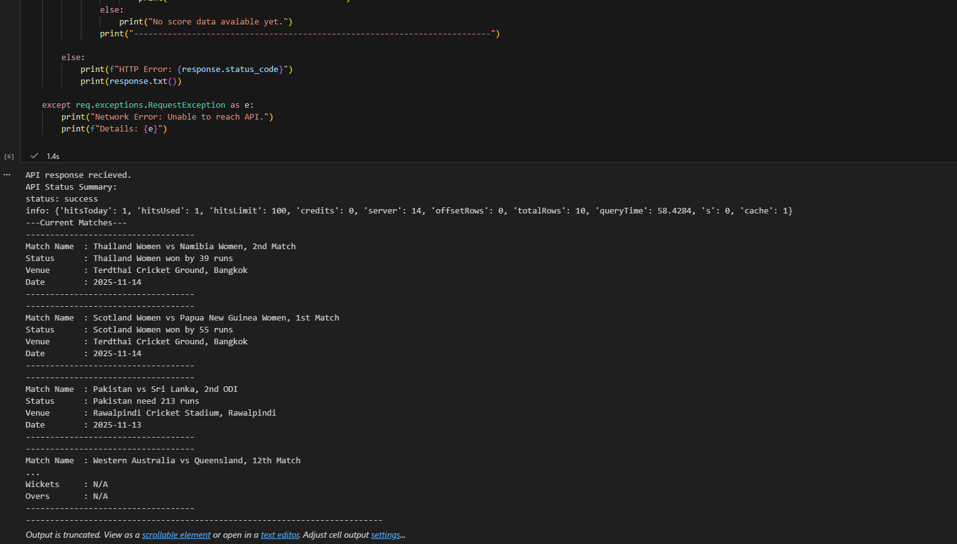

Q2:
import numpy as np
data=[]
with open("sensor_data.csv","r") as file:
for line in file:
data.append(line.strip().split(","))
print(f"Loaded data: {len(data)} rows, {len(data[0])} columns")
dataArr=np.array(data,dtype=float)
dataArr[dataArr==-999]=np.nan
dataArr[(dataArr<0)|(dataArr>100)]=np.nan

meanPerSensor=np.nanmean(dataArr,axis=0)
meanPerHour=np.nanmean(dataArr,axis=1)
nanCount=np.isnan(dataArr).sum(axis=0)
wrostSensorIndex=np.argmax(nanCount)
wrostSensorInvalids=nanCount[wrostSensorIndex]
print("Average moisture (per sensor):\n", meanPerSensor[:10], "...") # first 10 to make the output simple
print("\nMedian moisture (first 10 hours):\n", meanPerHour[:10])
print(f"\nSensor with most invalid readings: Column {wrostSensorIndex} ({wrostSensorInvalids} NaNs)")
minVal=np.nanmin(dataArr)
maxVal=np.nanmax(dataArr)
normalizedArr=(dataArr-minVal)/(maxVal-minVal)
np.savetxt("sensor_data_normalized.csv",normalizedArr,delimiter=",",fmt="%.4f",header="Normalized Sensor Data",comments="")
print("Done!") 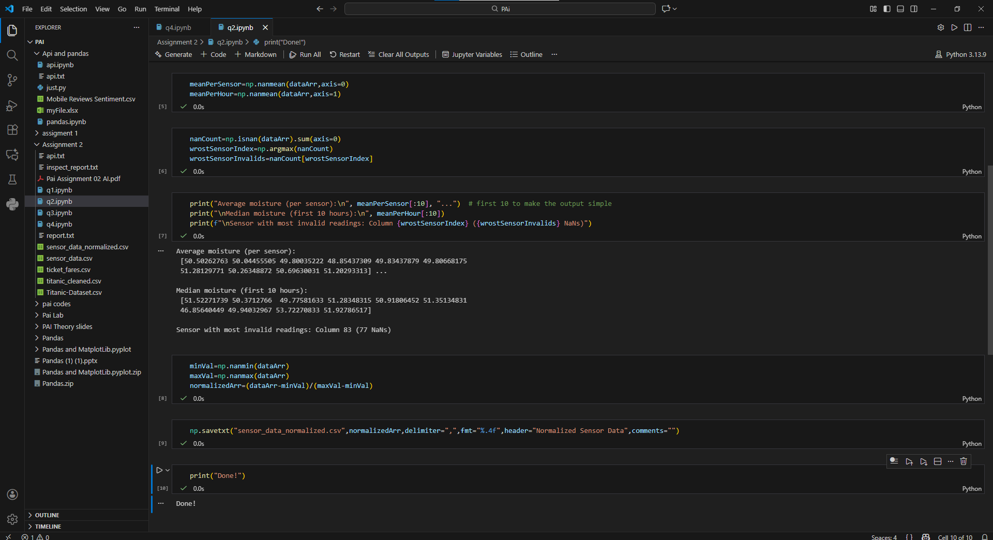

Q3:
import pandas as pd
data=pd.read_csv("Titanic-Dataset.csv")
data.columns
reportLines=[]
reportLines.append("Column, Dtype, % Missing ")
for col in data.columns:
dtype=data[col].dtype
missing=data[col].isna().mean()*100
reportLines.append(f"{col}, {dtype}, {missing:.2f}% \n")
with open("inspect_report.txt","w") as file:
file.writelines(reportLines)
print("Inspect report written sucessfully.")
print("preview (10 lines): ")
print("".join(reportLines[:10]))
groupMedian=data.groupby(["Pclass","Sex"])["Age"].transform("median")
data["Age"]=data["Age"].fillna(groupMedian)
data["Age"].info()
if data["Embarked"].mode().size>0:
embarkedMode=data["Embarked"].mode()[0]
else:
embarkedMode="S"
data["Embarked"].fillna(embarkedMode)
if "Cabin" in data.columns:
data=data.drop(columns=["Cabin"])
data.head(3)
data["familySize"]=data["SibSp"]+data["Parch"]
data["IsAlone"]=(data["familySize"]==0).astype(int)
data["Age"]=data["Age"].astype(int)
data.head(2)
data.to_csv("titanic_cleaned.csv",index=False)
print(f"Cleaned Data saved.") 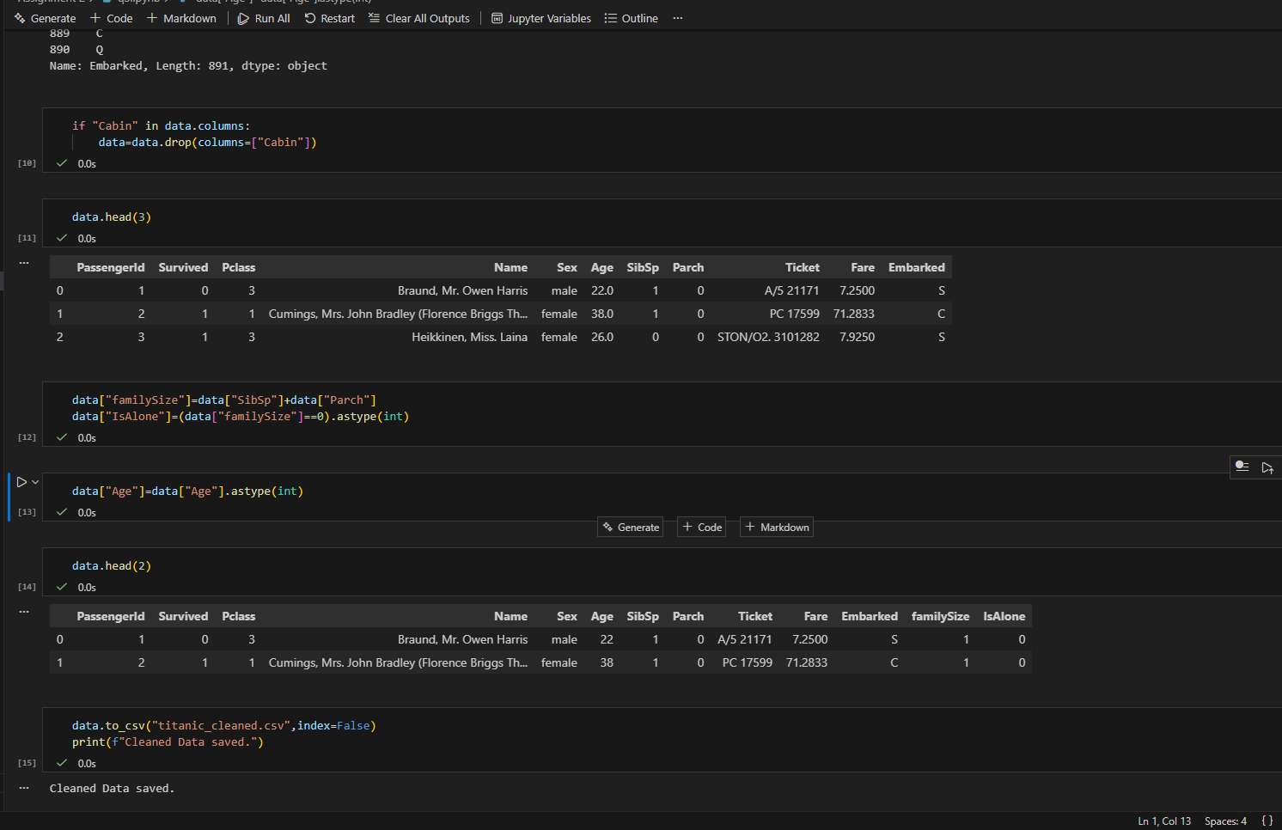

Q4:

