Name: Abdullah Tahir

Roll No: 19P-0067

Section : 5B

**Modes of router**

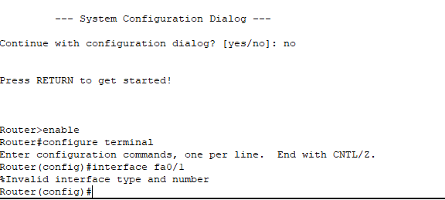

**CHANGING HOSTNAME**

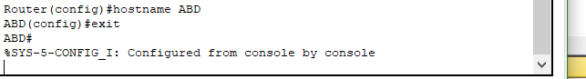

**Time**

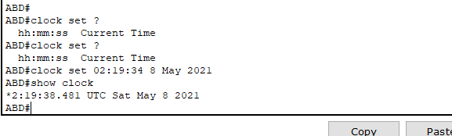

**Banner**



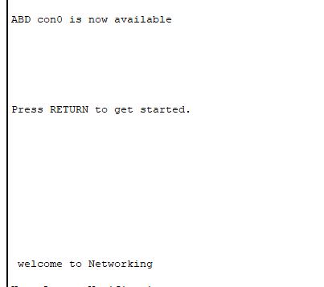

**DISPLAYING RUNNING-CONFIGURATION**

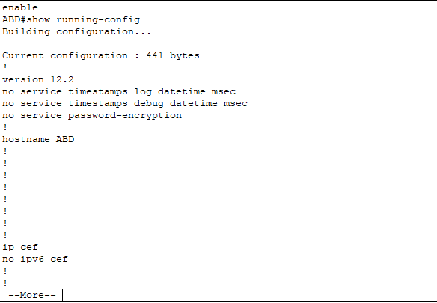

**Password**

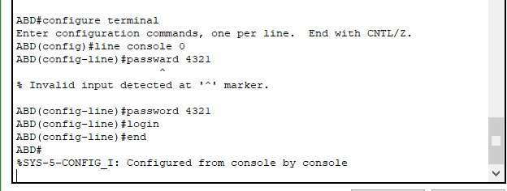

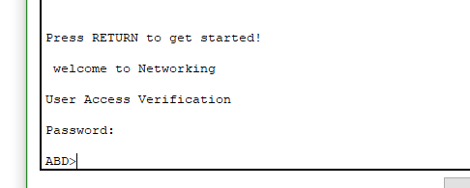

**Secret password**

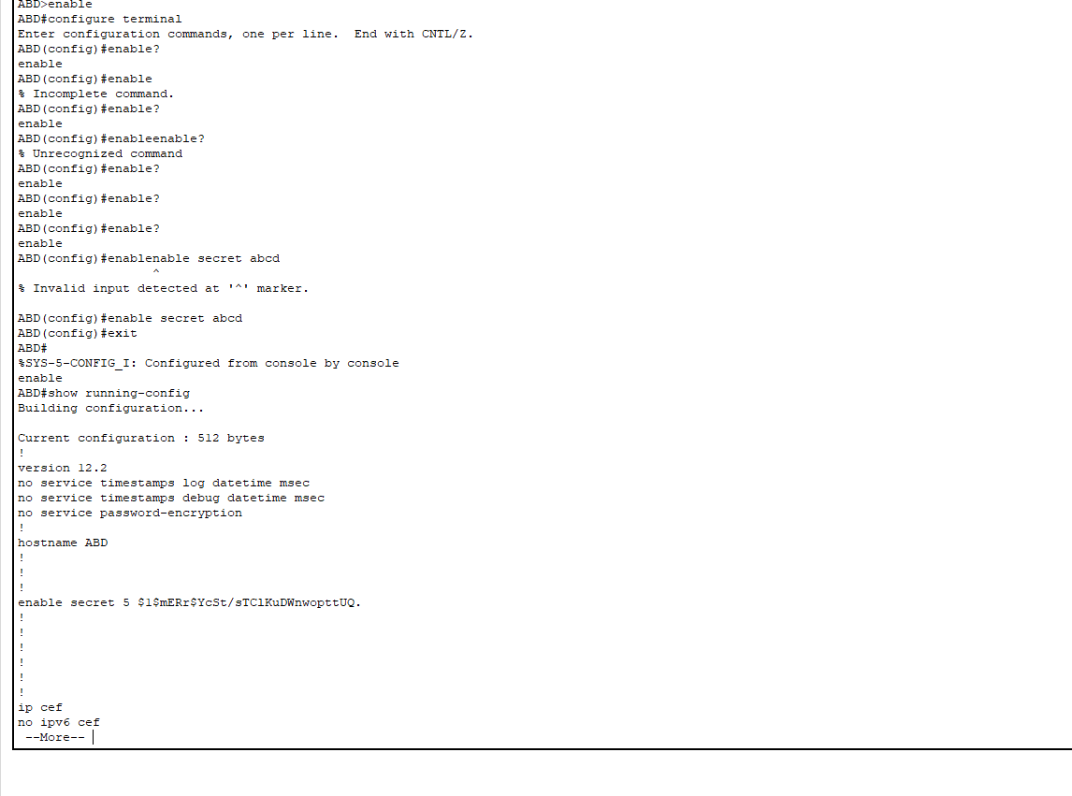

**What is telnet?**

Telnet is a network protocol used to virtually access a computer and to provide a two-way,

Collaborative and text-based communication channel between two machines. It follows a user

Command Transmission Control Protocol/Internet Protocol (TCP/IP) networking protocol for

Creating remote sessions.

**How to telnet?**

Typing telnet hostname would connect a user to a hostname named

Hostname. Telnet enables a user to manage an account or device remotely. For example, a user

May telnet into a computer that hosts their website to manage his or her files remotely.

**Line VTY/telnet password**

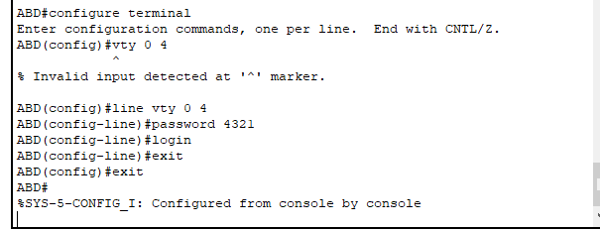

**Uses of router in different topologies?**

**Star topology for wireless networks**

The most obvious example of this would be a home network. All of the nodes – phones, printers, tablets etc. – connect to the wireless access point (hub), which is usually both a router for the local network and a bridge to the Internet. Star networks are highly suitable for connecting both wired and wireless nodes together seamlessly.

**Hybrid networks**

Tree networks connect Star networks together on a Bus network. This is often used when there are several clusters of nodes such as in a WAN. In such a case, each node is connected to a router to form a Star network and then the routers will be connected together to create a Bus connection between them. This can also be done with a Snowflake network, which connects multiple Star networks to a single central node, like a Star of Stars.

**Task 1**

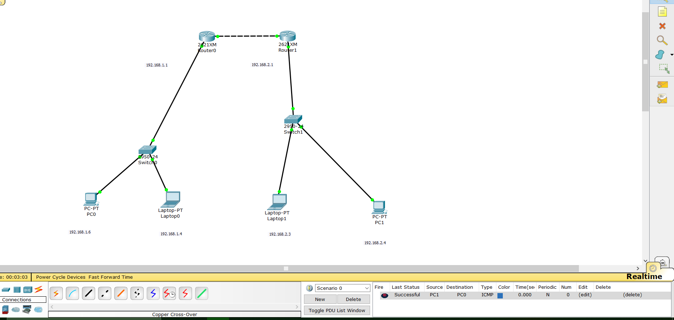

**Modes**

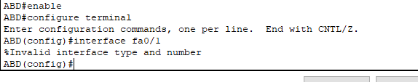

**Router SAR security**

