**UBUNTU COMMANDS**

**OPERATING SYSTEMS LABS**

**ASSIGNMENT # 01**

*Submitted By*

ABDULLAH TAHIR KHURSHID

(19P-0067)

*Submitted to*

MR. MUHAMMAD ABDULLAH

(COMPUTER INSTRUCTOR)

**DEPARTMENT OF COMPUTER SCIENCE**

**FAST NATIONAL UNIVERSITY OF COMPUTER AND EMERGING SCINCES, PESHAWAR**

Session 2020-2024

**WORD COUNT:**

wc is a linux command which is used to count words,lines and characters in that are present in a file.

by default, wc displays a four column output.

* the first column displays the numbers of lines.
* the second column displays the number of words.
* the third column displays the number of characters.
* and the last column displays the file name.

Example:

For our example I first made a file named called xyz with using touch command and then with cat>xyz, we inserted lines,words and character into “xyz” file



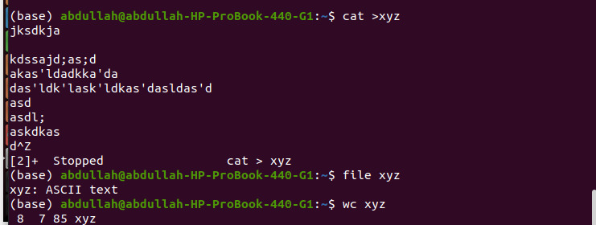

As shown above when wc command was used it displayed the number of lines,words,character and name of the file respectively.

**What defines a lines,word,character?**

1. Line is any group of characters not containing a newline.
2. A word is a group of character not containing a space ,tab or newline.
3. a character is the smallest unit of information and includes a space tab and newline.

**More commands of wc:-**

wc -l option counts the numbers of lines in a file.

wc -w option counts the numbers of words in a file.

wc -c option counts the numbers of character in a file.

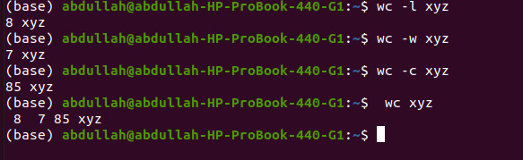

As shown above ,when wc -l was used it only displayed the number of lines the file had.When wc -w was used it only displayed the number of words in the file. When wc -c was used it only displayed the number of character in the file

**Using wc Command with multiple files:**

wc when used with multiple files it gives the counts of lines ,words and characters in each fine on a separate file and also gives the total count.

Example:-

For this example, I created a new file named “jkl” with touch command and add random words and character and used wc to see it’s number of lines,words and character.

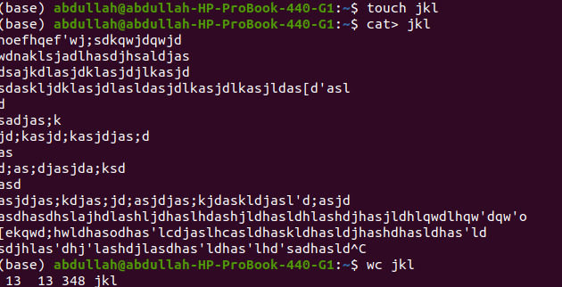

Now in order to use wc with multiple files we used the following command

“wc xyz jkl” ,As shown below

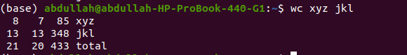

First it gave us the count of contents of xyz file then it gave us the count of content jkl file,

In the third line it added up the lines from both files ,it also added up words from both files and finally it added up the characters from both files on a separate file named a total as you can see from above.