2. TASK A - PASSENGER DEMAND STATISTICAL ANALYSIS

2.1 Dataset and Variables
The statistical analysis used the provided Air Transportation Regression Dataset, containing 200 observations and seven continuous numerical variables. passenger_demand was treated as the dependent variable, while airport_traffic, avg_income, fuel_price, avg_ticket_fare, flight_frequency, and route_distance were used as independent variables. The supplied data dictionary defines these variables as measures of airport activity, economic conditions, operating costs, fares, service frequency and route characteristics.
Initial inspection in R confirmed that all variables were numeric and that no missing values were present. This allowed the dataset to be used directly for descriptive statistics, normality testing, correlation and regression analysis.
Table 2.1: Variables Used in the Passenger Demand Analysis
Table 1- Variables Used in the Passenger Demand Analysis
Variable | Role | Description | Unit
Airport Traffic | Independent | Annual passengers handled by airport | Passengers
Average Income | Independent | Average income of population served | USD/year
Fuel Price | Independent | Average aviation fuel price | USD/litre
Average Ticket Fare | Independent | Average airfare per passenger | USD
Flight Frequency | Independent | Scheduled flights operating per day | Flights/day
Route Distance | Independent | Average route distance served | Kilometres
Passenger Demand | Dependent | Total passenger demand | Passengers
RStudio Dataset Inspection and Data Structure 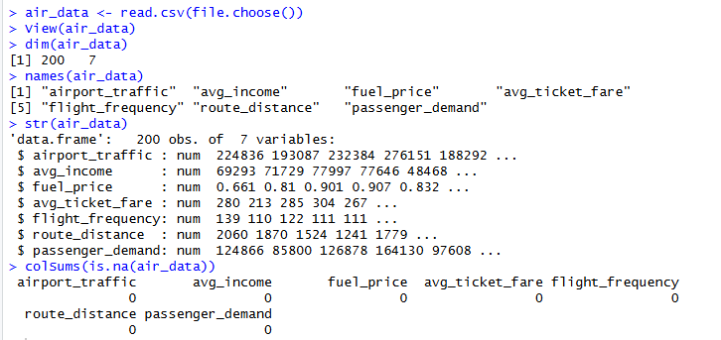
Figure 1- RStudio Dataset Inspection and Data Structure

2.2 Descriptive Statistical Analysis
Descriptive statistics were calculated to understand the central tendency and range of the variables before inferential analysis. Descriptive analysis provides an initial understanding of data behaviour and supports the identification of unusual values (Field, 2024).
Table 2.2: Descriptive Statistics of the Air Transportation Dataset
Table 2-Descriptive Statistics of the Air Transportation Dataset
Variable | Mean | Median | Minimum | Maximum
Airport Traffic | 197,961 | 199,790 | 69,013 | 336,008
Average Income | 66,030 | 65,946 | 26,105 | 111,233
Fuel Price | 0.887 | 0.888 | 0.529 | 1.362
Average Ticket Fare | 250.4 | 250.9 | 142.1 | 355.3
Flight Frequency | 122.57 | 122.61 | 71.52 | 170.54
Route Distance | 1,553.5 | 1,579.1 | 341.5 | 2,475.9
Passenger Demand | 107,811 | 109,586 | -60,240 | 268,128
Passenger demand averaged approximately 107,811, while airport traffic averaged approximately 197,961 passengers. A notable limitation was the negative minimum passenger-demand value, which is unrealistic as a literal passenger count. Since the supplied data dictionary does not explain this value, it was retained rather than modified without evidence.
Histogram of Airport Traffic here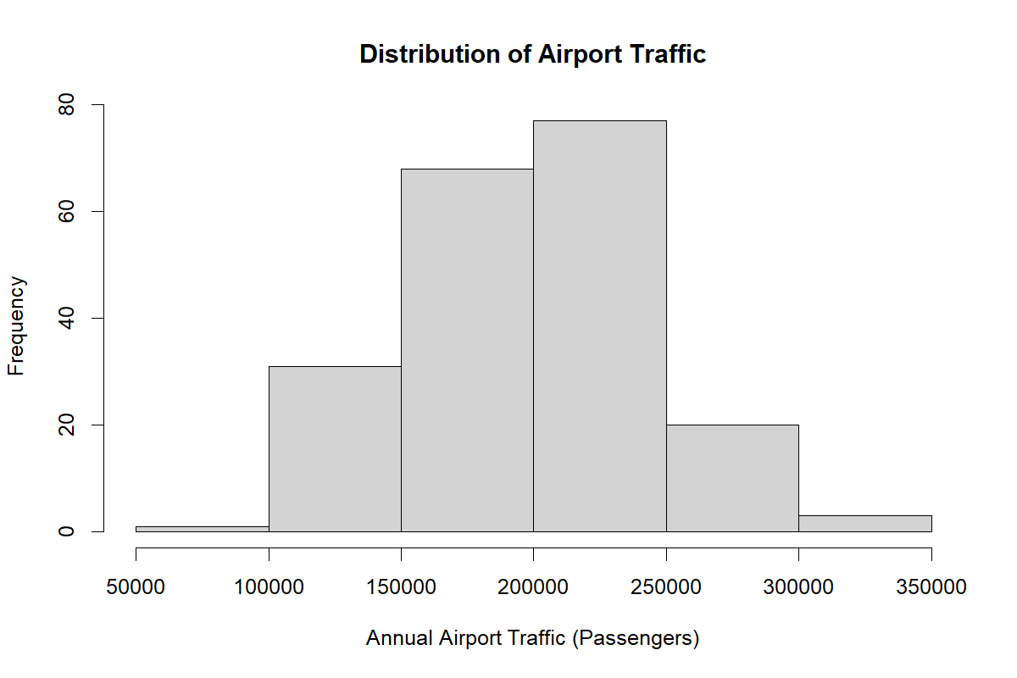
Figure 2 - A01_Histogram_Airport_Traffic
Histogram of Passenger Demand here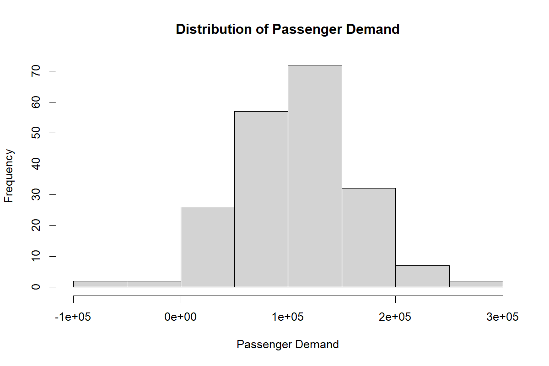
Figure 3 - A07_Histogram_Passenger_Demand
Overall, the descriptive analysis indicated substantial variation in both airport activity and passenger demand across the 200 observations. These initial findings provided the basis for subsequent normality testing, correlation analysis and regression modelling to determine which factors were statistically associated with passenger demand.

2.3 Normality Testing
The Shapiro-Wilk test was used to assess normality. The null hypothesis stated that each variable followed an approximately normal distribution, while the alternative hypothesis stated that it did not.
All variables produced p-values greater than 0.05: airport traffic (0.829), average income (0.250), fuel price (0.922), average ticket fare (0.777), flight frequency (0.600), route distance (0.440), and passenger demand (0.425). Therefore, the null hypothesis was not rejected for any variable, indicating no significant evidence of non-normality.
All seven variables produced p-values above the 0.05 significance threshold. The smallest p-value was 0.2498 for average income, while the largest was 0.9218 for fuel price. Therefore, the null hypothesis of normality was not rejected for any of the variables. These results indicate that the distributions were sufficiently consistent with normality for the subsequent parametric analysis.
The result for passenger demand was particularly important because it was the dependent variable used throughout the regression analysis. Passenger demand produced a Shapiro-Wilk p-value of 0.4249, providing no statistically significant evidence of departure from normality.
Q-Q Plot of Passenger Demand
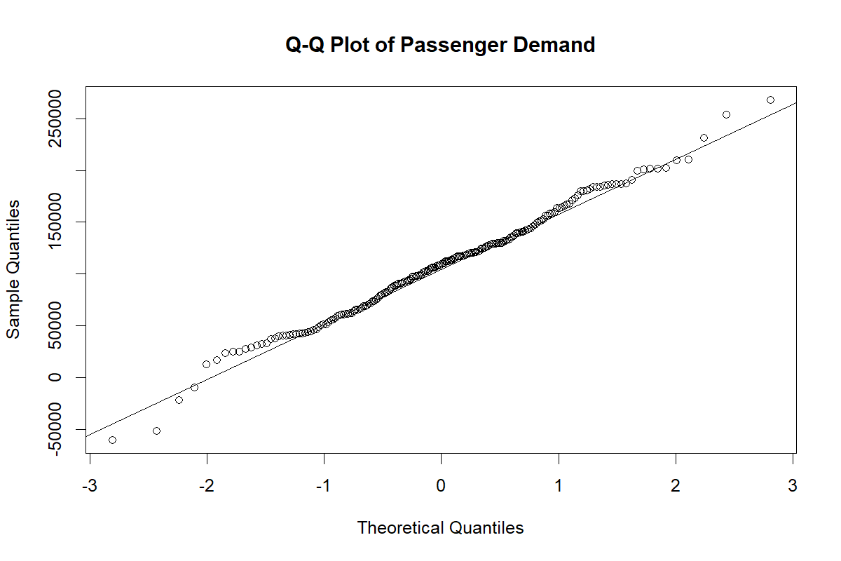
Figure 4 - A08_QQ_Plot_Passenger_Demand
The results supported the use of parametric techniques such as Pearson correlation and linear regression. Regression residuals were also checked separately during model evaluation because residual normality is a key regression assumption (Field, 2024).

2.4 Correlation Analysis
Pearson correlation was used to assess the strength and direction of relationships between passenger demand and each independent variable.
Table 2.4: Pearson Correlation Results with Passenger Demand
Table 3 - Pearson Correlation Results with Passenger Demand
Independent Variable | Pearson r | p-value | Significance | Interpretation
Airport Traffic | 0.385 | <0.001 | Significant | Positive weak-to-moderate relationship
Average Income | 0.050 | 0.486 | Not significant | Very weak positive relationship
Fuel Price | 0.086 | 0.228 | Not significant | Very weak positive relationship
Average Ticket Fare | -0.030 | 0.669 | Not significant | Negligible negative relationship
Flight Frequency | 0.052 | 0.463 | Not significant | Very weak positive relationship
Route Distance | -0.041 | 0.563 | Not significant | Very weak negative relationship
Airport traffic showed the strongest relationship with passenger demand (r = 0.385, p < 0.001) and was the only statistically significant bivariate relationship. The remaining predictors showed very weak and non-significant relationships.
Scatterplot of Airport Traffic versus Passenger Demand

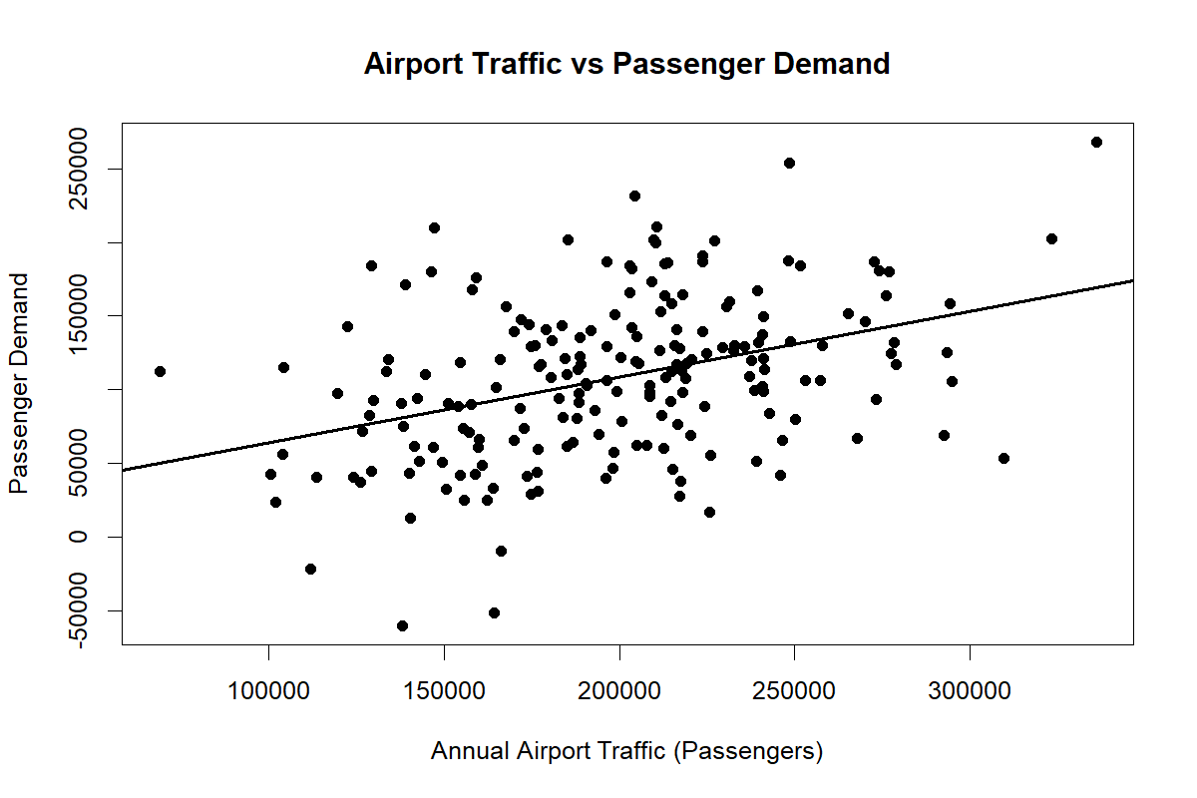
Figure 5 - A09_Scatterplot_Airport_Traffic
The positive relationship suggests that higher airport traffic tends to be associated with greater passenger demand. However, correlation indicates association rather than causation (Field, 2024).

2.5 Simple Linear Regression
A simple linear regression was conducted using airport traffic as the predictor because it was the only variable significantly correlated with passenger demand.
The estimated model was:
The model was statistically significant, F(1,198) = 34.54, p < 0.001, with R² = 0.1485. Therefore, airport traffic explained approximately 14.85% of the variation in passenger demand.
The coefficient indicates that an increase of 10,000 passengers in airport traffic was associated with an estimated increase of approximately 4,459 passengers in predicted demand.
Residual normality was supported by the Shapiro-Wilk test (W = 0.9949, p = 0.7374).

Table 2.5: Simple Linear Regression Results
Table 4 - Simple Linear Regression Results
Statistic | Result
Predictor | Airport Traffic
Intercept | 19,542.28
Airport Traffic Coefficient | 0.4459
R² | 0.1485
Adjusted R² | 0.1442
Residual Standard Error | 49,821.27
F-statistic | 34.54
Degrees of Freedom | (1, 198)
Model p-value | <0.001
The model was statistically significant, F(1,198) = 34.54, p < 0.001, demonstrating that airport traffic significantly contributed to predicting passenger demand. The model produced an R² value of 0.1485, indicating that airport traffic alone explained approximately 14.85% of the observed variation in passenger demand. The adjusted R² was similar at 0.1442.
Simple Linear Regression of Airport Traffic and Passenger Demand
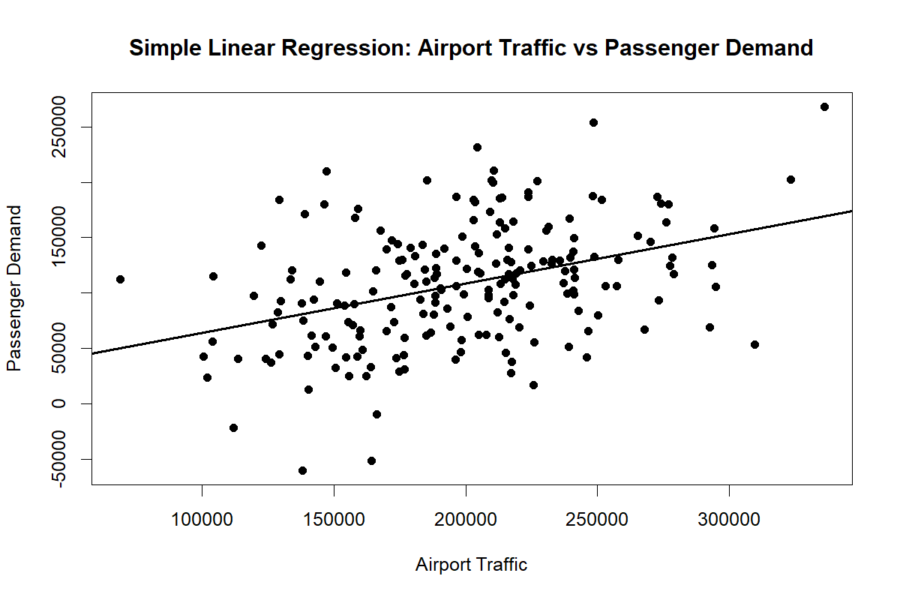
Figure 6- A15_Simple_Regression_Airport_Traffic

Diagnostic Plots for the Simple Linear Regression Model
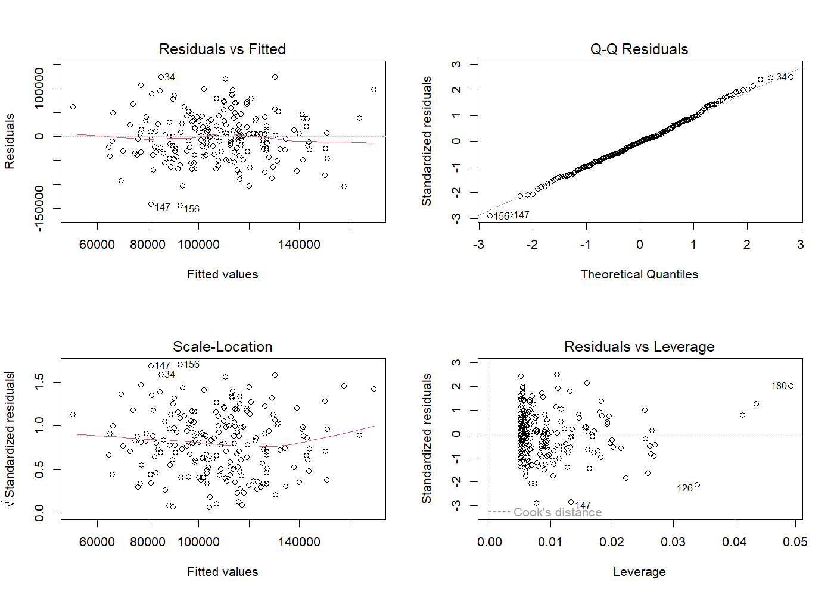
Figure 7 - A16_Simple_Regression_Diagnostics
From a civil aviation planning perspective, increased airport traffic can indicate higher passenger demand and the need for greater terminal capacity and operational resources. However, airport traffic alone is insufficient for forecasting, and other economic and operational factors should also be considered (Hair et al., 2019).

2.6 Multiple Linear Regression
A multiple regression model was then developed using all six independent variables. The full model was statistically significant, F(6,193) = 7.008, p < 0.001, with R² = 0.1789 and adjusted R² = 0.1534.
Airport traffic remained significant (β = 0.4759, p < 0.001), while fuel price also became significant (β = 53,537.84, p = 0.0268). Average income, ticket fare, flight frequency and route distance were not significant at the 5% level.
This demonstrates the advantage of multiple regression because variables can show different effects after controlling for other predictors (Hair et al., 2019)
Diagnostic Plots for the Full Multiple Linear Regression Model
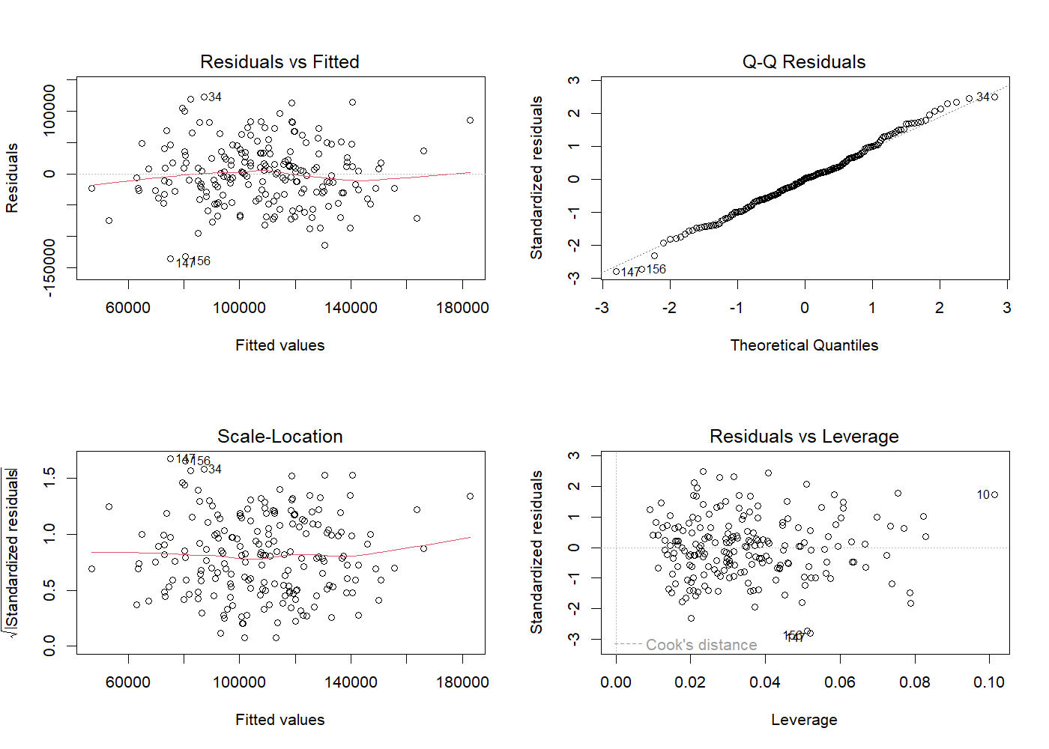
Figure 8 - A17_Multiple_Regression_Diagnostics
Residual normality remained acceptable (W = 0.9943, p = 0.6501).

2.7 Statistical Model
A reduced model containing only airport traffic and fuel price was developed to improve model simplicity.
The reduced model achieved:
- R² = 0.1678
- Adjusted R² = 0.1593
- F(2,197) = 19.85
- p < 0.001
- Residual standard error = 49,380.51
Its adjusted R² was slightly higher than the full six-variable model (0.1593 compared with 0.1534), while also producing the lowest residual standard error. Therefore, the reduced model was selected as the preferred model.
Variance Inflation Factor values ranged from 1.026 to 1.060, indicating no problematic multicollinearity among the predictors (Hair et al., 2019).
Reduced Model Diagnostic Plots here
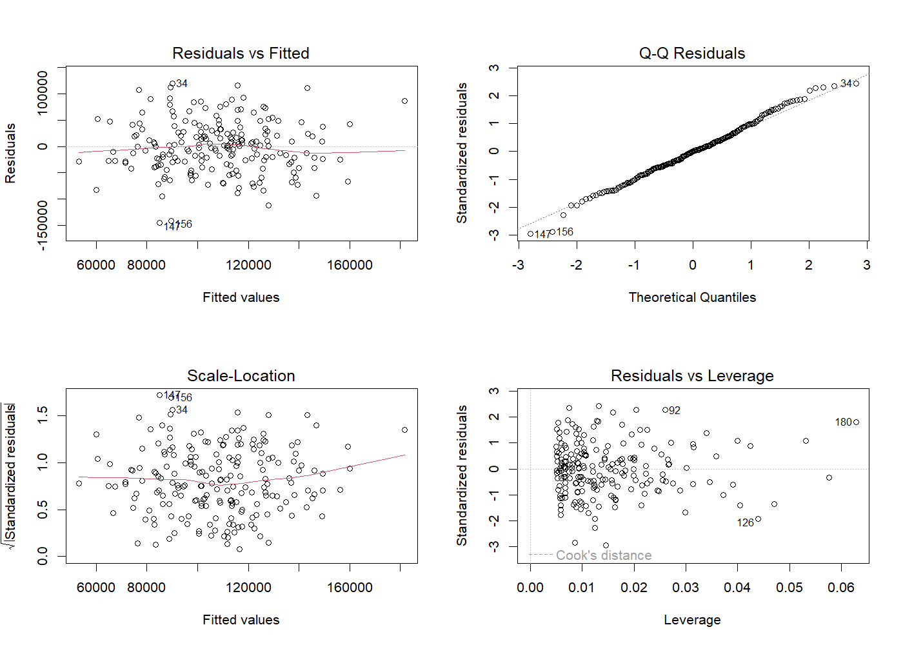
Figure 9 - A18_Reduced_Model_Diagnostics

2.8 Business Interpretation
The analysis identifies airport traffic as the most consistent predictor of passenger demand. Airport managers could therefore use changes in traffic volumes as an indicator when planning terminal capacity, passenger-processing resources, staffing and infrastructure investment.
Fuel price also contributed significantly in the multiple regression model, although its positive coefficient should not be interpreted as a causal relationship. The analysis only demonstrates statistical association within the supplied dataset.
The preferred reduced model explained approximately 16.78% of passenger-demand variation, meaning that a substantial proportion remained unexplained. Factors such as tourism seasonality, economic conditions, exchange rates, airline competition and international events may also influence aviation demand but were not included in the provided dataset.
Overall, the statistical analysis demonstrates how operational and economic data can be transformed into business intelligence for evidence-based aviation planning. However, the model should be used as a decision-support tool rather than a complete forecasting solution, particularly because of its moderate explanatory power and the limitations of the supplied data.

3. TASK B - AVIATION STAKEHOLDER NETWORK ANALYSIS

3.1 Network Construction and Visualisation
Social Network Analysis (SNA) was conducted in R using the igraph package to examine relationships and coordination among stakeholders within the Sri Lankan aviation sector. The supplied network contained 15 stakeholder nodes and 28 relationships, classified as commercial, operational, regulatory and support connections. The network was modelled as an undirected graph because the analysis focused primarily on stakeholder interdependence and coordination rather than assuming that every relationship represented one-way information flow.
The visualisation incorporated several network characteristics simultaneously. Node colour represents stakeholder category, while node size represents normalised degree centrality. Edge colour identifies the relationship type and edge thickness represents the supplied relationship weight. The three stakeholders with the highest betweenness centrality were also highlighted with red borders. This provides a visual representation of highly connected actors and stakeholders occupying important intermediary positions.
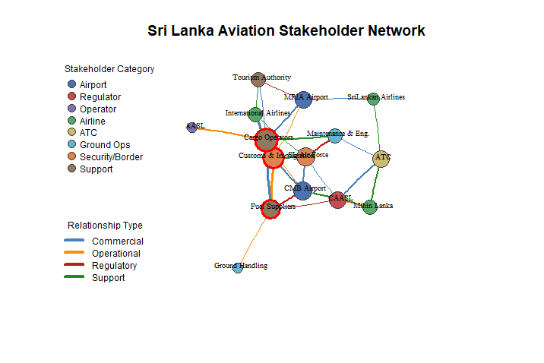
Figure 10-Sri Lanka Aviation Stakeholder Network based on degree and betweenness centrality.

3.2 Degree and Betweenness Centrality
Degree centrality measures the number of direct relationships held by a stakeholder, whereas betweenness centrality measures the extent to which a stakeholder lies on shortest paths connecting other actors. These measures are widely used to distinguish highly connected actors from those performing important brokerage or intermediary roles within a network (Freeman, 1979).
The analysis identified Cargo Operators, Fuel Supply Companies and Customs & Immigration as the three highest-betweenness bridge nodes. Cargo Operators also showed a particularly high level of direct connectivity, indicating that this stakeholder occupies an influential structural position within the supplied network. Fuel Supply Companies similarly connect several operational groups, while Customs & Immigration links important airport, airline and support relationships.
These findings should not, however, be interpreted as suggesting that actors with lower calculated betweenness are operationally unimportant. For example, the assignment scenario identifies Air Traffic Control (ATC) as a central operational coordinator during periods of heavy traffic and aircraft emergencies. Network centrality measures structural position within the relationships contained in the dataset, whereas operational importance also depends on regulatory responsibilities, specialist functions and real-world decision authority. Therefore, SNA should complement rather than replace operational judgement.

3.3 Network Connectivity and Structural Efficiency
Table 3.1: Summary and Interpretation of Network Structural Metrics
Table 5-Summary and Interpretation of Network Structural Metrics
Metric | Value | Interpretation
Network Density | 0.2667 | Approximately 26.7% of all possible stakeholder connections are present, indicating a moderately sparse and selective coordination structure.
Connected Components | 1 | All 15 stakeholders are structurally connected within one overall network.
Average Path Length | 2.000 | On average, two stakeholders are separated by only two relationship steps, indicating relatively efficient reachability.
Network Diameter | 4 | The greatest shortest-path separation between any two stakeholders is four steps, suggesting that no stakeholder is deeply isolated.
Global Clustering Coefficient | 0.2784 | Indicates moderate local clustering, with some neighbouring stakeholders also maintaining relationships with one another.
Number of Communities | 4 | Four distinct stakeholder communities were detected within the network.
Modularity | 0.3313 | Indicates a moderate community structure, with identifiable groups that still maintain cross-community relationships.
The density of 0.2667 means that approximately 26.7% of all theoretically possible relationships exist. The network can therefore be considered relatively selective rather than fully interconnected. This is reasonable in an aviation stakeholder environment because every organisation does not necessarily require a direct relationship with every other organisation. Instead, specialised operational, regulatory and support relationships form around particular functions.
The network consisted of one connected component, meaning every stakeholder could ultimately reach every other stakeholder through some sequence of relationships. The average shortest-path length was only 2.00, showing that stakeholders were typically separated by approximately two relationship steps. The network diameter of 4 further demonstrates that even the most structurally distant stakeholders remain relatively close within the overall network. Path length and connectivity are important indicators of how easily actors can potentially reach one another within a network (Newman, 2010).
From an operational perspective, this relatively compact structure is beneficial during periods of peak passenger traffic because coordination may need to move rapidly between airports, airlines, ATC, ground services, regulators and supporting organisations. However, short structural paths do not automatically guarantee fast real-world communication; organisational procedures, system availability and decision-making authority may also affect operational response.

3.4 Clustering and Community Structure
The global clustering coefficient was 0.2784, indicating a moderate degree of local interconnectedness. This suggests that some stakeholders connected to the same organisation are also connected to each other, creating smaller coordinated groups within the wider aviation network.
Community detection was conducted using the Louvain method, which identifies network communities through modularity optimisation (Blondel et al., 2008). The analysis detected four communities, with an overall modularity value of 0.3313. This indicates a meaningful but not highly separated community structure. In other words, stakeholder groups are visible, but they are not completely isolated from one another.
The detected communities were:
Community 1: Bandaranaike International Airport (CMB), Ground Handling Unit, Fuel Supply Companies, Customs & Immigration and International Airlines.
Community 2: Mattala Rajapaksa International Airport (MRIA), Airport & Aviation Services SL (AASL), SriLankan Airlines, Tourism Authority and Cargo Operators.
Community 3: Civil Aviation Authority of Sri Lanka (CAASL), Mihin Lanka and Air Traffic Control (ATC).
Community 4: Sri Lanka Air Force and Maintenance & Engineering.
The first community contains several actors closely associated with airport operations, passenger/border processes and supporting services around CMB. The second combines airport operation, airline, tourism and cargo-related stakeholders. Community 3 contains regulatory and coordination-oriented actors, while Community 4 links the Sri Lanka Air Force with Maintenance & Engineering.
These groups should be interpreted as structural communities produced from the supplied network, rather than formal organisational divisions. The moderate modularity score indicates that cross-community links remain important and prevent the aviation network from becoming strongly siloed.
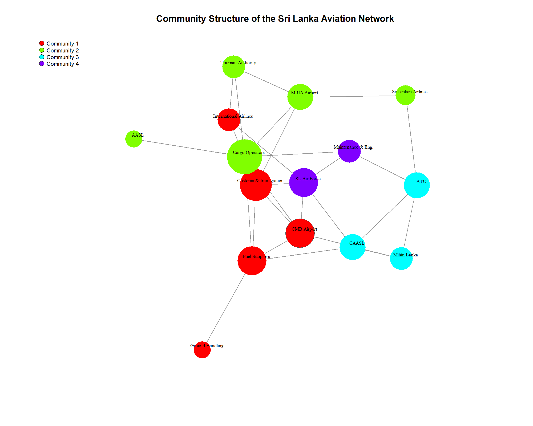

Figure 11 - Community Structure of the Sri Lanka Aviation Stakeholder Network.

3.5 Vulnerability Analysis
A node-removal analysis was performed to investigate how the network would respond if important stakeholders became unavailable. This directly supports the assignment scenario, where aviation operations must continue during heavy traffic and an aircraft technical emergency.
The main results are summarised below.
Table 3.2: Stakeholder Node-Removal Vulnerability Analysis
Table 6 - Stakeholder Node-Removal Vulnerability Analysis
Removed Stakeholder | Network Connected? | Components | Density | Average Path Length
Air Traffic Control (ATC) | Yes | 1 | 0.2637 | 2.055
Ground Handling Unit | Yes | 1 | 0.2967 | 1.901
Bandaranaike International Airport (CMB) | Yes | 1 | 0.2527 | 2.088
Cargo Operators | No | 2 | 0.2308 | N/A
Fuel Supply Companies | No | 2 | 0.2527 | N/A
Customs & Immigration | Yes | 1 | 0.2418 | 2.088
The most significant result is that removal of either Cargo Operators or Fuel Supply Companies caused the network to split into two connected components. These nodes can therefore be interpreted as structural vulnerabilities or articulation-like bridging points within the supplied stakeholder network.
Cargo Operators had a particularly important position because their removal reduced the network from 28 to 21 remaining relationships and fragmented the system. Similarly, removing Fuel Supply Companies left 23 relationships but also separated the network into two components. These findings are consistent with their high betweenness centrality values and indicate that they provide links that cannot be fully substituted by alternative structural paths.
Removing Customs & Immigration, despite its high betweenness centrality, did not fragment the network. The average path length increased slightly from 2.000 to 2.088, suggesting reduced structural efficiency but sufficient alternative routes.

3.6 ATC and Ground-Handling Failure Scenario
The assignment scenario particularly highlights possible disruption involving ATC and ground-handling functions. The node-removal analysis showed that removal of ATC left the network connected, with an average path length of 2.055, compared with 2.000 in the complete network. Similarly, removal of the Ground Handling Unit left one connected component with an average path length of 1.901.
These results should be interpreted carefully. They indicate structural resilience, meaning other network paths remain after the removal of those nodes. They do not demonstrate that actual airport operations would continue normally without ATC or Ground Handling.
ATC is responsible in the given scenario for coordinating aircraft movement and safe separation. Therefore, an ATC outage during peak traffic could still cause substantial operational disruption despite the mathematical network remaining connected. Likewise, failure of ground-handling functions could delay aircraft turnaround, baggage handling and related ground processes even if stakeholder communication paths continue to exist.
This demonstrates an important limitation of purely structural SNA: network connectivity measures whether relationships remain possible, not whether specialised operational functions can be substituted.

3.7 Implications for Peak-Traffic and Emergency Operations
The overall results indicate that the aviation stakeholder network is reasonably compact and interconnected. An average path length of two suggests that coordination between actors can potentially occur through relatively few intermediaries, which is advantageous during periods of high passenger demand.
In the aircraft technical-fault scenario, rapid coordination may be required between ATC, AASL, the affected airline, Ground Handling, Maintenance & Engineering, airport operations and potentially regulatory or emergency organisations. The existence of cross-community relationships can support such coordination.
However, the betweenness and node-removal results demonstrate that efficiency is accompanied by dependency risk. When multiple parts of the network rely on particular bridge stakeholders, those actors may become bottlenecks or structural single points of failure. This is particularly evident for Cargo Operators and Fuel Supply Companies in the supplied data.
The moderate clustering coefficient and modularity score provide an additional insight. Specialist groups exist, but the overall system remains connected through bridges between communities. This is beneficial for coordinated operations but means resilience depends on maintaining those cross-community relationships.

3.8 Recommendations for Network Resilience
Several measures could strengthen the resilience and coordination capability of the aviation stakeholder network.
First, redundant communication pathways should be established around stakeholders identified as critical bridges. Cargo Operators and Fuel Supply Companies should not represent the only effective structural connection between parts of the stakeholder network.
Second, ATC, AASL, airlines, Ground Handling, Maintenance & Engineering and airport authorities should maintain alternative coordination and escalation channels that can be activated during communication or system failures.
Third, cross-community coordination should be strengthened through joint operational procedures and information-sharing protocols. This would reduce dependency on individual intermediaries when information needs to move between regulatory, airport, airline, security and support groups.
Fourth, multi-agency emergency simulations and contingency exercises should be conducted periodically. Exercises involving aircraft technical faults, peak passenger demand, communication failures and stakeholder unavailability could identify weaknesses that cannot be detected through structural network analysis alone.
Finally, SNA should be repeated periodically as stakeholder relationships change. Centrality, community and vulnerability measures can provide useful business intelligence for identifying emerging bottlenecks and evaluating whether resilience initiatives create stronger alternative connections.
Overall, the analysis demonstrates that Sri Lanka's aviation stakeholder network represented by the supplied dataset is connected and relatively compact, with an average path length of two. Nevertheless, the concentration of bridging roles around Cargo Operators, Fuel Supply Companies and Customs & Immigration demonstrates that network efficiency can coexist with structural vulnerability. Strengthening redundancy, cross-organisational communication and contingency planning could therefore improve operational continuity during periods of high traffic and aviation emergencies.

