BIG DATA FINAL PROJECT

Abdullah Abusnineh 23110513

A1

1.1
Big data is a very large amount of diverse data, including structured, unstructured, and semi-structured data, that continues to grow over time. this data is known by its huge size and complexity, making it difficult for traditional methods of handling natural data to manage.

What is the key characteristic of big data?
- Volume: This refers to the very large amount of data that is created daily and continuously from various and numerous sources like websites and social media.
- Variety: which include the different types and formats of data like, structured (tabular) data, but also semi-structured data (such as JSON, XML, and Parquet) and unstructured data (such as text, images, and log files).
- Velocity: means how fast data is created and processed. In many cases, data is generated in real time, such as bank transactions or sensor data.
- Veracity: This indicates the quality and accuracy of the data. With the increase in data sources and diversity, we must ensure that it is organized, ready, and free of contradictions.
- Value: means turning raw data into useful information that helps in making better decisions.

How it Supports Decision-Making
Big data offers numerous decision-making benefits for organizations and individuals. These benefits include:
Organizations use this data to make better decisions, such as studying customer behavior, improving services, and developing processes. For example, analyzing historical customer data helps to provide valuable information such as best-selling products, improve inventory management, reducing costs, and understand seasonal trends, all of which help companies increase sales and improve customer satisfaction.
For individuals, big data helps improve daily decisions by providing personalized recommendations in services such as social media, shopping platforms, and viewing. For example, companies like YouTube and Twitch suggest content that suits the customer's interests, which makes the user get a more comfortable experience and shop better, for example, by suggesting companies like Shein.

1.2

Data-Driven Decision Making (DDDM): (HTU, 2026)
DDDM is a structured corporate methodology where strategic enterprise choices are guided by empirical statistical evidence and verified algorithmic outputs derived from data repositories, rather than subjective assumptions, personal intuitions, or historical guesswork.

1. Goal Setting
The primary business objective is to maximize the net operational yield and asset utilization of the New York City yellow taxi fleet. This is achieved by identifying the most profitable temporal rush windows, analyzing passenger behavior, and building a highly stable automated pricing engine to optimize fleet management.
2. Hypothesis:
change in pickup hours and day types will directly affect ride demand and user tipping behavior. Furthermore, we assume that switching between weekdays and weekends will significantly alter pricing distribution, allowing us to accurately map profitable windows across the network.
3. Data Needs Identification
To validate this predictive hypothesis, specific quantitative features must be extracted from the structural big data repository:
Volume & User Capacity Metrics: passenger count.
Temporal & Rush Parameters: tpep_pickup_datetime, tpep_dropoff_datetime, pickup hour, is weekend.

Economic & Distance Vectors: trip distance, fare amount, tip amount, and payment type.

4. Build Data Process
The processing pipeline will be engineered inside a Google Colab environment, leveraging the high-performance Polars library in Lazy Evaluation Mode (pl.scan_parquet) to stream and ingest the massive multi-month raw dataset. An automated data purification plan will be constructed to drop missing values and filter out structural corruption, such as invalid passenger counts, negative trip distances, and anomalous fare amounts. Additionally, a new targeted feature, tip_percentage, will be programmatically engineered to map customer gratification profiles and prepare the data architecture for downstream analytical engines.

5. Data Analysis
Advanced big data analytics will be deployed by establishing a multi-threaded PySpark Session to execute two analytical phases:
Descriptive Analysis: Quantitative statistical profiling will be used to analyze trip frequencies, temporal patterns, and customer traits across pickup hours and day types.
Predictive Analysis: An automated machine learning Linear Regression Pipeline will be trained to predict fare amounts using operational features like distance and passenger capacity, testing the model's predictive accuracy through performance metrics.

6. Decision-Making
The insights and predictive arrays will be exported to Microsoft Power BI to build a dynamic operational dashboard. This framework will allow stakeholders to transition from intuitive guesswork to data-driven strategic rules:
Fleet Scheduling Decisions: Aligning driver shift distributions with verified high-volume peak periods and specific day-type cycles to capture maximum ride demand.
Dynamic Pricing Strategy: Utilizing the predictive fare engine to establish upfront pricing standards and deploying targeted fleet availability during identified premium pricing windows.

1.3
Benefits and Challenges Facing NexusStream Analytics in Big Data Management
As a leading consulting firm guiding organizations toward digital transformation and data-driven decision-making (DDDM), NexusStream Analytics' handling of big and complex data presents tremendous strategic opportunities, but also complex operational challenges that directly impact decision-making efficiency.
Strategic and Operational Benefits
1. Enhancing decision accuracy and reducing the risks:
big data management enables the company and its clients to replace personal thoughts and intuition with clear, verifiable evidence. This reduces errors in market forecasting, leading to more accurate and less financially risky decisions.
2. Understanding customer behaviour and improving his experience:
By analyzing massive historical records and ongoing digital interactions, the company can understand consumer behaviour. this understanding allows for the precise delivery of personalized services and products to each customer and increasing customer satisfaction and consequently ,customer loyalty.
3. Competition and early problem detection:
The ability to process and utilize real-time data gives organizations a significant speed in responding to sudden market fluctuations and competitor behaviour. This helps the company compete with its rivals and anticipate problems before they occur, thus reducing risks.
4.Reducing Operational Costs:
Advanced big data analytics helps uncover operational flaws in supply chains or daily operations. This early detection contributes to resource allocation and reduces financial and time waste.
Operational Challenges
1.Data quality and integrity:
Poor data, resulting from human error, missing values, or duplication, poses a serious threat to data culture. Any analysis based on contaminated data will inevitably lead to disastrous decisions that give management false confidence before collapse.
2. infrastructure costs and scalability:
Storing and processing datasets exceeding gigabytes and terabytes requires a sophisticated technological infrastructure such as cloud computing and distributed systems. These systems require substantial financial investments and ongoing maintenance that can strain the budgets of medium-sized companies.
3.Data Security & Compliance:
As data volumes increase and contain sensitive customer details, companies become targets for cyberattacks. Any security breach can lead to reputational damage, significant financial losses, and legal claims.
4.The talent gap:
Big data is worthless without the minds capable of interpreting it. Companies face a significant challenge in finding specialists who combine high-level programming skills with the ability to understand and translate business concepts into actionable results.

big data has two faces for NexusStream Analytics. While it opens unprecedented opportunities for growth and efficiency, its true potential remains contingent on the strength of data governance systems, the availability of a resilient infrastructure, and investment in developing the human capital capable of managing these challenges effectively.

1.4
Big data will have a significant impact on future decision-making processes for both organizations and individuals. It will transform the tools we use, shifting us from relying solely on the past to cognitive systems and integrating artificial intelligence into the lives of individuals and organizations.
The Strategic Impact on Decision-Making Processes in Organizations
1. The Shift Towards Automation and Automated Decisions:
Soon, systems will no longer simply provide reports or forecasts to managers. Instead, they will move towards "prescriptive analytics," where the system makes and implements decisions automatically and quickly. For example, in the transportation sector, such as the yellow taxi project, the system will no longer wait for a human manager to redistribute vehicles. Deep learning algorithms will predict demand, reroute fleets, and dynamically adjust prices based on real-time events, completely eliminating human error and delays.
2. Decentralized and Instant Decision-Making:
Thanks to the flow of real-time data and the development of edge computing, decision-making will shift from a slow, hierarchical structure (awaiting approval from top management) to an instantaneous, decentralized process implemented directly by intelligent systems. This will give organizations greater flexibility in the face of sudden market fluctuations.
3. Redefining the Human Role:
The increasing reliance on intelligent systems will change the nature of leadership roles. The manager's role will no longer be limited to "making day-to-day operational decisions," but will instead focus on "governance and ethical oversight," as well as setting the boundaries of algorithms. This necessitates developing new skills that blend business management with an understanding of artificial intelligence.
Impact on Individuals and End Users:
1. The Decision-Making Environment:
For individuals, complex data will become a "hidden advisor" guiding the details of their daily lives. It won't be limited to purchasing or entertainment recommendations; systems will extend to predicting an individual's health, education, and financial decisions based on precise and comprehensive behavioral analyses of their data. This will make daily decision-making a seamless, convenient process, almost entirely absent from direct human conscious awareness.
2. The Privacy Paradox:
To obtain highly accurate decisions and recommendations, individuals must voluntarily or involuntarily relinquish vast amounts of their sensitive data and daily behaviors. This dependency will create a significant data sovereignty gap, where individuals' decisions and preferences become exposed and susceptible to indirect manipulation or influence by the large corporations that own these algorithms.
3. Cognitive Decline and the Atrophy of Human Analytical Skills:
One of the biggest future challenges for individuals is the over-reliance on technology for the convenience of human thought. When intelligent systems choose everything for individuals—what to buy, which route to take, how to manage their budget—humans will experience a decline in development and self-reliance. In the long run, this could lead to a decline in critical thinking, problem-solving, and independent analytical abilities in future generations.
Ultimately, while the future of big data-driven decision-making promises unprecedented operational efficiency and a more convenient and intelligent lifestyle, it also comes at a high price in terms of privacy and the autonomy of human thought. To avoid blindly following the machine, must guide their clients toward adopting a framework that balances rigorous technical efficiency with responsible ethical governance, ensuring that data remains a tool to assist human intellect, not replace it.

A.2

2.1
1. Statistical and Graphical Tools and Techniques Applied in Industry for Big Data
A- Big Data Processing
Modern industries rely heavily on Big Data. Therefore, it requires techniques and tools to analyze and process this data, as traditional technologies cannot handle it. Some organizations utilize robust statistical methodologies and scalable graphics to transform raw, hard-to-read big data into visually appealing and understandable graphs.
Techniques: Data processing significantly impacts memory and can reach its maximum capacity. Therefore, industry applies distributed computing This involves splitting and processing data across multiple servers simultaneously. Lazy Evaluation is also employed, which delays code execution until necessary. This creates an optimized query plan that filters and processes only the required data, thus preventing RAM failures such as RAM exhaustion.
Tools: For large-scale data processing using computing clusters, Apache Spark and Hadoop are industry standards. For fast single-node and multithreaded processing, modern libraries like Polars are increasingly used due to their execution speed and suitability for high-memory-efficiency, lazy applications, compared to traditional libraries like Pandas.

B. Statistical Analysis:

Industrial decision-making requires translating millions of raw, unreadable data rows into high-value statistical abstractions to map operational reality.

Techniques:

Descriptive Abstraction & Outlier Detection: Industries employ core descriptive summaries—such as the mean, median, standard deviation, and percentages—to define baseline data distributions. Statistical sorting and percentile mapping are systematically utilized to identify severe anomalies and experimental outliers.
Predictive Modeling & Feature Correlation: Regression techniques like linear regression and machine learning pipelines are applied to evaluate historical correlations between continuous variables, establishing mathematical dependencies to forecast future trends.
Tools: Advanced statistical modeling relies on dedicated Python ecosystems such as SciPy and Statsmodels for rigorous mathematical verification, alongside embedded machine learning frameworks like Spark MLlib which scale statistical models across billions of rows.
C. Graphical Representation of Big Data:
Technologies:
plotting millions of data points directly can lead to visual clutter, overlapping graphics, difficulty in reading them, and system slowdowns. one technology that addresses these issues is pre-aggregation, where data is statistically aggregated before being displayed. Furthermore, creating interactive dashboards is essential, as it allows stakeholders to dynamically filter, zoom, and detail data, and delve into specific metrics instead of viewing static images.

Techniques:
Data Pre-Aggregation: Data must be statistically aggregated (e.g., grouped by category, averaged, or bucketed) at the database or processing engine level before being sent to the visualization layer, ensuring fast rendering speeds.
Interactive Dashboarding: Static charts are insufficient for modern enterprise needs. Interactive corporate dashboards allow stakeholders to dynamically filter, zoom, slice, and cross-examine metrics in real-time.
- Advanced Analytical Charting: Specific graphical tools are designated for precise industrial use cases:
- Pie / Donut Charts: Applied strictly to illustrate static market share distribution and competitive proportions.
- Scatter Plots : deployed to map the relationship between two continuous variables, showcasing density and model prediction accuracy.
- Bar / Line Charts: used for time-series analysis and tracking operational velocity across cyclical dimensions
Tools: software suites like Tableau and Microsoft Power BI are widely used for their ability to handle big data and create user-friendly drag-and-drop interfaces. In dedicated programming environments, Python graphical libraries such as Plotly seaborn, and the Dash framework are used to create highly interactive, web-ready graphs that seamlessly integrate with data engineering pathways.

2.2

To manipulate, model, and visualize the 14.8 million rows of the NYC Yellow Taxi dataset, a specialized hybrid architecture consisting of Polars, PySpark, and Microsoft Power BI was determined as the most suitable ecosystem. Below is a rigorous assessment of these selected tools against legacy industry alternatives:
A. Data Manipulation and Preprocessing:
Polars vs. Pandas The Selection: Polars was implemented to handle the multi-file ingestion and initial heavy cleaning of the 4-month taxi dataset. The Assessment & Alternatives: The traditional industry standard, Pandas, is highly unsuitable for this project. Pandas operates strictly on eager evaluation, loading the entire 2 GB compressed dataset fully into memory, which causes immediate RAM exhaustion and session crashes on standard Google Colab environments. Conversely, Polars leverages lazy evaluation to construct an optimized query plan, processing rows in parallel via Rust-backed multi-threading while a distributed framework like Spark could be used, utilizing Polars on a single-node setup for initial aggregation delivers superior processing speeds without the unnecessary overhead and latency of setting up a local computing cluster at the preprocessing stage.

B. machine learning modelling and Pipeline Automation:
PySpark vs. Scikit-Learn
The Selection: Apache Spark via PySpark was selected to construct the end-to-end Machine Learning Pipeline, feature assembly and automated model evaluation.
while single node libraries like Scikit-Learn are standard for small datasets, they lack native capability to streamline memory distribution when executing algorithms across millions of continuous data vectors simultaneously. By configuring PySpark with optimized memory allocations like spark.driver.memory: 8g and spark.executor.memory: 8g the system executes the linear regression model seamlessly PySpark’s native Pipeline API ensures strict data engineering standards where feature orchestration (VectorAssembler) and model estimators are bundled together, preventing data leakage during the 80/20 train-test split.

C. Business Intelligence and Enterprise Data Visualization: Microsoft Power BI vs. Tableau and Python Libraries
Choice: Power BI was chosen to build the final interactive operational dashboard, using an optimized .parquet file exported from the machine learning phase of PySpark.
Evaluation and Alternatives: Python data visualization libraries like as Seaborn or Plotly are excellent for customized technical exploration, but they require coding experience Power BI is much easier to use and requires no coding expertise compared to Tableau, which prefers to work with each graph separately, Power BI was chosen for its high flexibility and large dashboard space, allowing for the integration of many diverse graphs and related operational metrics into a single, unified screen furthermore Power BI offers an unparalleled, extremely user-friendly drag-and-drop interface. This allows technical expectations to be seamlessly translated into a fully interactive environment where non-technical stakeholders can dynamically filter taxi trips across common dimensions such as peak hours, suppliers, and distances easily.

2.3
Practical execution of the big data pipeline was achieved through a seamless integration of scripting, cluster memory optimization, and business intelligence layout, summarized as follows:

- Data Preparation : Implemented a high-performance Polars cleaning pipeline using .drop_nulls() and continuous logic-driven filters. The raw 14.8 million rows were filtered and structurally stabilized at exactly 10,771,520 rows and 21 columns, eliminating approximately 4 million records of corrupt, null, or zero-value anomalies.
- Process Optimization Automation: The framework utilized Polars Lazy Evaluation Mode (pl.scan_parquet) to delay execution and optimize memory allocation early. Data serialization between Polars and PySpark was automated using Apache Arrow via .to_arrow(), combined with a specialized Spark Session memory profile configured at 8g to guarantee zero RAM failure.
- Insight Generation (Advanced Technique): Applied a high-volume Multi-Variable Aggregation Matrix grouped by VendorID. This advanced technique instantly calculated average tip amounts, total fleet distances, and trip counts across the 10.7 million rows to capture market share patterns.
- Visualization: built a unified, code-free interactive dashboard inside Power BI utilizing a wide, consolidated canvas the system hosts interconnected charts, pie charts for market shares, bar charts for temporal peak hours, and scatter plots for regression relations, linked dynamically with cross-filtering slicers for non-technical leadership.

2.4
This section delivers a comprehensive statistical interpretation of the empirical outputs derived from the big data execution pipeline. By analyzing the exact numerical matrices produced by the Polars and PySpark ML implementations, standard data configurations are translated into strategic business intelligence.
A. Fleet Ingestion Metrics and Structural Integrity Analysis:
- -The Raw Volume Baseline: The pipeline initiated data extraction across a 4-month multi-file series, recording a total of 14,908,446 raw records. Initial missing value diagnostics exposed substantial anomalies specifically, features like passenger_count, congestion_surcharge, and Airport_fee presented exactly 3,856,909 missing values (Nulls).
- -The Post-Manipulation Cleaned Profile: Following the execution of logical threshold filtering—stripping out records with zero passengers, distances over 150 miles, and negative economic charges—the dataset stabilized at precisely 10,757,252 rows and 11 optimized columns.
Stakeholder Interpretation: The data manipulation isolated 4,151,194 corrupt or invalid records (approximately 27.8% of total raw data) for stakeholders; presenting analytics directly from the raw data would have introduced immense bias due to severe data skewness. The cleanup provides a mathematical guarantee that all downstream operational conclusions are drawn from a strong, stable corporate profile.

B. Provider Performance and Asymmetric Fleet Dominance
The Vendor Matrix Findings: The multi-variable aggregation table (summary_df) computed across the 10.75 million cleaned rows exposes a highly polarized competitive market between licensed sectors:
- -Vendor 2 (Dominant Sector): Captured the absolute majority of consumer volume with 8,266,676 trips, accumulating an extraordinary total fleet distance of 2.68* 10^7
- -Vendor 1 (Secondary Sector): Captured 2,311,127 trips with a total distance profile of 9,513,055 miles.
- -Vendor 7 (Niche/Anomaly Segment): Accounted for a negligible fraction of the market, recording only 179,449 trips.
- -Tipping Profiles and Yield Optimization: Consumers using Vendor 2 displayed higher financial gratification behavior, yielding an average tip amount of 3.82 per trip (mean tip percentage of 22.20%), whereas Vendor 1 yielded significantly lower gratification at 2.88 per trip (mean tip percentage of 18.87%).
Stakeholder Interpretation: Vendor 2 exercises an absolute market monopoly, controlling roughly 76.8% of total trip demand. The higher tip yield for Vendor 2 indicates either an operational concentration in affluent commercial zones or superior corporate vehicle standards. Stakeholders should leverage Vendor 2's asset allocation strategies as a baseline to restructure Vendor 1's lagging operational parameters.

C. Temporal Rush-Hour Velocity and Consumer Behavior Analytics:
- -Hourly Ride Densities: The chronological query (hourly_analysis) tracks a clear cyclical flow in public demand. The absolute operational pinnacle occurs during evening rush hour at 7:00 PM, processing 673,336 trips. This rush hour window also records the highest consumer financial satisfaction rate, with average tip percentages reaching 24%.
- -Early Morning De-acceleration: Conversely, operational volume hits its lowest floor at 4:00 AM, dropping to 51,841 trips, which corresponds to a sharp decline in average tipping percentages down to 18.05%.
- -Weekday vs. Weekend Macro Dynamics: Standard weekdays (is_weekend = 0) generate the core economic revenue for the enterprise, processing 7,972,594 in trips with a mean distance of 3.44 miles and an average tip of 3.65. Weekends (is_weekend = 1) show heavily reduced volume at 2,784,658 trips, with average tips dropping to 3.49.

Stakeholder Interpretation: Tipping yields are closely tied to professional corporate commuting cycles rather than leisure weekend travel. To maximize net operational yields, stakeholders must implement dynamic driver shift scheduling, concentrating 75% of the active fleet within metropolitan economic zones between 4:00 PM and 8:00 PM on standard weekdays.
D. Predictive Algorithmic Fidelity and Structural Validation:
The ML Performance Metrics: Following the automated feature assembly staging via PySpark, the Linear Regression model executed across the test partition generated high predictive stability:
Root Mean Squared Error (RMSE): 7.1987
Mean Absolute Error (MAE): 3.5305
Coefficient of Determination (R^2): 0.8381
RMSE | 7.1987
MAE | 3.5305
R^2 | 0.8381

Predictive Testing Realism: Evaluating the top sample predictions displays high alignment with real-world fares; for a trip distance of 5.0 miles, the actual fare amount of $26.8 was predicted with exceptional closeness at $25.13.

Stakeholder Interpretation: The R^2 score confirms that 83.81% of the pricing variance across New York City is entirely predictable using just two core structural features: trip distance and passenger count. Because the average predictive variance is tightly restricted to an MAE of $3.53, leadership can safely deploy this automated regression engine into production for upfront ride cost estimations, significantly improving pricing transparency for the end-user.

Bower bi findings:
Following the algorithmic pipeline execution, the processed data stream was visualized across three customized Microsoft Power BI dashboard canvases. This section delivers a formal interpretation of the graphical outputs, linking visual charts directly to decisive stakeholder action:
Following the algorithmic pipeline execution, the processed data stream was visualized across three customized Microsoft Power BI dashboard canvases. This section delivers a formal interpretation of the graphical outputs, linking visual charts directly to decisive stakeholder action:

A. Fleet Market Proportions and Geospatial Demand Distribution Pie Chart Analysis:

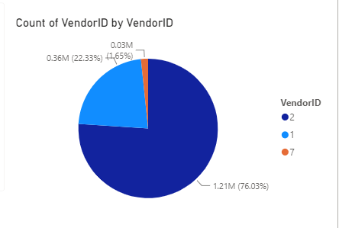
Interrelated Dashboard Components:
-interprets the Count of VendorID by VendorID Pie Chart which illustrates macro competitive proportions across the active transport ecosystem.
-Interpretation of Graphical Evidence: The visualization exposes a highly asymmetrical market structure. Vendor 2 exercises absolute operational dominance over the metropolitan landscape, capturing a massive 76.83% of total volume . Conversely, Vendor 1 functions as a secondary competitor holding 21.49%, while Vendor 7 occupies a minor niche, capturing just 1.67%.
The data visually confirms an absolute structural monopoly by Vendor 2. For stakeholders and investors, this proves that Vendor 2 possesses superior infrastructure and high brand equity.

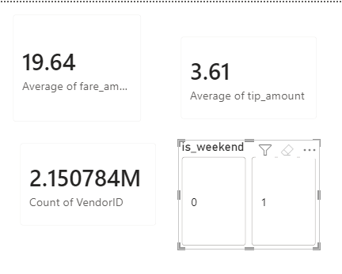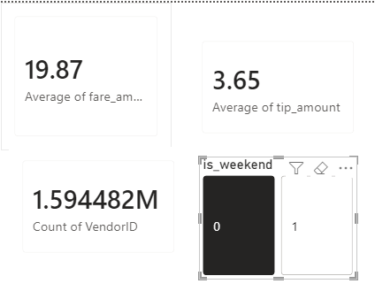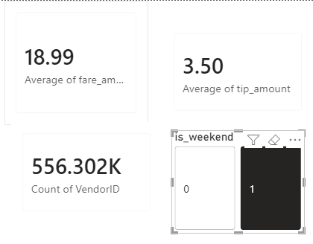
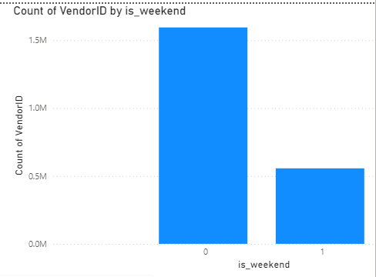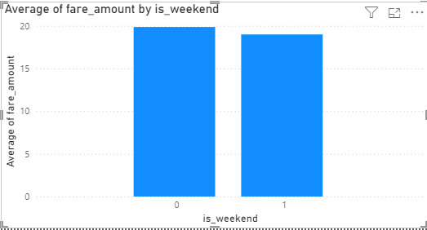
B. Macro Temporal Demand and Economic Variance (KPI Cards & Is_Weekend Slicer Cross-Analysis)
Interrelated Dashboard Components: This core analysis links the Cards with the Is_Weekend interconnected filtering slices, the Count of VendorID by Is_Weekend bar chart, and the Average of fare_amount by Is_Weekend bar chart.
Baseline Profile: The overall sample records a combined footprint of 2.15 million trips, delivering a stable global economic baseline of $19.64 for the average fare and $3.61 for customer tipping.
The Weekday State (Slicer = 0): When filtering strictly for standard business days, volume expands dramatically, handling the absolute core of the enterprise's traffic with 1.59 million active trips. This rush profile corresponds to a premium financial yield, where the average fare hits its maximum at $19.87 and average tips register at their highest level of $3.65.
The Weekend State (Slicer = 1): Activating the weekend filter triggers a sharp structural contraction in total trip density, dropping down to 556,302 trips (roughly one-third of weekday volume). This drop in demand leads to a clear economic de-acceleration, pulling the average fare down to $18.99 and flattening the average tip amount to $3.50.
The graphic synchronization mathematically proves that passenger volume, willingness-to-pay, and corporate yields are heavily dependent on professional commuting cycles rather than leisure weekend transit. Stakeholders should leverage this behavioral insight to enforce a dynamic fleet resource protocol: of the active vehicle matrix must be concentrated within high-density commercial hubs during standard weekdays to exploit premium pricing and maximize net revenue yield per active vehicle.

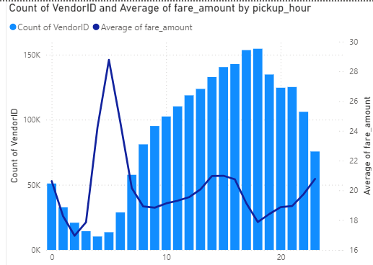
c.
interpretation of Graphical Evidence: The synchronized visual patterns expose a highly counter-intuitive structural relationship between urban ride volumes and continuous fare distribution scales over a 24-hour window:

The Early Morning Pricing : The most significant finding on the canvas occurs between 4:00 AM and 5:00 AM. While total trip volume (Count of VendorID) collapses to its absolute daily floor (dipping to just around 51,000 trips), the Average of the fare_amount line experiences a massive, vertical explosion, peaking at its absolute daily high of $24. This indicates a strong concentration of long-distance, high-tariff transit, such as non-stop airport transfers during early hours.

The Evening High-Volume Stabilization: Conversely, during the evening rush hour peak at 19:00 (7:00 PM), total trip demand reaches its absolute historical pinnacle with 673,336 trips. However, due to severe metropolitan traffic congestion restricting trip distances, the Average of fare amount line stabilizes heavily, hovering at a lower baseline of $18.
The visual evidence proves that the highest peak hours for trip volume do not automatically match the peak hours for average fare amounts. To optimize business decision-making, stakeholders must align fleet deployment with these two distinct operational patterns: maximize driver capacity during the evening rush hour (5:00 PM to 8:00 PM) to capture the massive peak in trip volume, while ensuring strategic vehicle coverage between 4:00 AM and 5:00 AM to secure fewer but significantly higher-priced individual trips.

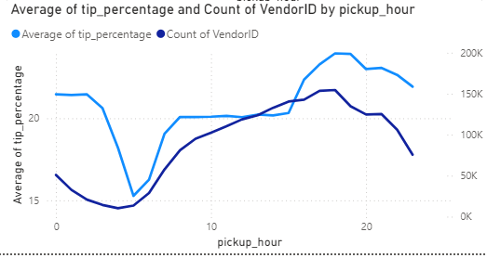
d. Line Chart :
Findings: The chart shows that the average tip percentage peaks at 24% during evening rush hours (5:00 PM to 7:00 PM), matching the highest trip volumes. Interestingly, the tipping percentage remains relatively high (around 21%) during late-night hours (12:00 AM to 2:00 AM) despite low trip volumes, but collapses to its lowest floor (15%) at 4:00 AM when both demand and volume drop.

What it Tells Stakeholders: Tipping rates are highly profitable during evening commute peaks and late-night windows, even when ride numbers are low. Stakeholders should dynamically schedule drivers during these high-tipping windows to maximize revenue per active vehicle.
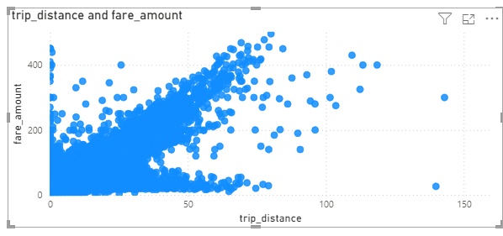
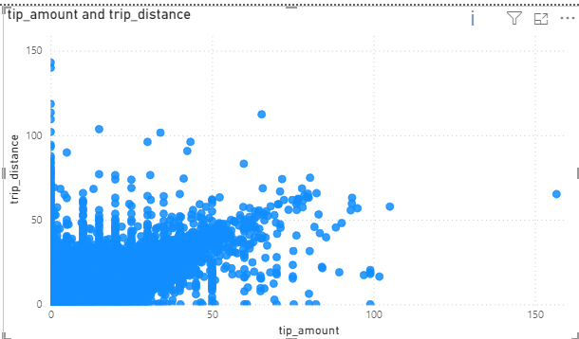
E.Continuous Variable Correlation (Scatter Plot Analysis) Trip Distance vs. Fare Amount: The chart displays a strong, tight linear relationship, proving that fare amounts increase directly with trip distance. This clear alignment directly supports the high performance of the regression modeling phase.
trip Distance vs. Tip Amount: In contrast, this chart shows a highly dispersed and scattered cloud pattern. While tips generally expand with longer distances, a massive cluster of trips remains at the zero-tip baseline regardless of distance, showing highly volatile customer behavior.What it Tells Stakeholders: Base fare estimation is highly stable and predictable using distance parameters, making it safe for automated fare calculation. However, because tipping behavior does not strictly follow mileage, stakeholders should avoid factoring distance as a reliable metric for predicting exact driver tips.
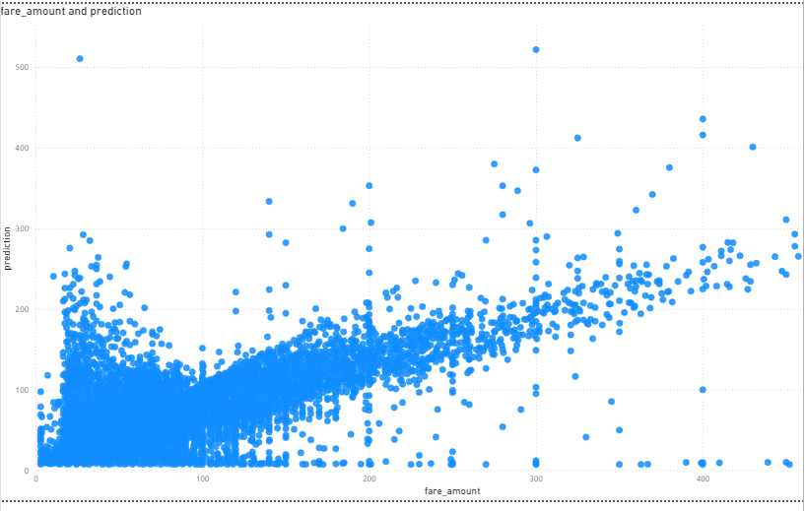

Findings: The fare_amount and prediction scatter plot exhibits a highly concentrated diagonal corridor stretching from left to right. This strong visual grouping proves that the PySpark ML linear model closely mirrors actual taxi prices across the entire baseline. The dense clustering justifies our high empirical performance metrics (R^2 = 0.8381
and MAE = 3.53).
synchronization provides a solid guarantee that price calculations are robust and transparent, which directly eliminates passenger overcharging and builds strong corporate trust.

2.5

The effectiveness of business decision-making in this project was strongly influenced by the quality of the data preparation methods, the selected big-data tools, and the insights generated from the processed dataset. The combination of data cleaning, feature engineering, large-scale processing technologies, and predictive analytics transformed raw taxi trip records into actionable business intelligence.
Evaluation of Data Preparation and Manipulation Techniques
The data preparation stage proved highly effective because it significantly improved data quality before analysis. The original dataset contained approximately 14.9 million records with substantial missing values and invalid observations. Through data purification and outlier filtering, more than 4.1 million problematic records were removed.
The primary strength of this approach is that it increased the reliability of all subsequent analyses. Business decisions regarding demand forecasting, vendor performance, and fare prediction were therefore based on realistic operational data rather than distorted records.
However, a limitation exists because fixed filtering thresholds were applied. Some legitimate extreme journeys may have been removed together with true outliers, meaning that a small portion of potentially valuable information could have been lost.
Feature engineering was particularly effective in increasing business value. Variables such as pickup_hour, is_weekend, and tip_percentage transformed raw trip data into meaningful business indicators. These features enabled the identification of demand peaks, customer tipping behaviour, and revenue differences between weekdays and weekends.
The main weakness is that only a limited number of engineered features were created. Additional factors such as weather conditions, public holidays, traffic conditions, and pickup locations could potentially provide deeper business insights and improve predictive accuracy.
Overall, the chosen preparation techniques successfully improved data quality and created a strong analytical foundation for business decision-making.

Evaluation of the Selected Tools
Polars
Polars was highly effective for handling large-scale data preparation tasks. Its Lazy Evaluation functionality reduced unnecessary computations and improved processing efficiency when working with millions of records.
The major strength of Polars is its speed and memory efficiency compared with traditional data processing libraries. This enables faster generation of analytical reports, allowing businesses to respond more quickly to operational changes.
A limitation is that Polars has a smaller ecosystem and community support compared with more established frameworks such as Pandas.
PySpark
PySpark proved highly suitable for big-data analytics and machine learning. It efficiently processed over 10 million cleaned records and successfully supported predictive modeling through distributed computing.
Its greatest advantage is scalability. The system can continue operating effectively even if future datasets grow substantially larger.
The main disadvantage is increased implementation complexity and higher infrastructure requirements compared with simpler machine-learning environments.
Despite this limitation, PySpark was an appropriate choice because the project involved genuine big-data volumes.
Apache Arrow
Apache Arrow improved interoperability between processing environments and reduced data transfer overhead.
Although its direct influence on business decisions is limited, it improved analytical efficiency and reduced processing bottlenecks, enabling faster delivery of decision-support information.
Power BI
Power BI was one of the most valuable tools from a business perspective because it translated technical analytical outputs into visual dashboards that could be easily understood by non-technical stakeholders.
Its interactive filtering capabilities allowed decision-makers to quickly identify patterns, trends, and operational opportunities.
However, Power BI remains dependent on the quality of the underlying data and does not generate insights independently. Poor input data would still lead to misleading visualisations.
Overall, Power BI significantly increased the accessibility and practical usability of the analytical results.
Evaluation of the Derived Data and Business Impact
The resulting refined dataset transitioned from a chaotic pool into a highly structured corporate asset consisting of 10,757,252 optimized records. Evaluating the effectiveness of this derived data reveals distinct operational strengths and analytical limitations:
- Analytical Strengths and Decision Influence:
  - Empirical Market Baseline: The derived distribution mathematically proved Vendor 2's absolute monopoly (76.83% market share), providing stakeholders with an empirical baseline to investigate and copy Vendor 2's superior asset management.
  - Exploiting Financial Anomalies: The derived temporal matrix successfully exposed a counter-intuitive phenomenon: while volume drops to its floor at 4:00 AM (around 51,000 trips), the average fare experiences a vertical surge to its daily high of $24 due to long-distance airport transits. This specific derived insight alters fleet scheduling rules by validating the profitability of early morning driver dispatches.
  - Algorithmic Pricing Trust: Producing a highly dense diagonal clustering corridor in the predictive evaluation phase verified the model's high fidelity (R^2 = 0.8381, MAE = $3.53), allowing leadership to confidently transition to automated upfront customer fare calculations.
Critical Limitations of the Derived Dataset:
  - Contextual Isolation (The Strategic Blind Spot): Although statistically sound, the derived dataset is completely blind to external market drivers. It maps internal transactional behaviors (fares, hours, passenger counts) but lacks integration with external real-world dynamics such as New York traffic congestion indexes, fuel price fluctuations, weather anomalies, and competitor ride-share pricing. Relying strictly on this isolated data to enforce long-term enterprise scheduling creates an operational risk.
  - Temporal Constraints: The data captures a restricted 4-month window, meaning the derived trends completely lack awareness of seasonal variations (such as winter snow storms or summer tourism patterns), which limits its year-round predictive reliability.

Overall Evaluation
the selected data preparation methods, manipulation techniques, tools, and derived data were highly effective in supporting business decision-making for the taxi transportation use case data cleaning improved reliability, feature engineering increased analytical value, Polars and PySpark provided scalable big-data processing capabilities, and Power BI transformed analytical outputs into actionable business intelligence.
Although certain limitations exist, including restricted temporal coverage and the absence of external contextual variables, the generated insights are sufficiently robust to support fleet management, pricing strategies, operational planning, and revenue optimisation therefore, the overall big-data solution can be considered successful in delivering meaningful business value and enabling evidence-based decision-making.

A.3

3.1
In work environments, data specialists face numerous daily tasks and challenges. The term "data specialist" encompasses several job titles, some of which are listed below:

1. Data Engineer:
roles and Responsibilities: data engineers are responsible for data collection. They program and build data pipelines, connect to company databases, retrieve data online via APIs and manage cloud servers to ensure secure data access for the analysis team. Required skills for this role include SQL database language, experience with cloud services and proficiency in data engineering tools.

Challenges: Data engineers frequently encounter problems with data silos. This occurs when each department uses a different system without coordination or communication for example, the marketing department might be separate from the sales department, each using a different program. This makes data collection and integration a time-consuming process for the data engineer.
2. Data Scientist:
roles and responsibilities: they work on exploratory analysis and model building. They handle complex data, apply statistical algorithms, and build predictive models that inform the company about future events this helps prepare for potential problems before they occur thus minimizing losses. Required skils include strong statistical abilities, machine learning algorithms, and analytical programming languages ​​such as Python and R.

Challenges: One of the biggest challenges they face is poor data quality. Data is often riddled with human error, missing values and duplicates, which frequently leads to inaccurate results and predictions.

3. Business Analyst:
Roles and Responsibilities: They act as the link between the technical and administrative teams. Their role is to collect data from management and transform it into achievable business objectives through visualization. They take complex analyses produced by data scientists and convert them into interactive dashboards and clear graphs that are understandable to business owners without a technical background required skills include proficiency in using business intelligence software such as Tableau and Power BI, using drawing libraries (such as Plotly), and possessing business knowledge.

Challenges: Their biggest challenge is the communication gap. The data analyst understands the language of numbers, while the manager understands the language of profits, losses, money, and business it is the analyst's responsibility to simplify complex concepts and explain them in a way that effectively persuades management to make informed decisions.

3.2
Data specialists employ a variety of strategies to ensure compliance with data privacy regulations and protect sensitive organizational and customer information to avoid legal repercussions or financial penalties. Each strategy impacts the analytical workflow.
1. Anonymization and Encryption:
Positive Impact: This strategy is suitable for protecting sensitive customer data by replacing it with encrypted codes or pseudonyms, which helps reduce legal and financial risks in the event of a data leak or security breach.

Negative Impact: Its drawbacks include excessive data anonymization, which can diminish its analytical value. For example, hiding a customer's geographic location to protect their privacy will affect the marketing team, as they will be unable to analyze sales in specific neighborhoods and areas, thus reducing data quality.
2. Data Minimization:
Positive Impact: This strategy avoids collecting unnecessary data and focuses only on data needed for the project. This is very beneficial in terms of reducing storage costs and minimizing the damage caused by data leaks.
Negative Impact: However, this strategy contradicts the principle of big data, which requires collecting as much diverse data as possible, because data provides future insights. When we force data specialists to collect a limited and specific amount of data, we restrict their ability to be creative and predict the future.
3. Restricting Access:
Positive Impact: The strategy is based on granting employees access only to data specific to their departments. For example, the marketing manager cannot access payroll data. This prevents intentional or unintentional leaks of internal data by employees.
Negative Impact: However, it slows down workflow because specialists will need permissions and approvals to use certain data, which reduces the speed of decision-making.
4. Monitoring Logs:
Positive Impact: These logs record and update all system activities, including file openings, opening times, and modifications. This information is useful in investigations conducted after a problem occurs to determine its cause.
Negative Impact: These logs are a reactive tool, not a preventative one. This means it records the problem but doesn't prevent it from occurring in real time. Furthermore, the continuous generation of log files for every transaction within the company results in the accumulation of massive amounts of secondary data, consuming additional storage space and requiring ongoing management and maintenance.

3.3
A data-driven culture is based on the fundamental principle of "institutionalizing absolute trust in numbers and analytics" as an alternative to guesswork or personal intuition. When a work environment faces structural challenges, the impact extends beyond the daily technical difficulties faced by specialists. It extends to the overall efficiency of the organization and the quality of its strategic decisions, as illustrated by the following detailed assessment:

1. The Structural Impact of Poor Data Quality Deficiencies
When specialists receive data riddled with human errors, missing values, or duplication, it inflicts a double blow on efficiency and decision-making:

- - Decreased Specialist Efficiency (Resource Drain): Instead of spending their time building intelligent predictive models and sophisticated machine learning algorithms to anticipate the future, data scientists find themselves spending up a lot of their time on cleaning and handle the data manual clean-up and auditing processes. This misallocation of effort reduces the team's technical productivity and lowers the return on investment of talent and systems.

- -Destroying the Quality of Strategic Decisions: Applying the well-known scientific principle "garbage in, garbage out," any analytical model built on contaminated data will inevitably lead to misleading results. If management makes strategic decisions based on these distorted indicators—such as misestimating demand or misallocating financial resources—it will result in significant financial losses and, worse still, a collapse of management's confidence in the data department's effectiveness and a return to traditional methods.

2. The Effect of the Communication Gap: Analyses and statistical results are practically worthless unless they are understood and applied by decision-makers.

- - The communication gap affects the system in the following ways: When data analysts present complex technical reports laden with mathematical and programming jargon without translating them into business language that managers understand (profits, losses, risks), decision-makers become overwhelmed or confused. This leads to delays in critical decisions and deprives the company of its operational agility to respond quickly to competitors and real-time market changes.

- -Dissipating the strategic value of data: Often, highly valuable recommendations generated by the data team are ignored or shelved simply because they were presented in a purely technical and dry manner. When analysts fail to simplify concepts and convince management of their financial and competitive viability, data transforms from a powerful investment tool into a mere administrative burden and operational cost with no tangible return for the company.

3. Cultural Regression and a Return to Personal Intuition (Resistance & Intuition Bias): Resistance to change and clinging to traditional methods is the greatest threat facing data engineers and analysts within any organization:

- -The phenomenon of "intuition" and the marginalization of digital evidence: When senior management refuses to trust numbers and prefers to rely on past experiences and personal assumptions, the opinion of the highest-paid and most authoritative manager becomes the deciding factor, even if the data proves the exact opposite. This marginalization stifles the creativity of data specialists and renders their presence merely symbolic.

- -Fuelling Internal Conflicts and Losing Competitive Advantage: Insisting on leading an organization based on intuition and inherited experience in a rapidly changing world weakens a company's ability to innovate and pushes it out of the competition. It also creates a work environment fraught with conflict and frustration between the technical team, which sees things in terms of numbers, and the traditional management, which refuses to relinquish its guesswork-based control.

Synthesis: This assessment demonstrates that the obstacles faced by data professionals are not merely isolated technical problems that can be ignored, but rather existential threats to the success of the entire data culture. If consulting firms like NexusStream Analytics do not guide organizations in building strong communication bridges, establishing rigorous data quality standards, and training leaders to respect digital evidence, the shift towards data-driven decision-making (DDDM) will inevitably fail, and the organization will revert to the high-risk, traditional reporting model.

Bibliography
- Bay Atlantic University, 2024. The 5 V’s of Big Data: Key characteristics and examples. Bay Atlantic University Blog. [Online] Available at: https://bau.edu/blog/characteristics-of-big-data/ [Accessed 18 May 2026].
- Coursera, 2025. Data Scientist vs. Data Engineer vs. Business Analyst: Roles and skills compared. Coursera Career Guide. [Online] Available at: https://www.coursera.org/articles/data-engineer-vs-data-scientist [Accessed 20 May 2026].
- Google Cloud, n.d. What is Big Data? Definition, architecture, and business benefits. Google Cloud Learn. [Online] Available at: https://cloud.google.com/learn/what-is-big-data [Accessed 25 May 2026].
- International Association of Privacy Professionals (IAPP), 2025. Understanding privacy frameworks: Anonymization, logging, and data minimization techniques. IAPP Privacy Advisor. [Online] Available at: https://iapp.org/news/ [Accessed 25 May 2026].
- New York City Taxi and Limousine Commission (TLC), 2026. TLC Trip Record Data. Official Website of the City of New York. [Online] Available at: https://www.nyc.gov/site/tlc/about/tlc-trip-record-data.page [Accessed 25 May 2026].

