Faculty of Computing
The Islamia University of Bahawalpur



Software Design Document

AI-Based Facial Emotion Recognition System

Submitted by
Abdullah Waqar
S23BINFT1M01138

Submitted to
Mr Munawar Ahmad

Summary
This project develops an AI-based Facial Emotion Recognition System capable of detecting human emotions from facial expressions within seconds. A Flutter mobile application captures facial images through the smartphone camera or a gallery upload and analyses them directly on the phone. Google ML Kit detects the face, and a Convolutional Neural Network (ResNet-18) trained on the FER-2013 dataset and executed with ONNX Runtime classifies it into seven emotions: angry, disgust, fear, happy, neutral, sad and surprise. The predicted emotion and confidence score are displayed immediately. Firebase provides user accounts, private cloud storage of results, insights and a supportive AI chat, while face images never leave the device.

Table of Content

1. Introduction 4
1.1. Purpose of SDD 4
1.2. Scope 4
2. Application Architecture 5
2.1. Architectural Overview 5
2.2. High-Level Architecture Components 6
2.3. Architecture Flow 7
3. User Interface Design 9
3.1. UI Overview 9
3.2. User Interaction Flow 9
3.3. Sample UI Conversation 10
3.4. UI Design Characteristics 10
4. Design Diagrams 11
4.1. Class Diagram 11
4.2. Architecture Diagram 12
4.3. Sequence Diagram 12
4.4. Component Diagram 13
4.5. Security Diagram 13
5. Scalability and Maintainability 14
6. Conclusion 14

1. Introduction

The system is designed to identify seven emotions (anger, disgust, fear, happiness, neutrality, sadness and surprise) using deep learning techniques and computer vision, running entirely on the user's phone.

1.1 Purpose of SDD

The purpose of this Software Design Document (SDD) is to describe the design and architecture of the AI-Based Facial Emotion Recognition System. This document provides detailed information regarding system architecture, user interface design, software components, workflows, security mechanisms, scalability considerations, and implementation strategies.
The SDD serves as a reference for developers, testers, project supervisors, and future maintainers to understand how the system is structured and how different modules interact to achieve on-device facial emotion recognition.

1.2 Scope

The AI-Based Facial Emotion Recognition System is designed to detect and classify human emotions from facial images captured through a mobile application. The system uses deep learning techniques, computer vision, and mobile technologies to provide emotion predictions within seconds.
The scope of the project includes:
- Capturing facial images through a Flutter mobile application.
- Detecting faces on the device using Google ML Kit.
- Cropping the largest detected face.
- Image preprocessing.
- Emotion classification using a CNN model.
- Producing emotion predictions and confidence scores on the device.
- Displaying results in a user-friendly interface.
- Storing results securely in Firebase with history, insights and an AI support chat.

2. Application Architecture

The system follows a modular, client-centric architecture: a Flutter application that contains the user interface and the complete AI pipeline (face detection, preprocessing and CNN inference), supported by Firebase cloud services for accounts, data and chat.

2.1 Architectural Overview

The system follows a three-layer architecture consisting of:

Presentation Layer
- Flutter Mobile Application
- User interaction
- Camera access
- Result visualization

Intelligence Layer (on device)
- Google ML Kit face detection (largest face)
- Preprocessing (crop, grayscale, 48x48, 112x112, normalisation)
- ResNet-18 CNN executed with ONNX Runtime
- Emotion classification and confidence scores (original and mirror image averaged)

Cloud Layer (Firebase)
- Firebase Authentication (email/password and Google sign-in)
- Cloud Firestore for per-user history and chats
- Firebase AI Logic (Gemini) support chat and App Check
The architecture separates concerns, keeps face images private, works offline for analysis and improves maintainability, scalability and performance.

2.2 High-Level Architecture Components

1. Mobile Application (Flutter)
- Camera and gallery integration (image_picker)
- Image capture
- On-device face detection and emotion classification
- Displaying prediction results
- Error handling

2. Cloud Services (Firebase)
- User authentication (email/password and Google)
- Secure, per-user storage of results (Cloud Firestore security rules)
- Offline-first sync of history
- AI support chat (text only)
- App integrity checks (App Check)
- No face images are uploaded or stored

3. Emotion Recognition Model
- Analyze facial expressions
- Classify emotions
- Generate confidence scores
Supported emotions:
- Happy
- Sad
- Angry
- Surprise
- Neutral
- Disgust
- Fear

4. Dataset Layer
Training datasets:
- FER2013 (35,887 grayscale 48x48 images, 7 classes)
- Model: ResNet-18 trained in PyTorch, exported to ONNX
Used for model training, validation and testing.

Data Model Diagram

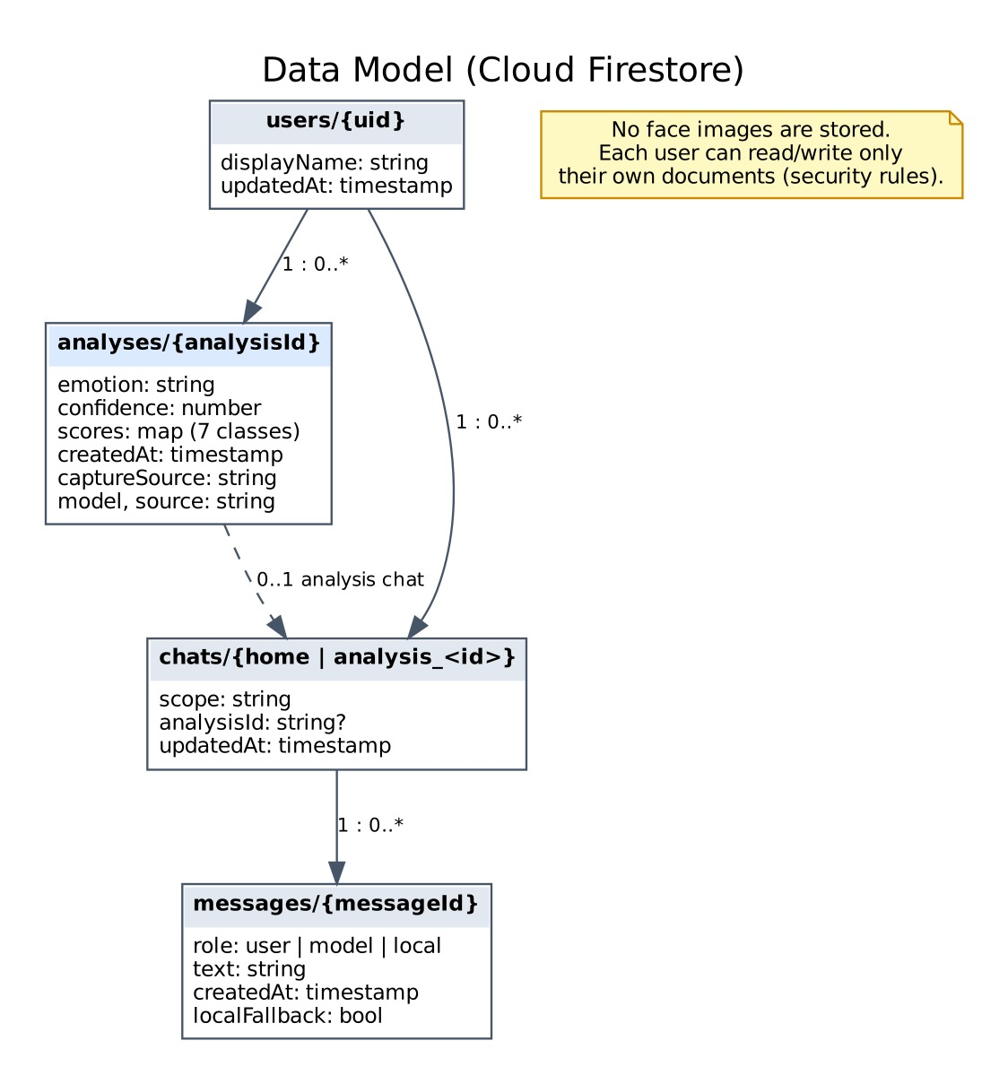
Shows the Cloud Firestore structure: each user owns their analyses and chat conversations. No face images are stored.

2.3 Architecture Flow
The system follows the workflow below:
- The user opens the Flutter application.
- User captures a facial image or uploads a photo.
- ML Kit detects the face regions on the device.
- The largest face is cropped with a 15% margin.
- Image preprocessing is performed (grayscale, 48x48, 112x112, normalisation).
- The processed image and its mirror image are passed to the CNN model.
- The model analyses the facial features.
- CNN predicts emotion.
- Confidence score is calculated.
- The result is saved locally and synced to Cloud Firestore.
- Flutter app displays prediction and confidence.

Activity Diagram

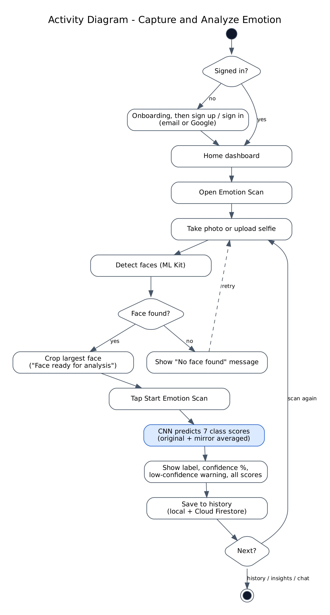
Illustrates the step-by-step workflow from sign-in to capturing an image, processing it through the on-device AI model, displaying the predicted emotion and saving it to history.

3. User Interface Design

3.1 UI Overview
The user interface is designed to be simple, intuitive, and mobile-friendly.
Main Screens:

Home and Emotion Scan Screens
- Home dashboard: greeting, AI Emotion Scan card, latest expression with emoji, AI insight card and recent analyses; bottom tabs Home, History, Insights, Profile
- Photo preview with face status ("Face ready for analysis")
- Start Emotion Scan button
- Splash and onboarding screens (3 pages) before sign-in

Processing Feedback
- Loading indicator on the scan button ("Analyzing...")
- Analysis status messages ("Analyzing face...", "No face found")

Result Screen
- Detected emotion
- Confidence percentage
- Emotion emoji (shown with saved results on Home, History and details)
- Retake image option
- Scores for all seven emotions and a low-confidence warning
- Additional screens: sign in / sign up / forgot password, history, analysis detail, insights, support chat with activity log, profile, edit profile, about

3.2 User Interaction Flow
- User launches application.
- User signs in and opens Emotion Scan from Home.
- User captures facial image.
- The face is detected and prepared on the device.
- The system analyzes the image.
- The prediction is generated by the on-device CNN.
- The result is displayed and saved to history.
- Users may retake the image.

3.3 Sample UI Conversation
System: Welcome to Emotion Detection App
User: Captures Image
System: Analyzing...
System: Emotion Detected: HAPPY
System: Confidence Score: 92%
User: Capture Another Image
System: Camera Ready

3.4 UI Design Characteristics
The interface should exhibit:

Simplicity
Minimal screens and controls.

Responsiveness
Fast response across devices.

Accessibility
Readable text and clear buttons.

Consistency
Uniform color scheme and layouts.

Feedback Mechanism
Loading indicators and result notifications.

4. Design Diagrams

4.1 Class Diagram

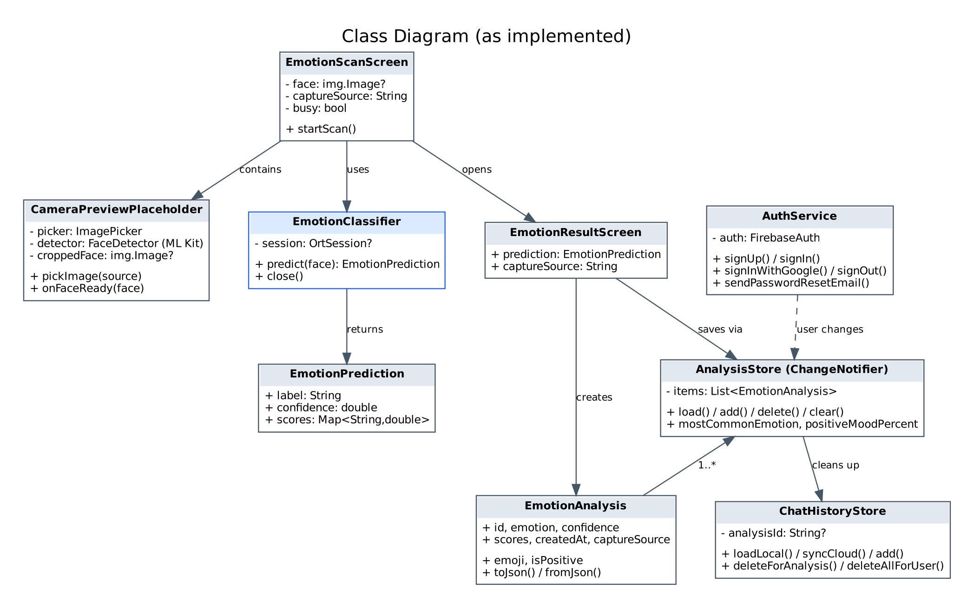

Represents the implemented classes, their attributes, methods and relationships involved in emotion detection.

4.2 Architecture Diagram
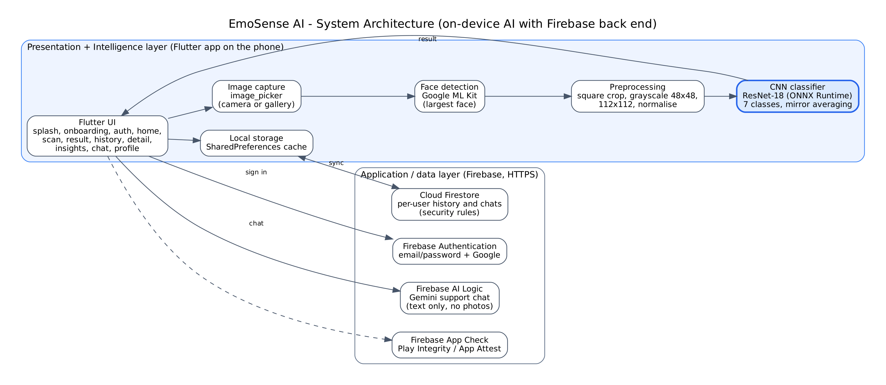

4.3 Sequence Diagram

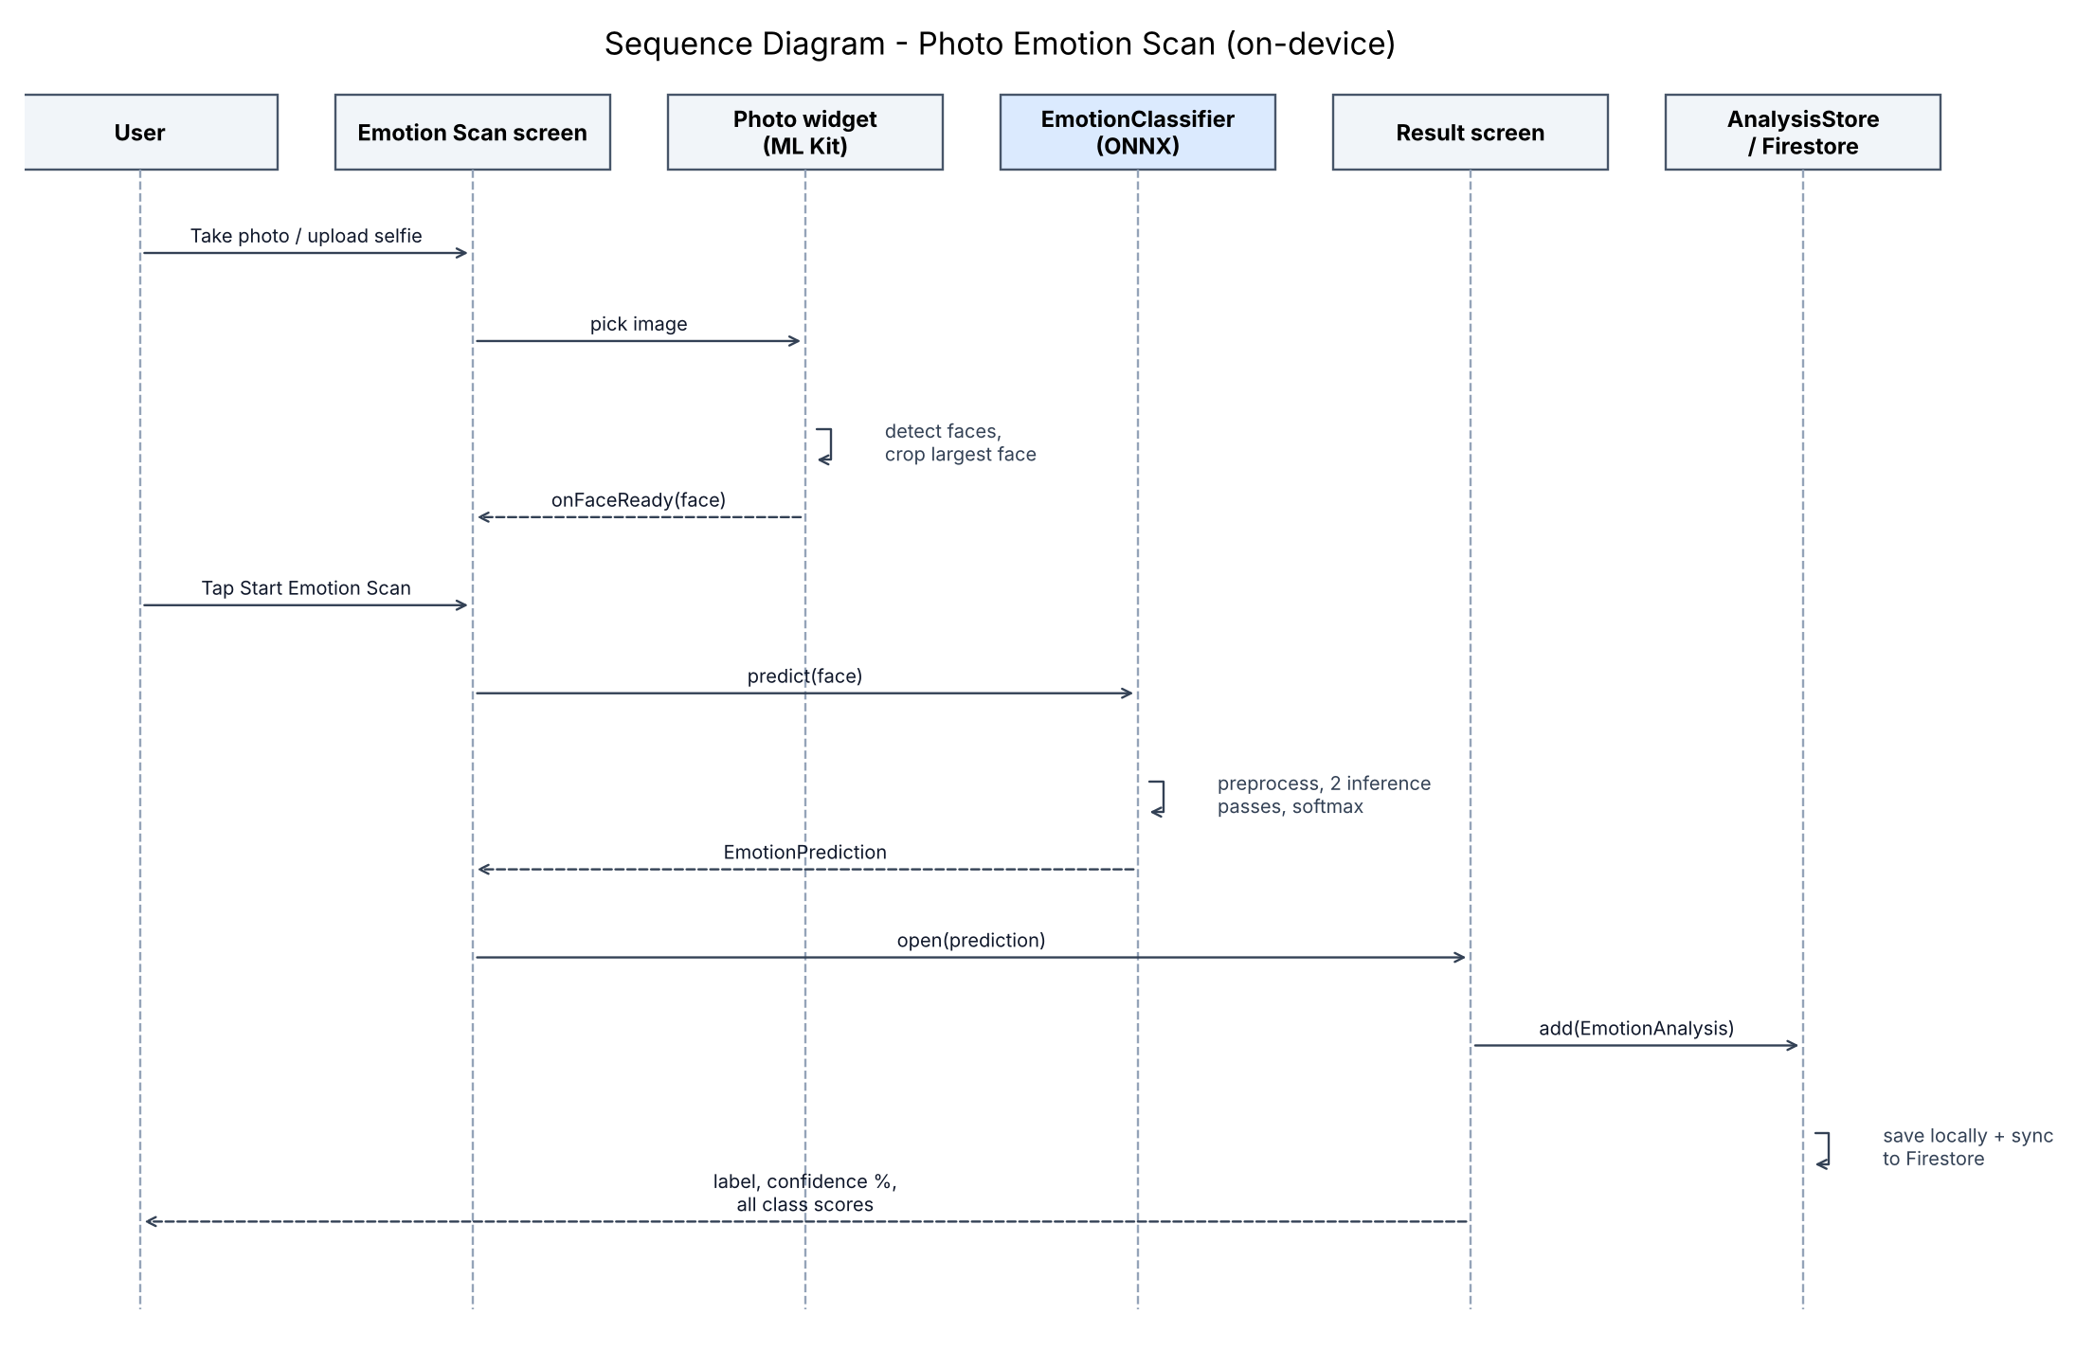

4.4 Component Diagram

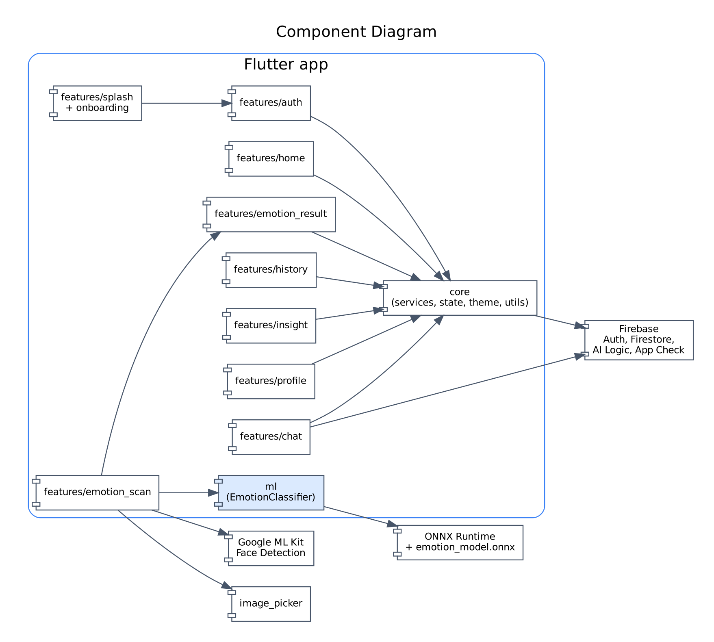

4.5 Security Considerations

- HTTPS (TLS) communication through Firebase SDKs
- Firestore security rules: each user can read and write only their own data
- No face images are uploaded or stored; photos are processed on the device
- Firebase App Check; re-authentication required to change email/password or delete the account; privacy notice before AI chat

5. Scalability and Maintainability
The system is designed with scalability and maintainability in mind.

Scalability
- AI inference runs on each user's device, so capacity grows with the number of users.
- Firebase services scale automatically for concurrent users.
- The model is bundled with the app; no model server is needed.
- Results are cached locally and synced when online.
- No server to host or load-balance for inference.

Maintainability
- Feature-first modular structure separates UI, AI pipeline and data layers.
- Individual modules can be upgraded independently.
- Easy replacement of CNN model with advanced architectures.
- Clear interfaces between screens, services (AuthService, AnalysisStore, ChatHistoryStore) and the classifier.
- Documentation supports future development.

Future Enhancements
- Real-time video emotion recognition from the live camera feed.
- Multi-face results (one label per detected face).
- Confidence calibration and training on larger datasets such as AffectNet or RAF-DB.
- Export of history as PDF or CSV and Urdu localisation.
- Hardware acceleration (NNAPI / Core ML) for faster inference.

6. Conclusion
The AI-Based Facial Emotion Recognition System provides an intelligent, private and scalable solution for recognizing human emotions from facial expressions. The system integrates Flutter, Google ML Kit, ONNX Runtime and a ResNet-18 CNN on the device with Firebase cloud services into a unified architecture that delivers fast, private emotion predictions.
The proposed design ensures high usability, modularity, scalability, and maintainability while providing a strong foundation for future enhancements. Through effective integration of mobile computing, computer vision, and artificial intelligence, the system demonstrates a practical implementation of modern machine learning technologies in real-world applications.
This SDD is based on the requirements and architecture defined in the project's SRS document.

