Tic Tac Toe – Terminal Project Report

Project Overview
This project is a terminal-based Tic Tac Toe game written in Python. Two players take turns on the same keyboard, entering numbers 1 through 9 to place their mark on a 3x3 grid. The game includes a main menu, win/draw detection, and a rematch option — all running entirely in the terminal without any external libraries.

How the Program Works
When the program starts, it enters a loop that keeps showing the main menu until the user chooses to exit. From the menu the user can start a game or quit. Once a game begins, the board is shown and players alternate turns. After each move the game checks if someone has won or if the board is full (draw). When the game ends, the players are asked if they want a rematch. If yes, a fresh game starts immediately. If no, control returns to the main menu.

Functions in the Project
print_board(board) — This function takes the list of 9 cells and prints them out as a formatted grid with separators between rows. It is called before every turn so the players can see the current state of the board.
check_winner(board, player) — This function checks all eight possible winning combinations: three rows, three columns, and two diagonals. If all three cells in any of those combinations belong to the current player, it returns True meaning that player has won.
is_draw(board) — This function simply checks whether any empty spaces remain on the board. If there are no empty spaces left and no one has won, the game is a draw.
play_game() — This is the main game function. It sets up a fresh board, sets the starting player to X, and runs a loop that handles input, validates moves, updates the board, and checks for a win or draw after each turn.

Terminal Screenshot
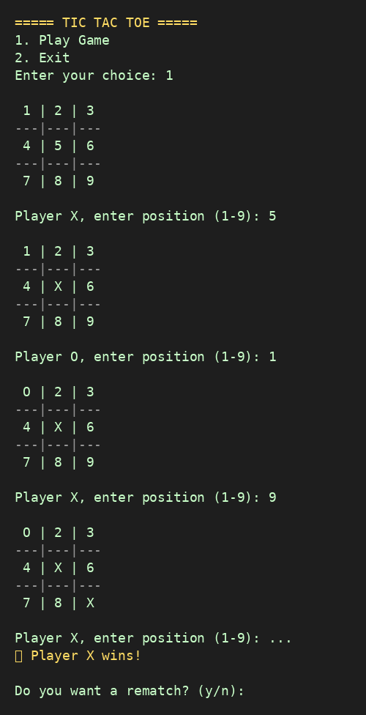

Programming Concepts Used
Lists — The board is stored as a Python list of 9 strings. Each index represents one cell. This makes it easy to update a cell by index and check cells by position.
While loops — Three while loops are used in total. The outer loop keeps the main menu running. The middle loop handles the rematch logic. The inner loop inside play_game keeps the game going until there is a result.
For loops — The check_winner function uses a for loop to go through each of the eight winning combinations and check if the current player occupies all three positions in any of them.
Functions — The code is split into clean, reusable functions. Each function has one clear job, which makes the code easier to read, test, and maintain.
Try/Except — Input validation is handled with a try/except block. If the player types something that is not a number, Python raises a ValueError which is caught and a helpful message is shown instead of crashing.
Conditionals (if/elif/else) — Conditions are used throughout: to check if a move is valid, to switch turns between players, to handle menu choices, and to decide whether to show a win or draw message.
String comparison — The board cells are compared to the player's symbol using the == operator. An empty cell holds a single space character, so checking if board[move - 1] != ' ' is how the game detects an already-taken spot.
Input/Output — The built-in input() function is used to read player moves and menu choices. The print() function handles all output including the board, prompts, and result messages.

Summary
This project covers the fundamentals of Python in a practical and interactive way. It shows how to structure a program with functions, manage game state with a list, handle user input safely, and use loops to keep a program running. The rematch and menu system also demonstrate how to nest loops to control program flow at multiple levels.

