**“Restaurant Order Management System”**

# Session: 2022-2026

**Submitted by:**

Name: Abdullah Awan Registration Number: 2022-CS-89

**Supervised by:**

Miss Maida Shahid

Department of Computer Science

**University of Engineering and Technology Lahore Pakistan**

**Table of Contents**

* CRC Diagram……………………………………………………… 3

4

5

6

* Introduction…………………………………………………….... .. 7
* OOP Concepts……………………………………………………... 7

8

* Design Pattern …………………………………………………….. 8

* Class Details ……………………………………………………… 9

10

* Conclusion …………………………………………………..…….. 11
* reference ……………………………………………..…………… 11

**CRC / UML Diagram of Business Application**

CRC is the overview of the project you can understand the Logic of the Project and its complexity by seeing CRC Diagram so I will attach some Pictures of the CRC Diagram of my Business Application which is a Restaurant Order Management System but if you want to see the whole CRC of Project, I will also Provide Google Drive Link of the CRC Diagram 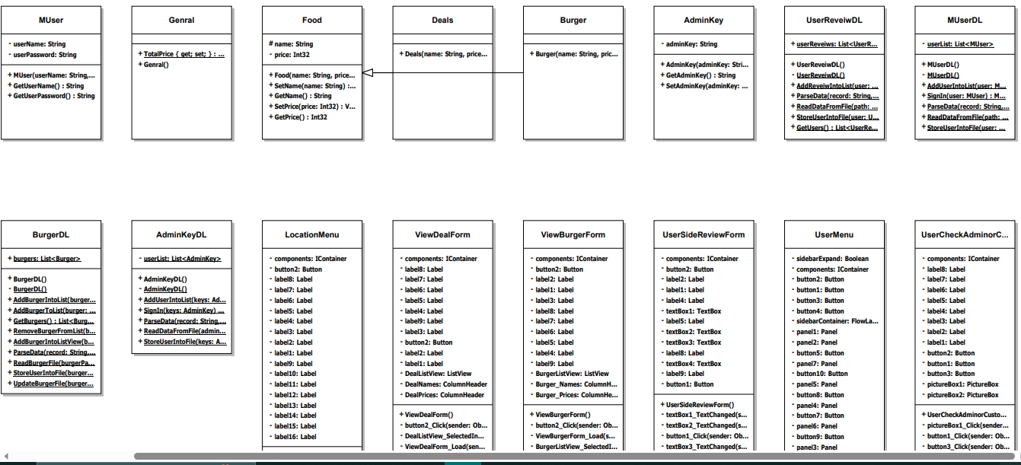

**CRC Google Drive Link is:** <https://drive.google.com/file/d/1Ca-AoVtf86nOVDOCHSTK-7kpONZzAMJJ/view?usp=drive_link>

**Introduction**

It’s a Restaurant Application made in c sharp programming Language and using .NET Framework. It’s a GUI application in which you can order your favorite products such as Burgers and it’s a heaven of Burgers its specifically triggers those applications that made up for specific community. My application is made up for Burger Restaurant like Burger King. That’s why its name is SMASH BURGERS. Once you open this application you get amazed by its cool interface because it was made up by extremely hard work of me. You can buy as much as you can and we also have some special burger deals just for you and also you can calculate your **total bill** and **Delivery Charges** if you want a delivery. We also collaborate with NGOs to help needy. Long Story Short this application covers all aspects of a good food restaurant application.

**OOP Concepts**

Object Oriented Programming is a type of programming in which you can make modules and make objects, classes, and relation among classes. The biggest advantage of OOP (modular approach) over procedural approach is that you can divide your whole project and make modifications accurately because it increases readability.

In my Business Application several OOP Concepts are used such as **Inheritance**, Object creation, several classes are used. I used inheritance in such a way that Burger and Deals class have several Methods same, so I made a food class (a parent class) and inherited both classes to Food class It save me from writing extra code every time for every class you can see I add a picture here.

and I also made several classes just to increase readability and to make workflow smoother. I tried to make abstract classes because in the **CLI** there also an abstract class with abstract method of calculation because every child class (food item) that want to add a new item to a menu also does calculation but, in the GUI, this can be performed by ListView Event Handler, and you cannot change datatype of a built-in method. Long Story Short in modular programming you can make modules so you can use them anywhere in the project. In modular programming you can make objects with different access specifiers and can access them anywhere in the project but in procedural you had to make a global variable or else you can pass it to every function that is surely a hectic work to do.

**Design Pattern**

BL

In the business layer your project logic is established, and your project main idea is in the BL Folder. In my project BL Folder classes like **Admin Key** (stores admin Key), **Burger**, **Deals**, **Food** (parent class of burger and deal class), **General** (to store general fields and methods), **Muser** (store user login information), **UserReveiew** (store reviews attributes and fields).

DL

In the Data Layer Folder all read-write functionalities of the BL classes lies. In my Data Layer Folder there are several classes such as **AdminKeyDL**, **BurgerDL**, **DealDL**, **MUerDL**, and **UserReviewDL** that store the methods like ReadDataFromFile() and WriteDataToFile() and also it contains lists or arrays to store data in the project and In my application for the permanent storage of Data I use text file to store menu information, user information and many other things

UI

In the User Interface Folder all input and output methods are taken. In CLI there are several classes in the UI Layer of my Project but in GUI there are several forms

I can list their names one by one as follows:

* AddBurgerMenu.cs
* AddDealMenu.cs
* AdminCheckForm.cs
* BillMenu.cs
* BurgerMenu.cs
* DealMenu.cs
* DeliveryMenu.cs
* NewAdminMenu.cs
* OurStoryMenu.cs
* SignInPage.cs
* SignUpPage.cs
* UserMenu.cs

Like these there are several UI Forms how much of them I can wrote here.

**Class Details**

Food

Food is a parent class of Burger and Deals Class. It contains getter setter and some more methods and the object list is made up of food class so that why it’s necessary and if there will be an addition of some food items in the application you can just inherit from food class and there is no need to write extra getter and setter methods for every class.

Burger

Burger is child class of Food class and in its Data Layer Class which is a BurgerDL class it holds the burger name and their respective prices and in data layer of burger class there is list of burger class to hold data in the program that is read from the text file.

Deals

Deals is child class of Food class and in its Data Layer Class which is a DealDL class it holds the deal name and their respective prices and in data layer of Deal class there is list of Deals class to hold data in the program that is read from the text file.

AdminKey

In Admin Key class, it stores the entry time password for admin when any user wants to get admin access, he had to prove himself an Admin by writing the admin password because access of Admin Password is only specified to Admin and only admin can change it or add another password for any other person entry in the admin side of the application.

MUser

In MUser class it stores the user information for Sign In purpose such as Username and password that can be permanently store in the text file unknown user cannot get into the application first, he had to provide his username and password then he can enter other than a wrong input message was displayed to the user.

UserReviews

In UserReviews class as displayed by name it stores the user reviews about the services and website ambiance and username, number, ratings, and message can be stored and displayed to the admin and store in the file for future use. Admin can see reviews to know about what his customer thinks about his restaurant food and services and many other things can get noticed by user message.

**Conclusion**

In this business application there are also some mistakes that I made. I cannot say that it is a perfect supplication because no one is perfect, and nothing is perfect, but I can say that I learned o much from this project. I remember that I made three projects are in que, but I am so confused about what to show to teachers and my mentors, I almost 3 times in a week work on this and today writing its documentation makes me so much happy that I which is a beginner in programming completed this. There is huge shift in Project direct CLI to GUI where you had to focus on every little thing and attract an eye-catching app is very difficult. Special thanks to my teachers and my seniors and Shammas Ahmad my classmate he helped me a lot in positive way.

**Reference and Links of Project**

**CRC Google Drive Link is:** <https://drive.google.com/file/d/1Ca-AoVtf86nOVDOCHSTK-7kpONZzAMJJ/view?usp=drive_link>

**Project Google Drive Link is:** [**https://drive.google.com/drive/folders/1TDGfHUppwmyML5LyKi8iObmby3WMv0Sm?usp=sharing**](https://drive.google.com/drive/folders/1TDGfHUppwmyML5LyKi8iObmby3WMv0Sm?usp=sharing)

**LinkedIn:** [**https://www.linkedin.com/in/abdullah-nazir-26002a262/**](https://www.linkedin.com/in/abdullah-nazir-26002a262/)