**OOP LAB ASSIGNMENT #9**

**ABDULLAH IMTIAZ**

**K20-1901**

**BSE-2B**

**Q#1-CODE**

class Job{  
 private String role;  
 private float id,salary;  
  
 public String getRole() {  
 return role;  
 }  
 public void setRole(String role) {  
 this.role = role;  
 }  
 public float getId() {  
 return id;  
 }  
 public void setId(float id) {  
 this.id = id;  
 }  
 public float getSalary() {  
 return salary;  
 }  
 public void setSalary(float salary) {  
 this.salary = salary;  
 }  
}  
class Person{  
  
 public Person() {  
 super();  
 Job j=new Job();  
 j.setSalary(10000);  
 System.*out*.println(j.getSalary());  
 }  
}  
public class Q1 {  
 public static void main(String[] args) {  
 Person p =new Person();  
 }  
}

**Q#1-OUTPUT**

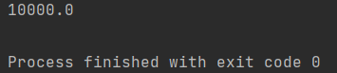

**Q#2-CODE**

class CPU{  
 double price;  
  
 class Processor{  
 String manufacturer;  
 double cores;  
  
 double getCache(){  
 return 4.2;  
 }  
 }  
 protected class RAM{  
 double memory;  
 String manufacturer;  
  
 double getClockSpeed(){  
 return 5.3;  
 }  
 }  
}  
  
public class Q2 {  
 public static void main(String[] args) {  
 CPU cpu=new CPU();  
 CPU.Processor process=cpu.new Processor();  
 CPU.RAM ram=cpu.new RAM();  
 System.*out*.println(process.getCache());  
 System.*out*.println(ram.getClockSpeed());  
 }  
}

**Q#2-OUTPUT**

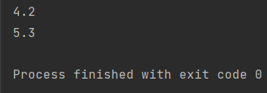

**Q#3-CODE**

import java.util.Scanner;  
  
class Car{  
 String carname;  
 String cartype;  
 Car(){}  
  
 public Car(String carname, String cartype) {  
 this.carname = carname;  
 this.cartype = cartype;  
 }  
 private String getCarname() {  
 return carname;  
 }  
 class Engine{  
 String Enginetype;  
  
 void setEngine(){  
 if(cartype.equals("4T")){  
 if(carname.equals("Mehran")){  
 this.Enginetype="Small";  
 }  
 else  
 this.Enginetype="Large";  
 }  
 else  
 this.Enginetype="Bigger";  
 }  
 public String getEnginetype() {  
 return Enginetype;  
 }  
 }  
}  
public class Q3 {  
 public static void main(String[] args) {  
 Scanner sc = new Scanner(System.*in*);  
  
 System.*out*.println("Enter the name of Car");  
 String carname = sc.next();  
 System.*out*.println("Enter Car Type");  
 String Cartype = sc.next();  
 Car c = new Car(carname,Cartype);  
 Car.Engine E = c.new Engine();  
 E.setEngine();  
 System.*out*.println("Engine Type = "+E.getEnginetype());  
 }  
}

**Q#3-OUTPUT**

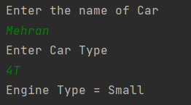

**Q#4-CODE**

public class Q4 {  
 public static void main(String[] args) {  
 int[] array=new int[2];  
  
 try {  
 System.*out*.println(array[3]);  
 }  
 catch (ArrayIndexOutOfBoundsException e){  
 System.*out*.println(e);  
 }  
 }  
}

**Q#4-OUTPUT**



**Q#5-CODE**

import java.util.*;  
public class Q5 {  
 public static void main(String[] args) {  
 int a[]=new int[5];  
 try{  
 Scanner sc=new Scanner(System.*in*);  
 int sum=0,total;  
 float result;  
 for (int i = 0; i < 5; i++) {  
 System.*out*.println("Enter the marks of "+(i+1)+" student:");  
 a[i]=sc.nextInt();  
 sum+=a[i];  
 }  
 System.*out*.println("Enter total marks");  
 total= sc.nextInt();  
  
 result=(int)sum/total;  
 System.*out*.println("Result: "+result);  
 }  
 catch (ArithmeticException e){  
 System.*out*.println(e);  
 }  
 }  
}

**Q#5-OUTPUT**

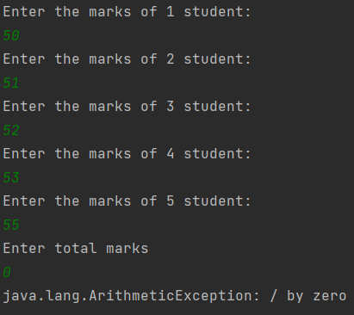

**Q#6-CODE**

import java.util.*;  
public class Q6 {  
 public static void main(String[] args) {  
 Scanner sc=new Scanner(System.*in*);  
 float a,b,c;  
 System.*out*.println("Enter the value of a:");  
 a= sc.nextInt();  
 System.*out*.println("Enter the value of b:");  
 b= sc.nextInt();  
 try{  
 c=a/b;  
 System.*out*.println("The result of division is:"+c);  
 }  
 catch (ArithmeticException e){  
 System.*out*.println(e);  
 }  
 finally {  
 System.*out*.println("Finally method running");  
 }  
 }  
}

**Q#6-OUTPUT**

