**AHTISHAM UL HAQ**

**FA21-BSE-072**

**OOSE-MED-LAB**

**24-05-2023**

**USE CASE: SUBMIT FINE:**

**MAIN SUCCESS SCENARIO:**

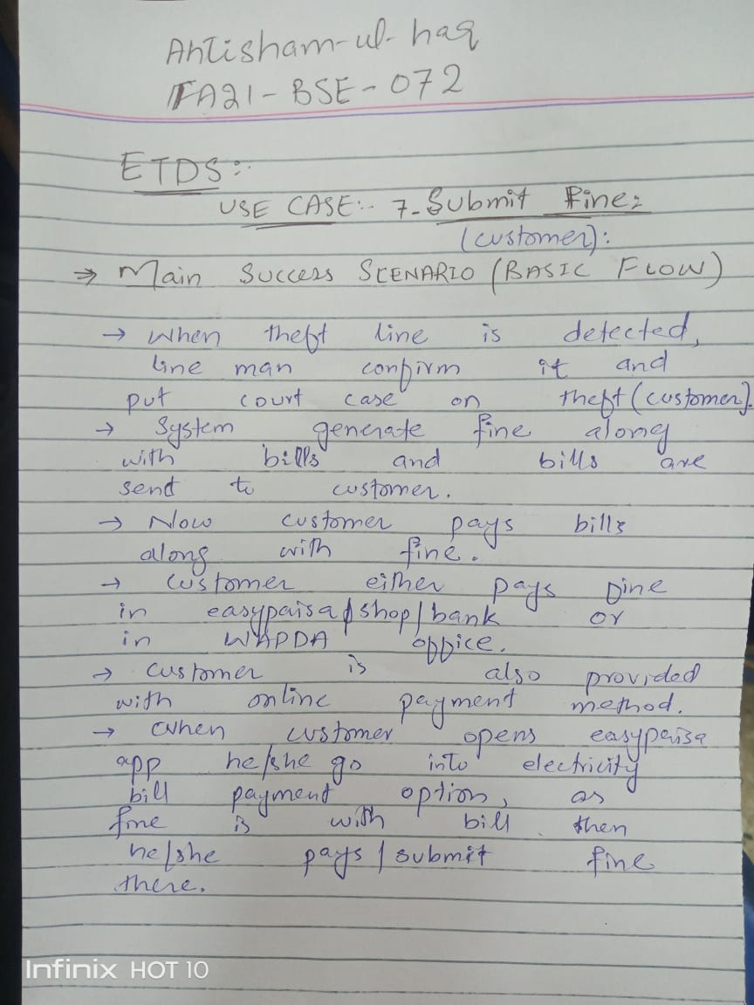

SSD:

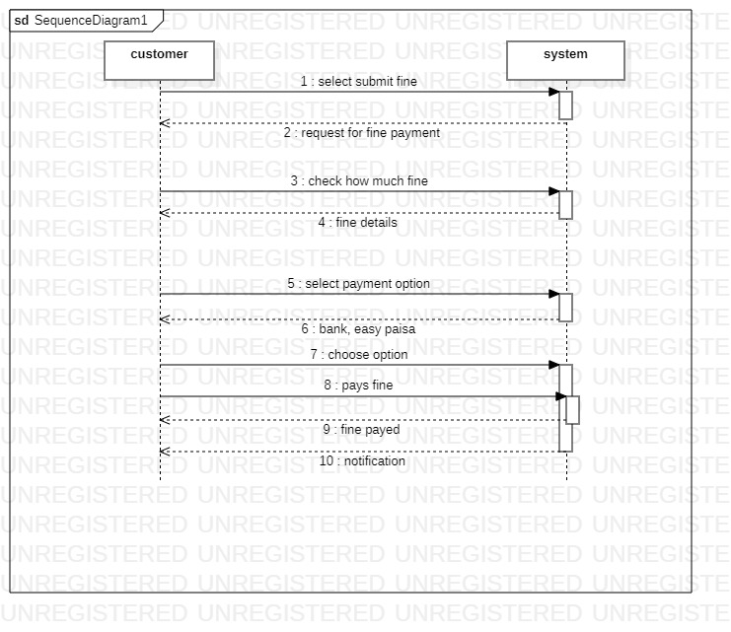

**PROTOTYPE:**

