CREATED BY:

Ibrahim khan fa21-bse-186

Submitted to:

Mukhtiar zamin

REVIEWED DATE:

24-May-2023

Midterm-Lab

**“Identify the Primary Actors, theirs goals and then draw its Use Case diagram”**

**Primary Actors:**

Line man

Electricity Meter

Customer

SDO (Sub-Divisional Officer)

System Clock

**Goals:**

Line man:

Monitor lines, detect theft, confirm theft, open court case, start/stop monitoring.

Electricity Meter:

Report consumption, detect theft.

Customer:

Pay bills, submit fines, request meter installation.

SDO:

Add/assign meters, add lines, set app configuration.

System Clock:

Generate bills.

**“For the main success scenario, draw its System Sequence Diagram and design the interaction diagram for two system events using GRASP principles only”**

**Main Success Scenario:**

Customer contacts the appropriate authority to submit a fine for a violation. The authority verifies the customer's identity and the details of the violation. The authority enters the fine amount and the reason for the fine into the system. The system records the fine information and generates a confirmation receipt. The authority provides the confirmation receipt to the customer.

**Extension (Exception with Alternative Course of Events):**

If the customer's identity cannot be verified, the fine submission process is halted, and the customer is informed of the issue.

**System Sequence Diagram (SSD):**

**Main Success :**

Submit Fine (Customer)

**Diagram:**

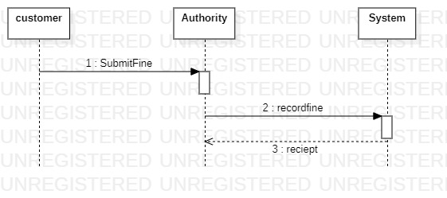

**Prototype:**

