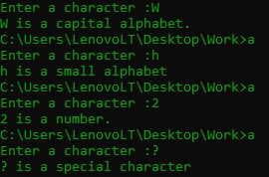

#include<stdio.h>

int main(){

char ch;

printf("Enter a character :");

scanf(" %c",&ch);

if(ch>='a' && ch<='z')

{

printf("%c is a small alphabet",ch);

}

else if(ch>='A' && ch<='Z'){

printf("%c is a capital alphabet.",ch);

}

else if(ch>='0'&& ch<='9'){

printf("%c is a number.",ch);

}

else{

printf("%c is a special character",ch);

}

return 0 ;

}