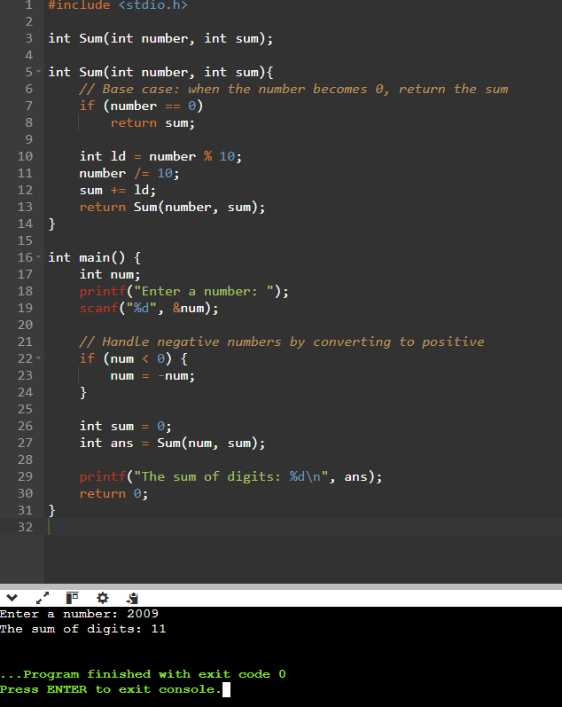

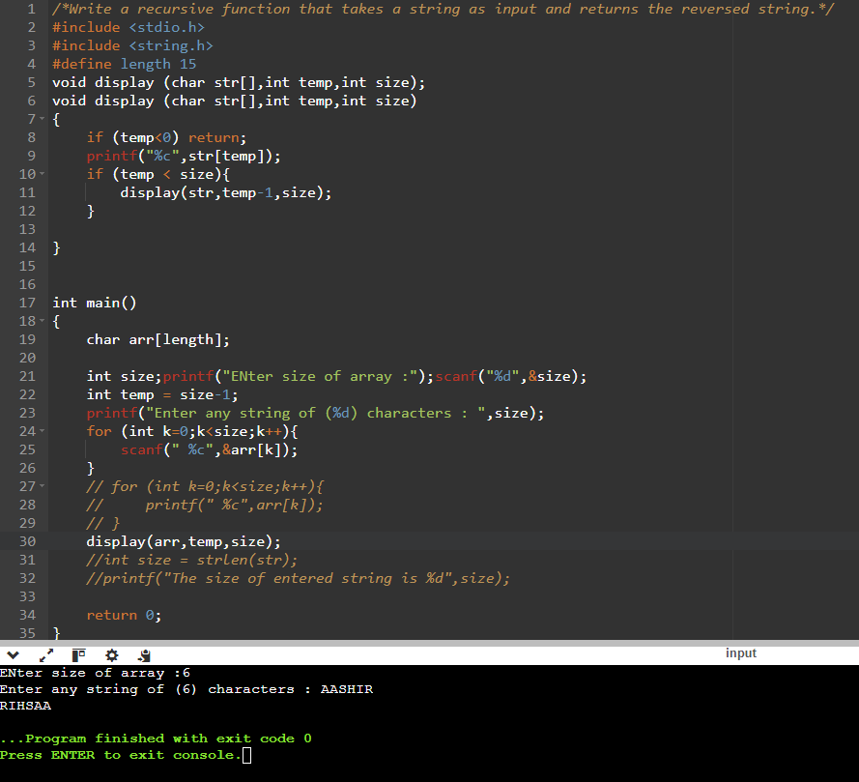

/*Write a program that uses structures to manage flight information, including flight

number, departure city, destination city, date, and available seats. Create functionalities

to book a seat and display flight details.*/

#include <stdio.h>

#include <string.h>

// Define a structure for Date

struct Date {

int day;

int month;

int year;

};

// Define a structure for Flight

struct Flight {

int flightNumber;

char departureCity[50];

char destinationCity[50];

struct Date flightDate; // Date is now a nested structure

int availableSeats;

};

// Function to book a seat

void bookSeat(struct Flight *flight) {

// Check if there are available seats

if (flight->availableSeats > 0) {

flight->availableSeats--;

printf("Seat booked successfully!\n");

} else {

printf("Sorry, no available seats for this flight.\n");

}

}

// Function to display flight details

void displayFlightDetails(struct Flight flight) {

printf("\nFlight Details:\n");

printf("Flight Number: %d\n", flight.flightNumber);

printf("Departure City: %s\n", flight.departureCity);

printf("Destination City: %s\n", flight.destinationCity);

printf("Date: %02d-%02d-%d\n", flight.flightDate.day, flight.flightDate.month, flight.flightDate.year); // Display the date in DD-MM-YYYY format

printf("Available Seats: %d\n", flight.availableSeats);

}

int main() {

struct Flight flight;

// Get flight details from the user

printf("Enter flight number: ");

scanf("%d", &flight.flightNumber);

printf("Enter departure city: ");

scanf(" %49[^\n]", flight.departureCity); // Read the departure city

printf("Enter destination city: ");

scanf(" %49[^\n]", flight.destinationCity); // Read the destination city

// Get the flight date details (Day, Month, Year)

printf("Enter flight date (Day Month Year): ");

scanf("%d %d %d", &flight.flightDate.day, &flight.flightDate.month, &flight.flightDate.year);

// Get the number of available seats

printf("Enter number of available seats: ");

scanf("%d", &flight.availableSeats);

// Display initial flight details

displayFlightDetails(flight);

// Ask user if they want to book a seat

char choice;

printf("\nDo you want to book a seat on this flight? (Y/N): ");

scanf(" %c", &choice); // Use a space before %c to consume the leftover newline

if (choice == 'Y' || choice == 'y') {

// Book a seat

bookSeat(&flight);

// Display updated flight details

displayFlightDetails(flight);

} else {

printf("No seat booked.\n");

}

return 0;

}

**Structure (flight ) code output :** 