Department of Computer Technology and Information Systems

## CTIS221 – Object Oriented Programming

FALL 2019 - 2020

# **Lab Guide 14 - Week 10-2**

|  |
| --- |
| **OBJECTIVE:** Exception + TextFiles + GUI |
| **Instructor** : Burcu LİMAN  **Assistant** : Burcu Alper, Leyla SEZER |

**Q1.** Create a class for calculation and write a static “**calculate”** method that divides numerator to denominator and returns the result.

* Create a **Calculate** frame as follows:

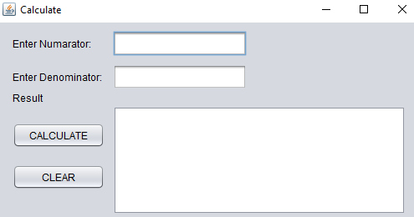

* There are 3 labels, 2 text fields, 2 buttons and 1 text area;
  + If user fills the fields and clicks on calculate button, calculate the result of the operation by calling the **calculate ()** method.
  + If the user makes a mistake, the program catches and handles the exception.
  + If the user enters a zero denominator, an ArithmeticException occurs.
  + If the user enters a string as a denominator, NumberFormatException occurs.
  + If user clicks on “Clear” button all the fields should be cleared.
* For each exception, the user should be informed about the mistake and asked to try again as in the following figures:

***a)*** *Write try, catch in action of Calculate button.*

***b)*** *Write try, catch inside the method.*

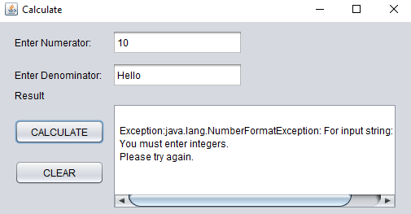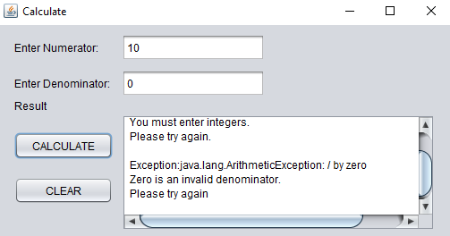

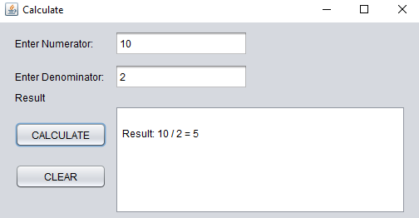

**Q2.** Write a Java program that gets ShoppingMall and displays the ShoppingMall information. Create ShoppingMall**,** ShoppingSys classes as shown in the following Class Diagram.

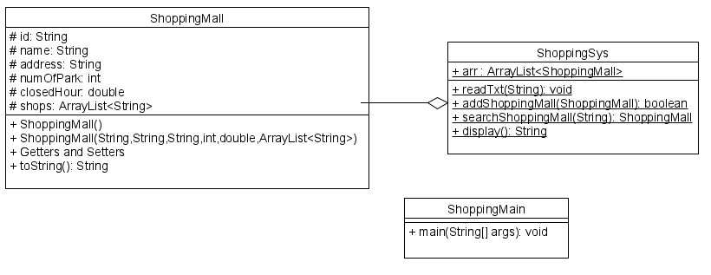

Create a **ShoppingMall** class, with the following instructions;

* Write data members; **id, name, address, numOfPark, closedHour and ArrayList<String> shops.**
* Write **non-default constructor.**
* Write **getId** method that returns the id of a **ShoppingMall**.
* Write **toString** method to show the content of the **ShoppingMall** object.

Create a **ShoppingSys** class, with the following instructions;

* Write a static method **readTxt**(…) that gets the file name as a parameter and puts the file content into the arraylist.
* Write a static method **addShoppingMall**(..) that gets a **ShoppingMall** objectFirst, method checks if the id already exist in the arraylist, if it is exist returns false, otherwise adds the object to the arraylist and returns true.
* Write a static method **searchShoppingMall** (…) that gets the id of the **ShoppingMall** then search that **ShoppingMall** from the list and returns that **ShoppingMall** object.
* Write a static method **display**() that returns the whole content of arraylist as a string.

**shopping.txt**

111 CEPA Ankara 1025 10 Penti H&M Ipekyol

222 PANORA Ankara 1256 11.30 Tefal Roman Karaca

333 KENTPLAZA Konya 678 9.30 D&R Accessories Atasun

444 ISTINYEPARK ISTANBUL 2258 12 Micheal&Kors Beymen Vakko

555 CADDE ESKISEHIR 456 10 LCW M&S Panco

Create a **ShoppingFrame** class, with the following components;

* 1 label “Shopping Info:”
* 1 textArea and 4 buttons “READ FILE CONTENT”, “ADD Shopping Mall”, “SEARCH”, “DISPLAY”

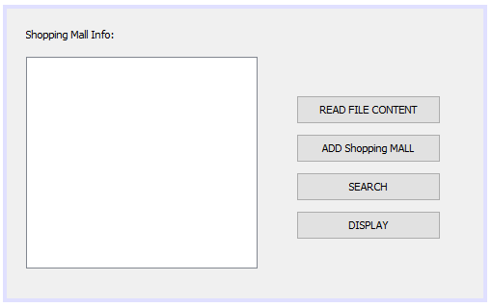

Create an **AddShoppingMallFrame** class, with the following components;

* 1 label “Adding New Shopping Mall:” at the top of the page.
* 8 labels; “ID”,”Name:”,”Address:”,”Number of Park:” ,“Closed Hour:” and Three Shop Names.
* 8 textFields and 1 button “ADD”.

Create an **SearchShoppingMallFrame** class, with the following components;

* 1 label “Shopping Mall ID:” at the top of the page.
* 1 ComboBox,
* 1 textarea and 1 button “Search”.

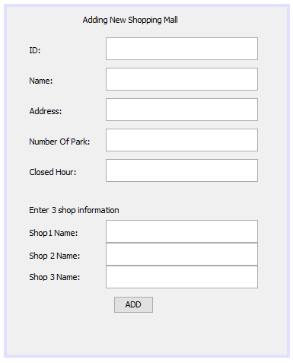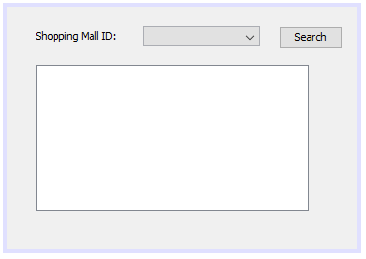

Create a **Main** class that has the static main method, inside create a ShoppingFrame object and sets its visibility to true.

When the user clicks on the “**READ FILE CONTENT**” button, content of the “shopping.txt” will be read and “File is read” message shown in the textArea. Then “**DISPLAY”** button shows the content of ArrayList.

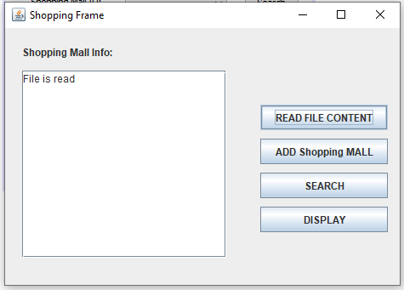

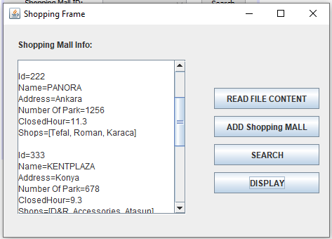

When the user clicks on the “**ADD**” button, AddShoppingMallFrame will be shown, when the user clicks on the “**SEARCH**” button, **SearchShoppingMallFrame** will be shown, The combobox of the search frame will be filled by the ids of the ShoppingMalls, with the given code of defaultcomboboxmodel.

ArrayList arr = new ArrayList();

search.getCmbID().removeAllItems();

for (int i = 0; i < ShoppingSys.arr.size(); i++) {

ShoppingMall sm = ShoppingSys.arr.get(i);

dcm.addElement(sm.getId());

}

search.getCmbID().setModel(dcm);

search.setVisible(true);

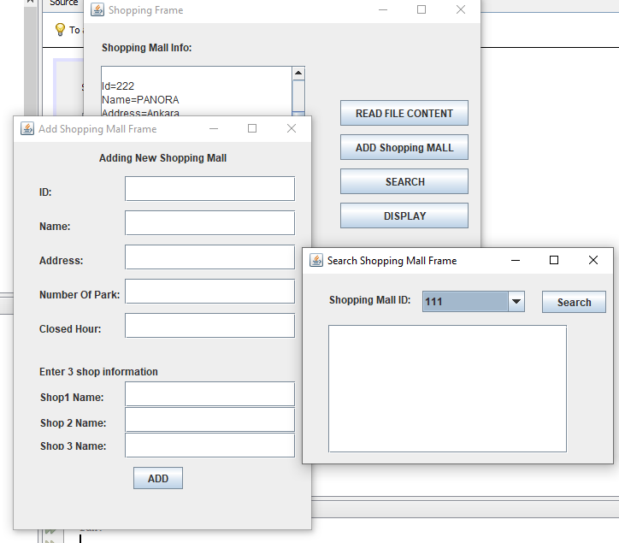

In the **AddShoppingMallFrame**, get all the information, invoke the addShoppingMall(…) method and depending on the return value, give the message at the bottom of page “Mall already exist!” or the message “Mall Added!”

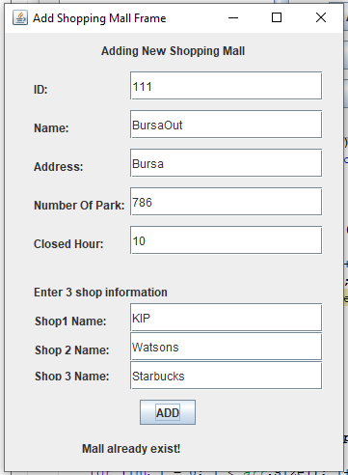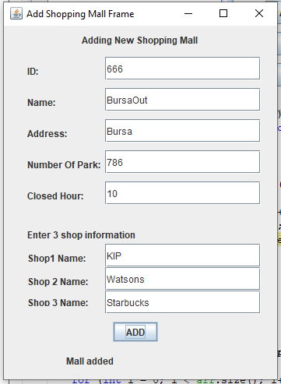

In the **SearchShoppingMallFrame**, the combobox will be filled by the IDs of the Malls **(Use DefaultComboBoxModel)**, when user selects the id and clicks the “Search” button, searchShoppingMall(…) will be invoked and the result will be displayed in the text area.

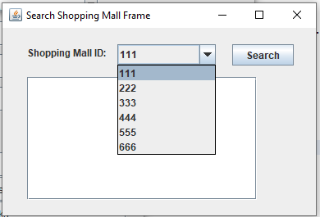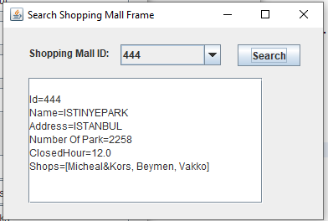

**Do not forget the make AddShoppingMallFrame and SearchShoppingMallFrame DISPOSE on close.**

