1.Python package -> Anaconda

2.Python Libraries ->
1.os -> Help script to Interact Directly with Operating System.
2.re -> allowing you to search, split, alter, and validate text patterns.
3.datetime -> Use for date & time related operations.
4.openpyxl -> Use for write excel file.
5.win32com -> Allowing you to Interact with Windows component Object Model (COM).

3.Modules
python 3.13.14
file -> email_automation.py

4.VARIABLES:
1.INTERNAL MAIL DOMAINS -> domains whose emails you want in Internal_emails folder.
2.ENABLE FOLDER CLEANUP -> set it to true if you want to delete day old folder from DELETE_OLDER_THAN_DAYS your outlook.
3.DELETE_OLDER_THAN_DAYS -> set days in this for which last day folder you want to delete(15).
4.NO_OF_DAYS -> no of days excel file you want.
5.HOD_EMAIL -> define email on which escalation and top up emails send to HOD.
6.ESCALATION_THRESHOLD -> define the threshold for which after that number consecutive unread send escalation email to HOD & after that number to & fro convo send escalation email to HOD.
7.FOLLOWUP_DAYS_THRESHOLD -> define no of follow up days threshold after which the system send the follow up email to the customer for the email we send to it regarding to any document or any number like chases, motor, or Mobile number.
8.IS_CUSTOMER_CARE -> make it true if the system is use by customer care department, (MAKE It FALSE if system is use by normal user on normal email); When you make it false it don't send HOD_EMAIL, no follow up, and no draft.
9.DAYS_OFFSET -> if you run system on today set it to 0 and on yesterday set it to 1.
10.promtoions -> define the array of promotions(which emails you want in promotion folder on outlook).
11.HOD_POPUP_BUSINESS_DAY -> After read customer email and after that no of days still no reply, Then a pop up msg is send to the HOD, that the xyz email is not entertain

5.FOLDER PATH:
PROJECT_DIRECTORY -> set directory in which you want all excel files.
FOLDER PATH -> C:\Users\Abdullahh\OneDrive\Desktop\Anaconda_Project\firstproject

6.What the system does
- Reads every email currently in Outlook's Inbox (and previously filed date folders), across every date present — not just today.
- Classifies each complaint by category (safety, mechanical, warranty, service delay, general) and by urgency, based on keyword rules.
- Tracks conversations, not individual emails — a customer's back-and-forth thread is treated as one unit, with reply timing and unanswered streaks computed across the whole history.
- Files each conversation into a date folder matching when it started (or its original folder, if it's a continuing thread), unless it belongs to an internal domain (→ Internal_Mails) or matches a promotion keyword (→ Promotions).
- Drafts replies automatically for common cases — asking for a missing contact number, sending a category-specific first response, or confirming resolution — when IS_CUSTOMER_CARE is enabled.
- Sends follow-up nudges to customers who've gone quiet after we asked for missing information.
- Escalates to the HOD in two ways:
- When a conversation has too many consecutive unanswered messages or too many total exchanges (ESCALATION_THRESHOLD).
- When a customer's message has gone unanswered for HOD_POPUP_BUSINESS_DAYS+ working days.
- Exports Excel reports — one row per conversation, color-coded by priority and status, for both the current run and a rolling multi-day window (NO_OF_DAYS).
- Cleans up old folders (optional) once conversations inside them are old enough (DELETE_OLDER_THAN_DAYS).
- Date folders and required subfolders (Promotions, Internal_Mails) are created automatically under Inbox on first run — no manual setup needed.

7.ARCHITECTURE DIAGRAM:

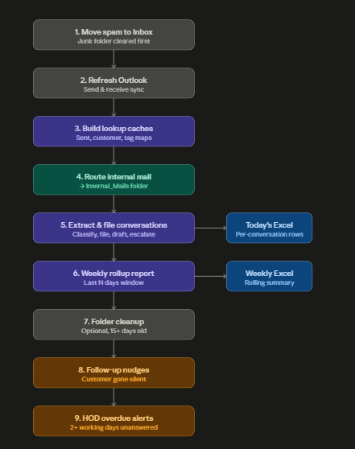

8.Functions
1.get_target_date() -> Give excat date w.r.t day_offset today or yesterday.
2.add_business_day() -> add business days to the start date of an email for help to HOD pop up.
3.build_hod_popup_sent_map() -> Check that the email is not already pop up to HOD.
4.Refresh_Outlook() -> Refreshing your Outlook.
5.move_all-spam_to_inbox() -> Some mails come to spam/junk, so this function move them to inbox.
6.check_promotion() -> Check email against the promotion array.
7.is_primary() -> If email is promotional like linkedIn or other then don’t read it.
8.is_internal_domain() -> Check that if email from internal email or not.
9.get_sender_email() -> Extract sender email & return it.
10.get_message_id() -> return the msg id of a trail.
11.get_outlook_folder() -> you pass a folder name and it return the reference of a folder.
12.check_outlook_item() -> check that it an email or not (like class 43 is an email only)
13.get_or_create_subfolder() -> you pass parent and foldername to be create then this function create a folder under the parent folder.
14.setup_promotions_folder() -> Create a promotion folder.
15.setup_internal_mails_folder() -> Create a Internal_email folder under inbox.
16.find_all_date_folders() -> All folders that are already in the inbox.
17.delete_old_date_folder() -> Delete the date folder we pass the days(eg -> last 15th day) to delete a folder.
18.compute_episode_dates() -> Tell in which date folder the new email should come if replied by team.
Episode -> A run of customer message that haven’t gotten a reply yet.
19._strip_quoted_history() -> Return the body only
20.check_resolve() -> Check by subject & body whether the complaint is resolve or not by matching words.
21.is_auto_resolvable() -> Calls check_resolve() function.
22.compute_status() -> Return the status based on the bool we pass as an argument.
23.has_resolved_tag() -> check that whether the email has resolved tag or not.
24.get_date_folder_cached() -> returns creating a folder if don’t exist in cache.
25.collect_inbox_dates() -> Returns the sorted list of distinct dates found among the given
Inbox mail items.
26.ensure_date_folder_for_inbox() -> take all dates from collect_inbox_dates() and send it to get_date_folder_cached().
27.mark_conversation_resolved() -> Mark the convo as resolve.
28.build_persistently_resolved_conversations() -> returns all resolved conversations ids.
29.build_sent_messages_map() -> Return all already sent messages map from sent items of outlook.
30.build_customer_messages_map() -> Returns all convo maps.
31.get_full_conversation_data() -> Build the complete text trail of a customer.
32.check_num() -> check whether the num is valid or not.
33.check_num_in_history() -> Check Number in previous emails If email so we can sent num missing template again.
34.generate_suggested_reply() -> Generate the reply of templates based on the category.
35.build_existing_draft_conversations() -> get ids of already created draft so don’t create again.
36.build_followup_sent_map() -> return set of already sent follow-up nudge.
37.sent_followup_to_customer() -> sent a followup nudge directly to the customer.
38.build_escalated_conversations() -> returns the convo maps which are already escalated to HOD.
39.send_hod_overdue_pop() -> Send Pop directly to HOD.
40.send_hod_escalated_email() -> Send Escalation Email to HOD directly.
41.create_draft_reply() -> Create draft for customer based on category.
42.analyze_complaint_text() -> Used Keyword to Build the priority.
43.Compute_priority() -> Calculate the priority from the analyze_complaint_text().
44.move_to_target_folder() -> Move msg to target folder.
45.move_to_intrenal_folder() -> Move msg to Internal_folder.
46.build_conversation_pairs() -> Build the complete pairs of a conversation complete trail.
47.calculate_avg_response_time() -> Calculate avg response time using receive and reply time.
48.count_consecutive_unanswered() -> Return no of consecutive un replied of a trail.
49._safe_mail_items() -> returns only read mail class item(class = 43).
50.extract_conversations() -> Perform all task on an email like call all above function and extract each email and perform every functionality (sorting mails, create draft, mark resolved) each and every operation perform in this.
51.write_to_excel() -> Write the provided emails to excel.
52.find_date_folders_last_n_days() -> returns all date folder within N-day.
53.extract_conversations_last_n_days() -> Extract the convo of emails of last N-day and return (only READ).
54.check_and_process_internal_mails() -> Perform all tasks of Internal Emails folder.
55.check_and_notify_hod_overdue() -> check the last reply to a recent msg and sent pop up to HOD.
56.check_and_send_followup_nudges() -> Sent Follow up nudge after no response from customer till N-day.

9.How to Run :

10.Where Excel File is Create:
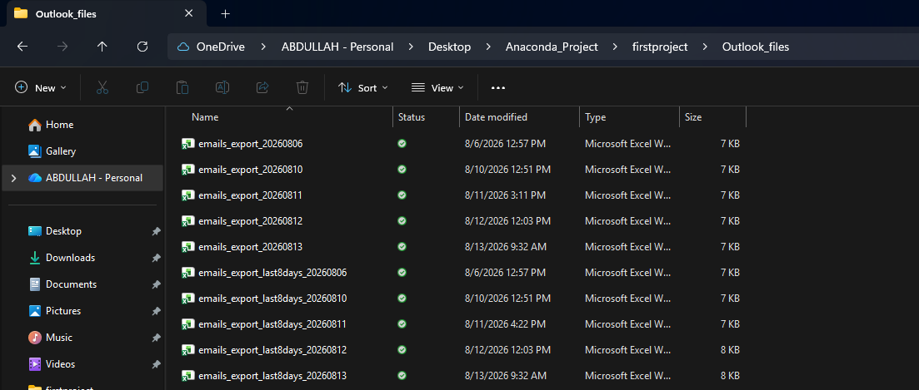

11.Folders Creation Under Inbox :
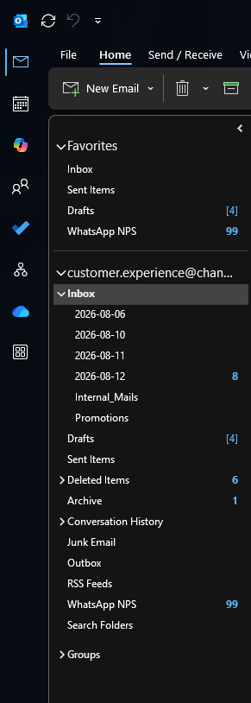
12.Output Files:
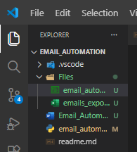
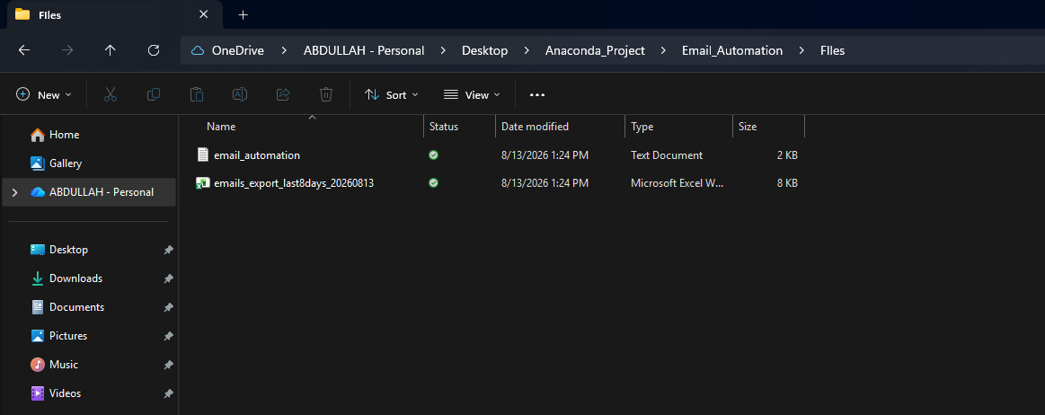
Log File :
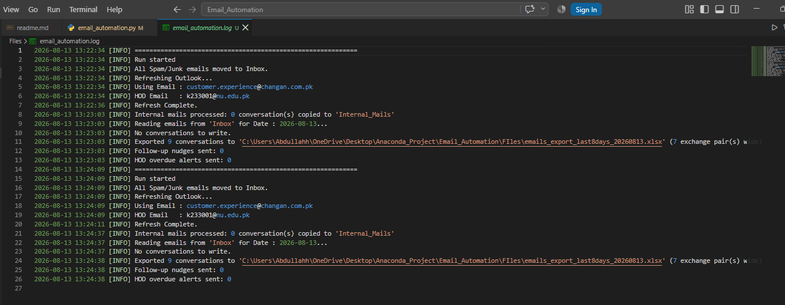
Excel File :
