PIZZA SALES SQL QUERIES

A.KPI’S :

1.Total Revenue :

select sum(total_price) as Total_Revanue from pizza_sales;

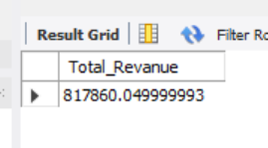

2. Average order value :

select round(sum(total_price)/count(distinct order_id),3) as avg_order_value from pizza_sales;

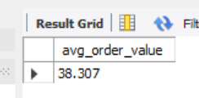

3. Total Pizza sold :

select sum(quantity) as Total_Pizza_Sold from pizza_sales;

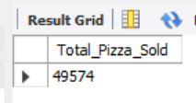

4. Total order :

select count(distinct order_id) as Total_order from pizza_sales;

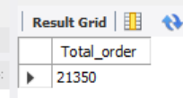

5. Average pizzas per order :

select cast(cast(sum(quantity) as decimal(10,2)) / cast(count(distinct order_id) as Decimal (10,2))

as decimal (10,2)) as Avg_pizzas_per_order from pizza_sales ;

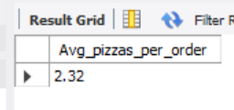

A. Daily Trend for Total Order :

SELECT

DAYNAME(STR_TO_DATE(order_date, '%d-%m-%Y')) AS order_day,

COUNT(DISTINCT order_id) AS total_order

FROM pizza_sales

GROUP BY DAYOFWEEK(STR_TO_DATE(order_date, '%d-%m-%Y')),

DAYNAME(STR_TO_DATE(order_date, '%d-%m-%Y'))

ORDER BY DAYOFWEEK(STR_TO_DATE(order_date, '%d-%m-%Y'));

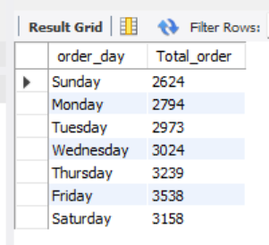

B. Monthly Trend for Total Order :

select monthname(STR_TO_DATE(order_date, '%d-%m-%Y')) AS Months,

count(distinct order_id) Total_order from pizza_sales

group by months, month(STR_TO_DATE(order_date, '%d-%m-%Y'))

order by month(STR_TO_DATE(order_date, '%d-%m-%Y')) ;

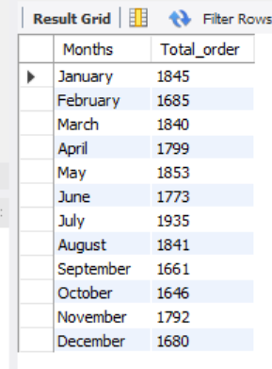

C. Percentage of sales by pizza category

select pizza_category ,sum(total_price) as Total_sales,

((sum(total_price) * 100 )/ (select sum(total_price) from pizza_sales)) as PCT

from pizza_sales group by pizza_category;

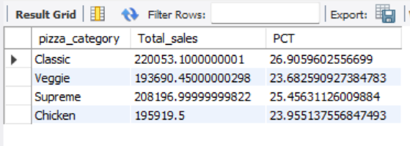

D. Percentage of sales by Pizza size :

select pizza_size, round(SUM(total_price),2) as Total_Revenue,

round((round(sum(total_price),2) * 100) / (select round(sum(total_price),2) from pizza_sales) ,2 ) PCT

from pizza_sales group by pizza_size;

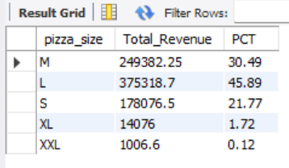

E. Top 5 best Pizzas by Revenue

select pizza_name,

sum(total_price) Total_Revenue

from pizza_sales group by pizza_name

order by Total_Revenue desc limit 5;

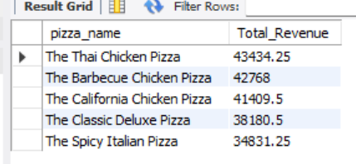

F. Top 5 best Pizzas by Total Quantity

select pizza_name,

sum(quantity) Total_quantity

from pizza_sales group by pizza_name

order by Total_quantity desc limit 5;

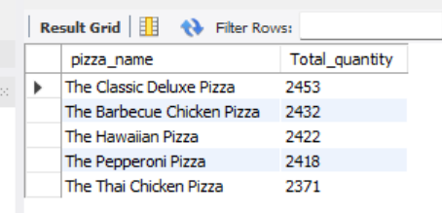

G. Top 5 best Pizzas by total order

select pizza_name,

count(distinct order_id) Total_order

from pizza_sales group by pizza_name

order by Total_order desc limit 5;

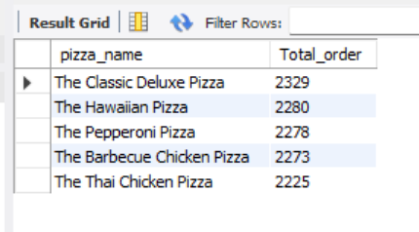

H. Bottom 5 best Pizzas by total order :

select pizza_name,

count(distinct order_id) Total_order

from pizza_sales group by pizza_name

order by Total_order limit 5;

