**DEPARTMENT OF ELECTRICAL & COMPUTER ENGINEERING**



**ASSIGNMENT #03**

**Name:** Muhammad Abdullah Javed

**Class:** BEMTS-2B

**Reg_ID:** 210760

**Instructor:** Umer Farooq

**Date Of Submission:** 11-05-2025

**Question:01**

**Code:**

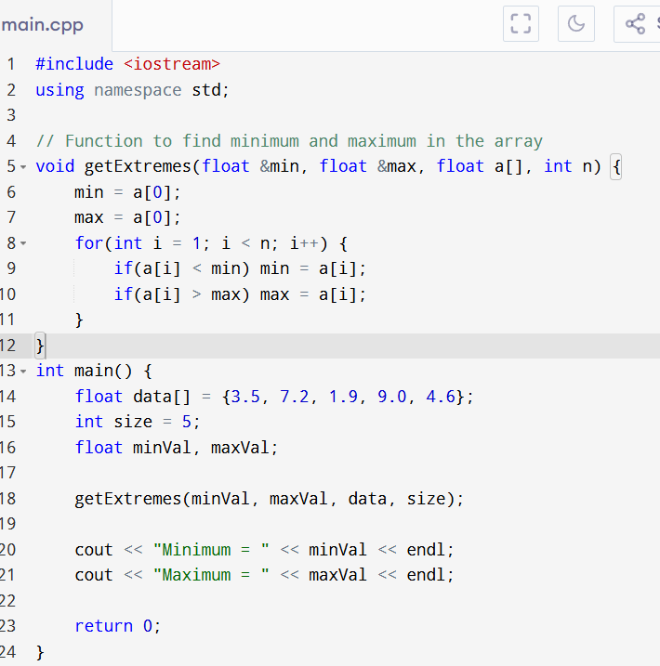

**Output:**

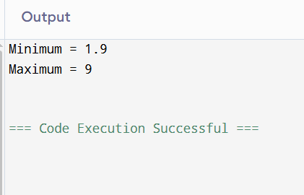

**Flowchart**

1. Start
2. Input: a[], n
3. Set min = a[0], max = a[0]
4. Loop i from 1 to n - 1:  
     If a[i] < min → set min = a[i]  
     If a[i] > max → set max = a[i]
5. End loop
6. Output min, max
7. End

**Question:02**

**Code:**

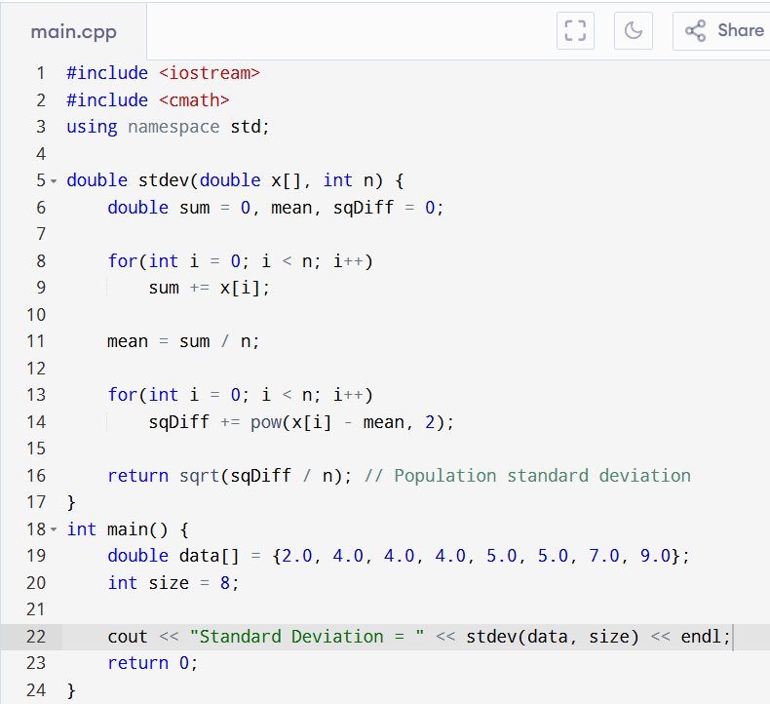

**Output:**

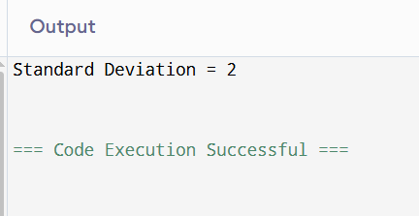

**Flowchart**

1. Start
2. Input: array x[], size n
3. Compute sum of all elements
4. Compute mean = sum / n
5. Initialize sumSquaredDiff = 0
6. Loop i = 0 to n-1:  
     → sumSquaredDiff += (x[i] - mean)^2
7. Standard deviation = sqrt(sumSquaredDiff / n)
8. Return result
9. End

**Question:03**

**Code:**

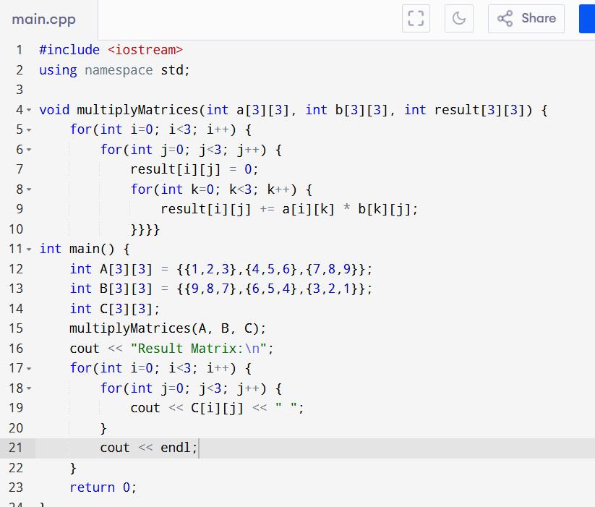

**Output:**

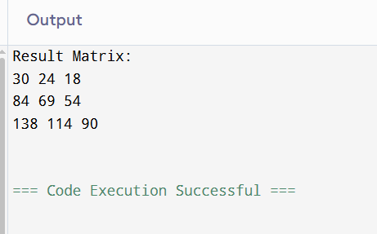

**Flowchart**

1. Start
2. Input: Matrix A and Matrix B
3. Initialize Matrix C[3][3] to zeros
4. For i = 0 to 2:  
      For j = 0 to 2:  
        C[i][j] = 0  
        For k = 0 to 2:  
         C[i][j] += A[i][k] × B[k][j]
5. End loop
6. Output Matrix C
7. End

**Question:04**

**Code:**

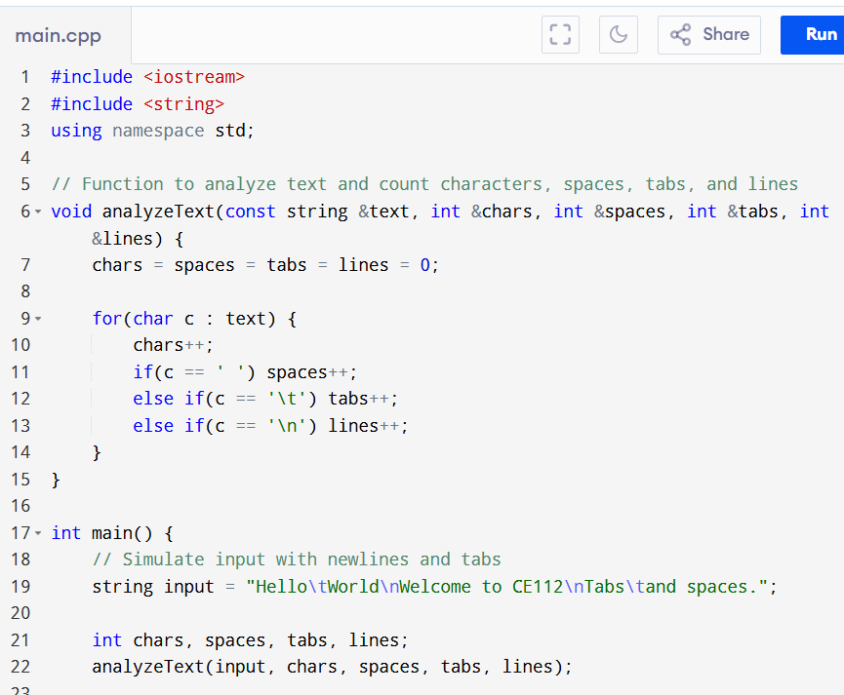

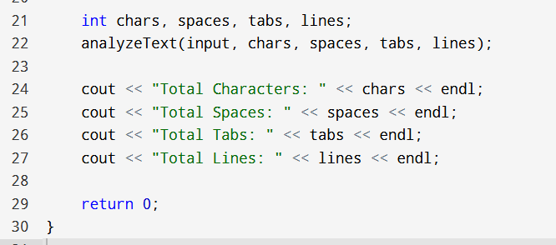

**Output:**

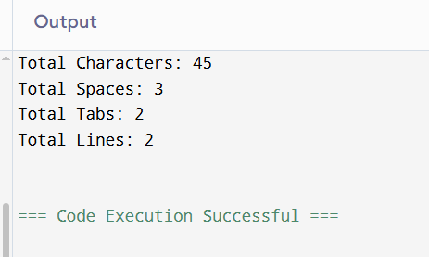

**Flowchart**

1. Start
2. Input a multiline string from the user
3. Initialize chars, spaces, tabs, lines to 0
4. For each character c in the string:  
     → Increment chars  
     → If c == ' ' → increment spaces  
     → If c == '\t' → increment tabs  
     → If c == '\n' → increment lines
5. Display all counts
6. End

**Question:05**

**Code:**

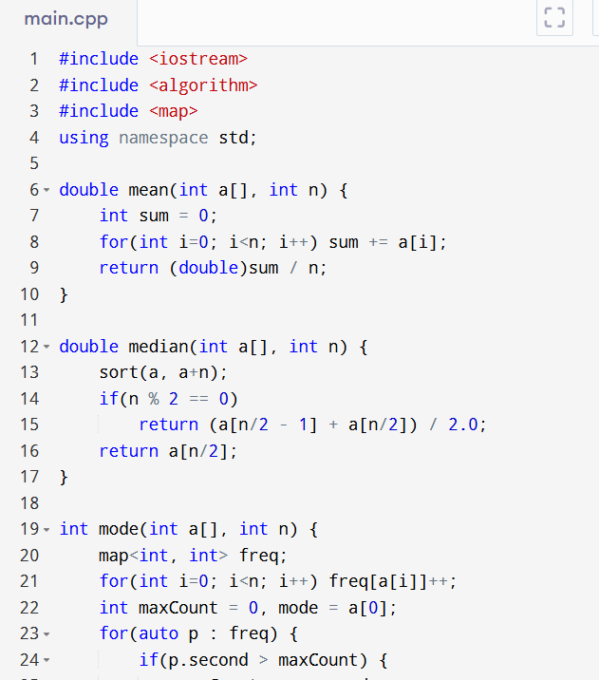

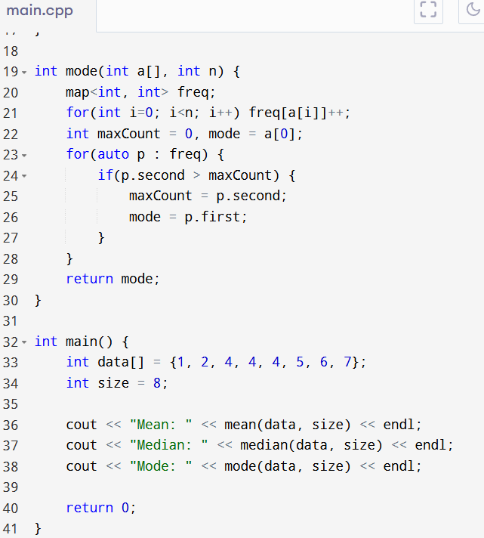

**Output:**

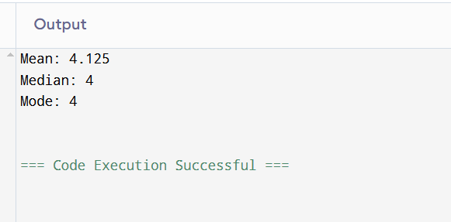

**Flowchart**

1. Start
2. Input: array a[], size n
3. Calculate mean: sum / n
4. Sort array
5. Calculate median:  
     → If n is odd: middle element  
     → If n is even: avg of two middle elements
6. Count frequency of each number
7. The number with highest frequency = mode
8. Output all three results

**Question:06**

**Code:**

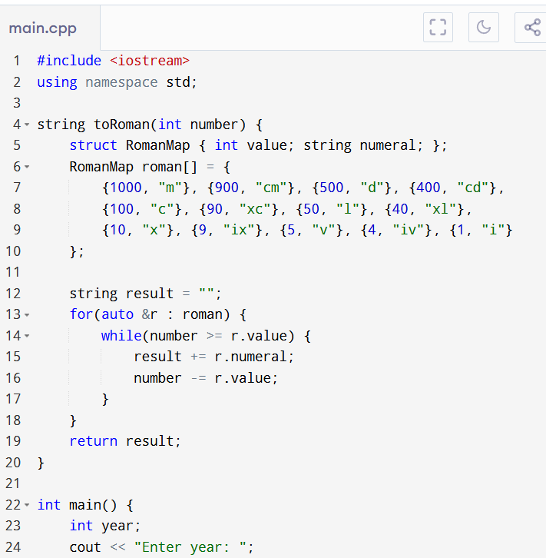

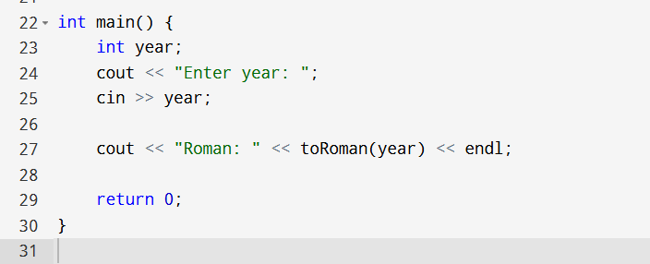

**Output:**

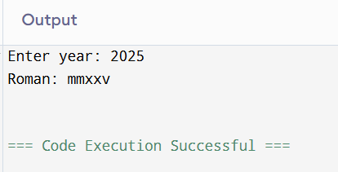

**Flowchart**

1. Start
2. Input: year
3. Define arrays of decimal values and matching Roman strings
4. Initialize result string = ""
5. Loop through decimal values:  
     → While year ≥ value[i]:  
       → Append roman[i] to result  
       → year -= value[i]
6. Output Roman numeral
7. End