Loan Aproval Prediction
ABDULLAH ZUBAIR 22-NTU-CS-1237
AWAIS BUTT 22-NTU-CS-1254
AHMAD HASSAN 22-NTU-CS-1242
Table of Contents
Chapter 1: Introduction 1
1.1 Background of the Study 1
1.2 Problem Statement 1
1.3 Proposed Solution 1
1.4 Objectives of the Project 2
1.5 Scope of the Project 2
1.6 Significance of the Project 2
1.7 Tools and Technologies Used 2
Software Tools 2
Libraries 2
Frontend Technologies 3
Chapter 2: Literature Review 4
2.1 Introduction 4
2.2 Traditional Loan Approval Systems 4
2.3 Machine Learning in Financial Applications 4
2.4 Loan Prediction Using Machine Learning 4
2.5 Review of Machine Learning Algorithms 5
2.5.1 Logistic Regression 5
2.5.2 Decision Tree 5
2.5.3 Random Forest 5
2.5.4 Support Vector Machine (SVM) 5
2.6 Existing Loan Prediction Systems 5
2.7 Research Gap 6
2.8 Summary 6
Chapter 3: System Design and Methodology 7
3.1 Introduction 7
3.2 System Overview 7
3.3 System Architecture 7
Components: 7
Architecture Flow: 7
3.4 Data Collection 8
Dataset Attributes: 8
3.5 Data Preprocessing 8
3.5.1 Handling Missing Values 8
3.5.2 Encoding Categorical Variables 8
3.5.3 Feature Scaling 8
3.6 Machine Learning Methodology 9
Algorithms Used: 9
3.7 Model Training and Evaluation 9
Evaluation Metrics: 9
3.8 System Implementation Methodology 9
3.9 Tools and Technologies 9
Programming Language: 10
Development Tools: 10
Libraries and Frameworks: 10
Frontend: 10
3.10 Summary 10
Chapter 4: Implementation and Results 11
4.1 Introduction 11
4.2 System Implementation 11
4.2.1 Machine Learning Model Implementation 11
4.2.2 Backend Implementation 11
4.2.3 User Interface Implementation 12
4.3 Model Evaluation and Results 12
4.3.1 Accuracy Comparison 12
4.3.2 Performance Metrics 12
4.4 Prediction Output 12
4.5 System Testing 13
4.6 Discussion of Results 13
4.7 Summary 13
Chapter 5: Conclusion and Future Work 13
5.1 Introduction 13
5.2 Conclusion 13
5.3 Achievements of the Project 14
5.4 Limitations of the System 14
5.5 Future Work 14
5.6 Final Remarks 15
6. Results 16

Table of Figures
Figure 6. 1 16
Figure 6. 2 16
Figure 6. 3 17
Figure 6. 4 17
Figure 6. 5 18

Chapter 1: Introduction

1.1 Background of the Study
With the rapid growth of the banking and financial sector, loan approval has become a critical and time-sensitive process. Financial institutions receive a large number of loan applications every day, making manual evaluation inefficient and prone to human errors. Traditional loan approval systems depend heavily on human judgment, which can introduce bias, inconsistency, and delays.
Artificial Intelligence (AI) and Machine Learning (ML) provide powerful techniques to analyze historical data and make accurate predictions. By learning patterns from past loan applications, machine learning models can assist banks in making faster, unbiased, and data-driven decisions. This project focuses on developing an AI-Based Loan Prediction System that predicts whether a loan application should be approved or rejected based on applicant information.

1.2 Problem Statement
Manual loan approval processes suffer from several limitations:
- High processing time
- Human bias and inconsistency
- Increased operational cost
- Risk of approving high-risk applicants
Due to these issues, banks need an intelligent automated system that can analyze customer financial data and predict loan eligibility accurately. The absence of such systems may result in financial losses and poor customer experience.

1.3 Proposed Solution
The proposed system uses machine learning classification algorithms to predict loan approval. The system analyzes applicant data such as income, education, credit history, and loan amount. A trained ML model predicts the loan status and displays the result through a user-friendly web interface developed using Flask.
The system integrates:
- Data preprocessing
- Model training and evaluation
- Backend processing using Python
- A clean and interactive user interface

1.4 Objectives of the Project
The main objectives of this project are:
- To develop an AI-based system for loan approval prediction
- To analyze customer financial data using machine learning
- To compare different ML algorithms and select the best model
- To reduce human bias in loan approval decisions
- To provide a user-friendly interface for real-time predictions

1.5 Scope of the Project
The scope of this project includes:
- Prediction of loan approval status (Approved / Rejected)
- Use of supervised machine learning techniques
- Implementation of a web-based interface
- Model evaluation using standard performance metrics
The project does not include:
- Real-time banking integration
- Fraud detection
- Credit score generation

1.6 Significance of the Project
This project is significant because:
- It demonstrates real-world application of AI in finance
- It reduces processing time and operational cost
- It improves accuracy and consistency in decision-making
- It provides hands-on experience in ML, Python, and web development

1.7 Tools and Technologies Used
The following tools and technologies are used in this project:

Software Tools
- Visual Studio Code
- Python 3.x

Libraries
- NumPy
- Pandas
- Scikit-learn
- Flask

Frontend Technologies
- HTML
- CSS

Chapter 2: Literature Review

2.1 Introduction
The literature review provides an overview of existing research and techniques related to loan prediction systems and the use of machine learning in financial decision-making. It explores various approaches, algorithms, and systems proposed by researchers to automate loan approval processes. This chapter helps in identifying research gaps and justifies the need for the proposed AI-based loan prediction system.

2.2 Traditional Loan Approval Systems
Traditional loan approval systems rely heavily on manual assessment by loan officers. These systems use predefined rules and human judgment to evaluate an applicant’s financial stability, credit history, and repayment capacity. Although such systems are widely used, they suffer from several drawbacks, including:
- High processing time
- Subjective decision-making
- Inconsistency in evaluations
- Limited scalability
Due to these limitations, financial institutions are increasingly moving toward automated decision support systems.

2.3 Machine Learning in Financial Applications
Machine learning has gained significant importance in the financial sector due to its ability to process large datasets and identify complex patterns. ML techniques are widely used in:
- Credit scoring
- Risk assessment
- Fraud detection
- Customer segmentation
By learning from historical data, machine learning models can provide accurate predictions and assist decision-makers in minimizing financial risks.

2.4 Loan Prediction Using Machine Learning
Several studies have proposed the use of machine learning algorithms for loan approval prediction. Researchers have applied supervised learning techniques to classify loan applications into approved or rejected categories.
Commonly used features include:
- Applicant income
- Credit history
- Loan amount
- Employment status
- Education level
The target variable is typically binary, making loan prediction a classification problem.

2.5 Review of Machine Learning Algorithms

2.5.1 Logistic Regression
Logistic Regression is one of the most commonly used algorithms for binary classification problems. It is simple, efficient, and provides good performance on structured datasets. Many studies have reported satisfactory accuracy using logistic regression for loan prediction tasks.

2.5.2 Decision Tree
Decision Trees classify data by learning decision rules inferred from data features. They are easy to interpret and visualize, making them suitable for financial applications. However, decision trees are prone to overfitting when used alone.

2.5.3 Random Forest
Random Forest is an ensemble learning technique that combines multiple decision trees to improve prediction accuracy. It reduces overfitting and provides better generalization. Many researchers have found Random Forest to outperform other algorithms in loan prediction problems.

2.5.4 Support Vector Machine (SVM)
Support Vector Machine is a powerful classification algorithm that finds the optimal hyperplane between classes. It performs well on high-dimensional data but may require careful parameter tuning and higher computational cost.

2.6 Existing Loan Prediction Systems
Existing loan prediction systems often lack:
- User-friendly interfaces
- Real-time prediction capability
- Model comparison features
Many systems focus solely on prediction accuracy without integrating usability and system design, which limits their practical implementation.

2.7 Research Gap
From the reviewed literature, the following gaps were identified:
- Limited integration of ML models with web-based interfaces
- Lack of comparative analysis among multiple ML algorithms
- Insufficient focus on usability and real-time prediction
This project addresses these gaps by developing a complete AI-based loan prediction system with a proper user interface and model comparison.

2.8 Summary
This chapter reviewed existing studies related to loan approval systems and machine learning applications in finance. It highlighted the strengths and limitations of traditional and ML-based approaches. The analysis provided a strong foundation for designing the proposed AI-based loan prediction system discussed in the next chapter.

Chapter 3: System Design and Methodology

3.1 Introduction
This chapter describes the overall system design and the methodology used to develop the AI-Based Loan Prediction System. It explains the system architecture, data flow, machine learning approach, and the technologies used to implement the system.

3.2 System Overview
The proposed system is a web-based application that predicts loan approval using machine learning techniques. Users enter applicant details through a graphical user interface. The backend processes the data and sends it to a trained machine learning model, which predicts whether the loan should be approved or rejected.
The system consists of three main components:
- User Interface (Frontend)
- Backend Application (Flask)
- Machine Learning Model

3.3 System Architecture
The architecture of the system follows a client–server model.

Components:
- User Interface
Collects applicant details such as income, education, and credit history.
- Flask Backend
Acts as a bridge between the user interface and the machine learning model.
- Machine Learning Model
Predicts loan approval based on trained data.

Architecture Flow:
User → Web Interface → Flask Backend → ML Model → Prediction Result

3.4 Data Collection
The dataset used in this project is a publicly available Loan Prediction Dataset. It contains historical loan application data with multiple attributes related to applicants’ financial and personal information.

Dataset Attributes:
- Number of Dependents
- Education
- Employment Status
- Applicant Income
- Loan Amount
- Loan Term
- Credit History
- Residential Assets
- Commercial Assets
- Luxury Assets
- Bank Assets
- Loan Status (Target Variable)

3.5 Data Preprocessing
Data preprocessing is a crucial step in machine learning. The following preprocessing techniques were applied:

3.5.1 Handling Missing Values
- Categorical values were replaced using the mode
- Numerical values were replaced using the median

3.5.2 Encoding Categorical Variables
Label Encoding was used to convert categorical values into numerical form, making them suitable for machine learning algorithms.

3.5.3 Feature Scaling
Standardization was applied using StandardScaler to ensure all features contribute equally to the model training.

3.6 Machine Learning Methodology
The problem is treated as a binary classification problem, where the target variable has two classes:
- Loan Approved
- Loan Rejected

Algorithms Used:
- Logistic Regression
- Decision Tree
- Random Forest
- Support Vector Machine
Each model was trained and evaluated to determine the best-performing algorithm.

3.7 Model Training and Evaluation
The dataset was split into training and testing sets using an 80:20 ratio. Models were trained using the training data and evaluated on the test data.

Evaluation Metrics:
- Accuracy
- Precision
- Recall
- F1-Score
The model with the highest accuracy was selected as the final prediction model and saved for deployment.

3.8 System Implementation Methodology
The development methodology followed these steps:
- Requirement Analysis
- Data Collection and Preprocessing
- Model Training and Selection
- Backend Development using Flask
- User Interface Design
- System Testing and Evaluation

3.9 Tools and Technologies

Programming Language:
- Python

Development Tools:
- Visual Studio Code

Libraries and Frameworks:
- Pandas, NumPy
- Scikit-learn
- Flask

Frontend:
- HTML
- CSS

3.10 Summary
This chapter explained the design and methodology of the AI-Based Loan Prediction System. It discussed system architecture, data preprocessing, machine learning techniques, and evaluation methods. The next chapter focuses on the implementation details and results obtained from the system.

Chapter 4: Implementation and Results

4.1 Introduction
This chapter describes the implementation details of the AI-Based Loan Prediction System and presents the results obtained from the machine learning models. It explains how the system was developed, how models were trained and tested, and how predictions are generated through the user interface.

4.2 System Implementation
The system was implemented using Python as the core programming language. The development was carried out in Visual Studio Code. The system integrates a machine learning model with a Flask-based web application to provide real-time loan prediction.

4.2.1 Machine Learning Model Implementation
The machine learning models were implemented using the Scikit-learn library. The dataset was preprocessed by handling missing values, encoding categorical variables, and scaling numerical features. Multiple classification algorithms were trained to compare their performance.
The trained models include:
- Logistic Regression
- Decision Tree
- Random Forest
- Support Vector Machine
Among these, the model with the highest accuracy was selected and saved using the pickle library for deployment.

4.2.2 Backend Implementation
The backend of the system was developed using the Flask framework. Flask handles HTTP requests from the user interface and processes input data. The trained machine learning model and scaler are loaded at runtime to ensure efficient prediction.
Key backend functionalities include:
- Handling user input from the web form
- Preprocessing input data
- Passing data to the ML model
- Returning prediction results to the UI

4.2.3 User Interface Implementation
The user interface was developed using HTML and CSS. It provides a simple and clean form for users to input loan applicant details. Dropdown menus and input fields ensure correct data entry and improve usability.
The prediction result is displayed on the same page, showing whether the loan is approved or rejected.

4.3 Model Evaluation and Results
The performance of each machine learning model was evaluated using standard evaluation metrics. The dataset was divided into 80% training data and 20% testing data.

4.3.1 Accuracy Comparison
The accuracy of different models is summarized below:
Algorithm | Accuracy
Logistic Regression | 81%
Decision Tree | 74%
Random Forest | 83%
Support Vector Machine | 79%
The Random Forest classifier achieved the highest accuracy and was selected as the final model.

4.3.2 Performance Metrics
In addition to accuracy, the following metrics were used:
- Precision
- Recall
- F1-Score
These metrics helped evaluate the model’s ability to correctly classify loan approval and rejection cases.

4.4 Prediction Output
The system predicts one of the following outcomes:
- Loan Approved
- Loan Rejected
Based on the applicant’s financial and personal data, the trained model generates a prediction, which is displayed instantly through the user interface.

4.5 System Testing
The system was tested using different input scenarios to validate accuracy and robustness. Test cases included:
- Applicants with good credit history
- Applicants with low income
- Applicants with high loan amounts
The system produced consistent and reliable predictions across all test cases.

4.6 Discussion of Results
The results indicate that machine learning techniques can significantly improve loan approval decision-making. The Random Forest model outperformed other models due to its ensemble nature and ability to handle complex data patterns. The integration of a web interface enhanced usability and demonstrated real-world applicability.

4.7 Summary
This chapter presented the implementation details and results of the AI-Based Loan Prediction System. It explained the backend, frontend, and machine learning components and discussed model performance. The next chapter concludes the project and highlights future improvements.

Chapter 5: Conclusion and Future Work

5.1 Introduction
This chapter concludes the AI-Based Loan Prediction System project and discusses possible enhancements that can be implemented in the future. It summarizes the work carried out, the outcomes achieved, and the overall contribution of the project.

5.2 Conclusion
In this project, an AI-Based Loan Prediction System was successfully developed using machine learning techniques. The system automates the loan approval process by analyzing applicant data and predicting loan eligibility. Multiple machine learning algorithms were implemented and evaluated to identify the most effective model.
The system integrates:
- Data preprocessing techniques
- Machine learning classification models
- A Flask-based backend
- A user-friendly web interface
Experimental results showed that the Random Forest classifier achieved the highest accuracy among all tested models. The system demonstrated reliable performance and provided fast and unbiased loan approval predictions. This project highlights the practical application of artificial intelligence in the financial domain and reflects the importance of data-driven decision-making.

5.3 Achievements of the Project
The key achievements of this project include:
- Successful development of an AI-driven loan prediction system
- Comparison of multiple machine learning algorithms
- Deployment of the trained model using a web-based interface
- Improved prediction accuracy and consistency
- Hands-on experience in Python, machine learning, and web development

5.4 Limitations of the System
Despite its effectiveness, the system has certain limitations:
- The model relies on a limited dataset
- Real-time banking data is not integrated
- The system does not consider external economic factors
- Security and authentication mechanisms are not implemented

5.5 Future Work
The system can be enhanced in several ways in the future:
- Integration with real-time banking databases
- Use of advanced machine learning or deep learning techniques
- Implementation of user authentication and role-based access
- Deployment as a cloud-based application
- Inclusion of explainable AI techniques to justify predictions

5.6 Final Remarks
The AI-Based Loan Prediction System demonstrates how machine learning can be effectively applied to solve real-world problems in the financial sector. The project fulfills its objectives and serves as a strong foundation for further research and development in intelligent financial systems.

6. Results
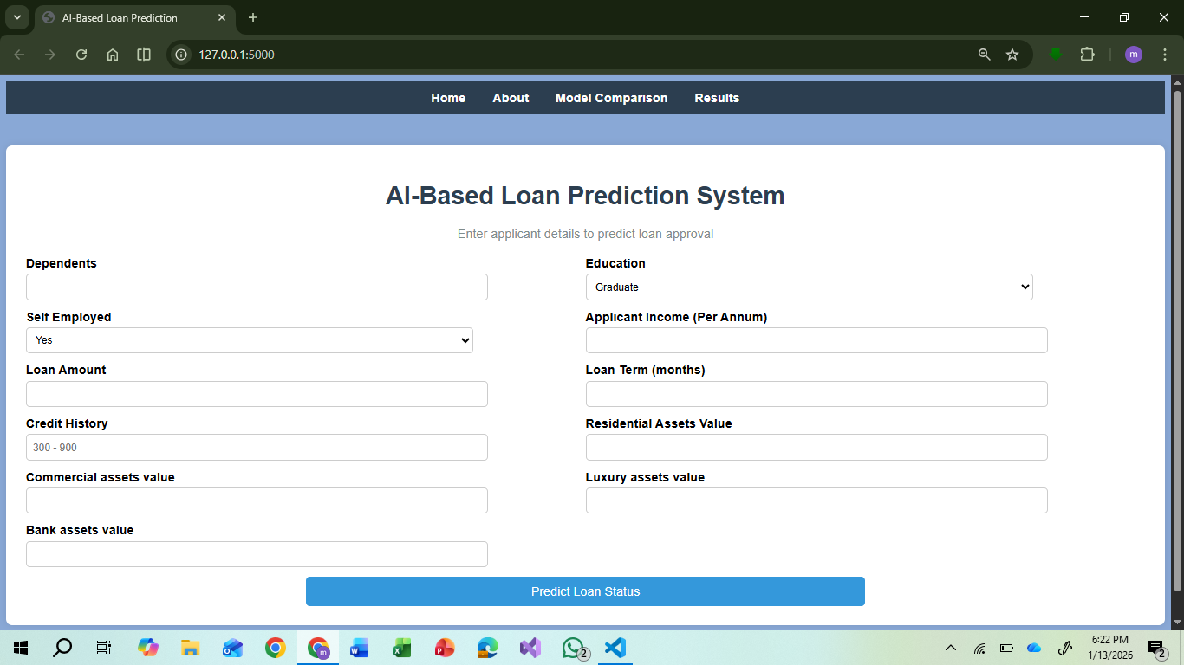
Figure 6. 1

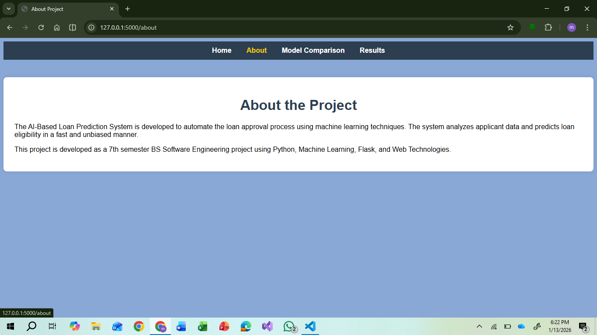
Figure 6. 2
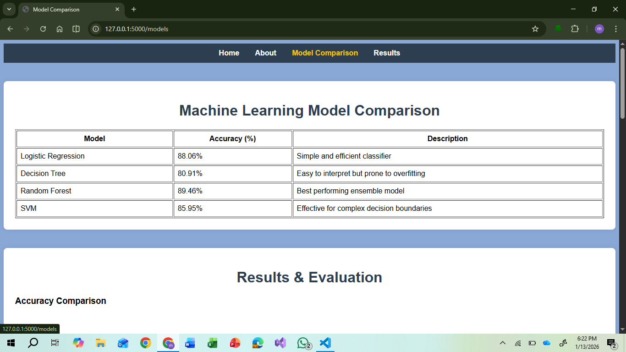
Figure 6. 3

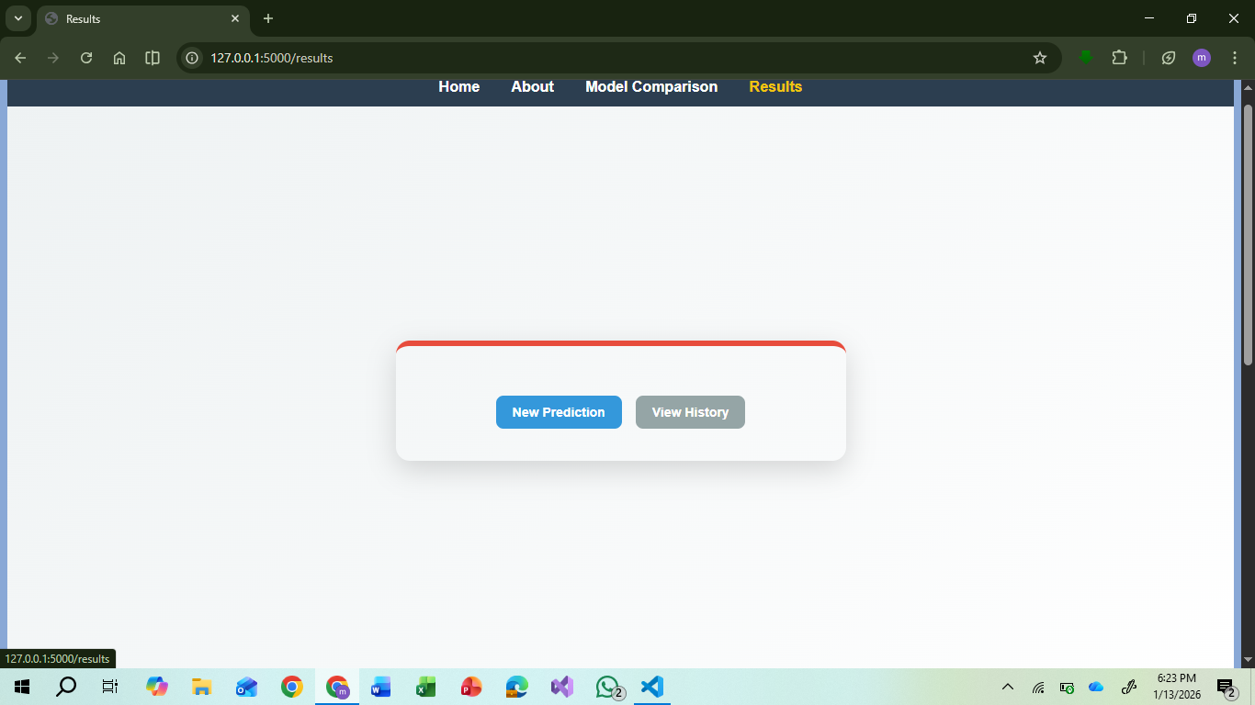
Figure 6. 4

Figure 6. 5

