Task1:

import java.util.Scanner;

public class taskOne

{

    public static *void* main(*String* *args*[])

    {

*Cylinder* cylinder1 = new Cylinder();

*Cylinder* cylinder2 = new Cylinder(10);

*Cylinder* cylinder3 = new Cylinder(6, 4);

        cylinder1.displayInfo();

        cylinder2.displayInfo();

        cylinder3.displayInfo();

    }

}

public class Cylinder

{

    private *double* radius = 7.756;

    private *double* height = 5.334;

        public Cylinder()

        {

            System.out.println("A no argument constructor");

        }

        public Cylinder(*double* *height*)

        {

            this.height = height;

            this.radius = 1;

        }

        public Cylinder(*double* *height*, *double* *radius*)

        {

            this.height = height;

            this.radius = radius;

        }

        public *void* setRadius(*double* *radius*)

        {

            this.radius = radius;

        }

        public *void* setHeight(*double* *height*)

        {

            this.height = height;

        }

        public *double* getRadius()

        {

            return radius;

        }

        public *double* getHeight()

        {

            return height;

        }

        public *double* computeArea()

        {

            return 2 \* Math.PI \* radius \* (radius + height);

        }

        public *double* computeVolume()

        {

            return Math.PI \* radius \* radius \* height;

        }

        public *void* displayInfo()

        {

            System.out.println("Cylinder Height: " + height);

            System.out.println("Cylinder Radius: " + radius);

            System.out.printf("Cylinder Area: %.3f", computeArea());

            System.out.printf("%nCylinder Volume: %.3f", computeVolume());

            System.out.println("\n");

        }

}

Output:

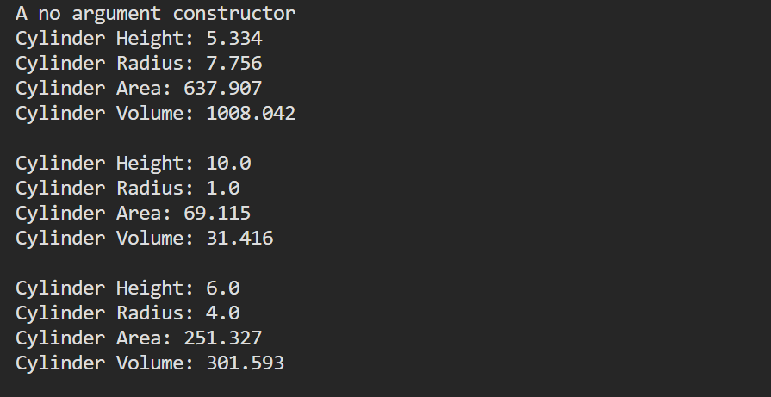

Task 2:

import java.util.Scanner;

public class taskTwo

{

    public static *void* main(*String* *args*[])

    {

*Date* d1 = new Date();

*Date* d2 = new Date(22, 9, 2023);

*Scanner* scanner = new Scanner(System.in);

        System.out.print("Enter day: ");

*int* day = scanner.nextInt();

        System.out.print("Enter month: ");

*int* month = scanner.nextInt();

        System.out.print("Enter year: ");

*int* year = scanner.nextInt();

*Date* d3 = d2;

*Date* d4 = d3;

        d3.setMonth(11);

        d1.printDate();

        d2.printDate();

        d3.printDate();

        d4.printDate();

    }

}

public class Date

{

    private *int* day;

    private *int* month;

    private *int* year;

        public Date() {

            this.day = 7;

            this.month = 10;

            this.year = 2020;

        }

        public Date(*int* *day*, *int* *month*, *int* *year*) {

            this.day = day;

            this.month = month;

            this.year = year;

        }

        public *void* printDate() {

            System.out.println(day + " / " + month + " / " + year);

        }

        public *void* setDay(*int* *day*) {

            if (day > 30) {

                day = 1;

            }

            this.day = day;

        }

        public *void* setMonth(*int* *month*) {

            if (month > 12) {

                month = 1;

            }

            this.month = month;

        }

        public *int* getDay() {

            return day;

        }

        public *int* getMonth() {

            return month;

        }

}

Output:

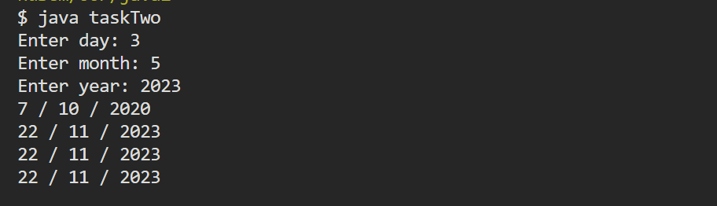

Task3:

import java.util.Scanner;

public class taskThree

{

    public static *void* main(*String* *args*[])

    {

*SavingsAccount* saver1 = new SavingsAccount(2000.00);

*SavingsAccount* saver2 = new SavingsAccount(3000.00);

        SavingsAccount.modifyInterestRate(0.03);

        saver1.calculateMonthlyInterest();

        saver2.calculateMonthlyInterest();

        System.out.println("After setting interest rate to 3%:");

        System.out.printf("Saver 1 balance: $ %.2f", saver1.getSavingsBalance());

        System.out.printf("\nSaver 2 balance: $ %.2f", saver2.getSavingsBalance());

        SavingsAccount.modifyInterestRate(0.04);

        saver1.calculateMonthlyInterest();

        saver2.calculateMonthlyInterest();

        System.out.println("\n\nAfter setting interest rate to 4%:");

        System.out.printf("Saver 1 balance: $ %.2f", saver1.getSavingsBalance());

        System.out.printf("\nSaver 2 balance: $ %.2f", saver2.getSavingsBalance());

    }

}

public class SavingsAccount {

    private static *double* annualInterestRate;

    private *double* savingsBalance;

    public SavingsAccount(*double* *savingsBalance*) {

        this.savingsBalance = savingsBalance;

    }

    public *void* calculateMonthlyInterest() {

*double* monthlyInterest = savingsBalance \* annualInterestRate / 12;

        savingsBalance += monthlyInterest;

    }

    public static *void* modifyInterestRate(*double* *newRate*) {

        annualInterestRate = newRate;

    }

    public *double* getSavingsBalance() {

        return savingsBalance;

    }

    public static *double* getAnnualInterestRate() {

        return annualInterestRate;

    }

}

Output:

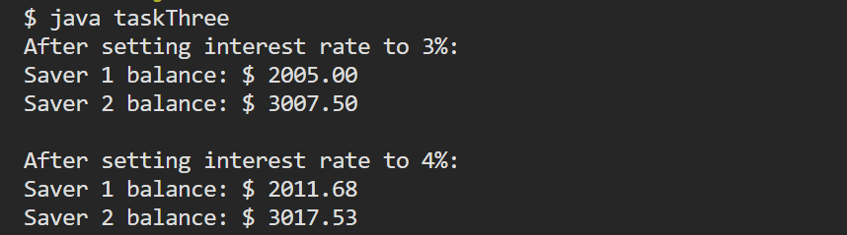

Task4:

public class GuessTheWord {

    static *int* score;

    public static *void* levelOne(*String* *word1*, *String* *word2*, *String* *word3*) {

        // Code for levelOne method

    }

}

public class GuessTheWordLevelTwo {

    public static *void* levelTwo() {

        // Code for levelTwo method

    }

}

public class GameTest {

    public static *void* main(*String*[] *args*) {

        // Code to load levelTwo based on score value

    }

}