

Faculty of Computers and Artificial Intelligence

Computer Science Department

2021/2022

**CS 395 Selected Topics in CS-1**

**Research Project**

Report Submitted for Fulfillment of the Requirements and ILO’s for Selected Topics in CS-1 course for Fall 2021

Team No. 60

|  |  |  |  |
| --- | --- | --- | --- |
|  | ID | Name | Grade |
|  | 201900261 | حسام الدين علي سيد علي |  |
|  | 201900466 | عبد الله محمد عبد الله محمود |  |
|  | 201900576 | كامل احمد كامل علي |  |
|  | 201900307 | رنا عبد الوهاب علي |  |
|  | 201900899 | نرمين ممدوح محمد السيد |  |
|  | 20180727 | محمد خير عماد محمد |  |
|  | 20180467 | محمد احمد علي عبد الحليم |  |

Delivered to:

**Dr. Wessam El-Behaidy**

**Eng. Islam Gamal**

**Eng. Muhammed Kamal**

I. NUMERICAL DATASET

1. Project Introduction

* 1. **Dataset Name**

Glacier_land_ice102

* 1. **Number of classes and their labels**

2 Classes [0: False ,1: True]

* 1. **Dataset Samples Numbers**

Number of rows in the dataset1048576 Rows

* 1. **Training, Validation and Testing**

75000 Training

25000 Testing

1. Implementation Details
   * 1. **Extracted Features**

**13 Features**:

LST

X_Coor

Y_Coor

band1

band2

band3

band4

band5

band6

band7

band8

band9

band10

* + 1. **Cross-validation:**

(Is cross-validation is used in any of implemented models? If yes, specify the number of fold and ratio of training/validation)

* + 1. **Artificial Neural Network (ANN):**
* **Hyper-parameters:**

optimizer=’adam’

batch size=60,

epochs=500

Dense

* + 1. **Support Vector Machine** **(SVM):**
* **Hyper-parameters:**

Kernel=’linear’

C=10

Gamma=’scale’

1. Models Results
   1. **ANN Results**

* **Accuracy**=0.991
* 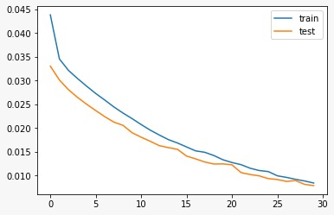**Loss curve:**
* **ROC:**

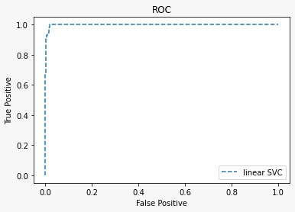

* **A screenshot of a computer

  Description automatically generated with low confidence**confusion matrix:
  1. **SVM Results:**
* **Accuracy=0.97**
* Chart

  Description automatically generated**Loss curve:**
* Chart

  Description automatically generated**ROC:**
* Chart, treemap chart

  Description automatically generatedconfusion matrix:

II. IMAGE DATASET

1. Project Introduction

* 1. **Dataset Name:**

Animal Faces

* 1. **Number of classes and their labels:**

3classes:

* Cat
* Dog
* Lion
  1. **Dataset Images Numbers and size:**

14,630 images (60 x 60)

* 1. **Training, Validation and Testing:**

10,972 Training image

3,658 Testing image

2. Implementation Details

* + 1. **Extracted Features:**
* Number of features is 3,600
* Name of feature is pixel
* Dimension of resulted features is 60x60
  + 1. **Cross-validation:**

(Is cross-validation is used in any of implemented models? If yes, specify the number of fold and ratio of training/validation)

* + 1. **Artificial Neural Network (ANN):**
* **Hyper-parameters**

optimizer=’rms’

epochs=100

* + 1. **Support Vector Machine** **(SVM)**

**Hyper-parameters**

The regularization parameter is C = 10

Kernel=’rbf’

Gamma=’scale’

3. Models Results

* 1. **ANN Results**
* **Chart

  Description automatically generatedAccuracy:**
* **Chart, histogram

  Description automatically generatedloss curve**:
* **Graphical user interface, application

  Description automatically generated**confusion matrix:
* Chart

  Description automatically generatedROC:
  1. **SVM Results**
     + **Accuracy:** **0.89**
     + 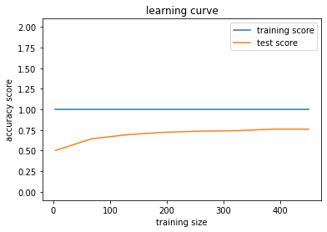**Loss Curve:**
     + 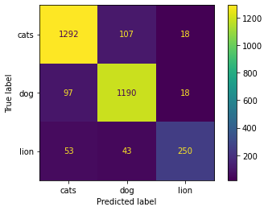Confusion Matrix:
     + 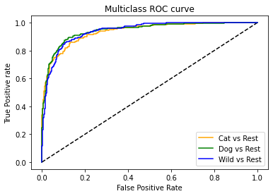ROC: