UML DIAGRAMME OF FINAL YEAR PROJECT

ACTIVITY DIAGRAMME

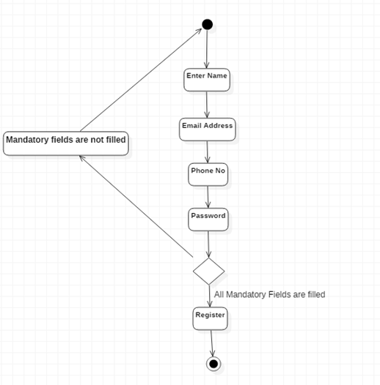

USE CASE DIAGRAMME

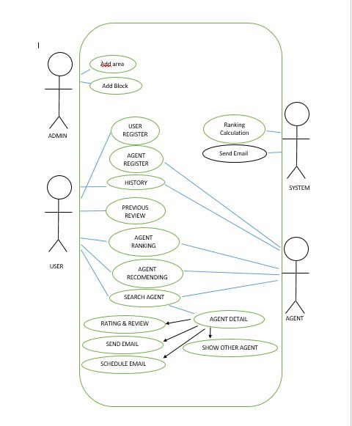

ER DIAGRAMME

