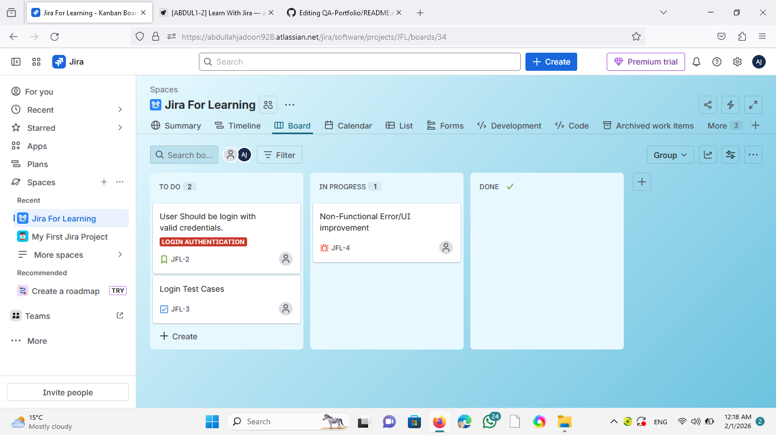
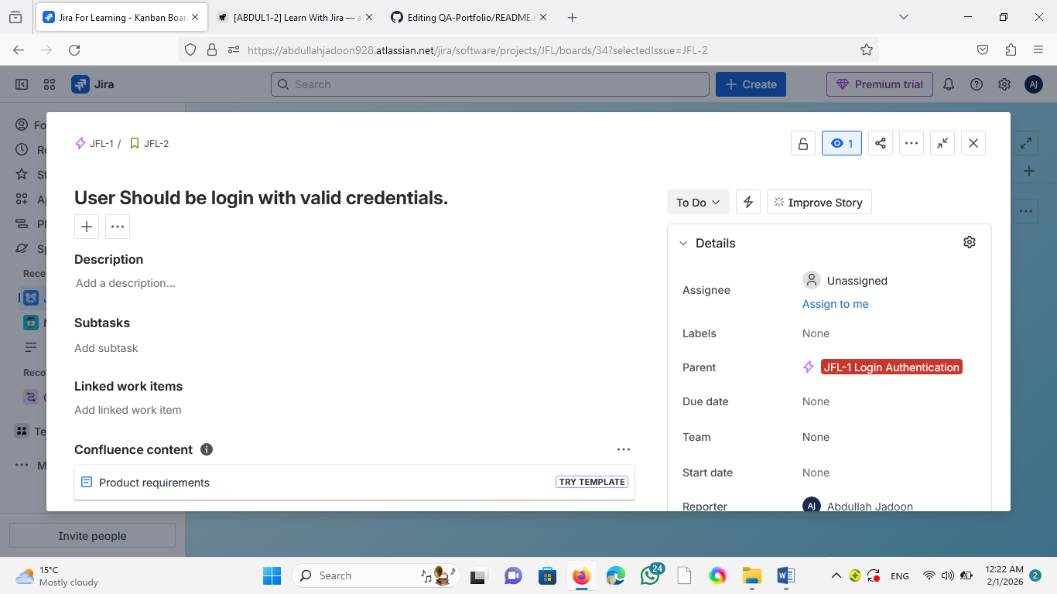
Creating Story:
Testing Login Authentication:

Creating Epic and linking it with the story
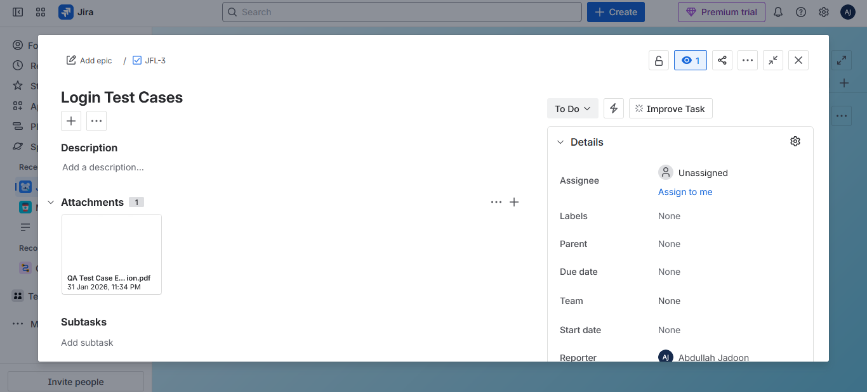
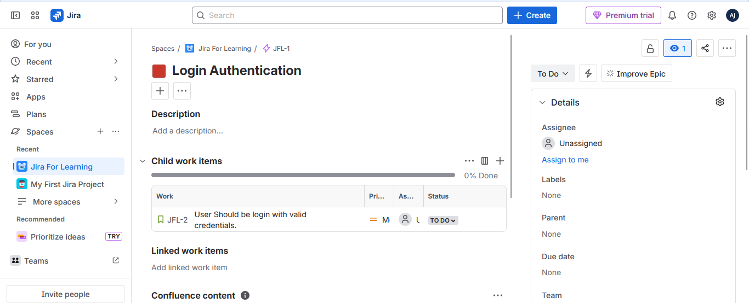
Created task with the title test case and added google sheets ( containing test cases and scenarios ) in the attachment.
Bug reporting along with screenshots of as steps to reproduce it

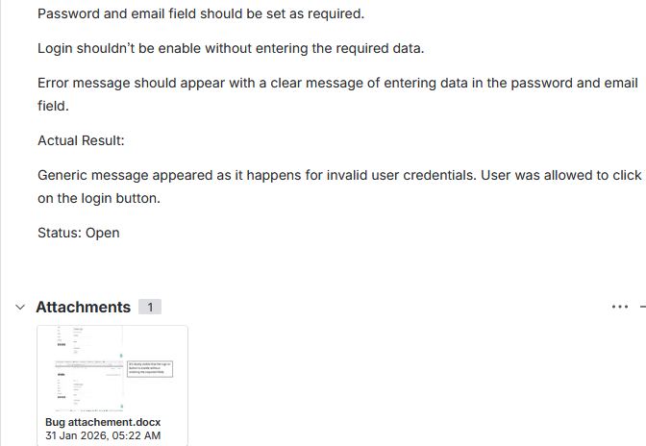
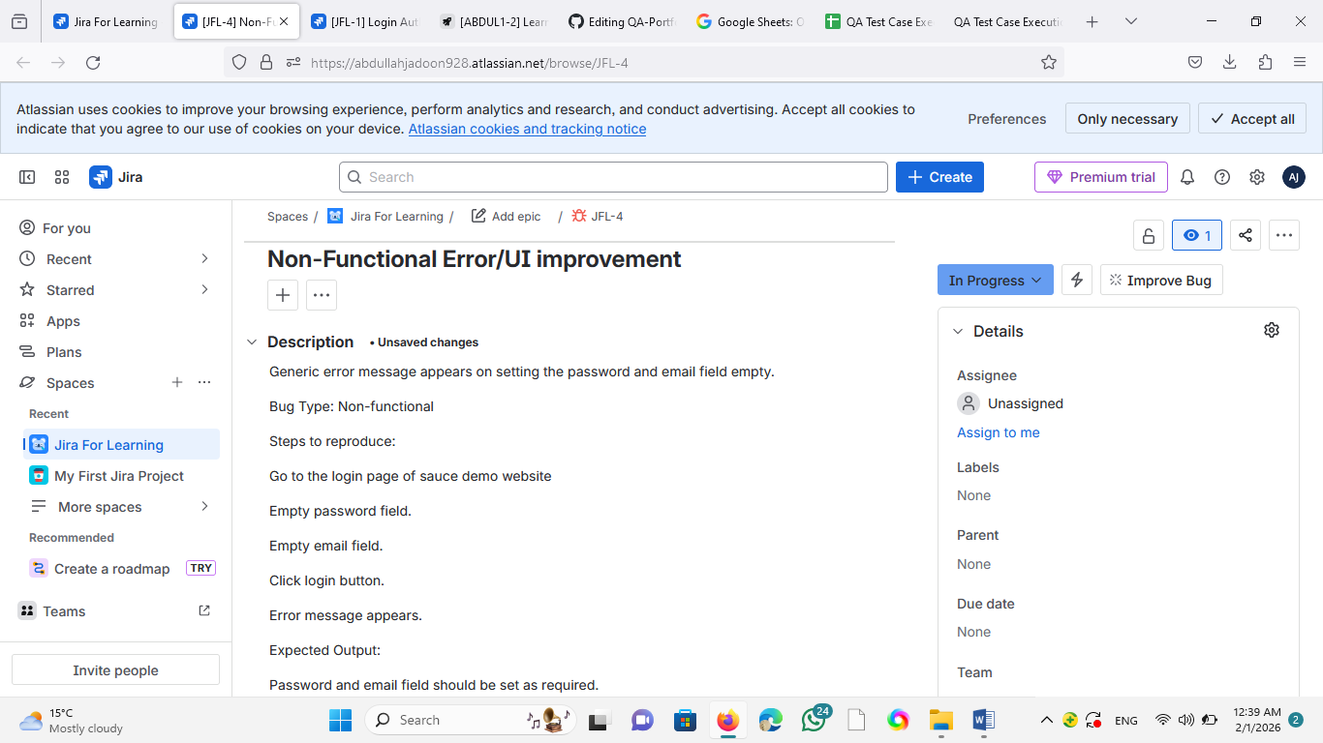
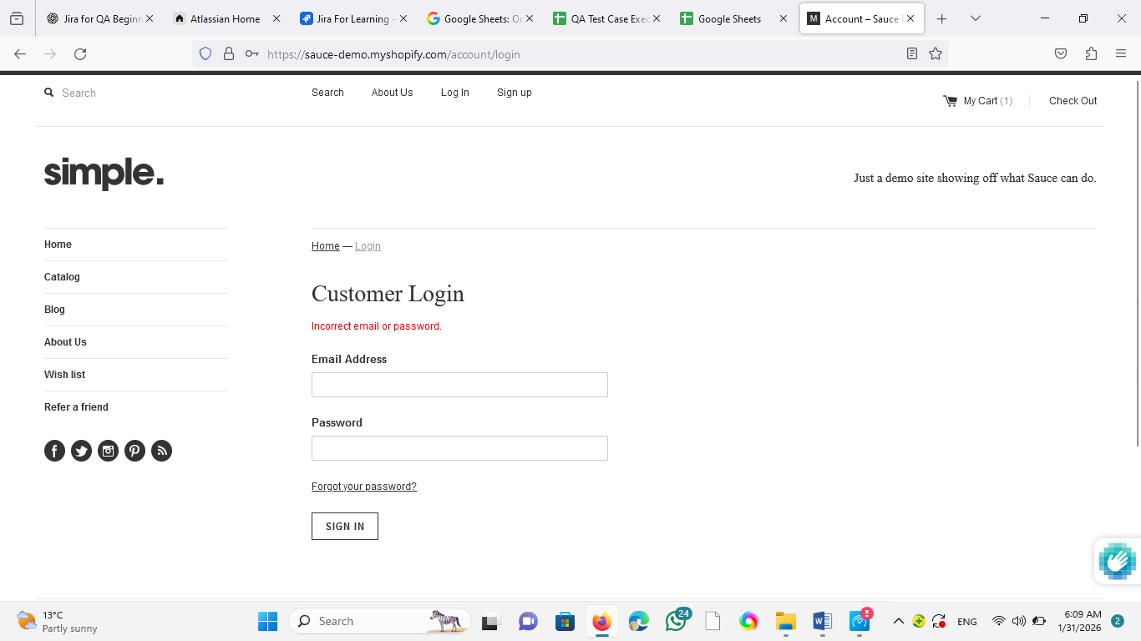
Set both password and email field empty. Both fields are not set as required.
Pictures provided as an attachment in the bug section
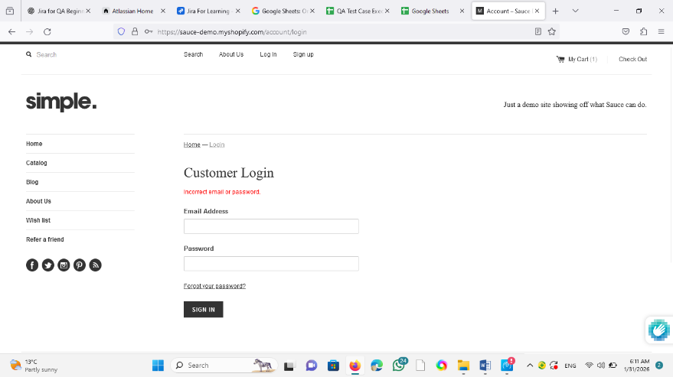
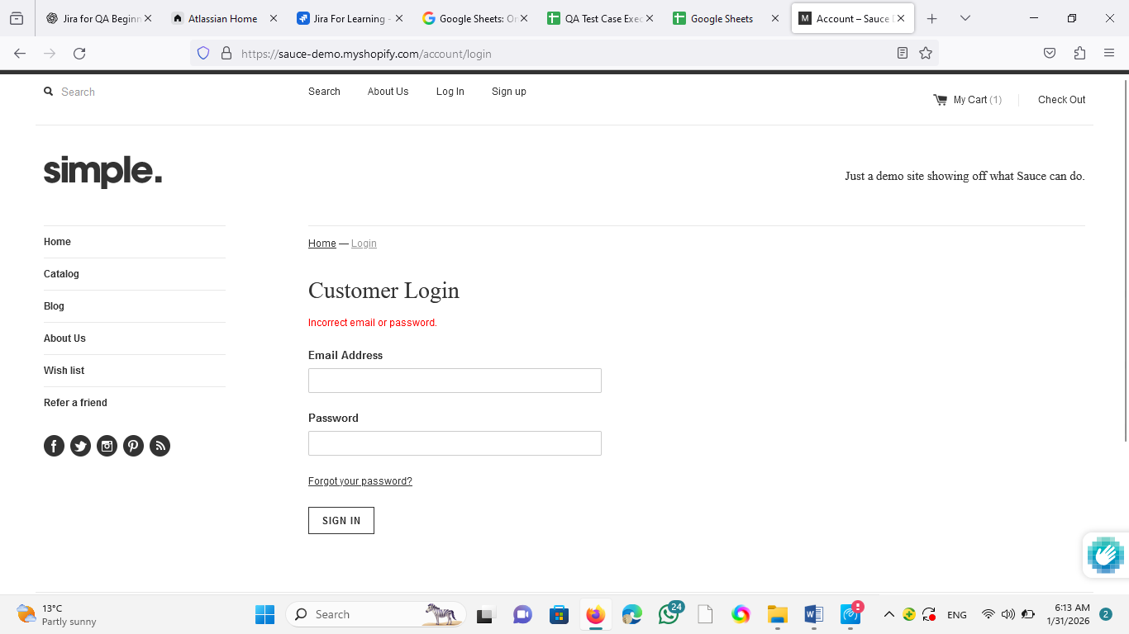
It’s clearly visible that the sign-in button is enable without entering the required fields.
Generic message appear on setting the password and email field empty.

