### JSON IN JAVASCRIPT JSON Object

**JSON Object**: A JSON object is a collection of key/value pairs. Keys are strings and should be enclosed in double quotes. Values can be strings, numbers, objects, arrays, booleans, or null.  
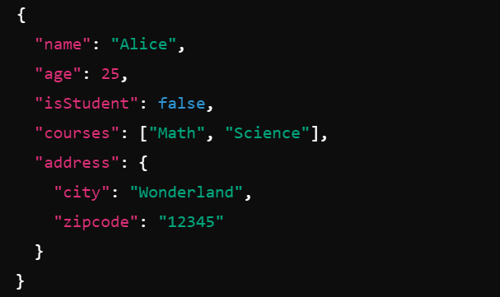

Breakdown:

1. **"name": "Alice"** - A key/value pair where the key is "name" and the value is "Alice", a string.
2. **"age": 25** - A key/value pair where the key is "age" and the value is 25, a number.
3. **"isStudent":** false - A key/value pair where the key is "isStudent" and the value is false, a boolean.
4. **"courses":** ["Math", "Science"] - A key/value pair where the key is "courses" and the value is an array containing two strings, "Math" and "Science".

### 

### Question

Given an array of objects representing students, print each student's name and grade.

### Step-by-Step Description

#### Step 1: Define the Array of Objects

First, we need to define an array that contains multiple objects. Each object represents a student with name and grade properties.

### students is an array.

### Each element in the array is an object.

#### Each object has two properties: name (a string) and grade (a number). Step 2: Iterate Over the Array

To iterate over the array and access each object (student), we can use the forEach method, which is a built-in array method in JavaScript.

### forEach is a method that executes a provided function once for each array element.

#### student is a parameter that represents the current element (object) being processed in the array. Step 3: Access and Print the Properties

Within the forEach method, we access the name and grade properties of each student object and print them using console.log.

* student.name accesses the name property of the current student object.
* student.grade accesses the grade property of the current student object.
* ${student.name}: ${student.grade} is a template literal that formats the string to include the student's name and grade.

### Full Example Code

### Example 2: Filtering an Array of Objects

**Question:** Filter the students who scored above 90.

### Step-by-Step Description

#### Step 1: Define the Array of Objects

We start with an array of student objects, each containing a name and grade property:  
  
  
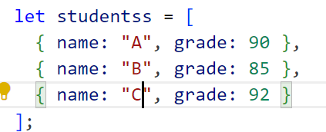

• students is an array containing three objects.

#### • Each object represents a student with name (a string) and grade (a number) Step 2: Use the filter Method

To filter the students who scored above 90, we use the filter method. This method creates a new array with all elements that pass the test implemented by the provided function.

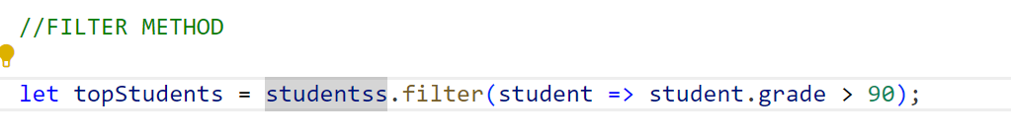• filter is a method that takes a callback function as its argument.

• The callback function is called for each element in the array.

#### • student represents the current element (an object) being processed. Step 3: Define the Filtering Condition

The callback function checks if the grade property of each student object is greater than 90:

### 