## ****What is PHP?****

**PHP (Hypertext Preprocessor) is a popular open-source scripting language** designed for web development. It is primarily used for creating dynamic web pages and applications that interact with databases. PHP runs on the server-side, meaning it executes code on the server before sending the output (HTML) to the client’s browser.

## ****Why Use PHP?****

1. **Server-Side Execution** – PHP processes data on the server before sending output to the user.
2. **Database Integration** – It easily connects with databases like MySQL, PostgreSQL, and MongoDB.
3. **Open Source & Free** – PHP is free to use, making it cost-effective for developers.
4. **Cross-Platform Compatibility** – It runs on multiple operating systems like Windows, Linux, and macOS.
5. **Strong Community Support** – Large community with plenty of resources, tutorials, and frameworks (Laravel, CodeIgniter, etc.).
6. **CMS & E-commerce Support** – PHP powers WordPress, Magento, Joomla, and other content management systems.
7. **Security Features** – It has built-in security functions to prevent SQL injection and cross-site scripting (XSS).

## ****When is PHP Used?****

PHP is widely used for:  
 **Dynamic websites and web applications  
 Server-side scripting and backend development  
 Database-driven applications (e.g., login systems, user authentication)  
 E-commerce platforms (e.g., Shopify, WooCommerce)  
  
Step 1: PHP Basics - How to Start?**

To begin with PHP, follow these steps carefully:

## ****Install Required Software****

You need the following tools to run PHP:  
✅ **XAMPP** (Recommended) – Contains Apache (server) & MySQL  
✅ **VS Code or Sublime Text** – For writing PHP code  
✅ **Web Browser** – Chrome, Firefox, or Edge

**Download XAMPP:** **https://www.apachefriends.org/download.html**

## ****Setup Your First PHP Project****

### **Step 1: Install & Start XAMPP**

* Install XAMPP and open **XAMPP Control Panel**
* Start **Apache** (for PHP) & **MySQL** (for databases)  
    
  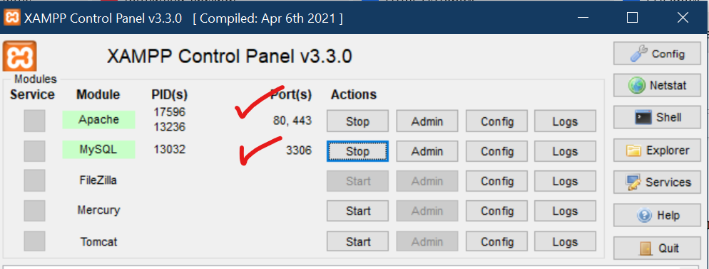

### **Step 2: Create a PHP File**

* Go to C:**\xampp\htdocs\ (on Windows) or /opt/lampp/htdocs/ (on Linux)**
* Create a new folder, e.g., **myphpapp**
* Inside it, create a file: **index.php**