**PHP Superglobals – Complete Guide with Real-Time Examples**Superglobals are **built-in PHP variables** that provide access to global data **from any part of the script**. These include:

**$_GET –** Retrieves data sent via the **URL** (Query Parameters)

**$_POST –** Retrieves data sent via a **Form Submission**

**$_SESSION –** Stores user data **temporarily** across multiple pages

## **$_COOKIE –** Stores user data ****permanently**** in the browser ****1. PHP**** $_GET ****Superglobal****

**$_GET** is used to collect data sent via the **URL parameters** (Query String).

### **How it Works?**

The data is **visible** in the URL.

## It is used for sending ****small**** and ****non-sensitive**** data ****2. PHP**** $_POST ****Superglobal****

$_POST is used to collect data from an **HTML form** using the POST method.

Data **is not visible** in the URL.

## It is used for ****sensitive**** information (e.g., Passwords). ****3. PHP**** $_SESSION ****Superglobal****

$_SESSION is used to store **user-specific** data across multiple pages **until the browser is closed** or session is destroyed.

### **How it Works?**

Data is stored on the **server**.

## Requires session_start() at the beginning of each page. ****4. PHP**** $_COOKIE ****Superglobal****

$_COOKIE is used to store user data in the **browser** for a specified period.

### **How it Works?**

The data is stored on the **user's device**.

Cookies **remain** even after the browser is closed.

**“PROJECT STRUCTURE”**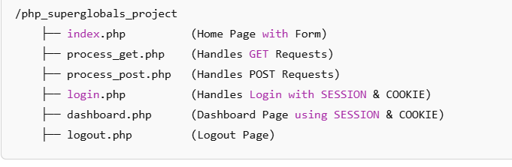

This page has a **form** for both GET and POST methods.  
  
Index.php  
  
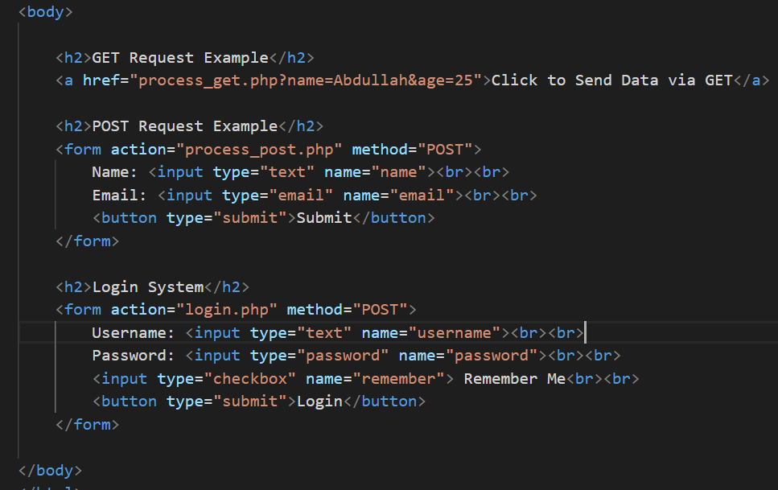  
  
**PROCESS.GET.php**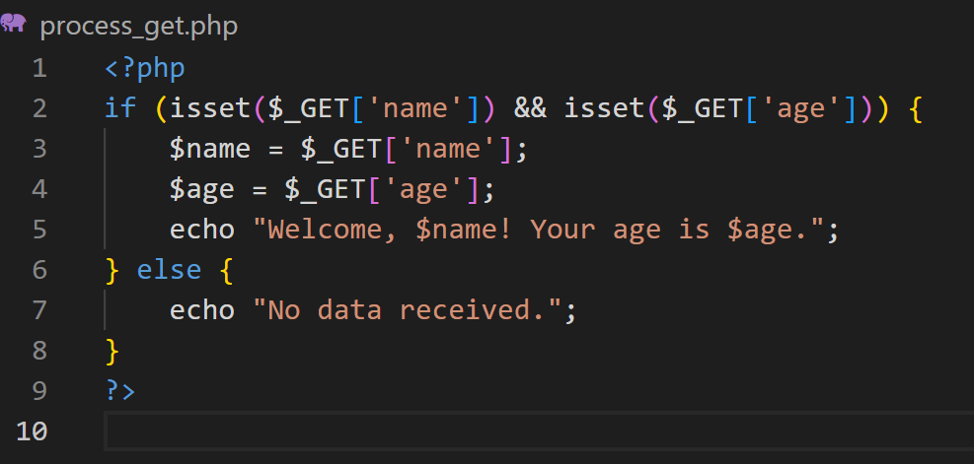  
  
  
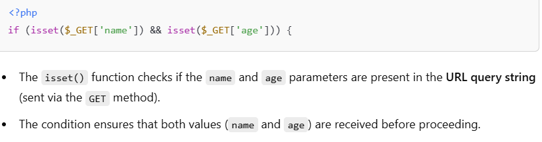

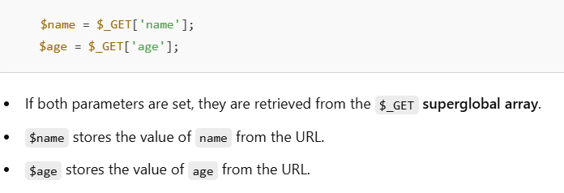  
  
  
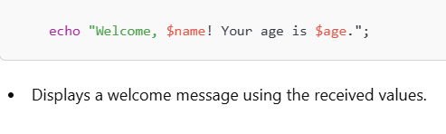  
  
**PROCESS_POST.php**

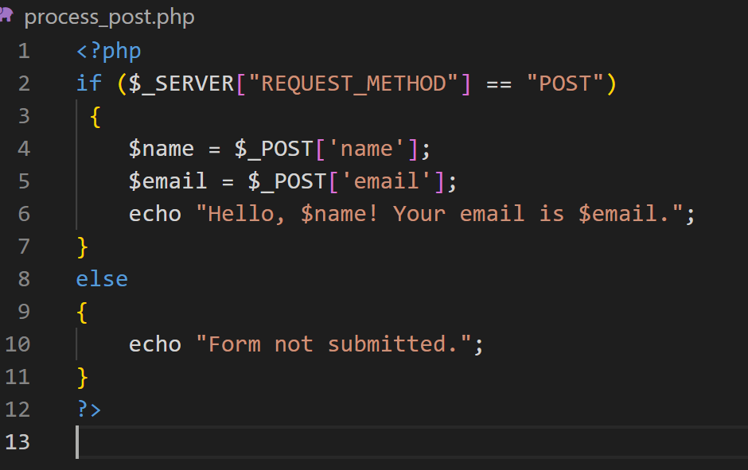  
  
  
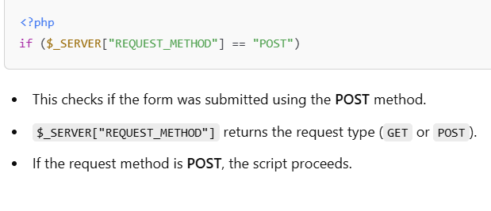  
  
  
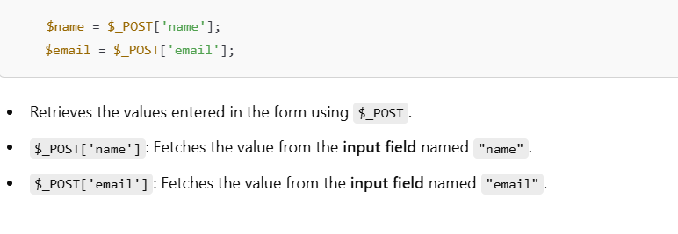

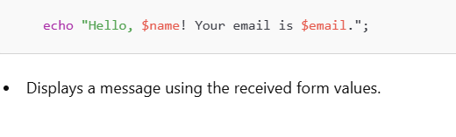  
  
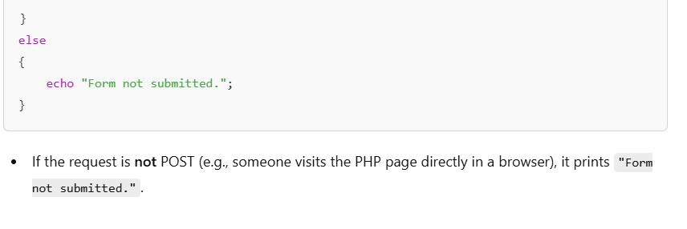  
  
**LOGIN.PHP**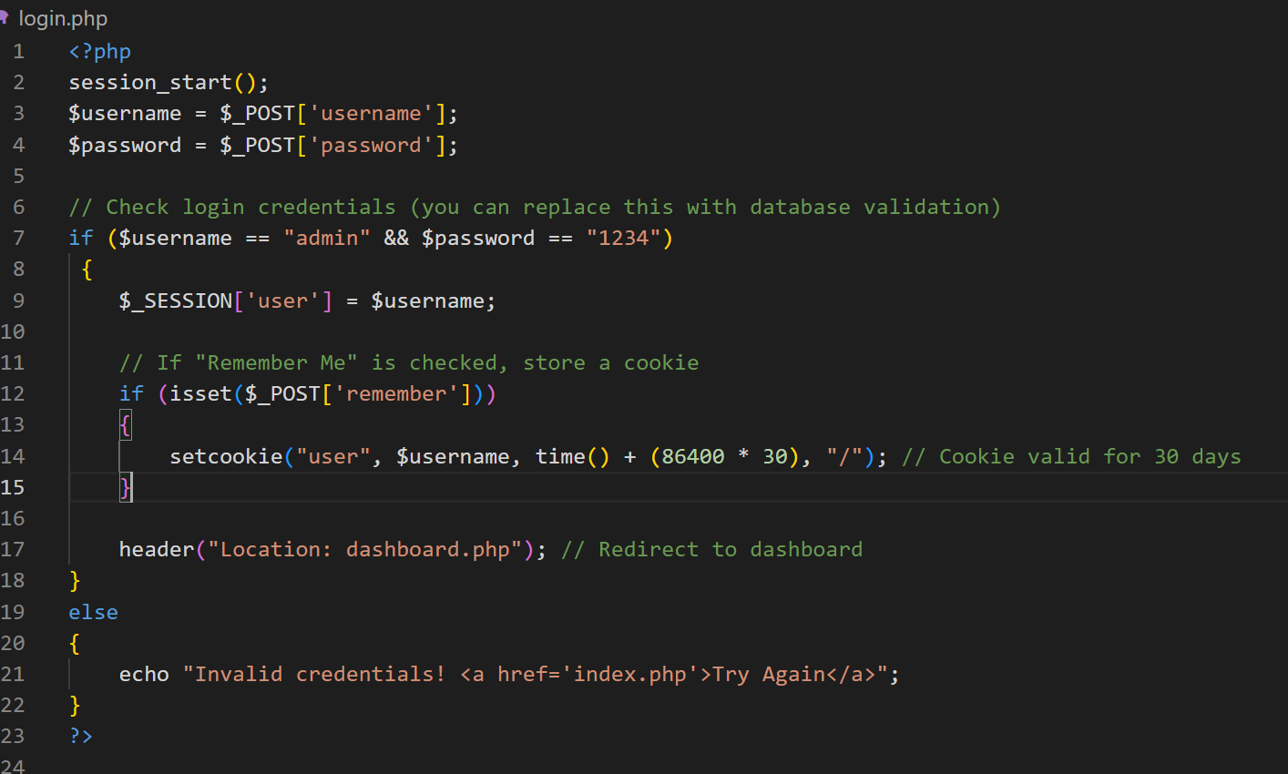  
  
  
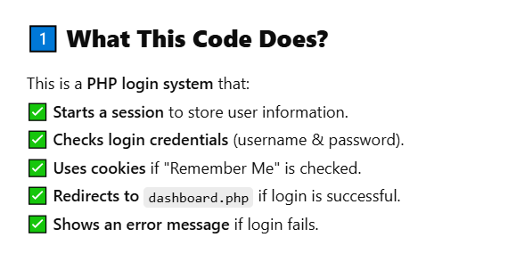

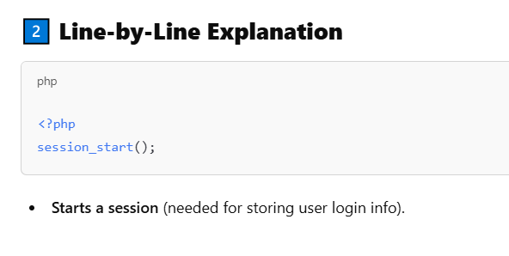  
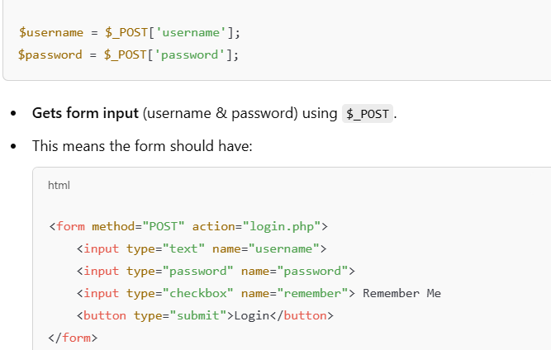  
  
  
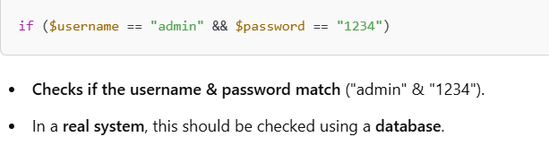  
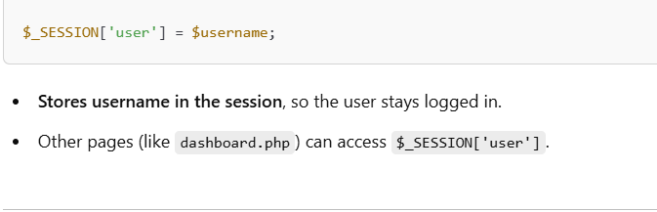  
  
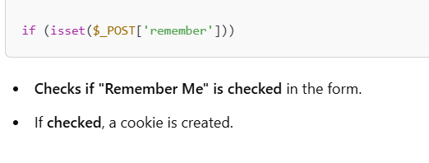  
  
  
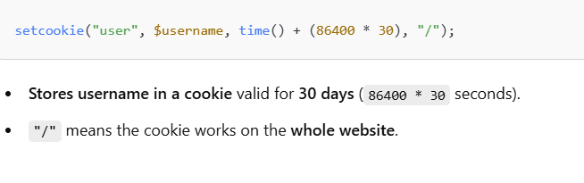  
  
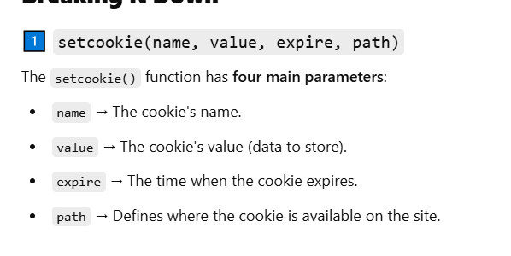  
  
  
  
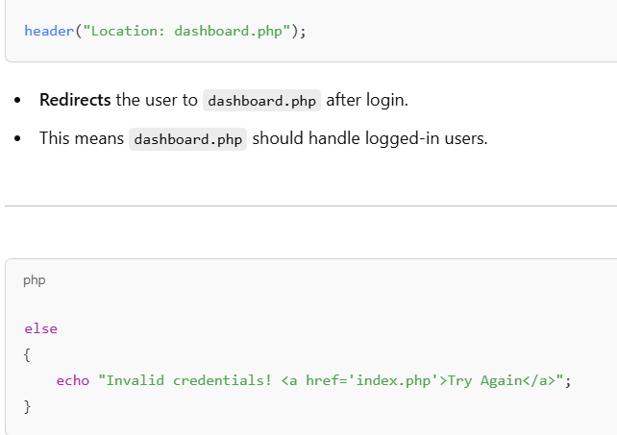  
  
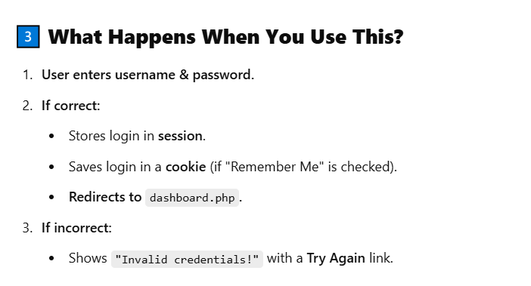  
  
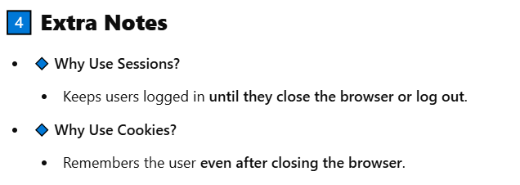  
  
  
  
**LOGOUT.PHP**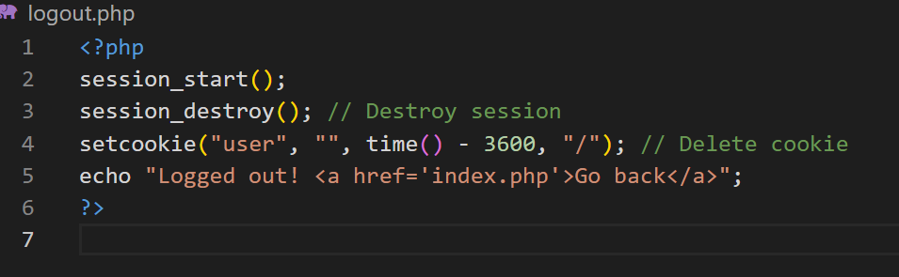  
  
  
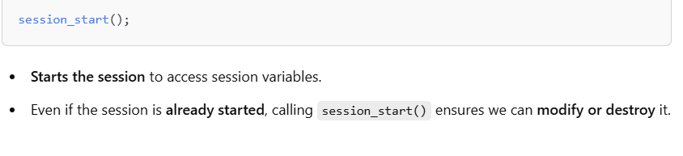  
  
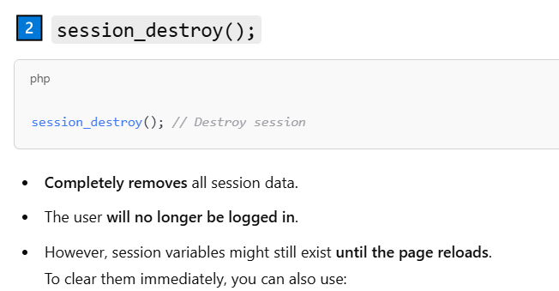  
  
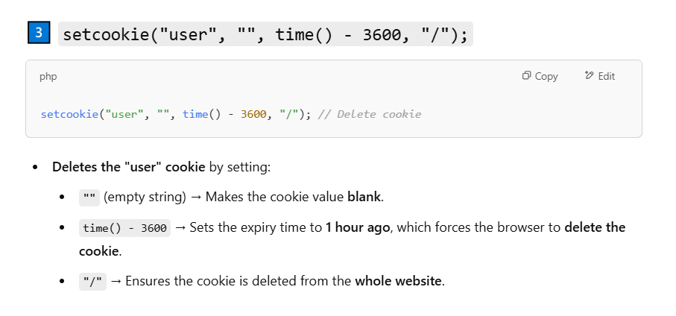  
  
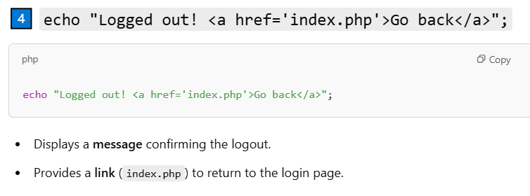  
  
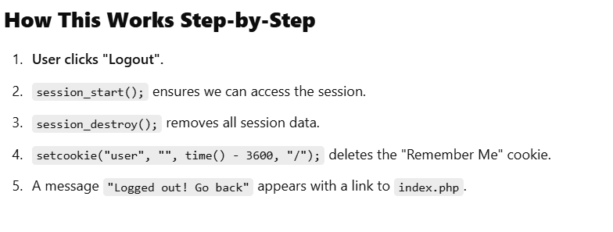  
  
  
  
  
  
  
  
  
  
  
  
**DASHBOARD.PHP**