## ****PHP Control Structures: If-Else, and Loops (Complete Guide).****

**Control structures** in PHP allow you to execute different blocks of code based on conditions or repetitions. This guide covers **if-else**, **switch**, and **loops** with examples.

## ****If-Else Statement****

The if-else structure is used for decision-making.  
  
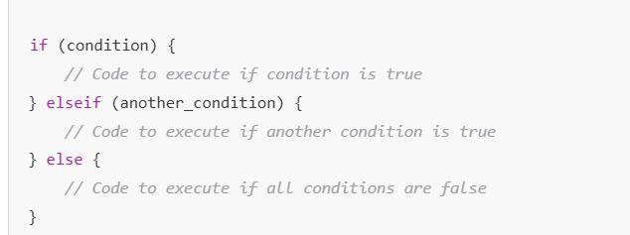

## **EXAMPLE** ****Loops in PHP****

Loops are used to execute a block of code multiple times.

### **Types of Loops in PHP**

**For Loop** - Used when the number of iterations is known.

**While Loop** - Used when the number of iterations is unknown but a condition is given.

**Do-While Loop** - Executes at least once, then checks the condition.

**Foreach Loop** - Used for looping through **arrays.**  
  
