**NAME:** Abdullah Aslam Qazi

**REGNO:** BCS 203263

**Hill Climbing**

CODE:

import random  
  
*# Function to calculate the heuristic (number of misplaced tiles)*def calculate_heuristic(state, goal_state):  
 count = 0  
 for i in range(3):  
 for j in range(3):  
 if state[i][j] != goal_state[i][j]:  
 count += 1  
 return count  
  
*# Function to generate valid moves*def generate_moves(state):  
 zero_pos = find_zero_position(state)  
 possible_moves = []  
  
 if zero_pos[0] != 0:  
 possible_moves.append((zero_pos[0] - 1, zero_pos[1])) *# Move up* if zero_pos[0] != 2:  
 possible_moves.append((zero_pos[0] + 1, zero_pos[1])) *# Move down* if zero_pos[1] != 0:  
 possible_moves.append((zero_pos[0], zero_pos[1] - 1)) *# Move left* if zero_pos[1] != 2:  
 possible_moves.append((zero_pos[0], zero_pos[1] + 1)) *# Move right* return possible_moves  
  
*# Function to find the position of the zero tile*def find_zero_position(state):  
 for i in range(3):  
 for j in range(3):  
 if state[i][j] is None:  
 return (i, j)  
  
*# Convert the 2D list state to a tuple for hashing purposes*def convert_state_to_tuple(state):  
 return tuple(map(tuple, state))  
  
*# Convert the tuple state to a 2D list for manipulation purposes*def convert_state_to_list(state):  
 return [list(row) for row in state]  
  
*# Hill climbing algorithm to solve the puzzle*def hill_climbing(initial_state, goal_state):  
 current_state = initial_state  
 current_heuristic = calculate_heuristic(current_state, goal_state)  
  
 while current_state != goal_state:  
 possible_moves = generate_moves(current_state)  
 best_state = current_state  
 best_heuristic = current_heuristic  
  
 for move in possible_moves:  
 new_state = convert_state_to_list(current_state)  
 new_state[move[0]][move[1]], new_state[find_zero_position(current_state)[0]][find_zero_position(current_state)[1]] = \  
 new_state[find_zero_position(current_state)[0]][find_zero_position(current_state)[1]], new_state[move[0]][move[1]]  
 new_heuristic = calculate_heuristic(new_state, goal_state)  
  
 if new_heuristic < best_heuristic:  
 best_state = new_state  
 best_heuristic = new_heuristic  
  
 if best_state == current_state:  
 print("No more improving moves.")  
 break  
  
 current_state = convert_state_to_tuple(best_state)  
 current_heuristic = best_heuristic  
  
 return current_state  
  
*# Test the hill climbing algorithm*initial_state = [  
 [1, 2, 3],  
 [4, 8, None],  
 [7, 6, 5]  
]  
  
goal_state = [  
 [1, 2, 3],  
 [4, 5, 6],  
 [7, 8, None]  
]  
  
print("Initial State:")  
for row in initial_state:  
 print(row)  
print("Goal State:")  
for row in goal_state:  
 print(row)  
  
print("Solving...")  
solution = hill_climbing(convert_state_to_tuple(initial_state), convert_state_to_tuple(goal_state))  
  
print("Solution:")  
for row in solution:  
 print(row)

OUTPUT:

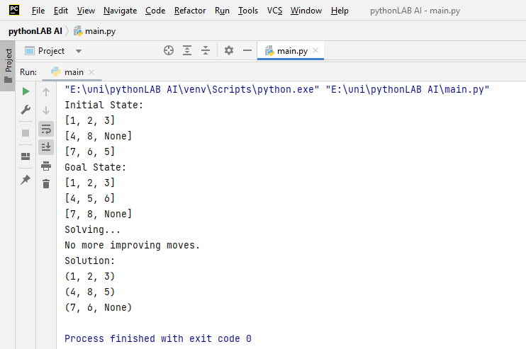

**Genetic Algo**

CODE:

import random  
  
*# Number of cards*NUM_CARDS = 10  
  
*# Target sums and product*TARGET_SUM = 36  
TARGET_PRODUCT = 360  
  
*# Genetic algorithm parameters*POPULATION_SIZE = 100  
MUTATION_RATE = 0.01  
NUM_GENERATIONS = 100  
  
def create_individual():  
 *"""Create a random individual."""* cards = list(range(1, NUM_CARDS + 1))  
 random.shuffle(cards)  
 return cards  
  
def evaluate_fitness(individual):  
 *"""Evaluate the fitness of an individual."""* sum_diff = abs(sum(individual[:NUM_CARDS // 2]) - TARGET_SUM)  
 product_diff = abs(  
 1 if sum(individual[NUM_CARDS // 2:]) == 0 else  
 (TARGET_PRODUCT / (sum(individual[NUM_CARDS // 2:]) or 1)) - TARGET_PRODUCT  
 )  
 return sum_diff + product_diff  
  
def crossover(parent1, parent2):  
 *"""Perform crossover between two parents to create two children."""* point = random.randint(1, NUM_CARDS - 1)  
 child1 = parent1[:point] + parent2[point:]  
 child2 = parent2[:point] + parent1[point:]  
 return child1, child2  
  
def mutate(individual):  
 *"""Mutate an individual by randomly swapping two cards."""* index1, index2 = random.sample(range(NUM_CARDS), 2)  
 individual[index1], individual[index2] = individual[index2], individual[index1]  
 return individual  
  
def genetic_algorithm():  
 *"""Run the genetic algorithm to find the optimal solution."""* population = [create_individual() for _ in range(POPULATION_SIZE)]  
  
 for _ in range(NUM_GENERATIONS):  
 *# Evaluate fitness for each individual* fitness_scores = [evaluate_fitness(individual) for individual in population]  
  
 *# Selection* parents = random.choices(population, weights=[1 / (score or 1) for score in fitness_scores], k=2)  
  
 *# Crossover and mutation* children = crossover(parents[0], parents[1])  
 mutated_children = [mutate(child) for child in children]  
  
 *# Replace the two worst individuals in the population* worst_indices = sorted(range(len(fitness_scores)), key=lambda i: fitness_scores[i], reverse=True)[:2]  
 population[worst_indices[0]], population[worst_indices[1]] = mutated_children[0], mutated_children[1]  
  
 *# Find the best individual after the evolution process* best_individual = min(population, key=evaluate_fitness)  
 return best_individual  
  
*# Run the genetic algorithm*best_solution = genetic_algorithm()  
  
*# Output the result*print("Optimal solution:")  
print("Pile 1:", best_solution[:NUM_CARDS // 2])  
print("Pile 2:", best_solution[NUM_CARDS // 2:])

OUTPUT:

