DATABASE MANAGEMENT SYSTEM

Online Food Ordering Management System

**PROJECT REPORT**



**Group Members:**

* **IBTEISAM KHALID BCS203056**
* **TALAL BHATTI BCS203078**
* **ABDULLAH ASLAM QAZI BCS203263**

**Section: BCS - 3**

**Submitted To: Mam Dr. Syeda Mariam Muzammal**

**Submission Date: 31th January, 2022**

**CAPITAL UNIVERSITY OF SCIENCE AND TECHNOLOGY**

**Table of Contents**

ABSTRACT 3

INTRODUCTION 3

OBJECTIVE: 3

SOFTWARE TOOLS 3

ENTITY RELATIONSHIP DIAGRAM (ERD) 19

PERFORMANCE: 4

NORMALIZATION 4

TABLES 5

JOINS 6

VIEWS 7

PROCEDURES 8

FUNCTIONS 10

TRIGGERS 14

USERS 17

FUNCTIONALITY 20

OUTPUTS 26

CONCLUSION 28

REFERENCES 28

CODE 28

**ONLINE FOOD ORDERING MANAGEMENT SYSTEM**

# ABSTRACT:

Online food ordering system provides service facility to restaurant and the customer. This service is too providing food ordering. Main objective is to provide ordering by online to the customer.in this system online, ordering management will become easier to replace the difficult system where we are still using paper.

# INTRODUCTION:

An online food ordering system is software that allows the restaurant business to accept and manage on the internet easily in a minimum time. Website or app for those customers who are hungry to view the menu and place the order at home

In this pandemic situation it is very useful for us to make our life easier and protective. We can order food and stay our home protective. This system helps restaurant to do all things more accurately and faster .it reduces manual work and improve effieciency.it stores many data base and manage the record easily. This software is helping food ordering to maintain the stock and flows and there are many more functionalities

* To maintain the records like user information, staff information, booking and food details etc.
* Control orders
* Keep record of amount
* Maintain the staff shifting information

# 

# OBJECTIVE:

Facing this pandemic situation, we all are in depression about are lives and after visiting many marts and stored we have this idea to maintain the system which store every data.

Food delivery aims to save manage your reservations on a computer and in the process let you keep the regular customer dealing. According to this system we can click one button and make your order reserve, check menu details and your total bill. There are also field for entering the customer address, phone, email.

# SOFTWARE TOOLS:

* SQL Plus
* Note pad ++
* Xaamp
* Command promt

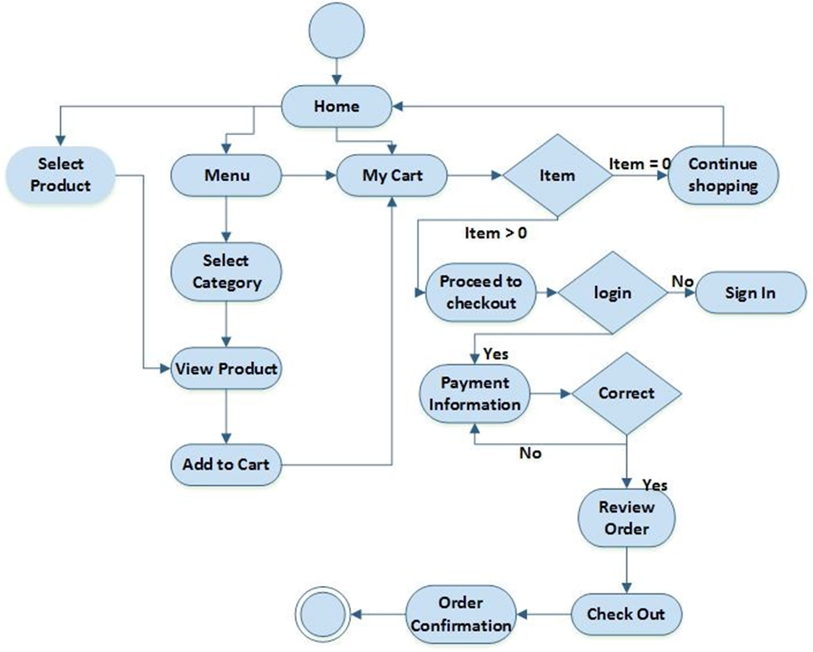

**ERD DIAGRAM:**

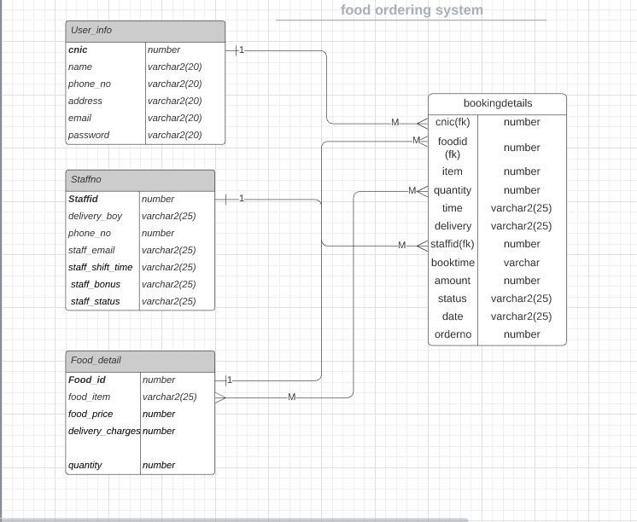

# PERFORMANCE:

## NORMALIZATION

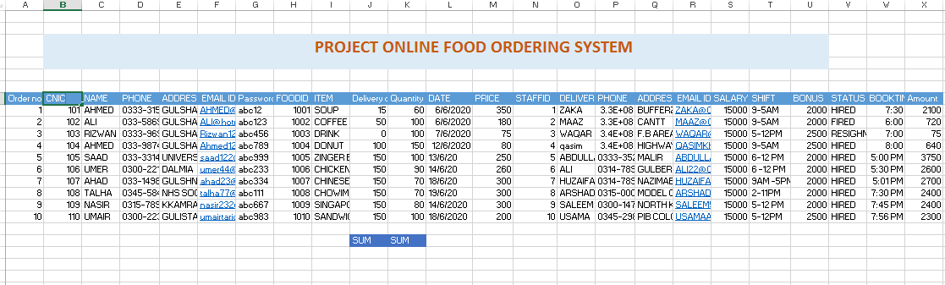

**NORMALIZED DATA:**

**1st NF**

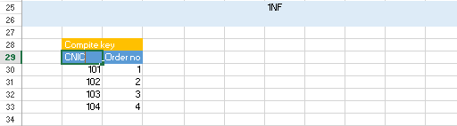

**2nd NF**

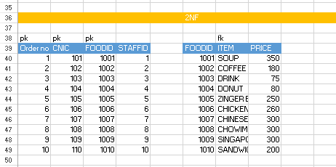

**3rd NF**

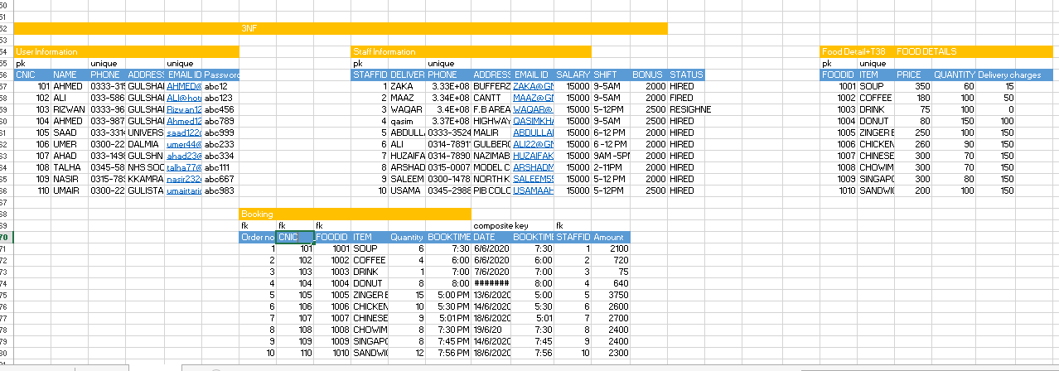

## TABLES

1. **User Information**

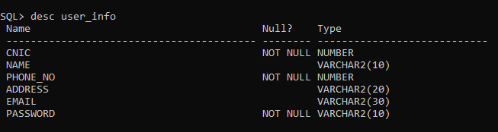

1. **Staff Information**

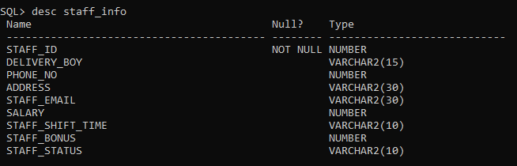

1. **Food details**

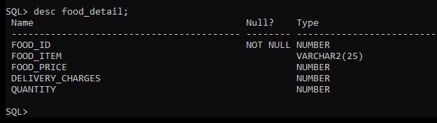

1. **Booking**

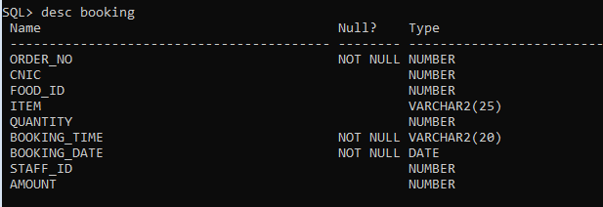

## **JOINS**

* select food_details.food_price, booking.booking_time from food_details INNER JOIN booking

on food_details.food_id = booking.food_id;

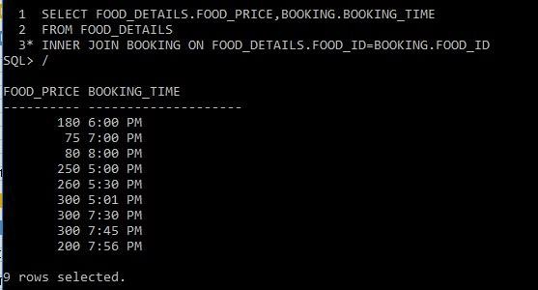

## VIEWS

* create view user_menu as select food_item, food_price from food_detail;

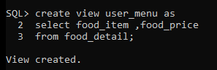

* create view deliveryboy_view as

select d.staff_id,b.foodid,b.totalamount,b.userid

from booking b inner join food_details f on b.foodid=f.food_id inner join user_info u on u.user_Id =b.userid

inner join staff_info d on d.staff_id=b.staff_id;

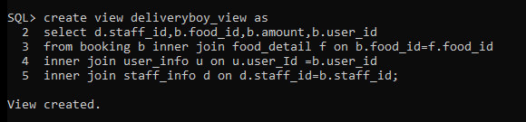

* create view hey

as select food_item from food_detail;

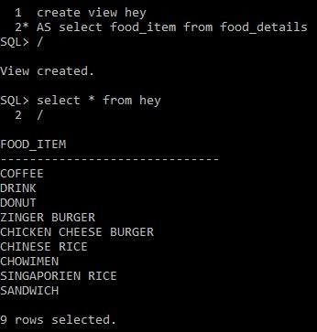

* create view project

as select food_id, quantity, booking_date from booking

where item = ‘DRINK’;

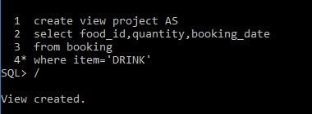

## PROCEDURES

* create or replace procedure adduser( in user_info.cnic%type,user_name in user_info.name%type, user_phone in user_info.phone_no%type,user_address user_info.address%type, user_email in user_info.email%type,user_password in user_info.passward%type )

is begin

insert into user_info(cnic,name,phone_no,address,email,passward) values(cnic,user_name,user_phone,user_address,user_email,user_password); dbms_output.put_line(' User ADDED! SUCCESSFULLY');

end;

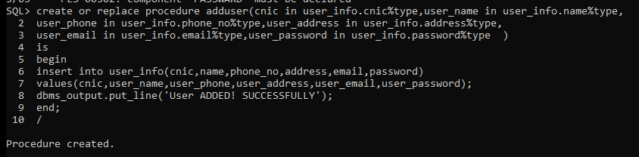

execute adduser(609, 'John', 03349821789, 'Clifton', 'john32@gmailcom', 'john12345');

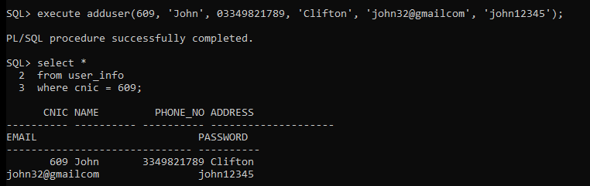

* create or replace procedure addstaff(staff_id in staff_info.staff_id%type, delivery_boy in staff_info.delivery_boy%type, phone_no in staff_info.phone_no%type, address in staff_info.address%type, staff_email in staff_info.staff_email%type, salary in staff_info.salary%type, staff_shift_time in staff_info.staff_shift_time%type, staff_bonus in staff_info.staff_bonus%type, staff_status in staff_info.staff_status%type)

is begin

insert into staff_info(staff_id,delivery_boy,phone_no,address,staff_email,salary,staff_shift_time,st aff_bonus,staff_status) values(staff_id,delivery_boy,phone_no,address,staff_email,salary,staff_shift_time,staff_ bonus,staff_status);

dbms_output.put_line(' STAFF ADDED! SUCCESSFULLY'); end;

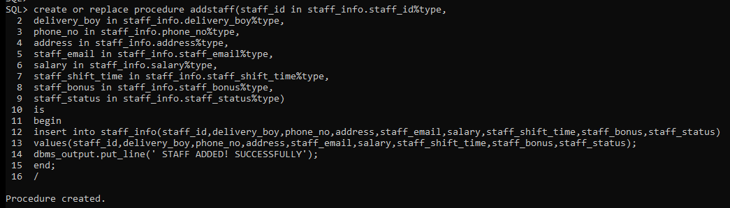

execute addstaff(23, 'Usman', 03321985621, 'North Nazimabad', 'usman12@gmail.com', 2400, '5-8 PM', 100, 'Hired');

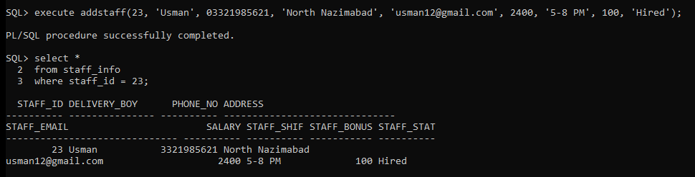

* create or replace procedure addfooditem(food_id in food_details.food_id%type,food_item in food_details.food_item%type, food_price in food_details.food_price%type, delivery_charges in food_details.delivery_charges%type,quantity in food_details.quantity%type)

is begin

insert into food_details(food_id,food_item ,food_price ,delivery_charges ,quantity) values(food_id,food_item ,food_price ,delivery_charges ,quantity) ;

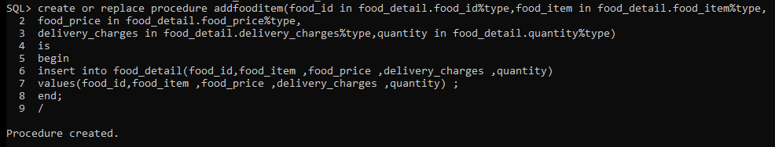end;

execute addfooditem(49, 'BISCUITS', 90, 50, 100);

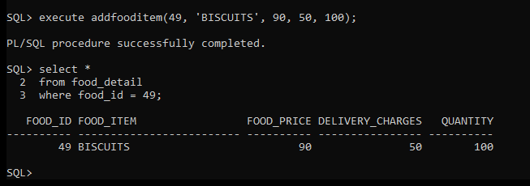

## FUNCTIONS

* create or replace function deliver return number

is

TOTAL_SALARY number;

begin

select sum(d.salary)INTO TOTAL_SALARY from staff_info s,staff_info d where s.delivery_boy=d.delivery_boy;

return TOTAL_SALARY; end;

declare

TOTAL_SALARY number; begin TOTAL_SALARY:=deliver();

dbms_output.put_line(TOTAL_SALARY); end;

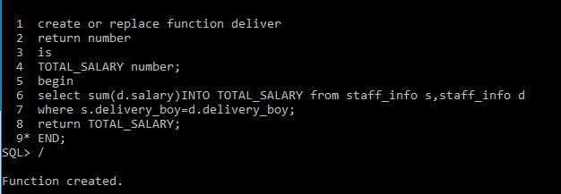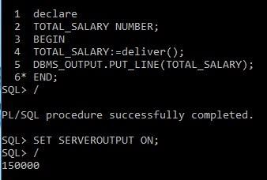

* create or replace function deliver return number

is

MAX_SALARY number; begin

select MAX(d.salary)

INTO MAX_SALARY from staff_info s,staff_info d where s.delivery_boy=d.delivery_boy;

return MAX_SALARY; end;

declare

MAX_SALARY number; begin MAX_SALARY:=deliver();

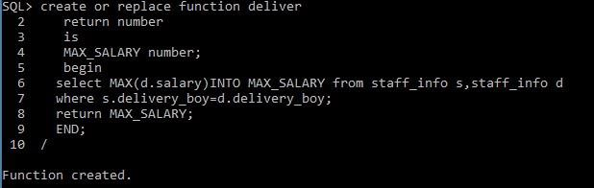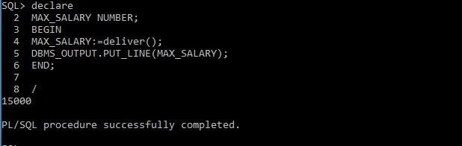dbms_output.put_line(MAX_SALARY); end;

* create or replace function total return number is

total number(2):=0; begin

select count(*)into total from staff_info;

return total; end;

declare

total_number number; begin total_number:=total();

dbms_output.put_line(total_number); end;

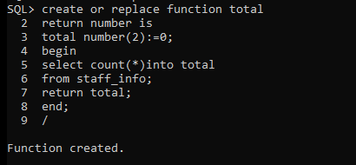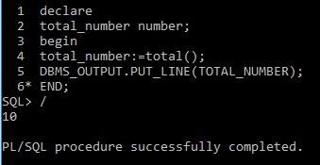

* create or replace function deliver return number

is

MIN_SALARY number; begin

select MIN(d.salary) into MIN_SALARY from staff_info s, staff_info d where s.delivery_boy = d.delivery_boy;

return MIN_SALARY; end;

declare

MIN_SALARY number; begin MIN_SALARY:=deliver();

dbms_output.put_line(MIN_SALARY); end;

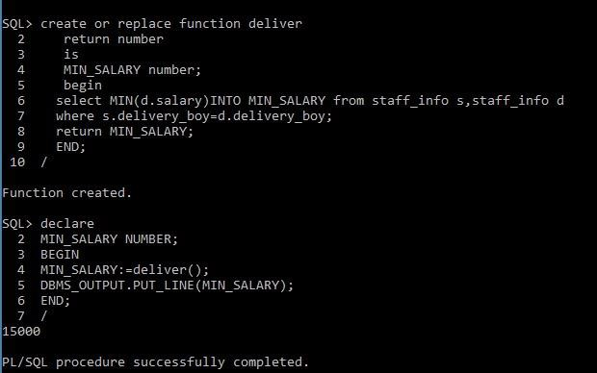

## TRIGGERS

* create or replace trigger quantity after update on food_detail

for each row begin insert into my_project

values (:old quantity , SYSDATE); end;

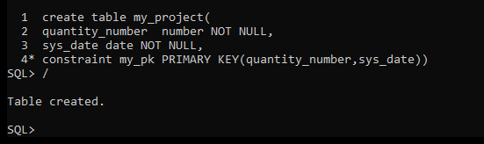

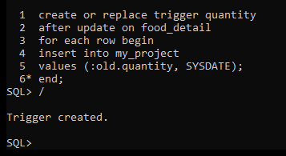

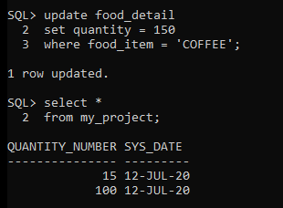

* create or replace trigger display_food_price_charges before delete or insert or update on food_detail

for each row

when (new.food_price> 0) declare

fp_diff number; begin

fp_diff := :new.food_price- :old.food_price; dbms_output.put_line('old food_price: ' || :old.food_price); dbms_output.put_line('new food_price: ' || :new.food_price); dbms_output.put_line('charges food_price: ' ||fp_diff);

end;

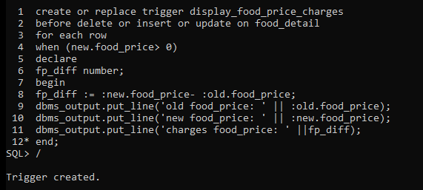

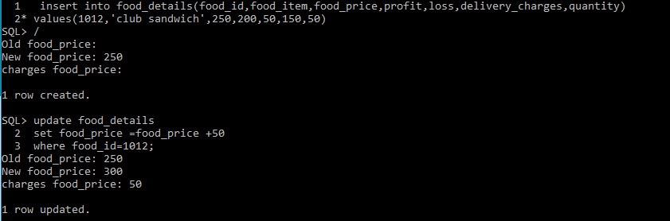

* create or replace trigger my_trig after update on food_detail

for each row begin insert into project

values (:old.food_id, SYSDATE); end;

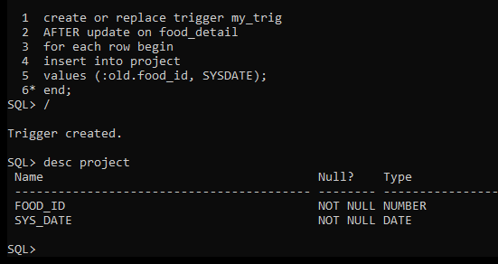

## CURSORS

* declare cursor staff is

select staff_id,delivery_boy from staff_info where phone_no=03358693345; v_staff_id staff_info.staff_id%type;

v_delivery_boy staff_info.delivery_boy%type; begin

open staff; loop

fetch staff into v_staff_id,v_delivery_boy; exit when staff%NOTFOUND;

dbms_output.put_line(v_staff_id||v_delivery_boy); end loop;

close staff; end;

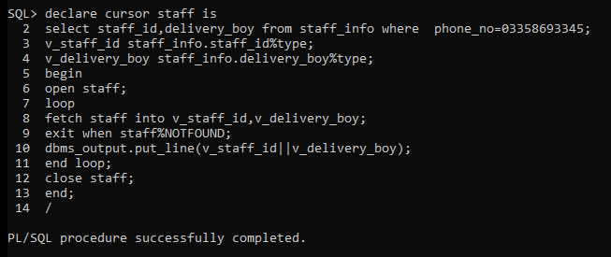

## 

## USERS

**User “ADMI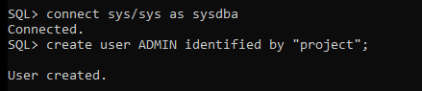N**

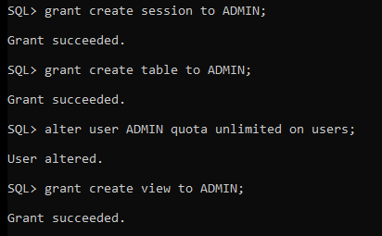

**User “CUSTOMER”**

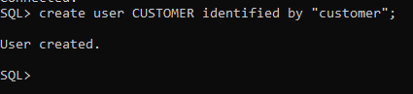

# FUNCTIONALITY

**Admin Page**

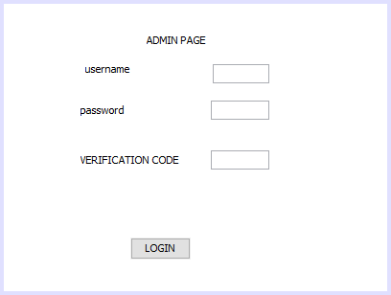

**Admin Dashboard**

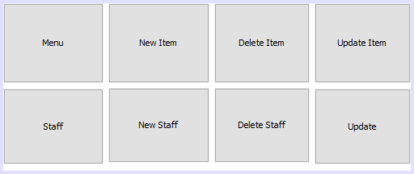

**Delete Food Item**

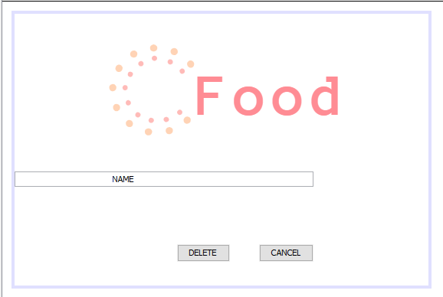

**Insert Staff**

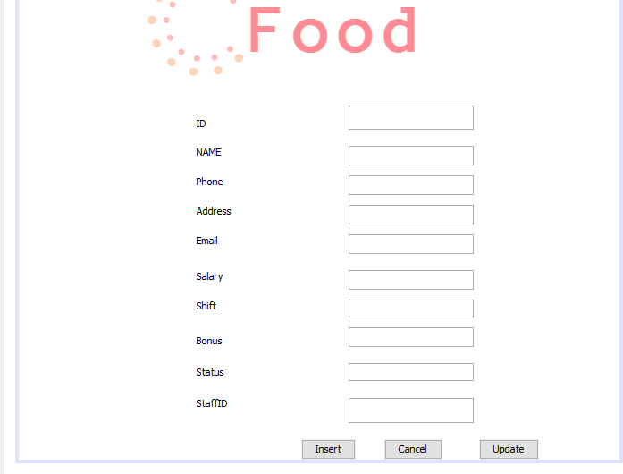

**Menu**

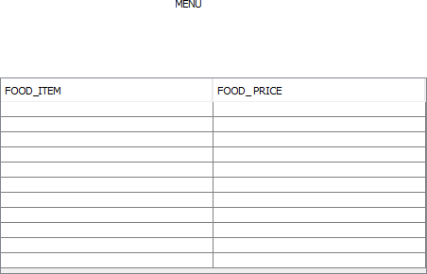

**Staff List**

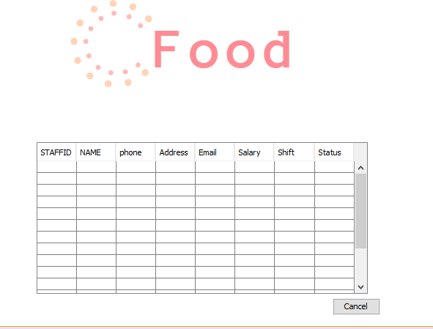

**Signup**

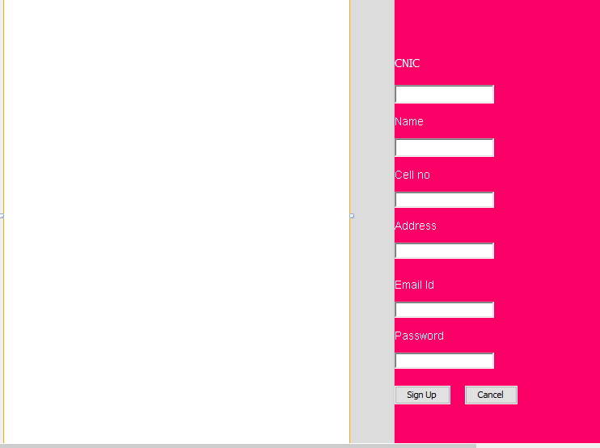

**Update Staff**

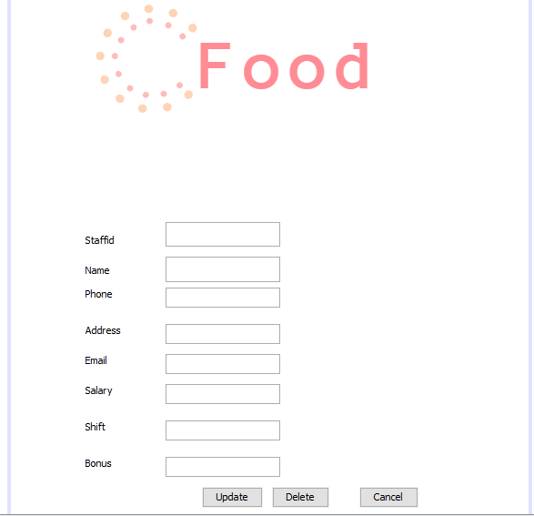

**Change Admin Password**

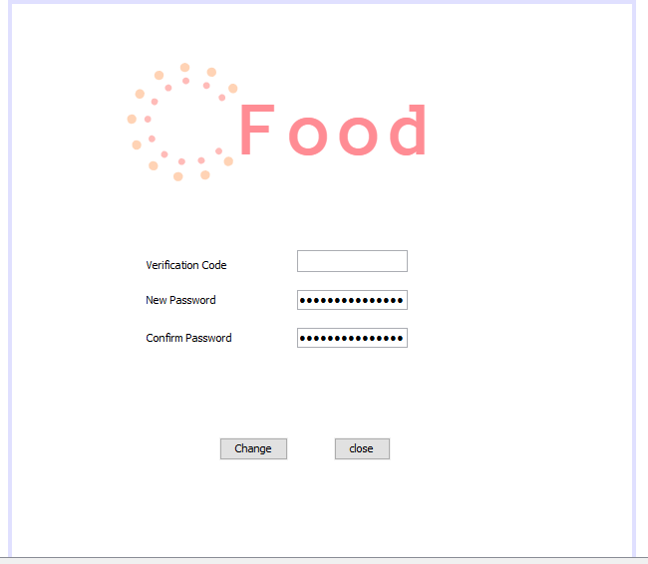

**Change Password User**

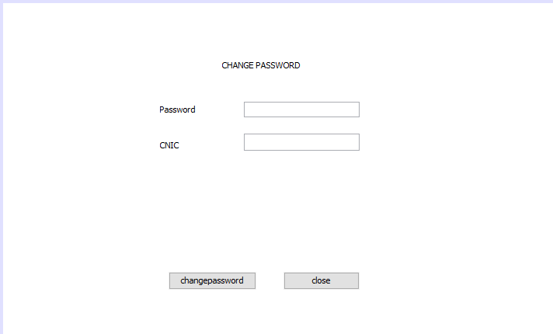

**Insert Menu Item**

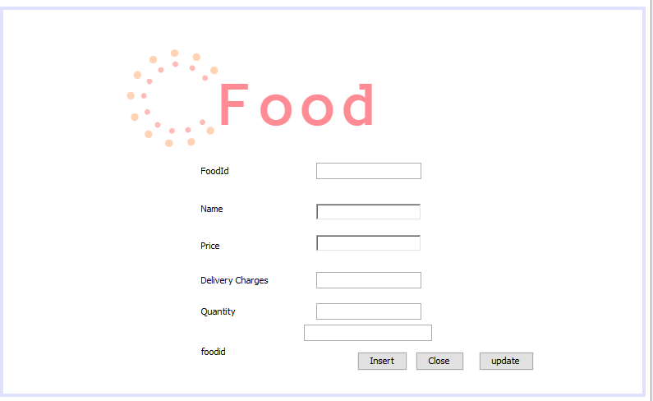

**Login**

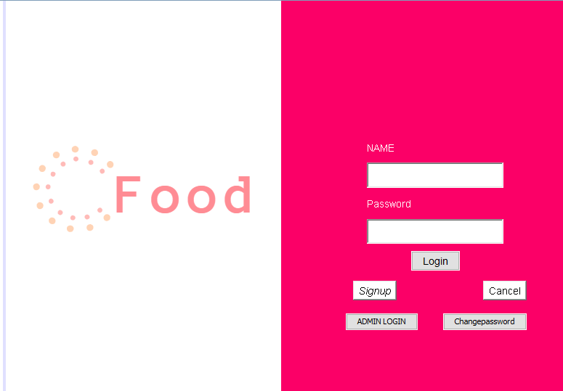

**Order**

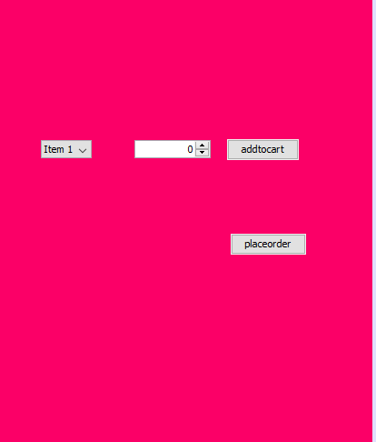

**Update Menu Item**

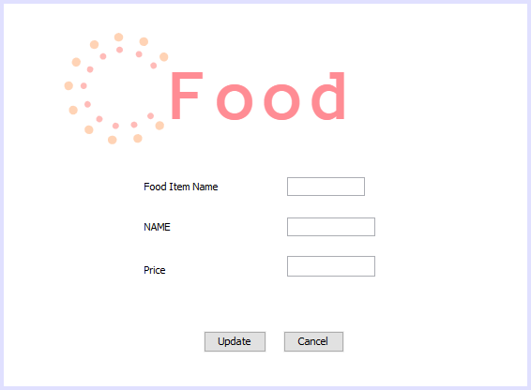

# OUTPUTS

**Admin Login User Login**

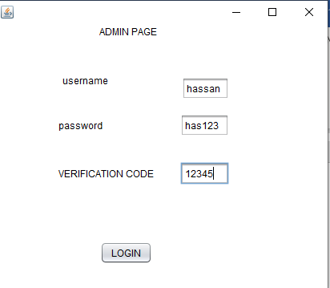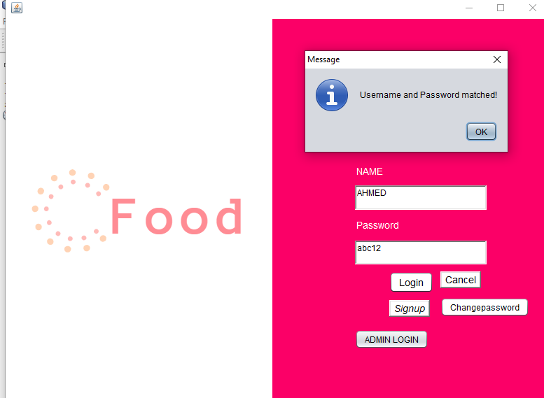

**Menu**

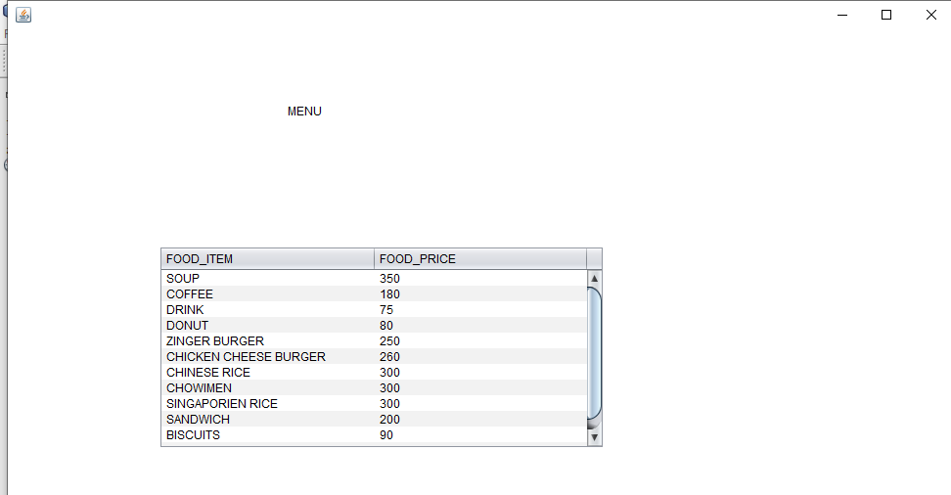

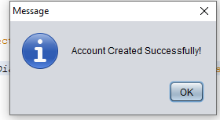**Signup**

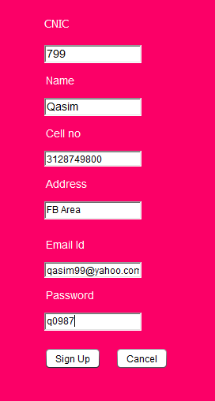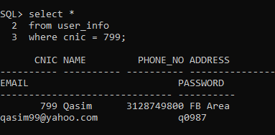

**Admin Dashboard Admin Menu**

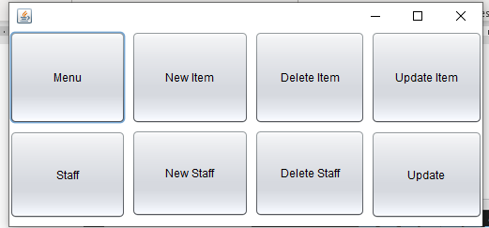**Insert Staff** 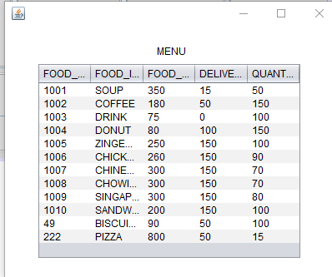

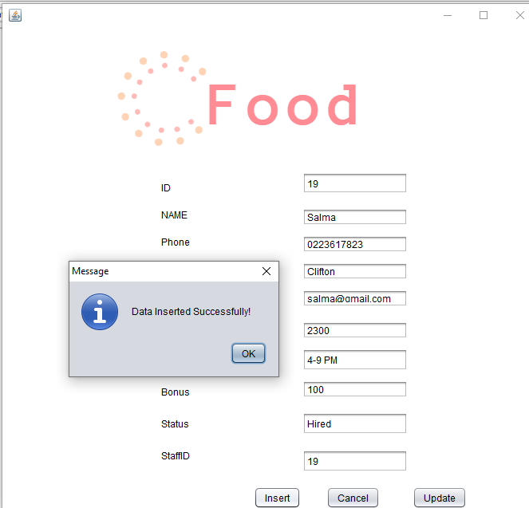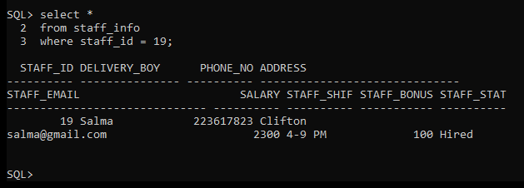

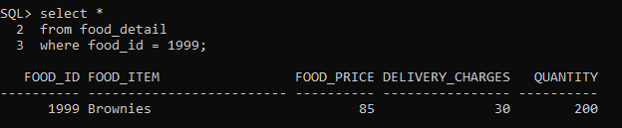**Insert Menu Item**

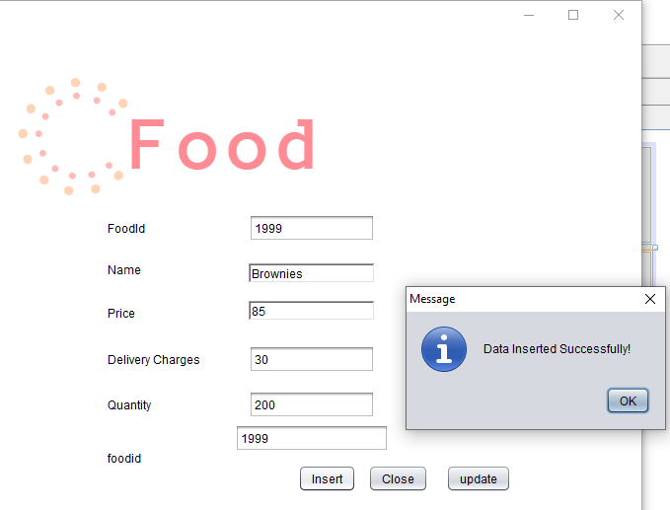

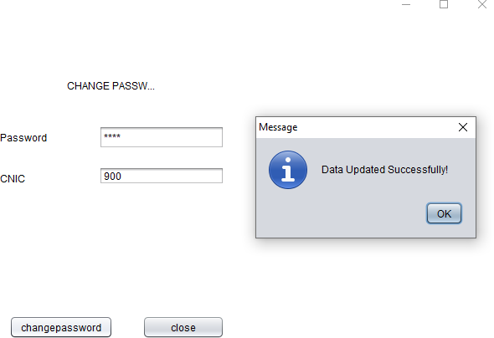

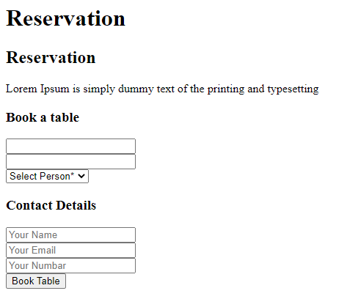

# 

# **CONCLUSION**

* All food order details like order type are stored daily.
* All the amounts updated daily in database.
* This system reduces manual works.
* All the shift timings of staff, delivery staff data, charges and bonus will be stored in the database for easy access.
* All data will be saved in database making it easier for the admin to view all the data.
* Data related to users, staff or food items can be inserted, updated or deleted.

# REFERENCES

* Stack Overflow
* Database Management Systems books and websites